Barwon Enabling Young Women
Leadership Program
Application form
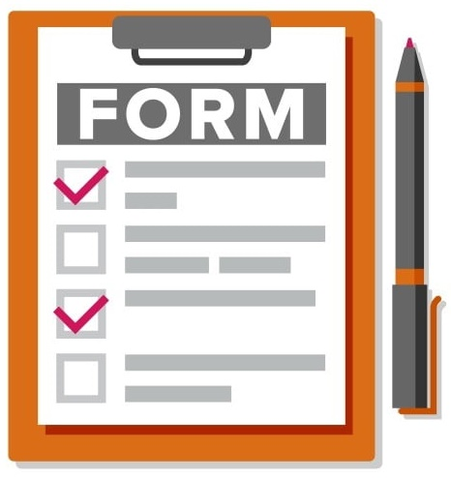

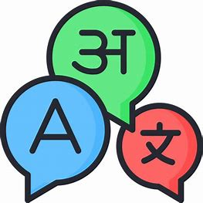
Do you want help understanding this document in another language?

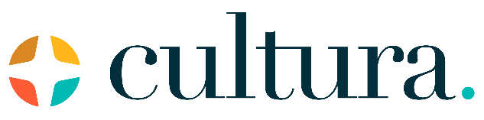
Contact Cindy Marshall from Cultura.

- Phone: (03) 4210 0000

- Email: cindy.marshall@diversitat.org.au

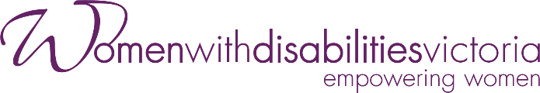
Women with Disabilities Victoria (WDV) is an organisation run for and by women and non-binary people with all kinds of disabilities.

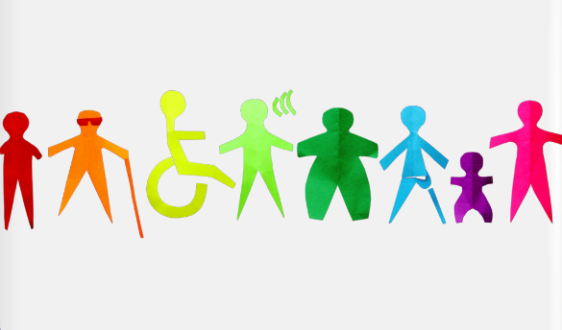
Our members are people of all ages, backgrounds and lifestyles. We are a proud LGBTIQA+ ally.
We strive to be a safe space and to include all women and non-binary people with disabilities.

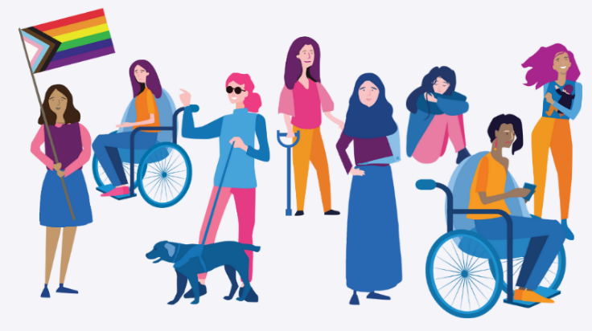
We focus on our right to safety and respect.
This includes being able to speak up four ourselves and be leaders.

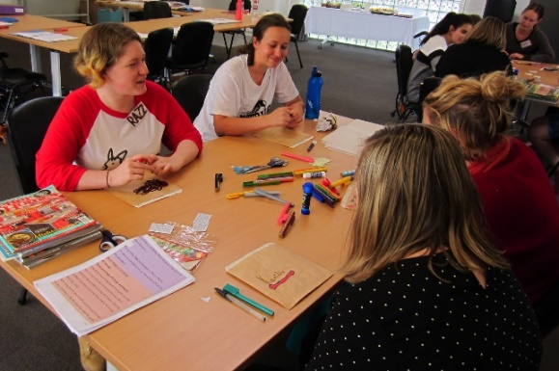
In The Enabling Young Women Leadership Program (also known as the Program) we look at what it means to be a leader for women and non-binary youth with disability. (Aged 18-25 years).
We do this in fun and meaningful ways.

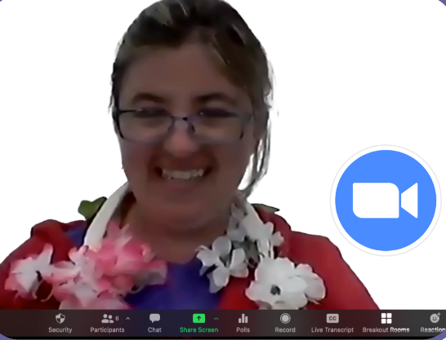
The Program will be on Zoom.
We will make it personal and fun.

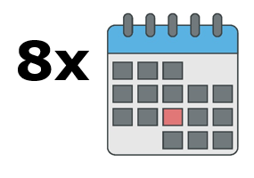
There will be 8 Program sessions.

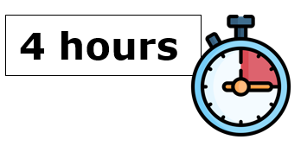
Each session will be 4 hours long
With lots of breaks.

The exact days and times of the Program will be confirmed when people have told us what times they can attend.

The Program will begin in November.

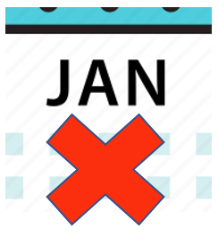
Program sessions will not run over Christmas and in January.

The Program will finish with a Graduation celebration in February
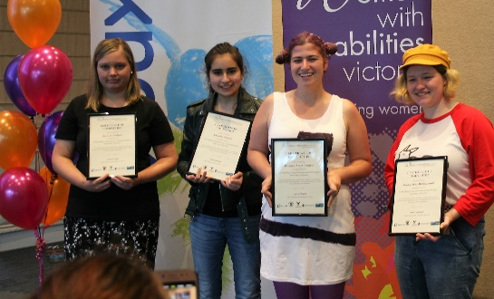
The Program will have upto 12 participants.

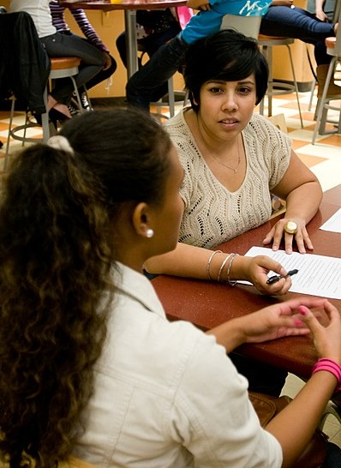
During the Program, participants will work with a mentor.

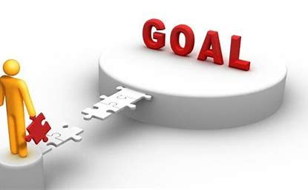
Mentors can help people achieve a goal

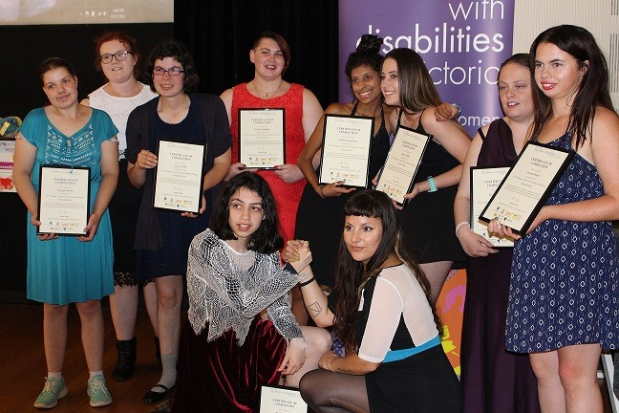
The Program is open to:

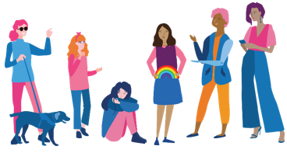
- Women and non-binary youth,

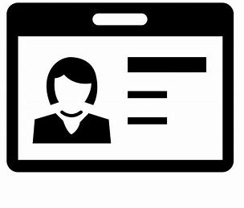
- who are aged 18-25 years,

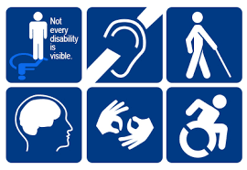
- who identifies as someone
- with disability (physical, sensory, intellectual, cognitive, etc.)
- who is Deaf / deaf / hard of hearing
- who lives with chronic illness, and/or pain
- who is neurodiverse, e.g. autistic
- who lives with mental health challenges

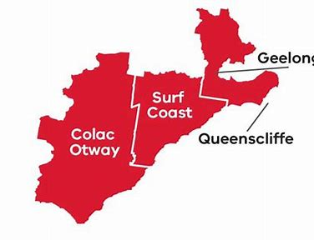
- and who lives, works, or plays in the Barwon area.

Do you want more information, or help to apply?

Go to WDV’s website.

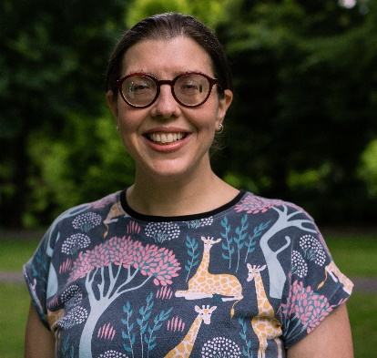
Or, you can contact Bridget Jolley at WDV.

Phone: 03 9286 7813

Email: bridget.jolley@wdv.org.au

Completing the Application Form

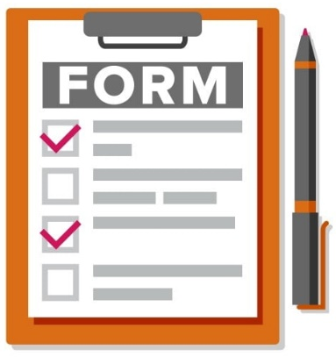
To do the Enabling Young Women Leadership Program you will need to fill out this Application Form.

You can ask someone you trust to help complete and send the form.

You can also contact Bridget Jolley at WDV for help.
- Phone: 03 9286 7813
- Email: bridget.jolley@wdv.org.au
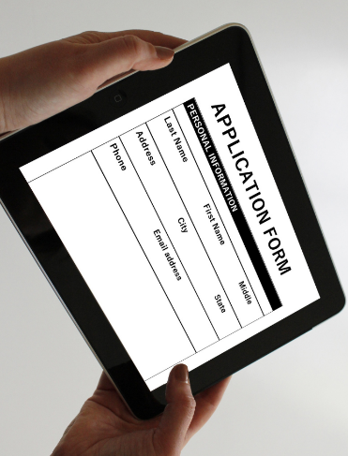
You can fill out the form on your computer, phone or tablet.

Or, you can print the form and fill it out by hand.

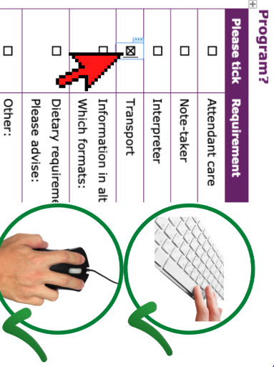
If you are using a computer to fill out this form, you can click the mouse or use the spacebar button to select the check boxes.

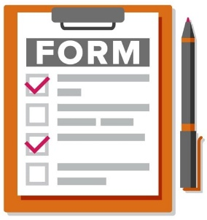
You need to email the completed form to bridget.jolley@wdv.org.au.

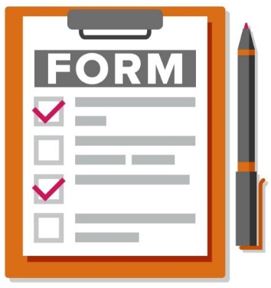
Application Form

Your Details
*Optional* = only answer if you want to

Information required | Your response
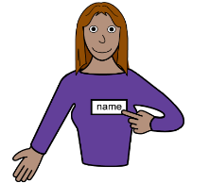
First and last name

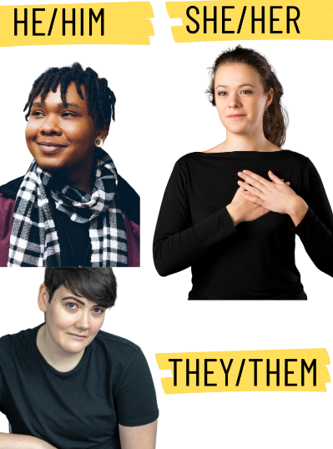  Pronouns  *Optional* | Example: Would you like people to refer to you and say “she”, “they”, “he”, or something else.  ☐ She/Her  ☐ They/Them  ☐ He/Him  ☐ Prefer not to say  ☐ Something else (Please tell us)
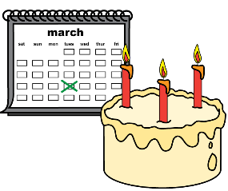
Year of birth

Street Address

Suburb
and
Postcode

Best contact phone number

Email address

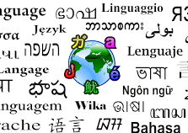  Do you speak a language other than English at home? | ☐ Yes – what language/s?  ☐ No
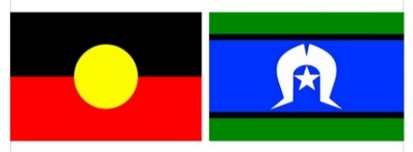  Do you identify as Aboriginal and/or Torres  Strait Islander?  *Optional* | ☐ Yes – Aboriginal  ☐ Yes – Torres Strait Islander  ☐ No  ☐ Prefer not to say

Questions about you
Information required | Your response
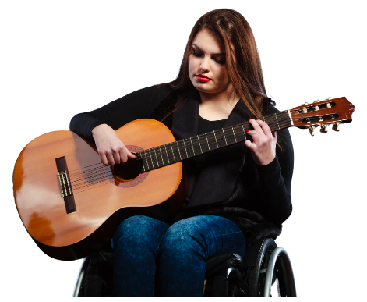
- What do you do for fun?

- Why are you interested in doing this Program?

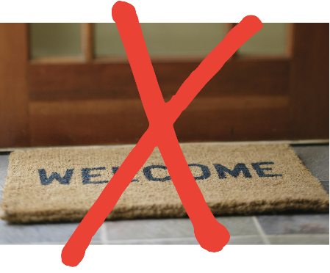  - Has anything stopped you from doing the activities you want to?  Particularly because of your age, gender, or disability? | ☐ Yes  ☐ No  ☐ Not sure  If yes, what sort of things? Examples, feeling left out, or not being able to get to places.
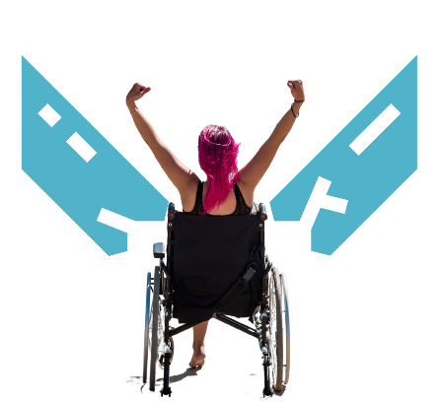  - Did you get through the problem?  If yes, how? | ☐ Yes  ☐ No  ☐ Not sure  If yes, how?
- What connection do you have with the Barwon area?

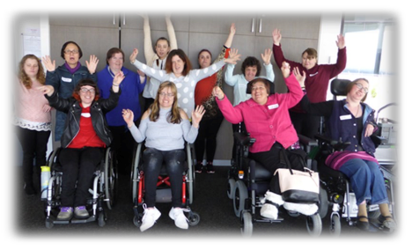  - Are you currently, or in the past, a member of any groups?  What groups? | Examples: advocacy group, sporting club, youth group, etc.
- Wht did you do as a member of these groups? | Examples: We met socially, or I chaired meetings where we made decisions as a group.
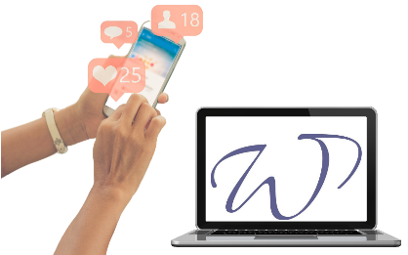
- How did you hear about the Barwon Enabling Young Women Program?

Participation Questions
Information required | Your response
- Do you have a computer or tablet with internet at home? | ☐ Yes – computer  ☐ Yes – tablet  ☐ No
- Does the internet work well? | ☐ Yes  ☐ No  ☐ Sometimes  ☐ Not sure
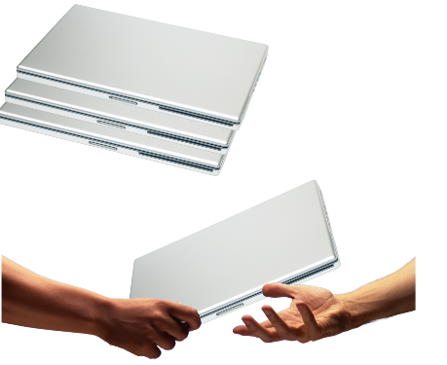  - If you do not have a computer or tablet, with good internet, would you like to borrow something? | ☐ Yes  ☐ No  ☐ Not sure
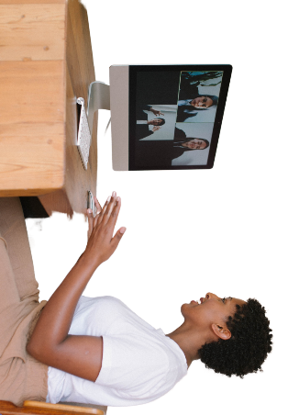  - Have you done an online video meeting before? | ☐ Yes - Zoom  ☐ Yes – Other. What did you use?  ☐ No
- Would you like any help to use Zoom? | ☐ Yes – Please tell us in what ways?  ☐ No  ☐ Not sure
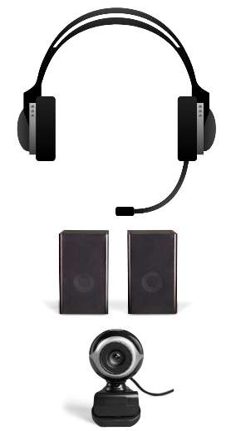  - If you have a computer, can you use these things with your computer? | ☐ Microphone  ☐ Headphones  ☐ Speaker  ☐ Webcam
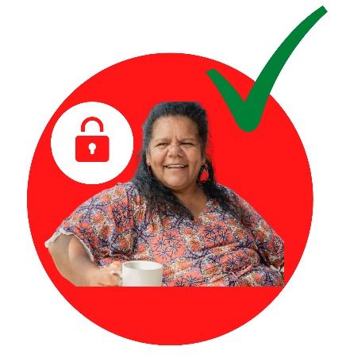  - Do you have a safe place at home to be alone and do the Program? | ☐ Yes  ☐ No  ☐ Not sure
- Do you feel comfortable doing the Program at home? | For example, you may not feel safe or comfortable being by yourself, or if other people are nearby.  ☐ Yes  ☐ No  ☐ Not sure

Access and Supports
Are there any access needs or supports that could help you to fully participate?
If you may need one of these supports, please tick the box and provide more information.
Information required | Your response
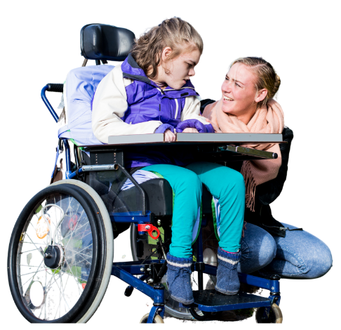  - Attendant care  To help with eating and going to the bathroom. | To help with eating, going to the bathroom, etc.  ☐ Yes - Tell us more:
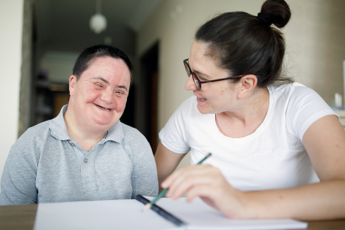  - Note-taker | To help take notes of what’s said, your ideas, etc.  ☐ Yes - Tell us more:
- Interpreter | ☐ Yes - Tell us more:
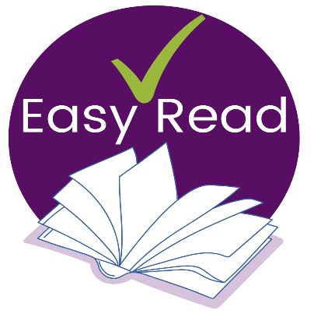  - Information in other ways | Examples: Examples: Easy English, braille, audio, etc.  ☐ Yes - Tell us more:
- Dietary requirements | Examples: Vegan, Halal, or soft foods, etc.  ☐ Yes - Tell us more:
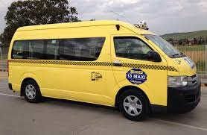  - Transport | For if we ever meet in person.  ☐ Yes - Tell us more:
- Other  What else could help you to participate? | ☐ Yes - Tell us more:

