Participants Wanted
Barwon Youth Leadership Program

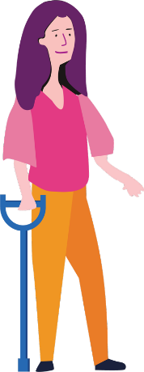
We are looking for women and non-binary youth with disability from the Barwon region who want to become better leaders.

Will you come join us for the Barwon Enabling Young Women Leadership Program?

You will explore who you are, and your strengths. As well as learn more about your rights, speaking up, and how you can be a better leader in your community.

Where: Online via Zoom - If you need support with participating online just let us know.
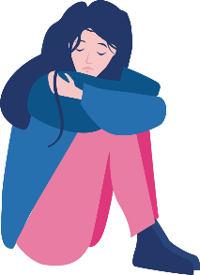
When: The day and time will be decided when we know everyone’s availability.
Sessions: Between November 2022 – February 2023, there will be 8 x 4 hour sessions (with lots of breaks), and a Graduation celebration. Program sessions will not run over Christmas and January.
Cost: Free!

Included in the Program:
- All materials like books, crafts supplies, online resources, etc.
- Supports if you need them.
- Food/snacks will be delivered each week.

To find out more, or to apply: visit our website (including for various accessible application forms). If you have questions, or would like help completing the Application form, please contact Bridget via email: Bridget.Jolley@wdv.org.au or phone 03 9286 7813.

