**Warrnambool, Port Fairy and the South West**

# The Enabling Women Leadership Program

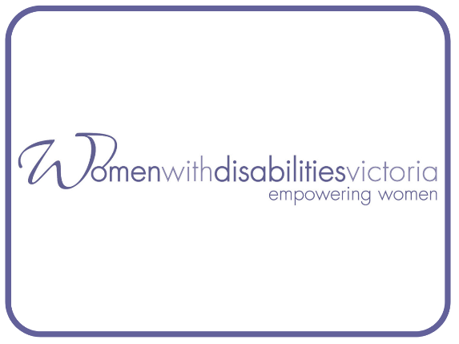**Women with Disabilities Victoria (WDV)** is an organisation run for and by women and non-binary people with all kinds of disabilities.

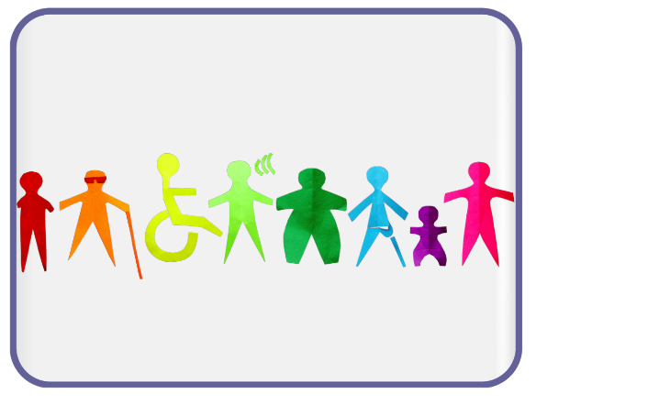Our members are people of all ages, backgrounds and lifestyles. We are a proud LGBTIQA+ ally. We strive to be a safe and inclusive service for all women and non-binary people.

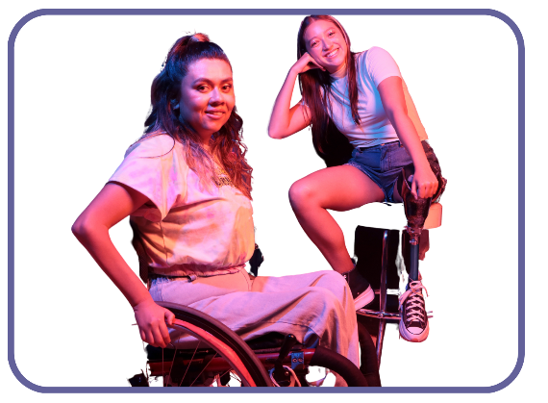

We advocate for our right to safety and respect with a focus on empowerment and leadership.

In **The Enabling Women Leadership Program (the Program)** we look at what it means to be a leader for women and non-binary people with disability.

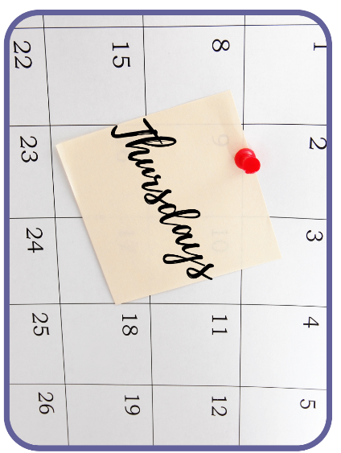

Program days and times will be decided when we know what everyone’s availability is.

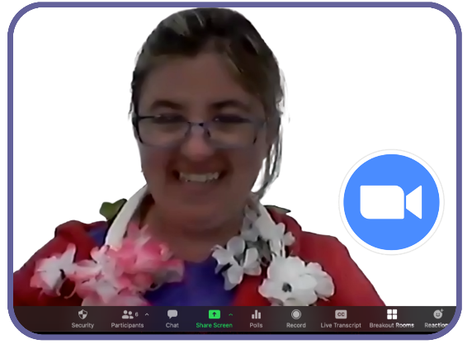

It will be delivered online via Zoom – but we will make it personal and fun. With lots of breaks.

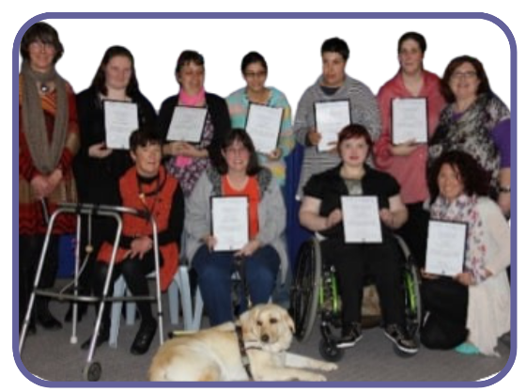

We will be looking for up to 12 participants to do the Program.

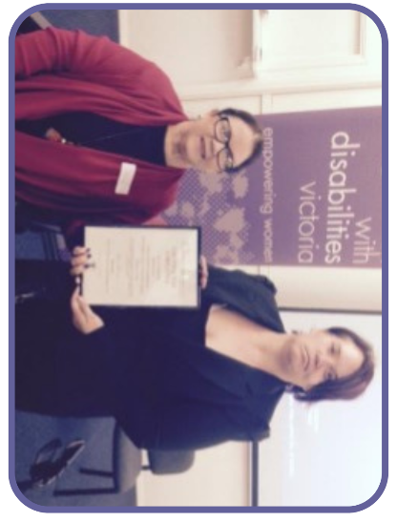

In early 2023, we will have a Graduation where friends and families can help us celebrate.

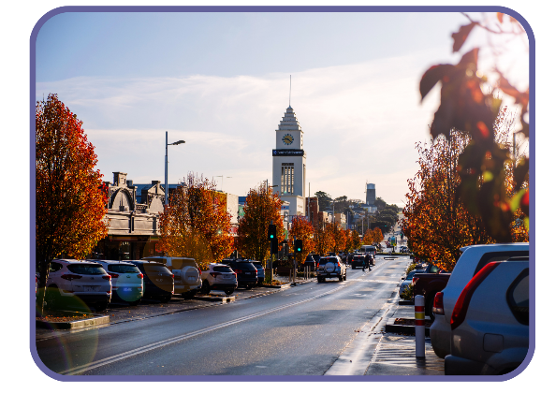

This year the Program will be for women and non-binary people with disability in Port Fairy, Warrnambool and the State’s South West.

# A woman writing with a pen, smiling.Participants Application Form

To do the Enabling Women Leadership Program you will need to fill out this **Application Form**.

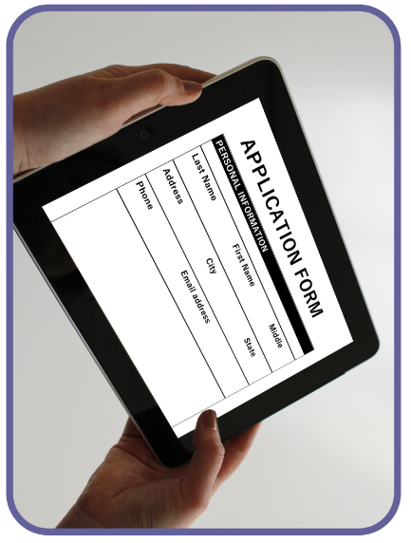

You can fill out the information on your computer, phone or tablet.

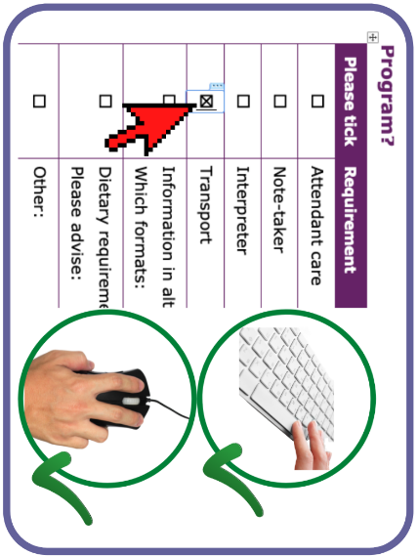

If you are using a computer to fill out this form, select the boxes by clicking the mouse or by using the spacebar.

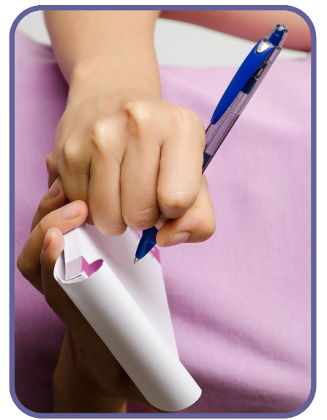

Or you can print out the form and write your answers in by hand and send it to us.

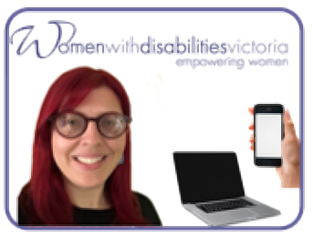

Or ask Bridget at WDV for help.​

**Call** Bridget on (03) 9286 78013 or **email** [bridget.jolley@wdv.org.au](mailto:bridget.jolley@wdv.org.au)

# Your Details

\***Optional** – only answer if you want to

|  |  |  |
| --- | --- | --- |
| A woman with Down syndrome. She is smiling and wearing a badge on her chest that says "HELLO my name is". | **First Name:** |  |
| **Family Name:** |  |
| *3 people of diverse appearance. Beside each one a label. "He/Him", "She/Her" and "They/Them".* | **Pronouns:**  **\*Optional** | She/Her  They/Them  He/Him  Other  Prefer not to say |
| *For example: if someone is talking about you, would you like them to say “****she*** *is or* ***they*** *are doing the Program”? You can choose more than one if that is right for you.* | | |
| **The Aboriginal Flag and the Torres Strait Island Flag** | **Do you identify as Aboriginal or Torres Strait Islander?**  **\*Optional** | Yes – Torres Strait Islander  Yes – Aboriginal  Both  No  Prefer not to say |
| A letter box with a letter sticking out. | **Postal Address:** |  |
| A map with a push pin stuck to it | **Postcode:** |  |
| **Suburb:** |  |
| **A laptop computer** | **Email Address:** |  |
| **A hand holding a mobile phone** | **Phone Number:** |  |

# Questions about you

*Put your answer in the column next to the question.*

|  |  |
| --- | --- |
| Question | Your Answer |
| 1. *A woman playing an acoustic guitar in her wheelchair* What do you do for fun? | *Examples: playing music, sport or watching TV* |
| 1. *Two older women, one in a wheelchair. Both smiling.* Why do you want to do the Enabling Women Program? | *Examples: to be more empowered or to meet new people* |
| 3. What links do you have with the South West Region?  Liebig Street , Warrnambool. Autumn. A street with cars on it and a clock tower in the background | *Examples: you live, work, study or have friends here.* |
| 1. *A "welcome" mat with a crross drawn through it* a. Has anything stopped you from joining in the activities you want? | ***Example: feeling like you are not welcome.***  Yes  No |
| A photo over the shoulder of a person with a clipboard. On the Clipboard a wheelchair logo with a cross drawn through it. In front a woman in a wheelchair with her head in her hands b. If you answered yes, do you think this was worse because of your disability? | Yes  No |
| The back of a wheelchair user with her arms raised in celebration. She has broken through the graphic of a barrier, that is now split in half.  c. Did you get through the problem? | Yes  No |
| An image of a hand signalling no. Text reads "No!"d. If yes, what did you do? | ***Example: Telling someone no.*** |
| 1. a. Are you a member of any groups?   Photo of a group of diverse women and non binary people with disability, some with arms raised proudly. | *Example: Self-Advocacy Group*  Yes  No |
| b. What did you do as a member of these groups?  *Photo of a woman with limb difference. She is using her mouth to write with a pen.* | *Example: Writing letters to the local council or art projects.* |
| Photo of a hand holding a smart phone. Graphics of social media floating out of it. And a laptop computer with the WDV logo on it. 6. How did you hear about the Enabling Women Program? | *Example: Facebook or the WDV Newsletter* |

**To do the Program online:**

|  |  |
| --- | --- |
| Requirement | Please tick |
| Desktop computer screen with the internet connection logo on it. It is all green indicating full internet connection. Do you have a computer with the internet at home? | Yes  No |
| Two internet connection logos. The first one is all green indicating full internet connection. A thumbs up next to it. The second logo is only 1/4 green indicating no or little connection. A thumbs down next to it.  Does the internet work well? | Yes  No  Sometimes |
| A stack of laptop computers. A hand passing a laptop to another hand. If you do not have a computer with the internet, would you like to borrow one? | Yes  No |
| A pair of headphones. A pair of speakers. A webcam.Does your computer have: | Microphone  Headphones  Speaker  Webcam |
| A person at a desk engaged in conversation with people in an online meeting on a desktop computer. Have you done an online video meeting before? | No  Yes - Zoom  Yes - Other |
| A person sitting at a desk with a computer and doing both thumbs up.If no, would you like help to use Zoom? | Yes  No |
| At times we may talk about hard topics, like violence and safety | |
| A caution symbol in a speech bubble. Two images under it.  A woman in a wheelchair with a dog on her lap. She is safe and happy. A thumbs up above her. Next to that an image of a threatening shadow and a woman looking fearful. A thumbs down above it. Do you feel comfortable doing the Program from your home? | Yes  No |
| In a red circle a woman looking comfortable. A Lock symbol and a green tick next to her. Do you have a safe place at home to be alone to do the Program? | Yes  No |

## Are there any access needs you have to support you to do the Program from home?

|  |  |
| --- | --- |
| Requirement | Please tick |
| A woman in a powered wheelchair and a woman crouching beside her. Attendant care | Tell us more: |
| A person with Down syndrome talking and smiling and a woman writing in a book. Note-taker  *Someone to help write down your thoughts and information you may want to remember from the Program.* | Tell us more: |
| A person smiling with the hand up  Interpreter | Tell us more: |
| Easy Read LogoInformation in alternative formats | Tell us more:  *Example: Easy Read* |
| *Gluten Free Symbol, Halal Symbol, Vegan Symbol and an image of a soft food plate.* Dietary requirements | Tell us more:  *Example: Vegan, Soft Food or Halal* |
| A picture containing transport Taxi van Transport | Tell us more: |
| Other: |  |

Supported by the Enabling Women

Local Reference Group:

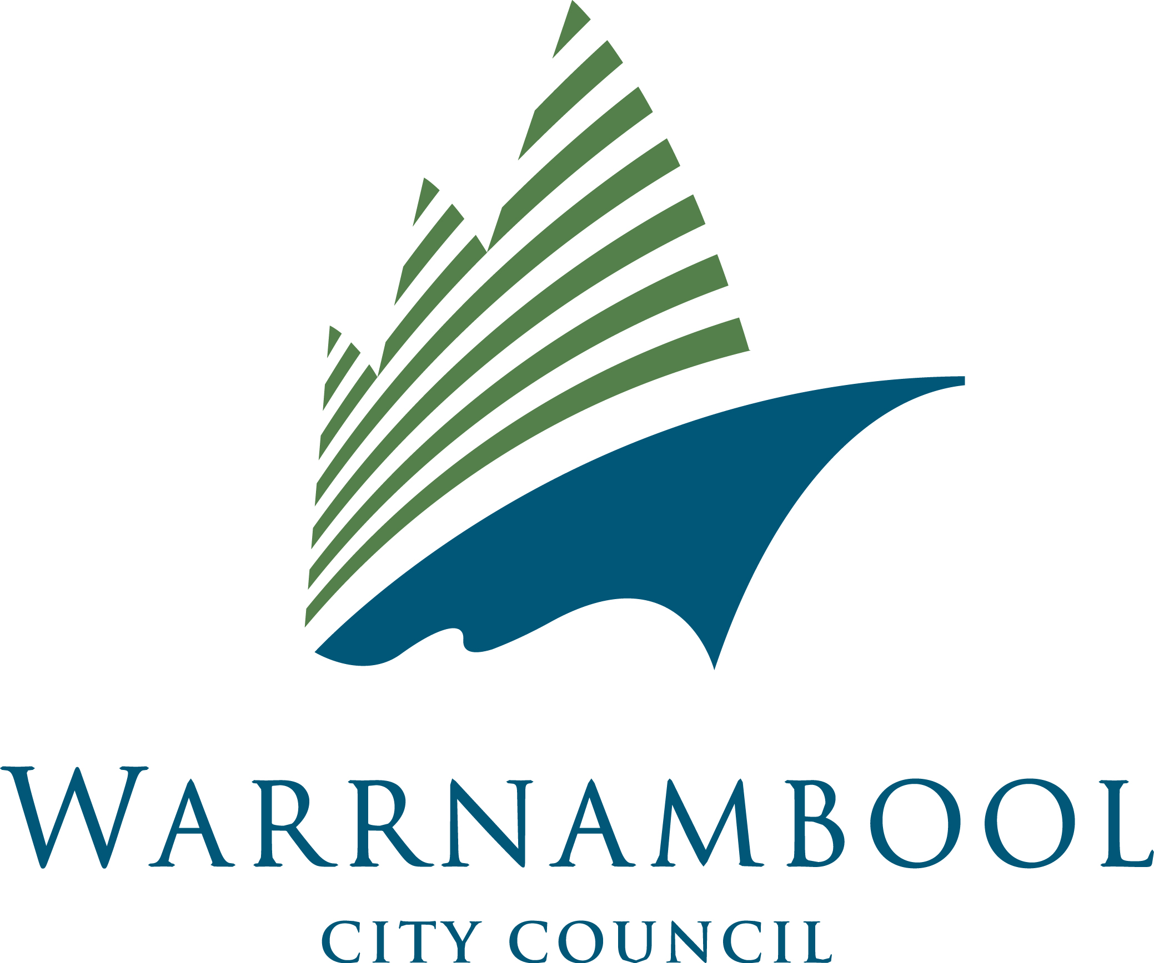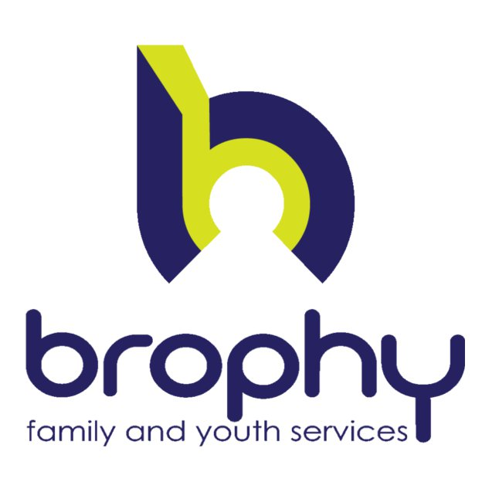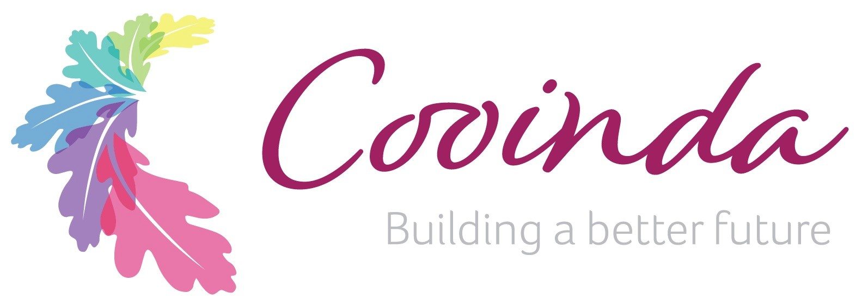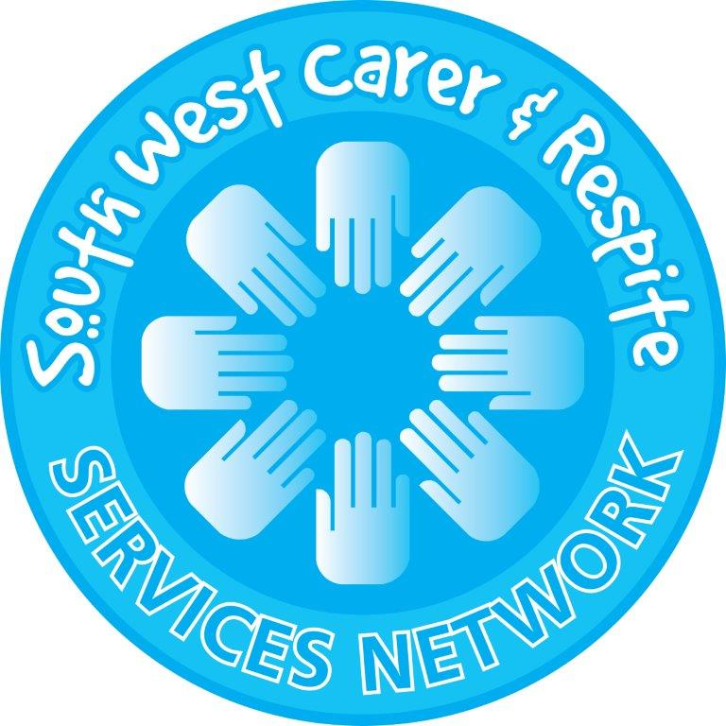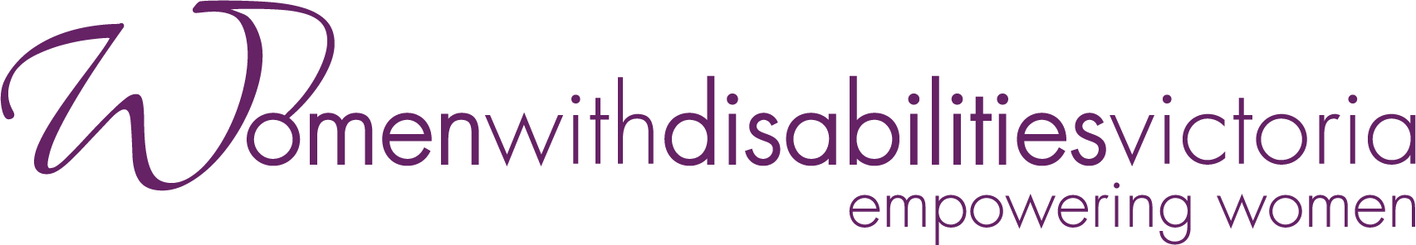

*Funded by the Australian Government Department of Social Services.*