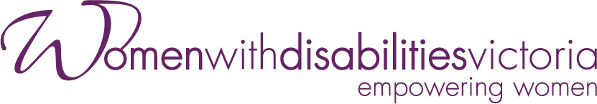

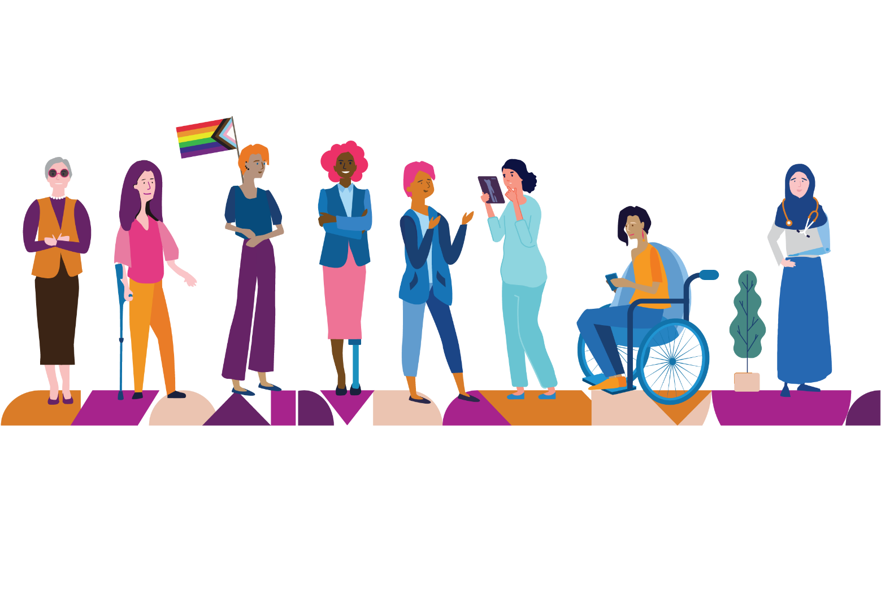

Annual Report
2021-2022

Our Vision
A world where all women are respected and can fully experience life.

Our Mission
To advance real social and economic inclusion for women with disabilities in Victoria, we will:
Be a voice for women with disabilities.
Create opportunities for women with disabilities to be visible and to be heard in their communities.
Build partnerships to deliver the best results for women with disabilities.
Engage the community to challenge attitudes and myths about women with disabilities.

Our Values
Our values uphold human rights and social justice.
Equal Opportunity
Accessibility
Respect
Collaboration
Effectiveness
Creativity
Diversity
Accountability

Our Approach
We will:
Work with our members’ experiences as women with disabilities.
Provide specialist policy advice and representation to government.
Create opportunities for women with disabilities to realise their leadership and advocacy potential.
Adopt a collaborative approach to government and community organisations.
Build the evidence base to develop and share knowledge and resources to inform best practice.
Monitor our work and report on outcomes.

Women with Disabilities Victoria acknowledges Aboriginal and Torres Strait Islander peoples as the first inhabitants and traditional custodians of the lands on which we live and work. We pay our respects to ancestors and Elders, past, present and emerging.
The WDV Community is committed to honouring the unique cultural and spiritual relationship Aboriginal and Torres Strait Islander peoples have with the land and waters, and their rich contribution to society.

CEO and Board Co-Chairs’ Statements
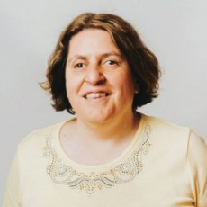

CEO Report
This year has again continued to be a mix of great achievements and enormous challenges, not just for us, but for everyone. We continued to work remotely, worked face-to-face and a combination of both.
We have been able to move most of our program work to an online format. We have delivered our first online Enabling Women Leadership Program for participants in the Colac Otway Region of Victoria.
We have continued to engage with our Lived Experience Experts to deliver outcomes for our Gender and Disability Project, our Health Services Project and our Enabling Women Leadership (Youth) Project.
We were also very excited to partner with Our Watch to develop Changing the Landscape: A National resource to prevent violence against women and girls with disabilities.
We said farewell to a number of staff including our CEO, Leah van Poppel and I would like to thank Leah and all staff who have left, for their work and commitment to WDV.
We continue to engage with government about the very particular effects of the pandemic on women with disabilities – both good and bad.
We would like to thank all of our project partners, state and federal government and those we work with in the community sector who have supported our work during this financial year.
Nadia Mattiazzo, CEO

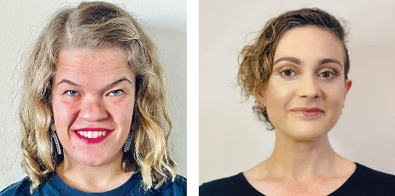

WDV Board Co-Chairs’ Report
This year, the Board has once again focused on ensuring good oversight of WDV in the changed COVID-19 environment. We continued to implement the 2021-2024 Strategic Plan with an intersectional focus on gender inclusion and anti-racism. The board undertook diversity training in gender and sexuality as well as specialised not-for-profit sector training in financial accountability.
The last year has been a significant period of transition for WDV. WDV farewelled CEO Leah Van Poppel who made the difficult decision to move on from WDV and re-locate to regional Victoria with her young family. Following Leah’s departure, we have had the privilege of securing Nadia Mattiazzo’s appointment as CEO. Senior Operations Manager Kerrie Doherty also departed WDV, along with Board Governance Officer, Elyse Cox. Elyse departed WDV to progress their career within the Arts and remains committed to accessibility in their practice. The Board wishes WDV’s recent alumnae all the best in their next endeavours.
The Board welcomed our new Board Governance Officer, Belinda Burns. Belinda has hit the ground running (sprinting) and the Board values her insights and expertise.
At the 2021 AGM, WDV welcomed two new Directors to the Board; Helena Jordan and Alex Holland. We bid a fond farewell to outgoing Board Chair Imogen Newhouse and Directors Sharon Granek and Andrea Mayne. We would like to thank all outgoing Directors for their dedication and commitment to WDV during their Board tenure. The Board continues to seek talent and Directors with specialised skill sets, and as a result, we are pleased Elyse Cox has continued their relationship with WDV in a Member Director appointment. Rachael Arbon was also welcomed as a newly Co-opted Director to the Board. Rachael brings with her extensive experience in finance, operations and executive leadership.
The Board was fortunate to spend half a day with WDV staff at the Zoo for a staff development day. The Board found it an insightful day where both staff and Directors were able to discuss WDV’s vision in practice. Importantly, it was an opportunity to meet in person and put names to faces!
Despite the ongoing challenges of the COVID operating environment, the Board has achieved an enormous amount. The Board have supported WDV to find solutions to help reduce the barriers women with disabilities face in achieving and staying in leadership positions.
It is pleasing to see strong WDV representation in the most recent composition of the Victorian Disability Advisory Council (VDAC). The Council provides independent policy and strategy advice to the Minister for Disability, Ageing and Carers to increase the inclusion and participation of people with disability in the Victorian community. Board Co-Chairs Samantha Lilly and Diana Piantedosi have both been confirmed as council members, along with Senior Policy Officer Jen Hargrave and former staff member Laura Petenuzzo. The Board also celebrates our Treasurer, Anaab Rooble, being awarded the Victorian Refugee Leadership Award 2022. It is fantastic to see Anaab’s contribution to our wider community recognised.
The Board had the pleasure of awarding the 2021 Brenda Gabe Leadership Award to Elena MacDonald. As a young, disabled Indigenous person who passionately engages with disability justice, abolition, and Indigenous philosophies in their day-to-day practice, Elena’s leadership and voice continues to encourage other young Aboriginal and Torres Strait Islander women and gender diverse people to engage with the disability community.
The Board has continued to operate remotely, as this was the safest and most accessible option. It has been a challenging year for the staff as they navigated a year of constant change in working conditions.
The WDV Board are grateful for the achievements that WDV staff have made in such uncertain times and commend WDV for their creativity, tenacity and flexibility during these challenging and changing times. WDV staff have made in such uncertain times.
Sam Lilly & Diana Piantedosi
Board Co-Chairs

WDV Goals

1. Visibility and voice
Engage women with disabilities, build our self-advocacy and strengthen our membership across Victoria

2. Pursue safety, wellbeing and connectedness for women with disabilities
Leverage government funded policy reform and programs

3. Create long term change
through engagement, education and advocacy

Goal 1: Visibility and Voice
Engage women with disabilities, build our self-advocacy and strengthen our membership across Victoria

Priorities include membership engagement strategies, continued development of regional hubs and Experts by Experience (EBE) and other opportunities that arise, using our decision-making principles.

Community Inclusion and Women’s Empowerment Hubs
The Community Inclusion and Women’s Empowerment Team has had another year full of community connection and development. Our YPCG (Young Person’s Co design Group) team worked to develop recommendations to capture the changing needs of young people. This included the appointment of a Youth Experts Group to work alongside our health experts and violence prevention experts (experts by experience groups).
The Colac Otway Leadership program saw the program move fully online for the first time to continue the work during a tough time of lockdown and restrictions to face to face meetings. The course itself was hugely successful and the graduation ceremony was a highlight of the year.
Hubs continued to work with women rurally and to share experiences and difficulties that occur outside of the metro area: transport disadvantage, lack of access to health services and isolation during Covid. Hub Liaison Officers (HLOs) worked collaboratively with Women’s Health Goulburn Northeast, Barwon Health, and Disability Resource Centre to team up to contribute to better outcomes. Membership continues to grow and flourish.

Hub Liaison Officers
HLOs moved online, connected individually with members, and continued to share information, resources, and support to membership.
HLOs meet fortnightly with Women’s Empowerment officers and Program Manager to collectively discuss and share resources that support member goals. Transport disadvantage is an issue for rural residents and WDV supports the Transport for All campaign alongside other advocacy organisations and community groups.
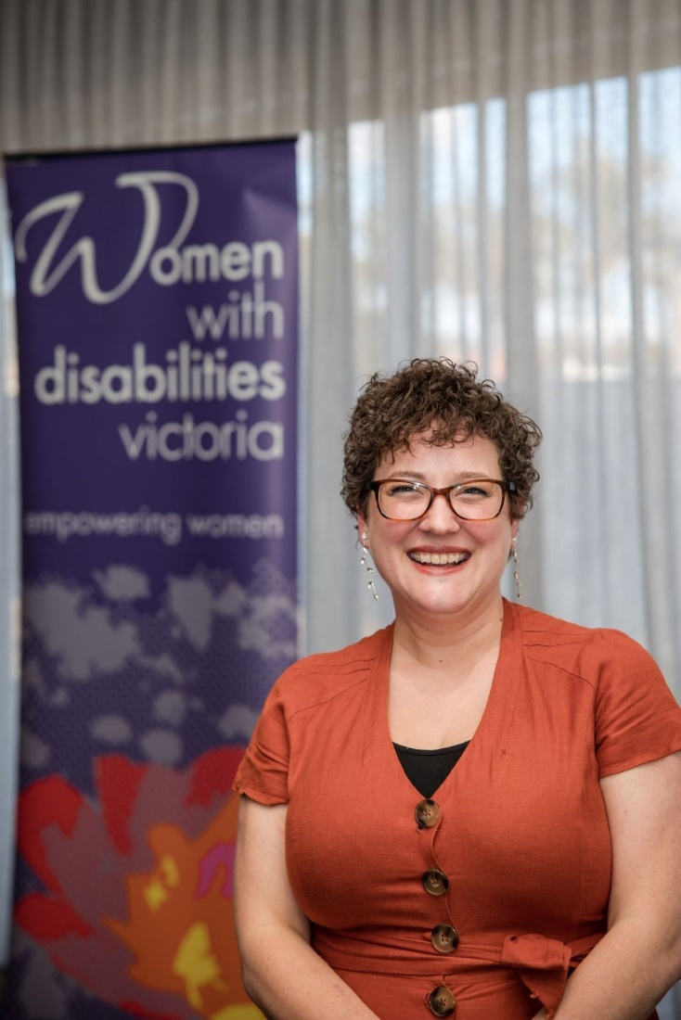
Emma Klemm, Hub Liaison Officer of the Bendigo Loddon Hub hosting the launch of the Bendigo Hub in May 2022.

Policy - Violence Against Women with Disabilities
WDV’s Policy program is funded to focus on violence against women with disabilities. We do this through writing submissions, contributing to research and service development and promoting women’s rights in a range of settings. Some of the year’s highlights follow.
WDV’s representation to the Disability Royal Commission continued. Following our written submission, we were invited to give evidence at the hearing on October 14, 2021.
Following the hearing, our Senior Policy Officer, Jen Hargrave, was invited to speak on national news programs with ABC and SBS, for both TV and radio.
Jen attended later hearings supporting WDV members to give evidence. We await outcomes from the Commission.
We were pleased to have the opportunity to undertake research into fairness for women in the NDIS in a research partnership with Dr Sophie Yates from the Public Service Research Group, UNSW Canberra. Many WDV members participated in the research and said they found the project reports useful to understand the types of discrimination we experience in the scheme. This discrimination impacts our health and our potential to be safe from violence.
Two things which WDV has advocated for over many years came to fruition over the year.
- We supported the establishment of Disability Family Violence Practice Leaders in three Victorian areas. These workers can promote strategies to increase disability access to family violence services.
- We helped form the re-establishment of a governance group to coordinate various projects to respond to violence against women with disabilities. This group is co-chaired by WDV’s CEO, Nadia Mattiazzo, alongside Family Safety Victoria.
We look forward to seeing these areas of work strengthen in coming years.
We reached the culmination of a major three year partnership project. We launched Changing the Landscape. We discuss this in a feature below.
WDV is in a more knowledgeable position to directly influence policy development at all levels of government.
WDV members and subscribers to our media receive timely information regarding WDV’s policy work.
Key Policy Highlight
On 9 February 2022 we launched Changing the landscape: A national resource to prevent violence against women and girls with disabilities. This was a partnership between WDV Policy and Our Watch.
This national, evidence-based resource names ableism and gender inequality as the two consistent, intersecting drivers of violence against women and girls with disabilities, and sets out the actions needed to address these drivers and stop this violence before it starts.
Developing Changing the Landscape was a three year project with Project Advisory Groups and extensive national consultation. The project started due to a generous donation from a strong advocate for the rights of women with disabilities, the late Sue Salthouse.
470 people attended the online launch and heard the voices of many women with disabilities presenting the framework. The launch received 341 media items, including ABC, SBS, Yahoo News and local papers. The resource has received hundreds of page views per month, and Our Watch analytics show that when people visit the page they stay there for some time.
WDV and Our Watch are both building the framework into our training, resources and practices. WDV sincerely thanks all project partners and contributors, with particular recognition of Melissa O’Reilly who was the project leader at Our Watch.
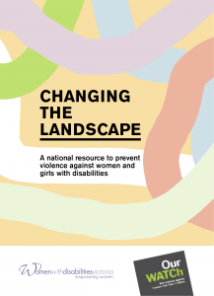

Health Services Program
The Health Services Program, through its various projects, promotes the rights of women with disabilities to access all aspects of health and to live free from violence and abuse.
The Experts in Our Health project empowers women to advocate for accessible and inclusive health services which meet their specific needs through training and resource development. Health service professionals are offered information and training regarding accessible, trauma informed and rights-based service provision for women with disabilities.
Women with disabilities are offered training to explore and advocate for their rights to accessible and inclusive health care. Training and resource content is co-designed by a panel of lived experience experts. Through the Victorian Women’s Health Capacity Building project, Victoria’s Women’s Health Services network members undertaking projects and activities to prevent violence against women in their regions are provided with tools, training and advice in order that their activities include the rights, needs and voices and perspectives of women with disabilities.
The Women’s Mental Health and Covid project produced a podcast resource highlighting the importance of including women with disabilities in the design and implementation of policies and practices responding to Covid-19. WDV’s partnership with Women’s Health East was again supported this year through participation in the Margins to Mainstream project, bringing the voices of women with disabilities to gender-based violence prevention activities in the eastern region of Melbourne.

Being surrounded by a great bunch of advocates, we all have something unique to contribute. Using our skills, knowledge and expertise to collaborate together, we have co-designed a great arrangement of health resources. They will hopefully be widely available. Our expertise is based on living with our bodies and knowing ourselves. Listening means providing women with disabilities with the time and support to communicate our whole experience. Researching a disability is different to living it. When the services that we use as a group work it out it will benefit all. We’ll get assistance from professional groups. Creating these resources and being a part of the process has been an invaluable way to gain other skills. Improvising with each other and sharing our ideas in different environments has helped us as we advocate in different areas of our everyday lives.
Renee McCarthy, Experts in Our Health Lived Experience Team Member
Women with disabilities possess skills in inclusive co-design, consultation, training delivery and resource development.
10 PD sessions were offered to the health experts team to build capacity in inclusive co-design, resource development and training delivery, covering advocacy and facilitation skills, Human Rights, communication, storytelling for change and workforce inclusion.
Women with disabilities directly influence resource content, peer and workforce training and inclusive practice in stakeholder organisations through workforce training, consultancy and leadership.
50 opportunities were made available for health experts to co-facilitate training, contribute to resource development and participate in external leadership or consultancy.
Health services activities are informed by current policy or evidence frameworks.

Activities within the experts in Our Health Project, including resource development, peer and workforce training and ongoing professional development of the health experts team are informed by:
Australian Commission on Safety and Quality in Healthcare. (2019). Australian Charter of Healthcare Rights.
Australian Institute of Health and Welfare. (2020). Health of People with Disability. AIHW Snapshot.
United Nations. (2006). Convention on the Rights of People with Disabilities. UN Department of Economic and Social Affairs.
World Health Organization. (2015). WHO global strategy on people-centred and integrated health services: interim report.
Agency for Clinical Innovation, 2021. A Guide to Build Co-design Capability.
Australian Human Rights Commission, Commonwealth Disability Discrimination Act 1992.
Kerrie, Renee, Kieran, Karleen, Carly from WDV discussing health resources

Gender and Disability Workforce Development Program
The Gender and Disability Workforce Development Program (the Program) seeks to prevent violence against women with disabilities before it occurs. As a primary prevention initiative, the Program contains several mutually reinforcing activities that target the underlying causes of violence, also known as the drivers of violence, in order to transform them.
The Program has a strong focus on activities that work across multiple levels of society to influence change, specifically the individual, community, organisational and societal levels. Activities are targeted at specialist and contributor sectors and workforces that have a role to play in preventing violence against women with disabilities. Activities seek to build capability in these sectors and workforces for intersectional prevention practice.
The Program aims to:
- Build and consolidate strategic positions, communications, representation and partnerships for preventing violence against women with disabilities.
- Increase the infrastructure in disability and primary prevention.
- Increase women with disabilities workforce engagement, leadership and representation in primary prevention and disability.
- Lead primary prevention, disability and intersectional practice.
- Enhance Program accountability, sustainability and opportunities for constant improvement.
Program activities include (but are not limited to):
- The Experts by Experience Advocates (EBEAs), a group of twelve women with diverse experiences of disability, who support the work of WDV and other organisations by sharing their experience of disability through consultations and awareness raising sessions.
- Delivery of PVAWD training sessions to professionals and organisations, and facilitation of a PVAWD Community of Practice.
- Development of PVAWD resources.

I am an Expert by Experience for WDV and I have been in this role since 2021.
Since joining WDV, I have been amazed at the support and acceptance offered by the organisation and the other Experts. I have felt incredibly accepted, safe and valued within the role. The accommodations and inclusive practices of WDV are also quite amazing. I have never had this in any other workplace. I have felt supported and safe to be myself and share my views as an Autistic woman.
Being an Expert has supported me to find my own voice. I feel I have really grown in my ability to use my voice as an Autistic woman. I have felt valued, my opinion and experience count and matter. Being part of the Experts has had a profound impact and I am grateful that I have been given this opportunity.
The consultations and other opportunities that have been presented to us have allowed us to use our lived experience to inform and create change. It has never felt tokenistic and I feel that, even in a small way, the Experts contribute to societal change, as well as empowering all individuals involved, whether that be us Experts, other WDV staff, or external individuals, services and organisations engaging us for consultations.
As part of the Experts, I was invited to deliver an Autism awareness raising session to the other Experts. The session, created by myself and an Autistic co-facilitator, is factual and informative, and aimed at raising awareness while incorporating aspects of our lived experience. This was a great opportunity for us to use our voice and present from a lived experience perspective, and give the other Experts an insight into Autism.
Other opportunities I have had while being an Expert include taking part in the Train the Trainer workshop to be trained to deliver PVAWD awareness raising sessions, and being a member of the Endorsement Model Working Group. Without firstly being an Expert, I would have not been presented with these other opportunities. All these opportunities with WDV have allowed me to grow my knowledge, confidence and voice in this space.
Natasha Siryj, Gender and Disability Expert by Experience Advocate

Engage women with disabilities, build our self-advocacy and strengthen our membership across Victoria
Women with disabilities are a major part of the primary prevention workforce.
The Gender and Disability Workforce Development Program recruited 6 new EBEAs to join the 6 existing EBEAs in the group, increasing women with disabilities workforce engagement, leadership and representation in primary prevention and disability. The recruitment of women with diverse experiences of disability, and from a range of backgrounds, works towards the inclusion of women with disabilities within the primary prevention workforce. As a result of their involvement in the group, an EBEA secured part-time employment at WDV, while another EBEA became an Ambassador for the Victorian Electoral Commission (VEC) as well as a Safe and Equal Survivor Advocate.
Women with disabilities gained significant primary prevention and disability knowledge and skills.
The EBEAs were offered 5 PD sessions to increase their disability inclusion and violence prevention knowledge and skills. The sessions focussed on the recently released PVAWD framework, Changing the landscape, and how to use lived experience purposefully, increasing EBEAs’ capacity to represent, consult and deliver a range of prevention, violence, advocacy and rights-based consultations and products. As a result of these sessions, the EBEAs gained significant primary prevention and disability knowledge and skills: 75% indicated that they increased their PVAWD confidence and awareness, as well as their PVAWD knowledge and skills.
Additionally, four EBEAs were offered the Train the Trainer workshop, increasing their capacity to deliver PVAWD awareness raising sessions. As a result of this workshop, the trained EBEAs gained significant primary prevention and disability knowledge and skills: 80% of the EBEAs increased their confidence to facilitate PVAWD awareness raising sessions, and an EBEA said ‘As always, I learnt from others and the passion and engagement from the group’.

Goal 1: Facts and Figures
1 online member event
53 attendees
21 editions of e-news published with an average open rate of 40%
2 editions of Violence and Disability Quarterly (VDQ)
27.5K per annum website hits = 27% growth, 4% growth in repeat users, 289% in new users, 54.5K page views
808 WDV members = 770 Full Members, 38 Associate Members
Facebook: 5,173 followers = 25% growth
Instagram: 1,453 followers = 245% growth
Twitter: 2,159 followers = 12.5% growth
LinkedIn: 912 followers = 78.5% growth

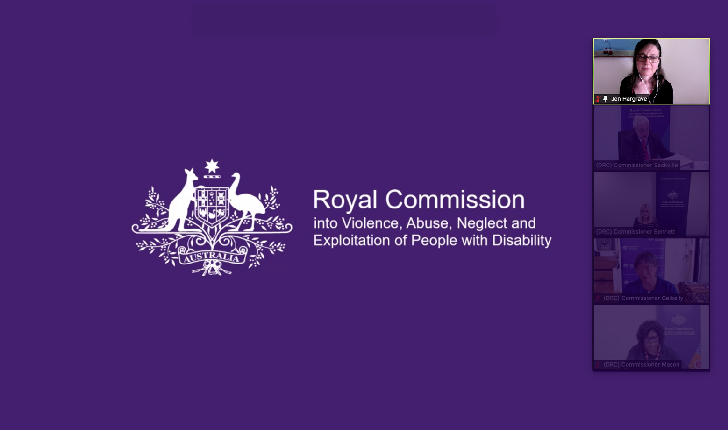
Jen Hargrave from WDV giving evidence online to the Royal Commission into Violence, Abuse, Neglect and Exploitation of People with Disability.

Goal 2: Pursue safety, wellbeing and connectedness for women with disabilities
Leverage government funded policy reform and programs

Priorities include prevention and response to family violence, gender equality reform and social/economic inclusion of women with disabilities via the NDIS (National Disability Insurance Scheme) system and State and National Disability Plans.
During 2021-24 WDV will pursue and develop opportunities for enhancing access to primary health/sexual and reproductive health services for women with disabilities.
WDV may engage in relevant opportunities that arise from the Royal Commission on Mental Health and government investment in public health, emergency preparedness and enabling inclusive economic participation.
The Young Person’s Co-Design Group developed recommendations to inform the leadership program and develop an experts’ group. The expert’s group is developing a calendar of workshops for young people with disability.
The Community Inclusion and Women’s Empowerment team (CIWE) has enlisted the skill and expertise of other teams on topics such as health, safety, and respect.
WDV is well informed and well placed to be involved in systemic advocacy and programmatic opportunities arising from the release of the plan and the inquiry report.
Alliance members are familiar with the safety and service needs of women with disabilities to represent them in their advocacy work.
WDV is a recognised and credible expert in disability inclusive PVAW.
Two partnerships were developed with organisations undertaking prevention of violence against women, for the purpose of offering technical support, assistance and training to build their capacity in disability inclusive practice.
Eight external presentations were delivered to a variety of women’s health, local government and violence prevention organisations in order to increase knowledge of disability inclusion, the drivers of violence against women with disabilities and essential actions for its prevention.
Women with disabilities presented their lived experience of COVID and advocate for their rights to be fully included in planning and decision-making in service and policy responses.
Four episodes of a podcast series “Making Our Voices Heard”, were produced this year to explore the perspectives and experiences of women with disabilities in the context of Covid-19.
3 women and nonbinary advocates within the disability community were interviewed in the production of the “Making Our Voices Heard” podcast series. 3 podcast presenters were sourced from WDV staff and lived experience experts groups to conduct the interviews.
WDV is a resource from which health service providers can seek guidance in building inclusive health service provision.
The Experts in Our Health project has co-designed and produced a resource package for women with disabilities and health service providers, with resources intended for release in August 2022. The package includes 10 resources in multiple accessible formats: The Experts in our Health Guide, the Experts in Our Health Factsheets, the Experts in Our Health Poster, the Experts in Our Health Video, the Inclusive Co-Design in Practice Poster and the Inclusive Co-Design in Practice Postcard set. Examples of some of the resource package are on the follow page.
WDV is a major disability and primary prevention stakeholder.
The Gender and Disability Workforce Development Program represents and promotes PVAWD through a number of regular commitments, increasing cross sector collaborations, partnerships and capacity in disability and primary prevention. We are a proud member of the Margins to the Mainstream Project Advisory Group, the Municipal Association of Victoria (MAV) Gender Equality, PVAW and Gender-Based Violence Network, the Gender Equity Victoria (GEN VIC) Gendered Violence Prevention Community of Practice, and the Department of Jobs, Precincts and Regions (DJPR) Preventing Violence Against Women through Sport Community of Practice, contributing to WDV being a major disability and primary prevention stakeholder.
Additionally, we developed a statewide Community of Practice to expand sectoral knowledge around primary prevention of violence, gender equity and disability inclusion.
The Disability Inclusion and Violence Prevention CoP received 22 expressions of interest representing a diverse array of groups including women’s health services, local government, legal services and disability organisations, acknowledging WDV as a major disability and primary prevention stakeholder. The CoP launch session provided an opportunity for CoP members to get to know each other and discuss expectations.
WDV leads lived experience expertise in disability and primary prevention.

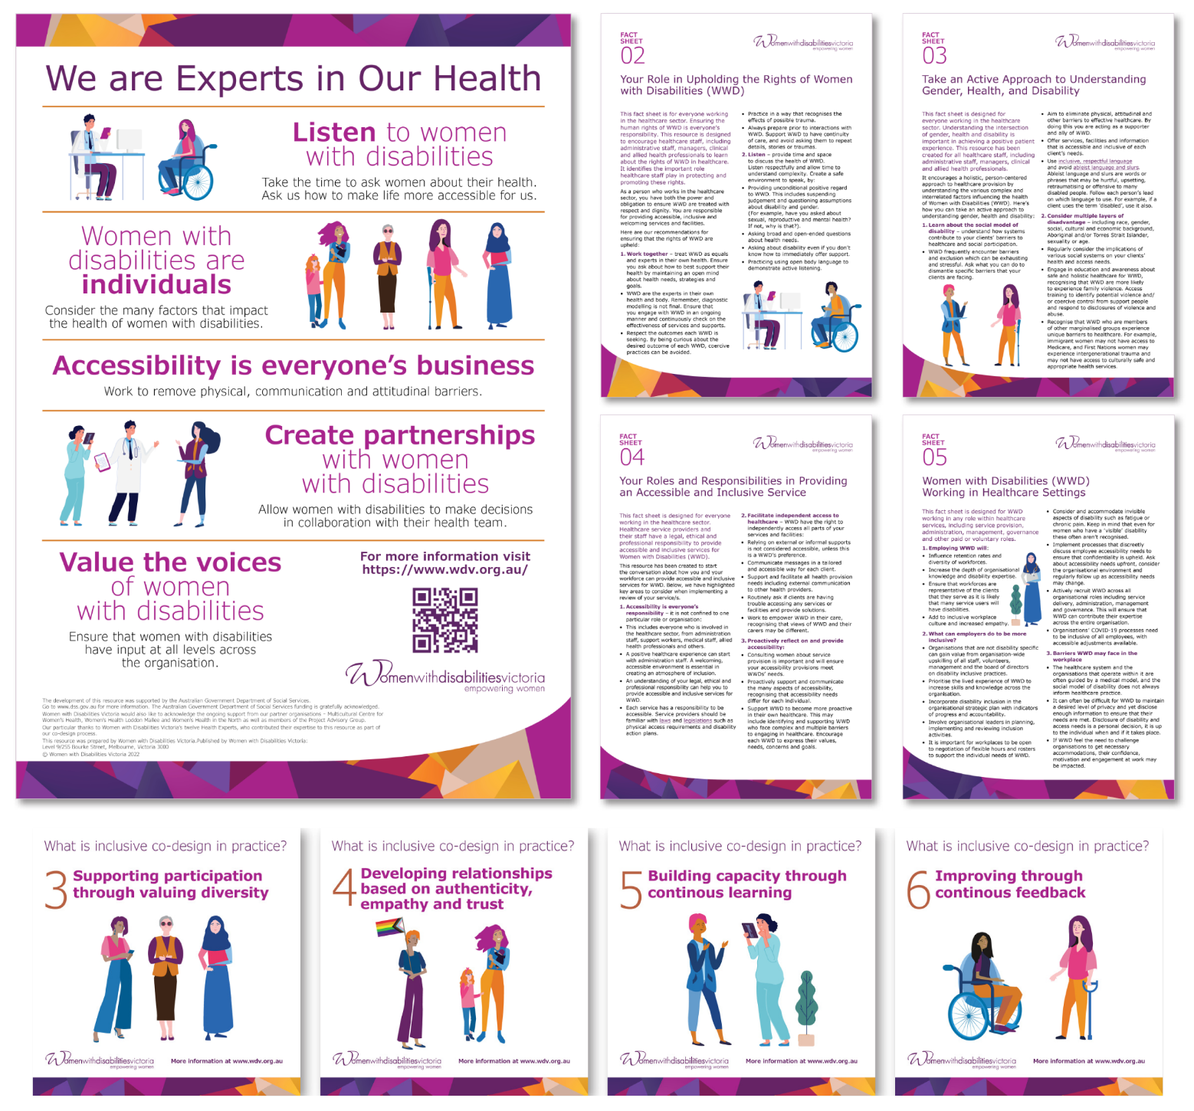

We co-designed two resources with women with disabilities, both the EBEAs and WDV staff, providing lived experience expertise in disability and primary prevention.
The Understanding Disability guide explores six keystones to provide understanding of respectful engagement and planning with women with disabilities, while the Facts on Violence against Women with Disabilities factsheet showcases the latest data on violence against women with disabilities. Both resources highlight lived experience expertise in disability and primary prevention.

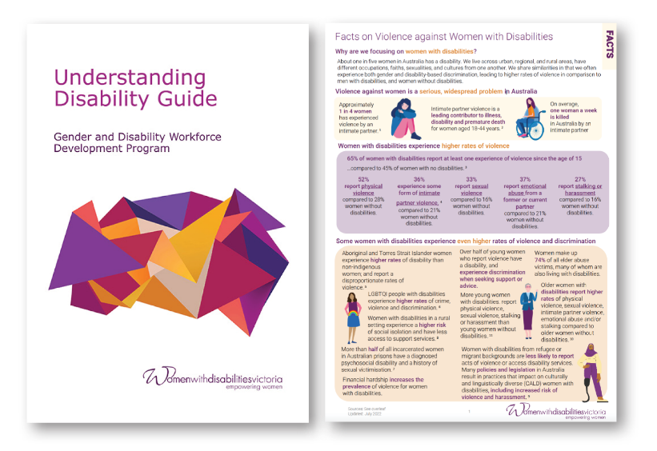
Goal 2: Facts and Figures
Community Inclusion and Women’s Empowerment
All CIWE programs collaborated across WDV programs to share information, resources and networks via reporting, social media, and introduction.
Gender and Disability Workforce Development Program
Offered 4 regular G&D commitments per year to represent and promote PVAWD – working groups, committees, communities of practice (CoP), etc.
Developed a statewide disability inclusion and primary prevention CoP and deliver a CoP launch session.
Developed 2 G&D resources that build on lived experience expertise.
Health Services Program
Supported partnerships with two WHS/PVAW sector organisations and provide technical assistance in the form of training delivery and consultancy.
Provided 8 instances of short-term technical assistance/consultation on PVAW and disability inclusion to organisations within the PVAW, disability or wider local government or community sector.
Produced a resource featuring women’s lived experience of COVID 19 and their insights in to how their mental health in this context can be promoted by wider society.
Promoted the sharing of lived experience of COVID 19 among women with disabilities.
Produced ten resources promoting the rights of women with disabilities to access inclusive and accessible health care, and actions to promote greater inclusion by health service providers.
Policy
Attended and contributed to at least 4 policy fora where these initiatives were be discussed.
Attended the majority of network meetings, presented at least one meeting, and shared WDV’s work through at least 2 Alliance publications.

Goal 3: Create long term change
through engagement, education and advocacy

Priorities include information gathering and advocacy to influence government policy on gendered violence and women’s social and economic inclusion, both through specific government policy reforms as well as through mainstream service delivery policy and program frameworks.
WDV will work to improve the accessibility of service provision through representing the diverse lives of women with disabilities and offering education, training, referrals and advice to service providers.
WDV is continuing to build an evidence base for the rights of women with disabilities to be respected, to access services and to be safe from violence.
Key researchers are informed about WDV’s role in representing the rights of women with disabilities to be safe from violence.
A resource launch is available to showcase disability access and tailored violence prevention approaches.
Key audiences are informed of our resource.
Partnership project outputs are agreed upon and achieved.
All opportunities granted by the DRC to advise on WDV’s violence policy priorities are taken and maximised.
WDV is recognised as a primary source of co-designed and rights-based advice and material concerning the rights, safety and inclusion of women with disabilities.
The Experts in Our Health project has engaged with 38 organisations through its Project Advisory Group and for the promotion of training workshops.
20 workshops and training sessions for women with disabilities and workforces have been delivered.
WDV is recognised as a source of expertise concerning the rights, safety and inclusion of women with disabilities.
Health Services program staff participated in 4 meetings of the Women’s Health Service Council, three meetings of the Practice Reference Group of Safe and Equal, and one meeting of the Statewide Women’s Health Services Sexual and Reproductive Health Community of Practice.
Women with disabilities are acknowledged primary prevention and disability workers.
The Gender and Disability EBEAs offered 11 consultations to WDV and external organisations, increasing the representation and leadership of women with disabilities in all areas of PVAWD workforce development, policy, and cultural change products and resources. In particular, Safe and Equal consulted the EBEAs prior to their PreventX conference on event accessibility. Consultants acknowledged the EBEAs as primary prevention and disability workers:
“The group were absolutely fantastic and had SO many practical suggestions for how we can improve the accessibility of PreventX. We will be implementing many of their suggestions.”
Consultants came back after the conference to reflect on event accessibility and ensure an even more inclusive conference in future.
Increase the capacity of a range of workforces to effectively address the drivers of VAWD and implement the essential actions.
WDV leads the provision of disability and primary prevention workforce training.
We delivered scheduled and tailored training to 341 participants with an overall rating of 4.7/5 from respondents. Training participants represented a wide range of workforces including women’s health services, Victorian agencies, local government, disability service providers, violence prevention organisations and multicultural services, and the training sessions, which targeted the drivers of violence in order to transform them, increased participants capacity to effectively address the drivers of violence and implement the essential actions.

Training participants said:
“This training has been helpful and informative […] examples of lived experience are insightful,”
...acknowledging WDV’s leadership in the provision of disability and primary prevention workforce training.
WDV leads the provision of disability and primary prevention workforce training.
Additionally, we established a Working Group to provide guidance on the development of an initiative that would endorse individual practitioners and recognise their commitment to preventing violence against women with disabilities. The Endorsement Model Working Group provided excellent feedback on the current stage of the initiative during their first meeting, acknowledging WDV’s leadership in the provision of disability and primary prevention workforce training.…

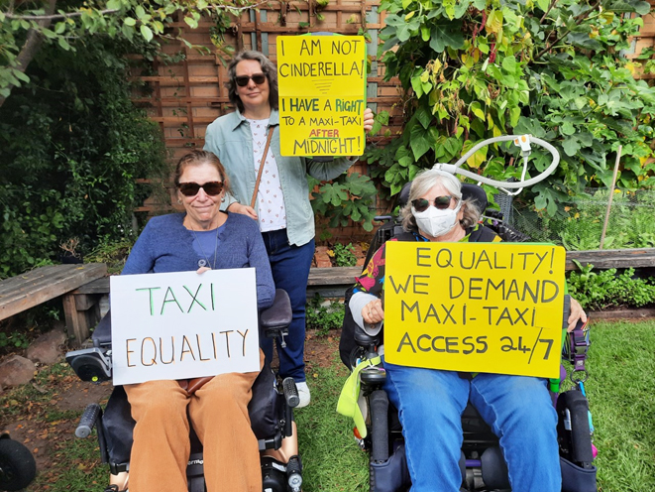
Members of the Barwon Hub took part in a protest about the availability of taxi services.

Thank you
to the following funders, partners and supporters

Australian Vietnamese Women’s Association

Barwon Integrated Family Violence Committee

Brotherhood of St Laurence

Centre for Non-Violence

Cobram Community House

Coonara Community House

Department of Social Services

Family Safety Victoria

Geelong Region Alliance G21

GenVic

GenWest

Health Issues Centre

Dr Helen Sykes

Mat Collins and Dee Papworth

Melbourne Polytechnic

Multicultural Centre for Women’s Health

Office for the Prevention of Family Violence and Coordination/Department of Families, Fairness and Housing (DFFH)

Office for Women (OFW)

Our Watch

People with Disabilities Australia

Public Service Research Group, School of Business, UNSW Canberra

Rainbow Health

Respect Victoria

Royal Women’s Hospital

Safe and Equal

Scope Australia

Scope Property Advisory

Sexual Assault Services Victoria

Southwest Advocacy Association

Sparke Helmore Lawyers

STAR Community Health

State Government of Victoria

Victorian Department of Families, Fairness and Housing (DFFH)

WLK Consulting

Women with Disabilities Australia

Women’s Health Victoria (WHV)

Women’s Health East

Women’s Health in the North

Women’s Health Loddon Mallee

Women’s Legal Service Victoria

Donors who supported WDV this year
Charelle Cuolahan
Ellise Gilbert
Helen Gwilliam
Gross Foundation
Molly Hoffman
Anna Kellerman
Philip Kostolnik
Sue Olney
Alana Plucinski
Adam Seymour
Jemma Swan

WDV Regional Hub Partners
Centre for Non-Violence
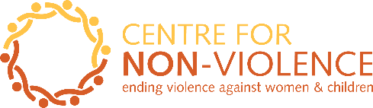

Cobram Community House
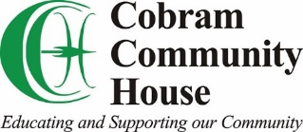

Coonara Community House
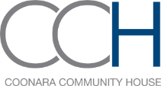

Geelong Region Alliance G21
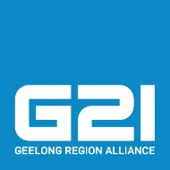

South West Advocacy Association
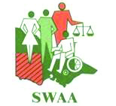

Financial Statements

The WDV Board and Finance & Risk Committee continued to strengthen WDV’s financial position.
WDV is in a strong financial position, and we are able to pay our debts if and when they are due.
The Profit and Loss Statement shows a surplus (gain) of $134,524 in the 2021/22 financial year.
Revenue (money coming in) for this year was $2,326,810, a decrease of $172,649 from last year.
Expenses (money going out) for this year was $2,192,286, an increase of $137,321 from last year.
Equity (value of WDV) for this year was $1,909,280, an increase of $134,524 from last year.
This year Current Assets are $3,183,042.00, which is equal to 2.7 times our Current Liabilities of $1,192,875.00. This is a healthy position.
Cash Reserves increased this year to $3,142,916.00 an increase of $243,877.00 from last year.

Statement of profit or loss
and other comprehensive income for the year ended 30 June 2022

 | 2022  $ | 2021  $
Continuing operations
Revenue | 2,326,810 | 2,499,459
Expenditure
Depreciation expenses | (9,426) | (15,150)
Employee benefits expenses | (1,630,738) | (1,626,039)
Other expenses | (552,122) | (413,776)
Total expenses | (2,192,286) | (2,054,965)
Surplus (Deficit)  before tax | 134,524 | 444,494
Income tax expenses |  | –
Surplus (Deficit)  for the year | 134,524 | 444,494
Other comprehensive income | – | –
Total comprehensive Surplus (Deficit)  for the year | 134,524 | 444,494

Statement of financial position
as at 30 June 2022

 | 2022  $ | 2021  $
ASSETS
Current Assets
Cash and cash equivalents | 3,142,916 | 2,899,039
Trade and other receivables | 4,504 | 5,135
Other current assets | 35,622 | 43,018
Total Current Assets | 3,183,042 | 2,947,192
Non-Current Assets
Property, plant & equipment | 11,486 | 4,522
Total Non-Current Assets | 11,486 | 4,522
Total Assets | 3,194,528 | 2,951,714
LIABILITIES
Current Liabilities
Trade and other payables | 1,192,875 | 1,026,947
Total Current Liabilities | 1,192,875 | 1,026,947
Non-Current Liabilities
Provisions | 92,373 | 150,011
Total Non-Current Liabilities | 92,373 | 150,011
Total Liabilities | 1,285,248 | 1,176,958
NET ASSETS | 1,909,280 | 1,774,756
EQUITY
Retained Earnings | 1,909,280 | 1,774,756
TOTAL EQUITY | 1,909,280 | 1,774,756

Statement of changes in equity
for the year ended 30 June 2022

 | Retained Earnings  $ | Total  $
Balance at 1 July 2020 | 1,330,262 | 1,330,262
Surplus/(Deficit) attributable to members | 444,494 | 444,494
Balance at 30 June 2021 | 1,774,756 | 1,774,756
Surplus/(Deficit) attributable to members | 134,524 | 134,524
Balance at 30 June 2022 | 1,909,280 | 1,909,280

Cash flow statement
for the year ended 30 June 2022

 | 2022  $ | 2021  $
CASH FLOWS FROM OPERATING ACTIVITIES
Receipts from customers | 2,321,549 | 2,488,092
Payments to suppliers and employees | (2,066,543) | (2,362,478)
Interest received | 5,261 | 11,367
Net cash provided by (used in) operating activities | 260,267 | 136,981
CASH FLOWS FROM INVESTING ACTIVITIES
Payments for plant and equipment | (16,390) | –
Net cash provided by investing activities | (16,390)
Net increase in cash held | 243,877 | 136,981
Cash at beginning of financial year | 2,899,039 | 2,762,058
Cash at end of financial year | 3,142,916 | 2,899,039

Get in touch
Keep up-to-date with WDV; join our community

https://www.facebook.com/womenwithdisabilitiesvictoria
@WDVtweet
https://www.instagram.com/womenwithdisabilitiesvic/
https://www.linkedin.com/company/womenwithdisabilitiesvictoria/

https://www.youtube.com/user/WDVchannel

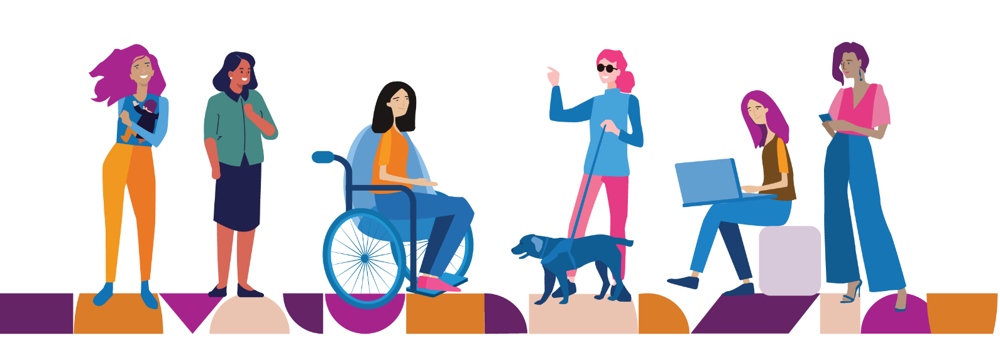

Wurundjeri Country
Level 9, 255 Bourke Street
Melbourne VIC 3000

Postal: PO Box 18314
Collins Street East VIC 8003

Phone: 03 9286 7800

Email: wdv@wdv.org.au
www.wdv.org.au

