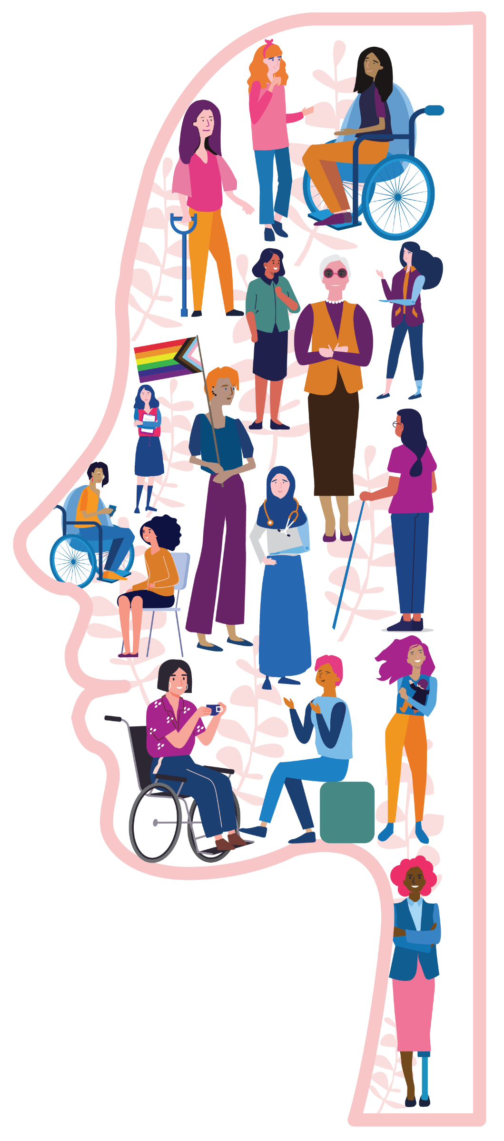

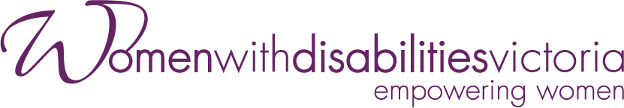

Prevention of Violence
against Women
with Disabilities

Taking
Action
Guide

June 2023

This resource was developed by Women with Disabilities Victoria on the land of the Wurundjeri people of the Kulin Nation. We pay our respects to Aboriginal and Torres Strait Islander people past and present, and we value Aboriginal and Torres Strait Islander histories, cultures, and knowledge.
This resource was developed as part of Women with Disabilities Victoria’s Workforce Development Program on Gender and Disability. For more information about our work, visit: www.wdv.org.au
The Office for Prevention of Family Violence and Coordination and the Victorian Government’s support is gratefully acknowledged.
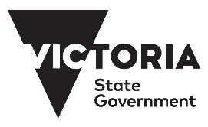
Content of this resource has been adapted from:
Our Watch & Women with Disabilities Victoria (2022). Changing the landscape: A national resource to prevent violence against women and girls with disabilities. Melbourne, Australia: Our Watch.
Our Watch (2021). Change the story: A shared framework for the primary prevention of violence against women in Australia (2nd ed.). Melbourne, Australia: Our Watch.
These documents and all their components are copyright. Apart from fair dealing for the purposes of private study, research, criticism or review as permitted under the Copyright Act 1968, no part may be reproduced, copied, transmitted in any form or by any means (electronic, mechanical, or graphic) without the prior written permission of Women with Disabilities Victoria.
Published by Women with Disabilities Victoria, 2023
PO Box 18314, Collins Street East, VIC 8003
©Women with Disabilities Victoria 2023.

A note on this resource:
Prevention of Violence against Women with Disabilities: Taking Action has been developed to expand upon the important work of Changing the landscape: A national resource to prevent violence against women and girls with disabilities and Change the story: A shared framework for the primary prevention of violence against women in Australia (2nd ed.).
In Australia, Changing the landscape is the national, evidence-based resource to guide the prevention of violence against women and girls with disabilities. It is intended to serve as a companion document to Change the story: A shared framework for the primary prevention of violence against women in Australia. Change the story was a ground-breaking piece of work, setting the roadmap for how to actualise the prevention of violence against women. Changing the landscape complements, but also expands on and extends, the evidence and guidance by placing a disability lens over the evidence.
Women with disabilities experience the same kinds of violence experienced by other women but they also experience ‘disability-based violence.’ Gender-based and disability-based discrimination intersect, and this increases the likelihood of women with disabilities being targeted for violence by perpetrators. This leads to women with disabilities experiencing far higher rates of violence than the general population. It is essential then that we have a framework to highlight the specific drivers of violence against women with disabilities and the specific actions that we can take as a society to prevent this targeted violence.
Prevention of Violence against Women with Disabilities: Taking Action provides workplaces in the social services, disability sector, local government and prevention settings with information to increase awareness, skills, knowledge and confidence to implement prevention strategies specifically focusing on the intersection of gender and disability.
For more information about Changing the landscape and Change the story, and to download these frameworks, visit: www.ourwatch.org.au

Contents
What is violence against women? 4
Types of violence 5
Facts on violence against women with disabilities 7
How does gender and disability affect rates of violence? 10
What is primary prevention and why focus on it? 11
What is intersectionality and why is it important? 13
The socio-ecological model of violence prevention 15
What drives violence against women with disabilities and how do we prevent it? 16
Reinforcing factors 19
Ableist Driver 1 – Negative stereotypes about people with disabilities 22
Ableist Driver 2 – Accepting or normalising violence, disrespect, and discrimination
against people with disabilities 23
Ableist Driver 3 – Controlling people with disabilities’ decision-making and
limiting independence 24
Ableist Driver 4 – Social segregation and exclusion of people with disabilities 25
Action 1 – Address the underlying social context that gives rise to violence against
women and girls with disabilities 28
Action 2 – Challenge the acceptance and normalisation of violence against
women and girls with disabilities 29
Action 3 – Improve attitudes towards women and girls with disabilities by challenging
ableist and sexist stereotypes 30
Action 4 – Promote the inclusion of women and girls with disabilities in all aspects of life 31
Action 5 – Promote women and girls with disabilities’ independence, agency and
participation in leadership and decision-making 32
Action 6 – Engage men and boys to challenge controlling, dominant and aggressive forms of masculinity 33
Supporting actions 34
Principles for prevention in practice 35
Glossary of terms 36
Support referral services 38
Further information and resources 44
References 45

How to use this guide
This resource provides information and lived experience insights to inform professionals to implement intersectional primary prevention strategies, with a focus on the intersection of gender and disability.
This guide does not need to be followed chronologically; you can use the contents page to easily access the specific material that is of interest. Readers are invited to consider how to apply the information to their particular setting. As such, the guide contains: essential actions that address the underlying drivers of violence against women and girls with disabilities lived experience insights from women with disabilities.
Implementing place-based strategies that are creative and locally-based are encouraged.

What is violence against women?
Violence against women is one of the most widespread human rights abuses in Australia today. It affects women’s physical and mental health, has significant long-term consequences on children and families, and reduces women’s ability to participate in social, economic, and political life.
Violence against women with disabilities has many similarities to violence against women in general, but there are some important additional drivers of this violence that need to be understood in order for it to be effectively prevented.
The Declaration on the Elimination of Violence against Women (1993) defines violence against women as:
“Any act of gender-based violence that results in, or is likely to result in, physical, sexual or psychological harm or suffering to women, including threats of such acts, coercion or arbitrary deprivation of liberty, whether occurring in public or in private life.”
This includes (but is not limited to):
Intimate partner violence
Family violence
Sexual assault
Sexual harassment
Female genital cutting
Forced sex work and trafficking.
In addition to these forms of violence, women with disabilities also experience disability-based violence and institutional violence, such as:
Violence from a support worker or carer (including a family member who is a carer)
Forced sterilisation
Violence within a group home or other disability service environment.
Violence and abuse can take many forms. As well as the common examples of violence experienced by women across society, women with disabilities can experience distinctive forms of violence that are often specific to their disability. To prevent violence against women with disabilities, it is important to be able to recognise these additional forms of abuse.
The following pages outline some of these types of violence and provide examples of how they are often experienced by women with disabilities.
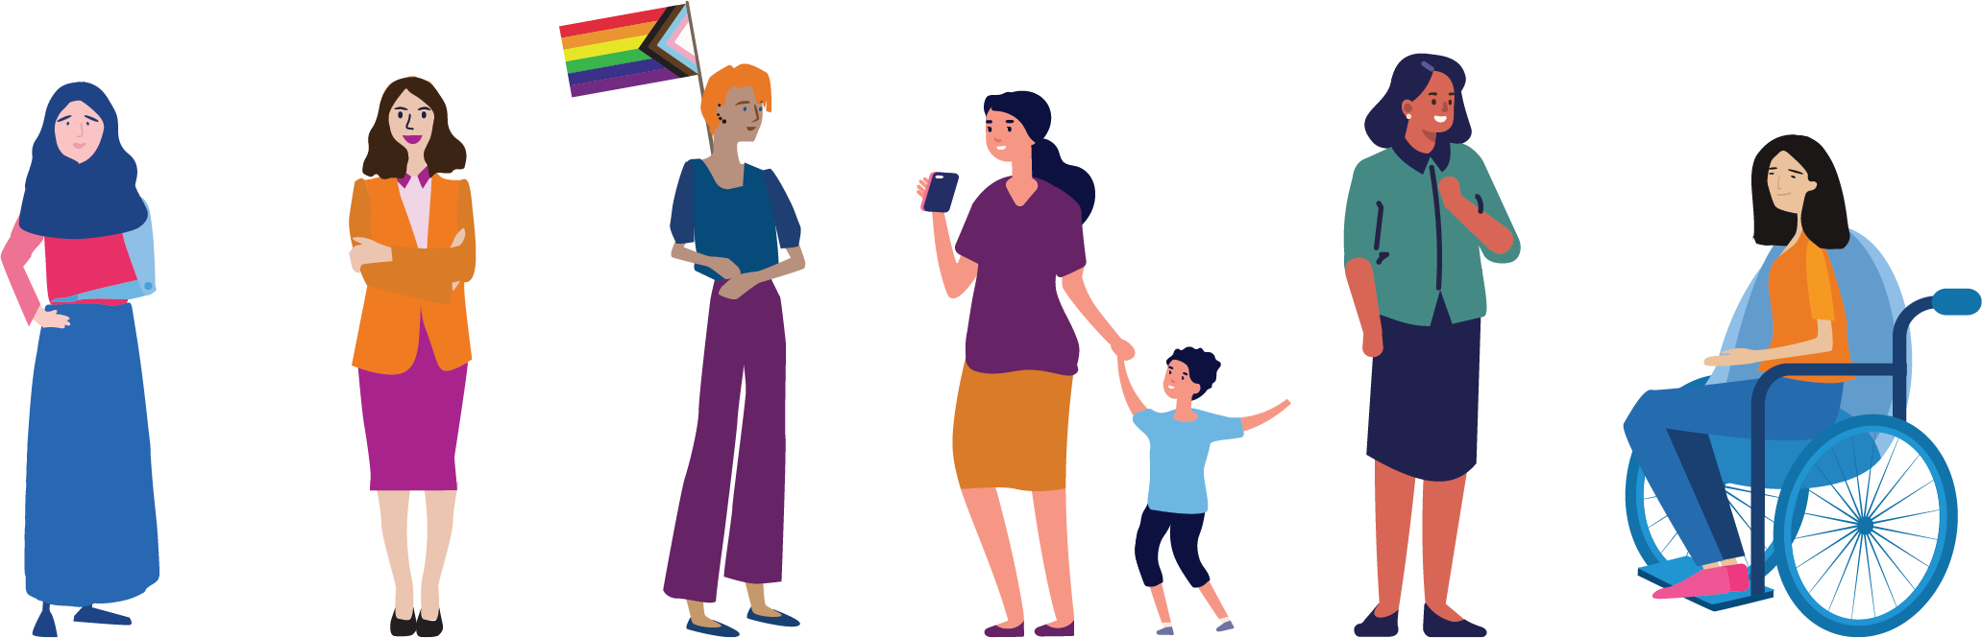

Types of violence
Violence against women with disabilities takes many different forms. While physical violence may be the most widely understood, other forms such as sexual, emotional, spiritual and economic abuse can be equally harmful. The types of violence commonly experience by women with disabilities include, but are not limited to:
Types of violence experienced by women and girls with disabilities
Disability hate crime: Crimes, typically involving violence, that are motivated by extreme ableism, where the perpetrator targets someone because of their disability. Examples: can include any form of violence against a person with disabilities.
Domestic violence: Violence in domestic settings between two people who are, or were, in an intimate relationship. Examples: can involve any form of violence (e.g. physical, sexual, emotional, psychological, or financial abuse).
Family violence: A broader term than domestic violence as it extends to violence between family members (including e.g. elder abuse, adolescent violence against parents, or violence from co-residents). Examples: can involve any form of violence (e.g. physical, sexual, emotional, psychological, or financial abuse).
Financial violence: Limiting or removing someone’s access to their money or controlling their financial decisions. Examples:
Withholding money (including government pensions) for necessities like food, medication, or disability-related equipment
Not allowing access to debit/credit cards
A disability organisation taking money for services not actually provided or needed
Limiting access to employment
Abusing access to a PIN number when assisting a woman with disabilities to manage her bank account.
Intimate partner violence: Violence within current or past intimate relationships (including marriages, de facto relationships, and other intimate relationships between people who may or may not live together). Examples: can involve any form of violence (e.g. physical, sexual, emotional, psychological, or financial abuse).
Medical exploitation or abuse: Acts, treatments, and procedures that interfere with the autonomy of a person to make decisions about their health. Examples: Forced or coerced psychiatric interventions; Withholding of, or forced medication or medical intervention.
Neglect: Depriving a person of the necessities of life such as food, water, shelter, clothing, medical care, or education, either wilfully or passively. Examples:
Withholding or denying personal care or access to disability-related equipment
Tampering with medication or mobility or communication devices
Denying that someone needs the supports they say they need
Physical violence: Behaviour that intentionally harms a person’s body. Examples:
Punching, hitting, slapping, kicking, strangling
Restraining, providing care in hurtful ways (such as washing someone in cold water), or not getting consent to touch/assist
Physical violence can also be directed towards the assistance animals of people with disabilities
Psychological / emotional abuse: Behaviour that aims to cause psychological or emotional harm. Examples:
Verbal aggression
Coercive control
Humiliation, regularly putting someone down to damage their self-worth
Stalking
Threats of violence (e.g. institutionalisation, withdrawing care, having children removed, harming pets, assistance animals or family members)
Denying or trivialising the experience of disability
Isolating a person, or preventing them from seeing certain people.
Restrictive practices: Practices or interventions that restrict the rights or freedom of movement of a person with disabilities. Examples:
Physical restraint – a person using their body to restrain someone
Mechanical restraint – using equipment to restrain someone
Chemical restraint – using drugs/medicines to restrain or control someone
Seclusion – putting a person in a room or space they cannot leave
Environmental restraint – preventing or restricting someone’s access to the community, areas of their homes, or personal possessions.
Sexual and reproductive coercion or violence: Acts, treatments, and procedures that interfere with the autonomy of a person to make decisions about their sexual and reproductive health. Examples:
Making a woman feel guilty if she does not agree to sex
A woman’s partner refusing to provide care assistance until she agrees to sex
Forcing, coercing or not getting consent before giving birth control or a hysterectomy.
Sexual harassment: Any unwelcome conduct of a sexual nature which makes a person feel offended, humiliated and/or intimidated, where a reasonable person would anticipate that reaction in the circumstances. Examples:
Unwelcome sexual advances or requests for sexual favours
Suggestive comments or innuendo
Unwanted text messages, emails, or contact via social media that is sexual in nature (including photographs).
Sexual violence/assault: Sexual activity that happens where consent is not obtained or freely given. It occurs any time a person is forced, coerced, or manipulated into any sexual activity. Examples:
Rape
Sexual assault
Unwanted sexual touch
Forced marriage.
Spiritual and cultural abuse: Using spiritual or religious ideas or beliefs to hurt, scare or control someone.
Forcing someone to participate in spiritual or religious practices they do not want to, or using scripture to justify abuse
A carer imposing their own belief systems on a woman or telling her she can’t make her own mind up about religion, or refusing to transport a woman to her place of worship
Approaching people with disabilities for unsolicited ‘healing’, or telling them they can pray to God for a cure.
Technology facilitate abuse: Using technology to harass, threaten, monitor, control, impersonate or intimidate. Examples:
Sending nude or embarrassing images of a person to others without consent
Removing or limiting access to a means of communication.

Facts on violence against women with disabilities

Why are we focusing on women with disabilities?
About one in five women in Australia has a disability. We live across urban, regional, and rural areas, have different occupations, faiths, sexualities, and cultures from one another. We share similarities in that we often experience both gender and disability-based discrimination, leading to higher rates of violence in comparison to men with disabilities, and women without disabilities.

Violence against women is a serious, widespread problem in Australia
Approximately 1 in 4 women has experienced violence by an intimate partner.
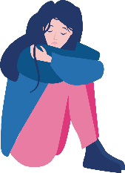
Intimate partner violence is a leading contributor to illness, disability and premature death for women aged 18-44 years.
On average, one woman a week is killed in Australia by an intimate partner.
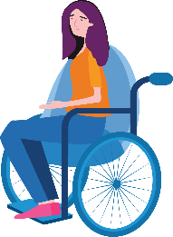

Women with disabilities face unique forms of violence and risk factors
Often, women with disabilities have multiple disabilities, compounding disadvantage and are being targeted by those who use violence.
Women with disabilities can experience other risk factors for violence, such as living in institutions or being dependent on informal or formal care in the home.
Women with disabilities are less likely to report violence or access support services, and their experiences of violence are more likely to be minimised, excused, or not believed.
Although internationally recognised as forms of violence, practices of forced or coerced sterilisation, abortion, or contraception for women with disabilities occur in Australia.
Women with disabilities also experience heightened rates of violence and harassment in public spaces, and technology-based abuse and online harassment.
Women with disabilities also report exploitation, abuse, or neglect, including forced or withholding of medical intervention, delaying of medical care, or denial of support.
Many women with disabilities also experience financial abuse, where their access to money is limited, removed, or controlled based on assumptions about their capability to manage their finances.

Some women with disabilities experience even higher rates of violence and discrimination
Aboriginal and Torres Strait Islander women experience higher rates of disability than non-indigenous women; and report a disproportionate rate of violence.
LGBTQI people with disabilities experience higher rates of crime, violence and discrimination.
Women with disabilities in a rural setting experience a higher risk of social isolation and have less access to support services.
More than half of all incarcerated women in Australian prisons have a diagnosed psychosocial disability and a history of sexual victimisation.
Financial hardship increases the prevalence of violence for women with disabilities.
Over half of young women who report violence have a disability, and experience discrimination when seeking support or advice.
More young women with disabilities report physical violence, sexual violence, stalking or harassment than young women without disabilities.
Women make up 74% of all elder abuse victims, many of whom are also living with disabilities.
Older women with disabilities report higher rates of physical violence, sexual violence, intimate partner violence, emotional abuse and/or stalking compared to older women without disabilities.
Women with disabilities from refugee or migrant backgrounds are less likely to report acts of violence or access disability services. Many policies and legislation in Australia result in practices that impact on culturally and linguistically diverse (CALD) women with disabilities, including increased risk of violence and harassment.
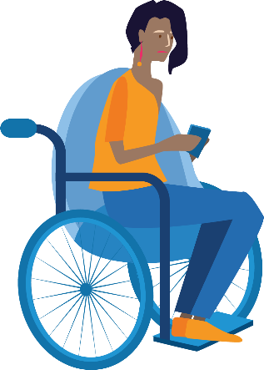

Women with disabilities experience barriers to support, and fear reporting due to:
Lack of access to the physical and sensory environment.
Inappropriate assumptions.
Focusing on disability instead of our concerns.
Lack of access to communication support.
Lack of access to information in accessible formats.
Ableism – attitudes or practices that discriminate against people with disabilities.
Lack of workforce trauma awareness.

Violence against women with disabilities is preventable. Working with women with disabilities, we can:
Address the social context that gives rise to violence against women and girls with disabilities.
Challenge acceptance of violence against women and girls with disabilities.
Improve attitudes towards women and girls with disabilities by challenging ableist and sexist stereotypes.
Promote the inclusion of women and girls with disabilities in all aspects of life.
Promote women and girls with disabilities’ independence, agency and participation in leadership and decision-making.
Engage men and boys to challenge controlling, dominant and aggressive forms of masculinity.

How does gender and disability affect rates of violence?
Men and women experience violence differently, and nearly all perpetrators of violence are male.
While a person of any gender can perpetrate violence, and a person of any gender can be the victim of this violence, there are some important gendered differences in the way violence is perpetrated and experienced. It is important to understand these gendered differences in order to effectively prevent violence.
Gendered Experiences of Violence
95% of all victims of violence – whether male or female – experience violence from a male perpetrator.
Men are more likely to experience once-off incidents of violence from a stranger in a public space. Women are more likely to experience a pattern of violence over time from an intimate partner in their home.
Approximately one in four women (23% or 2.2 million) experience violence by an intimate partner, compared to one in thirteen men (7.8% or 703,700).
The violence perpetrated by men (compared to the violence perpetrated by women) is more likely to result in serious injury or death.

People of all genders and all abilities experience violence in Australian society, and all violence is unacceptable. However, women with disabilities experience high levels of violence compared to people without disabilities and men with disabilities.
The charts below show that women with disabilities experience the highest rates of violence when compared to men and women without disabilities, and men with disabilities. Further to this, rates of violence are higher for people with psychosocial disabilities, intellectual disabilities, or complex communication needs.

Prevalence of Reported Violence across Gender and Disability
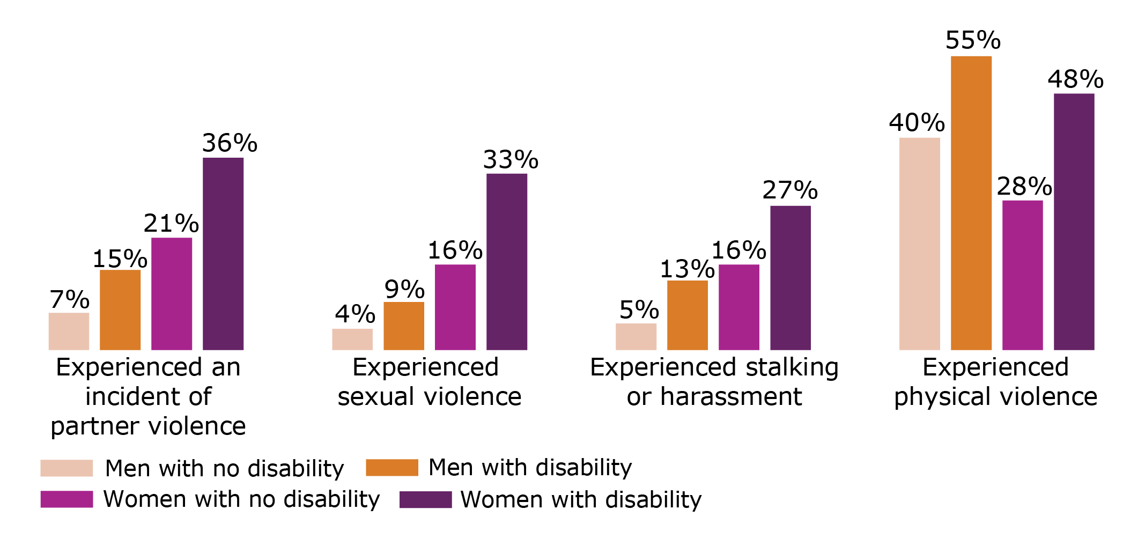

What is primary prevention and why focus on it?

Primary prevention focuses on what needs to happen to stop violence from occurring in the first place.
It takes a whole-of-population approach to identify what drives violence and then seeks to address each of these drivers to create a society where violence is not accepted and is less likely to occur. A primary prevention approach tells us that family violence is preventable and that if we focus on addressing its drivers across all levels of our society, we will be able to create a world where all people live safely and free from violence.
Successful primary prevention also requires a strong early intervention, response and recovery system.
This means that people experiencing violence can get the support they need, whilst at the same time, prevention efforts are underway to reduce future rates of violence.
Early intervention approaches support people with disabilities to understand their rights, provide information and/or link them to education or empowerment programs, advocacy or peer support groups. While the response system might focus on how to make police responses, courts and refuges more accessible for people with disabilities, and recovery might focus on connecting women with disabilities to local support services, primary prevention focuses on how society needs to change to stop violence against women with disabilities from occurring in the first place.

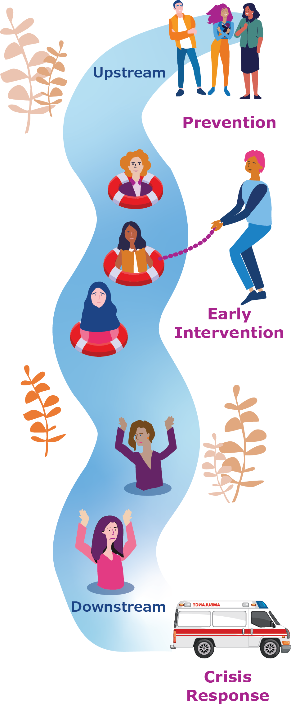

Image adapted from: Our Watch and Women with Disabilities Victoria (2022)

What is intersectionality and why is it important?
The term ‘intersectionality’ describes the ways in which different aspects of a person’s identity can contribute to overlapping forms of structural or systemic oppression and discrimination.
Using an intersectional approach seeks to address the reason that gender inequality may be compounded by other forms of disadvantage that a person may experience due to other characteristics, such as:
Race
Aboriginality
Religion
Ethnicity
Disability
Age
Sexual orientation
Gender identity.
Taking an intersectional approach helps to demonstrate how systems and structures, such as health, education, social services, and legal and justice systems, often favour some groups while oppressing and undermining others.
For example, while women as a group face gender discrimination, the dominant social systems favour and privilege women without disabilities over women with disabilities.
Gender inequality and ableism are the two consistent elements that drive violence against women and girls with disabilities.
Women and girls with disabilities who also experience other forms of oppression, such as racism or hetero-normativity, are likely to experience greater rates of violence.
For example, the prevalence of violence experienced by Aboriginal and Torres Strait Islander women with disabilities is significantly higher compared to non-Aboriginal or Torres Strait Islander women with disabilities. Similarly, lesbian, gay, bisexual, trans and intersex (LGBTI) people with disabilities experience high rates of discrimination and exclusion, and limitations on their freedom of sexual expression.

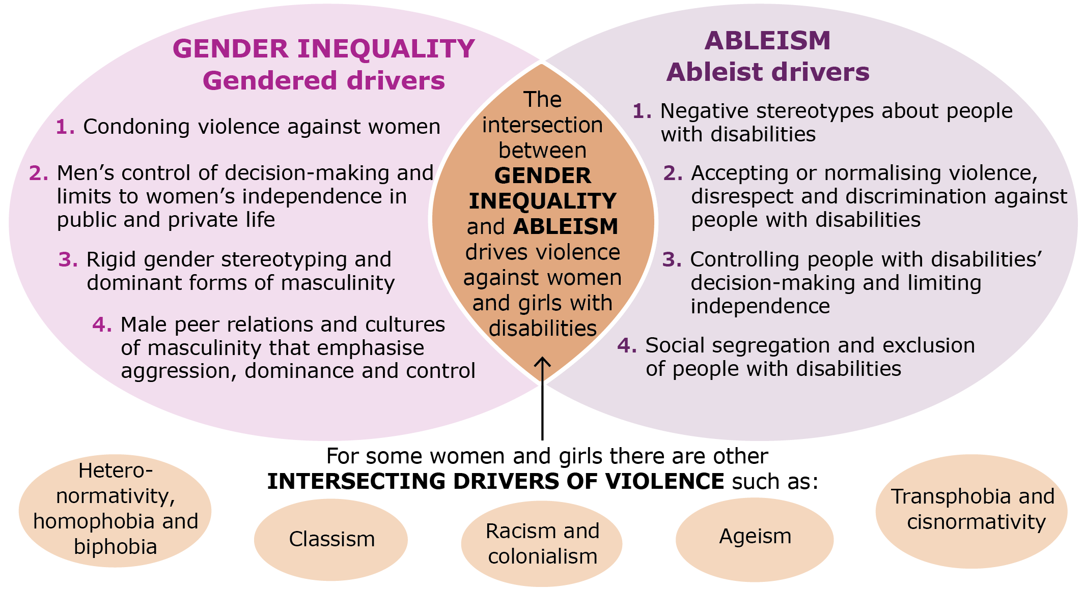

Image adapted from: Our Watch and Women with Disabilities Victoria (2022)

The socio-ecological model of violence prevention
A primary prevention approach recognises that the drivers – or causes – of violence occur across all levels of society, not just the individual. To address these drivers, action must be taken at all levels of society.
The below diagram of the socio-ecological model provides a helpful way to understand these different levels of society. Every individual has a choice about whether or not to use violence.
However, this individual decision-making is influenced by the organisations, systems and institutions that make up the society we live in. The structures, norms and practices in each of these levels either reinforce or challenge the drivers of violence.
This means that violence perpetration is not just about ‘a few bad eggs,’ and it cannot be prevented by only focusing on changing individual behaviour. Rather it is something that requires a whole-of-population response to integrate gender and disability equality across all levels of society.

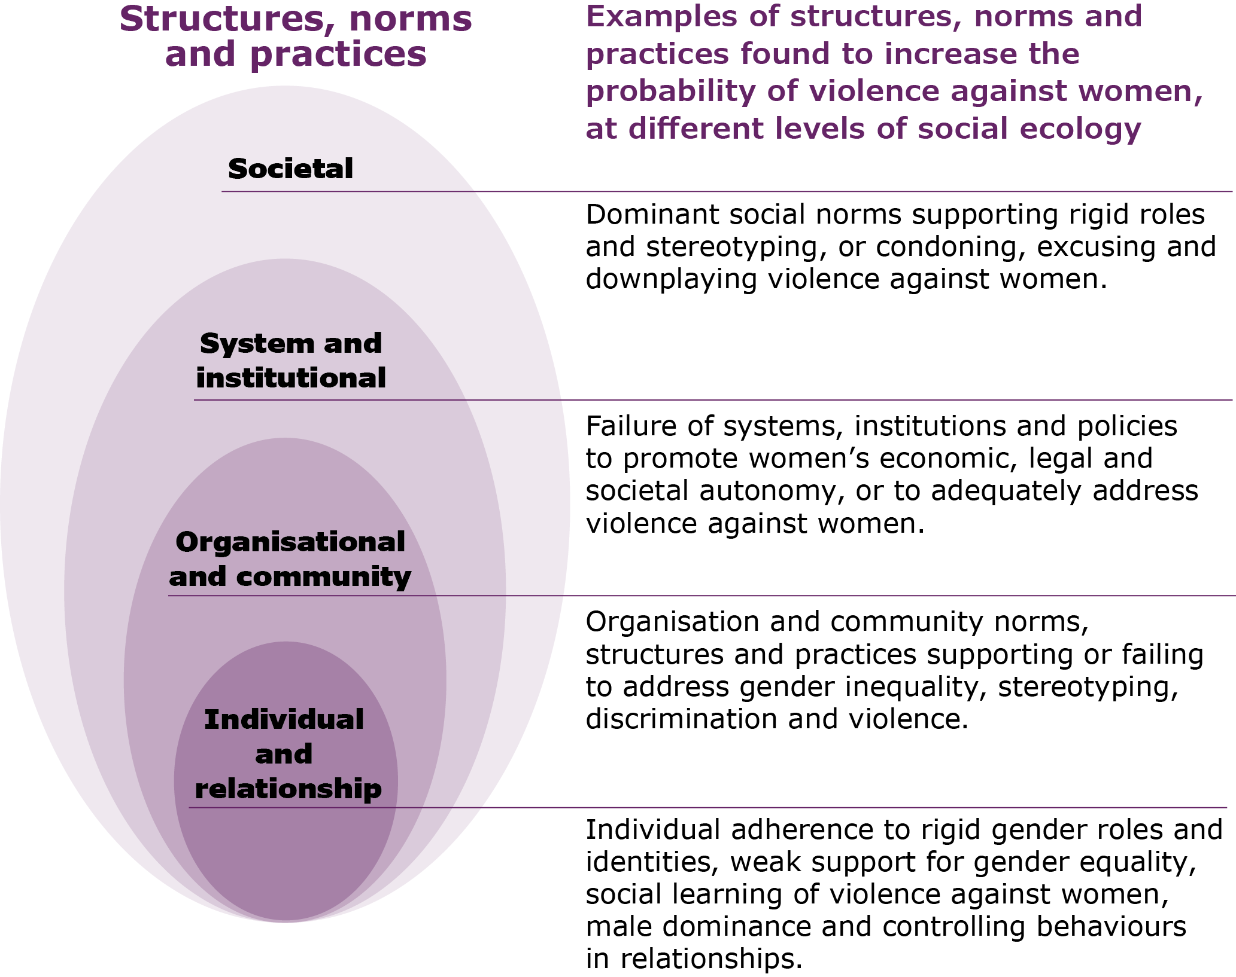
Image adapted from: Our Watch and Women with Disabilities Victoria (2022)

What drives violence against women with disabilities and how do we prevent it?
Within this resource, we use the socio-ecological model to understand how the drivers of violence against women with disabilities occur across all levels of society.
The evidence explained in Changing the landscape, tells us that violence against women with disabilities is consistently higher when four key gender and disability inequalities exist. These are known as the ‘Ableist drivers’ of violence against women with disabilities.

The four ABLEIST DRIVERS of violence against women with disabilities include:
DRIVER 1: Negative stereotypes about people with disabilities. See page 19 for more information.
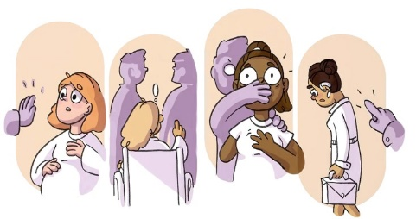
DRIVER 2: Accepting or normalising violence, disrespect and discrimination against people with disabilities. See page 20 for more information.
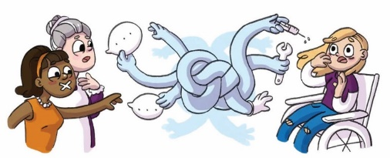
DRIVER 3: Controlling people with disabilities’ decision-making and limiting independence. See page 21 for more information.
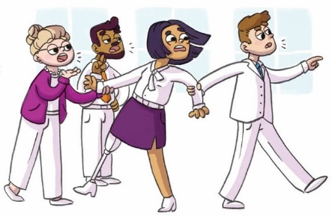
DRIVER 4: Social segregation and exclusion of people with disabilities. See page 22 for more information.
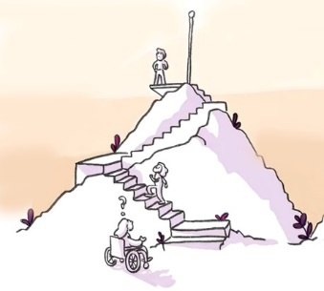
By addressing each of the drivers, and by mainstreaming gender and disability equality, we can take action to prevent violence against women with disabilities.

The six ESSENTIAL ACTIONS to prevent violence against women with disabilities are:
ACTION 1: Address the underlying social context that gives rise to violence against women and girls with disabilities. See page 24 for more information.
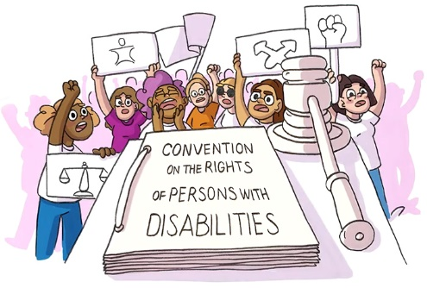
ACTION 2: Challenge the acceptance and normalisation of violence against women and girls with disabilities. See page 25 for more information.
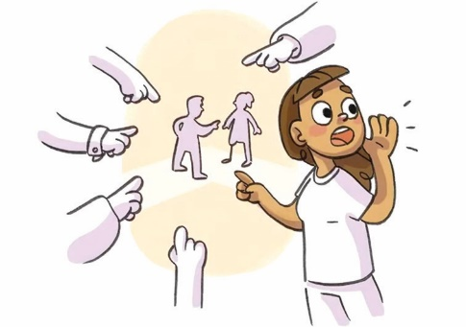
ACTION 3: Improve attitudes toward women and girls with disabilities by challenging ableist and sexist stereotypes. See page 26 for more information.
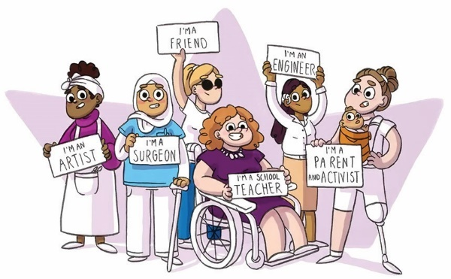
ACTION 4: Promote the inclusion of women and girls with disabilities in all aspects of life. See page 27 for more information.
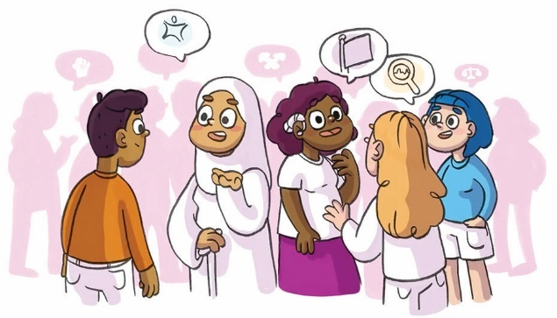

ACTION 5: Promote women and girls with disabilities’ independence, agency and participation in leadership and decision-making. See page 28 for more information
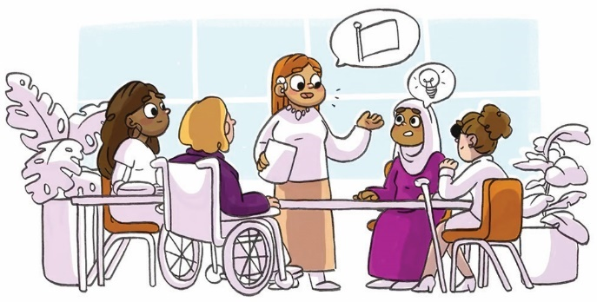

ACTION 6: Engage men and boys to challenge controlling, dominant and aggressive forms of masculinity. See page 29 for more information.
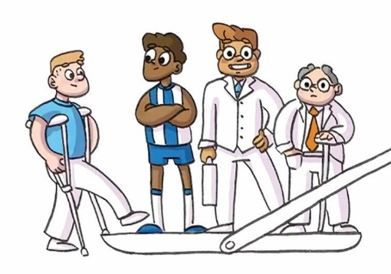

Pages 19-29 of this framework provide an in-depth look at each of these drivers and actions.

Reinforcing factors

While gender inequality and ableism are the two consistent drivers of violence against women and girls with disabilities, there are a range of other factors that may play a role in some contexts.
While reinforcing factors do not account for the prevalence of violence against women and girls, they can increase the probability or frequency of violence. These reinforcing factors can also be assumed to play a role in violence against women and girls with disabilities.

Reinforcing factors for violence against women:
Condoning of violence in general
Experience of, and exposure to, violence​
Factors that weaken prosocial behaviour
Backlash and resistance to prevention and gender equality​​

There are additional reinforcing factors that intersect with the drivers to influence the perpetration of violence against women and girls with disabilities, such as:

Additional reinforcing factors for violence against women with disabilities:
Employment discrimination and economic inequality
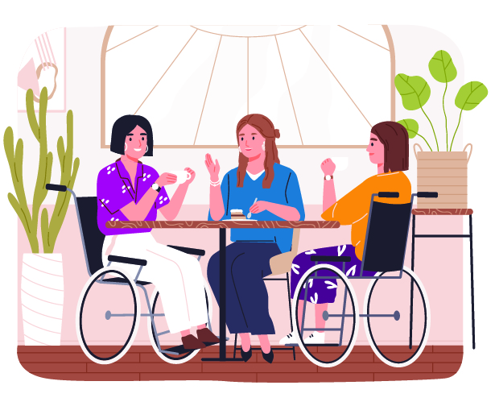
People with disabilities, in particular women, experience higher rates of unemployment and poverty due to no or minimal opportunity to participate in paid employment. This is largely driven by:
Sexist and ableist ideas about the competency and ability of women with disabilities
Unequal hiring and promotion standards
Unequal access to training
Access requirements not being met
Gender-based discrimination.
This has a profound impact over the lifespan, with average incomes and superannuation levels significantly reduced for women with disabilities.

The impacts of economic inequality include:
Reduced access to support services or information about violence
How women and girls with disabilities are treated if they try to leave or report a violent situation, as they may be less likely to be believed or taken seriously
Difficulty meeting the costs of living independently, resulting in reliance on others for support.

Inaccessible housing, transport, education, and other public services
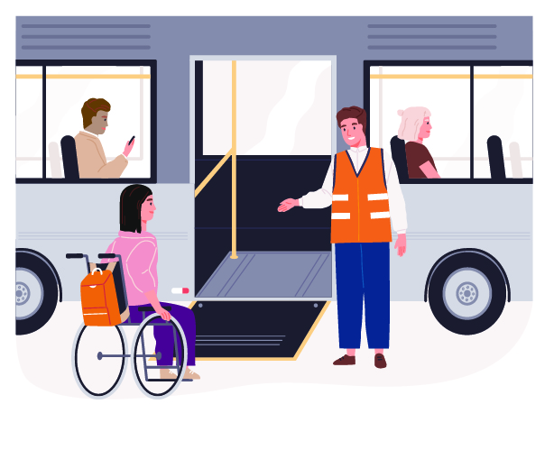
Unequal access to housing, transport, education, and other public services contributes to:
Increased rates of homelessness and insecure housing among people with disabilities
Reduced access to employment opportunities
Increased rates of poverty and financial constraints
Barriers to obtaining information about what violence and abuse is, and how to report it.
The impacts of inaccessible housing, transport, education, and other public services include:
Limited choice and control that many women with disabilities have in their lives
Strengthened stereotypes about women and girls with disabilities, and further reduced social status and perceived value
Making it easier for perpetrators to target them
Increased risk of ongoing violence by making it harder for women and girls with disabilities to leave violent situations and relationships

The following pages go into detail on each of the ableist drivers and the essential action to prevent violence against women with disabilities.
While the research and evidence indicates that gender and disability inequality drives violence against women with disabilities, the evidence and research also shows that this violence is preventable.

Ableist Drivers
DRIVER 1: Negative stereotypes about people with disabilities.
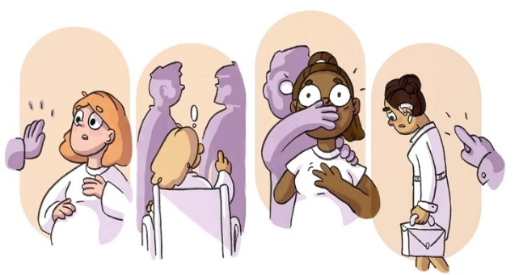

DRIVER 2: Accepting or normalising violence, disrespect and discrimination against people with disabilities.
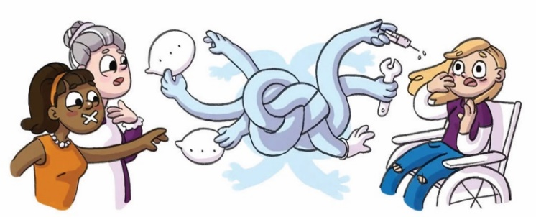

DRIVER 3: Controlling people with disabilities’ decision-making and limiting independence.
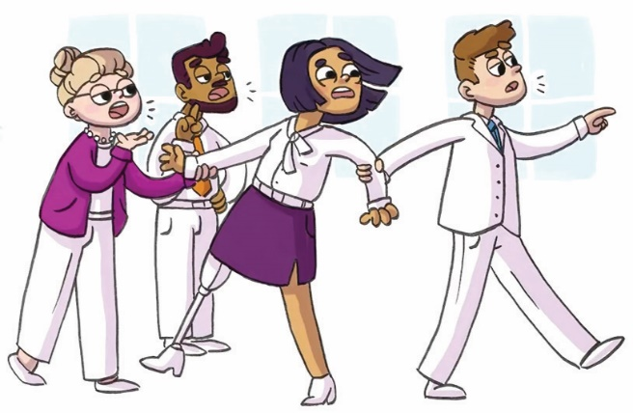

DRIVER 4: Social segregation and exclusion of people with disabilities
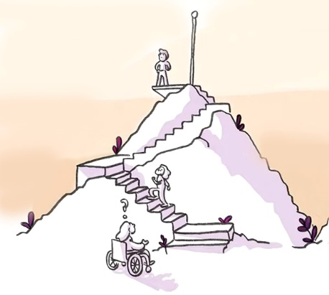

Ableist Driver 1 – Negative stereotypes about people with disabilities
Negative stereotypes, assumptions, and attitudes contribute to violence against women and girls with disabilities.

Stereotypes often depict people with disabilities as:

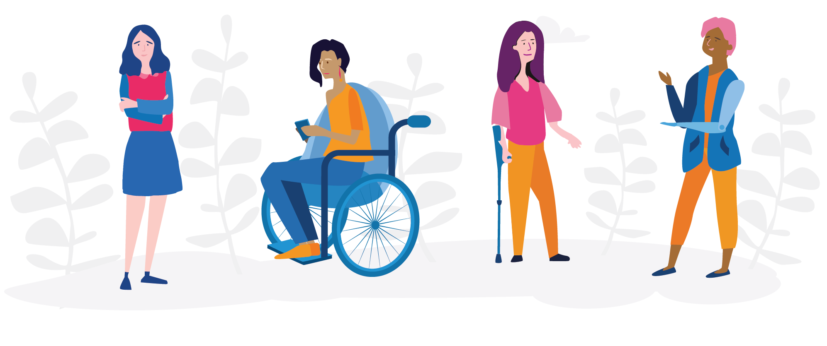
Child-like Burdensome Tragic Dangerous
Incapable Extraordinary Sexless, genderless or hypersexual
Stereotypes can be harmful and limiting, and people who don’t fit into the stereotypes can face criticism, stigma, or punishment.
These gendered and ableist stereotypes drive violence against women and girls with disabilities because they:
- Lead to false beliefs about the needs, wants and daily lives of women with disabilities.
- Assume women with disabilities do not have sexual desires or want intimate relationships.
- Can be used to allow the use of restrictive practices due to the belief that people with disabilities are incapable or dangerous.
- Contribute to low expectations about the capabilities of people with disabilities and can reduce their opportunities to access and fully participate in society.
- The perception women with disabilities are burdensome for carers or partners and are incapable parents who should have their fertility managed or their children removed.
- Being viewed as vulnerable and in need of protection, or hypersexual and promiscuous, contributes to restrictive and repressive practices over their sexual and reproductive health.

“Upon returning from my very first trip overseas I had a family member say that it was so good of my friends to take me on the trip with them. This suggests that just because I have a physical disability, I don’t bring equal value to the friendship, and they were burdened by inviting me on the trip.”
– Woman with a disability

Ableist Driver 2 – Accepting or normalising violence, disrespect, and discrimination against people with disabilities
This includes excusing or justifying perpetrator behaviour, shifting blame to the victim, trivialising and downplaying violence, and using deficit language.*
* Deficit language is when disability is framed as a tragedy, a weakness, or an extreme and unusual way of existing. When used in the context of violence against women, deficitlanguage imposes the idea that women with disabilities are ‘better off dead’, or thatviolence against women with disabilities is inevitable, to be expected, or has lesser impact.

Victim blaming: Her disability makes her vulnerable to violence.
Perpetrator excusing: He was just experiencing carer stress.
Deficit language: She is severely disabled and has high needs.
Trivialising violence: It was just a bit of rough handling.
Deficit language: She has the mentality of a 3 year old.
Trivialising violence: She doesn’t know how good she has it.
Victim blaming: Her disability causes her to have wild mood swings.
Perpetrator excusing: He’s actually a really devoted carer.
Trivialising violence: It was for her own good.
Deficit language: She has a lower quality of life.
Perpetrator excusing: He was depressed and overwhelmed from having to care for her.
Victim blaming: She is too demanding about her needs.
Victim blaming: She is a burden.
Perpetrator excusing: He’s such a great guy for looking after her.
Trivialising violence: Sometimes you have to use a bit of force on someone like that.
Deficit language: She is ‘afflicted with’ and ‘suffering from’ her disability.

“There was a time I was being seen by an emergency doctor who didn’t look at me at all and only addressed my sister, talking about me as if I wasn’t there. The doctor directed every question about my medical history and why I was presenting to the emergency department to my sister. This was a frustrating and dehumanising experience, which sadly isn’t an isolated incident.”
– Woman with a disability

Ableist Driver 3 – Controlling people with disabilities’ decision-making and limiting independence
Examples of this include:
Coercive decision-making around parenting, including making decisions for women with disabilities, not providing appropriate and accessible parenting support, and high rates of child removal
Coercive reproductive practices, including forcing or pressuring women with disabilities to undergo sterilisation, use birth control or have a termination
Inaccessible transport, buildings, education, services, workplaces and spaces
Discrimination in employment and under-representation in decision-making roles in society, such as high-paying work, leadership roles and in politics
Family members or carers controlling who she spends time with
Men’s control in relationships is often normalised, in pop culture, in family relationships, in peer groups and in workplaces
Family members or carers making decisions about care or living arrangements without consulting
Family members or carers controlling how money is spent.

These inequalities increase the likelihood of women with disabilities being targeted for violence in society. This is because they:
- Send a message that women with disabilities are less worthy of respect and are therefore perceived as more legitimate targets for violence.
- Make women with disabilities more economically, socially and physically dependent on men and on able-bodied people and institutions – this can lead to someone thinking that they can perpetrate violence against women with disabilities without consequence.
- Undermine women with disabilities’ participation in the public sphere, particularly in formal decision-making and civic action. This has a compounding impact because women with disabilities in positions of power are more likely than men and able-bodied people to make policy decisions to secure freedom from violence for women with disabilities.
- Make it difficult for those who do experience violence to be able to leave.

“Further education was denied by my family as I have a disability… My disability now limits my involvement in the workplace…”
– Woman with a disability

“My life as a lady over 50 living with a disability, I find it hard to trust people as they take advantage of me.”
– Woman with a disability

Ableist Driver 4 – Social segregation and exclusion of people with disabilities
Practices of segregation and exclusion are informed by harmful ableist social norms, beliefs, and practices, and send a message that people with disabilities are more legitimate targets of violence.
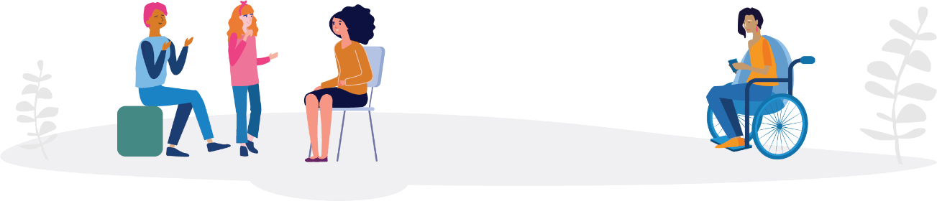

Segregation
Many people with disabilities are separated from the rest of the community because of law, policy and practice frameworks. Examples include:
Special development schools
Australian Disability Enterprises
Group homes and supported living residential settings.
Impacts include:
Isolation of people with disabilities due to less opportunities to be involved in the community and form relationships with people without disabilities.
Limited choice and control about living arrangements due to a lack of available options that enable them to live independently and receive necessary support services.
“Special” laws and policies that reinforce the belief that some people with disabilities are incapable of living within mainstream settings, or that they pose a risk to themselves or others.

Exclusion
Widespread environmental, attitudinal, communication and institutional barriers exclude people with disabilities. Examples include:
Buildings not being physically accessible.
Communication requirements not being met.
Discriminatory ableist attitudes.
Inaccessible recruitment and retention processes.
Impacts include:
Preventing people with disabilities from being able to meaningfully participate in everyday activities, such as catching public transport, going grocery shopping, participating in sport and recreation, going out for a meal with friends or family, or participating in mainstream schools and workplaces.
“I don’t have a partner or many friends, except for work and a few family members I see rarely. So, life gets a bit lonely and I also feel isolated living in an outer suburb, where it takes a while to get anywhere so I don’t travel much anymore due to my mental and physical disabilities which combine to make life difficult and I stay home a lot.” – Woman with a disability

Essential Actions
ACTION 1: Address the underlying social context that gives rise to violence against women and girls with disabilities
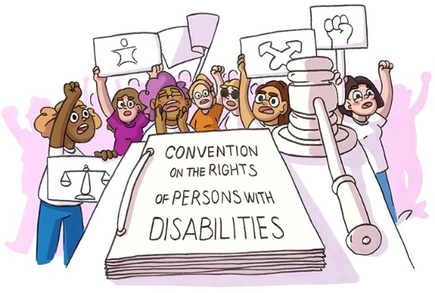
ACTION 2: Challenge the acceptance and normalisation of violence against women and girls with disabilities
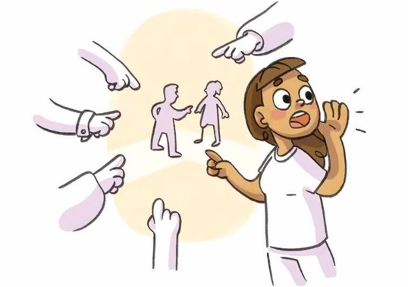
ACTION 3: Improve attitudes toward women and girls with disabilities by challenging ableist and sexist stereotypes
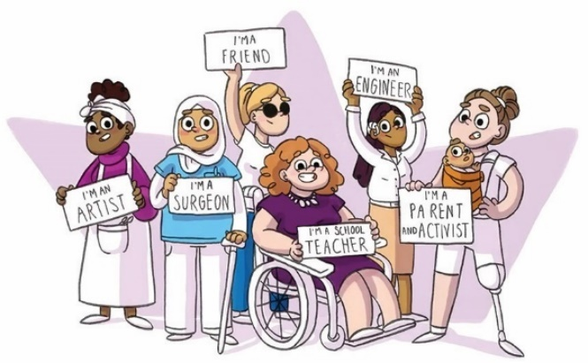
ACTION 4: Promote the inclusion of women and girls with disabilities in all aspects of life
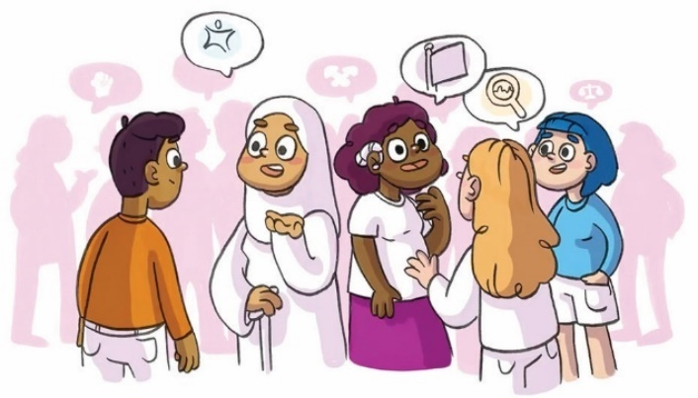

ACTON 5: Promote women and girls with disabilities’ independence, agency and participation in leadership and decision-making
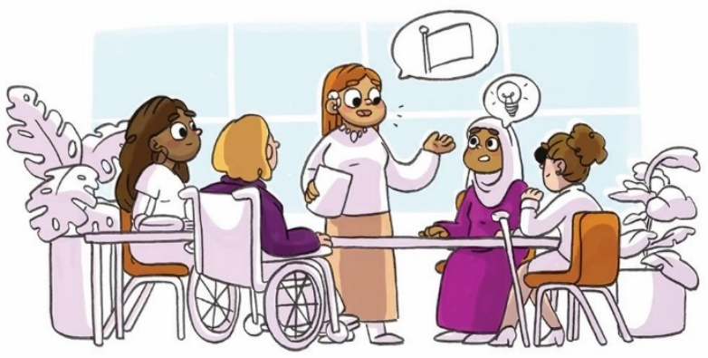

ACTON 6: Engage men and boys to challenge controlling, dominant and aggressive forms of masculinity
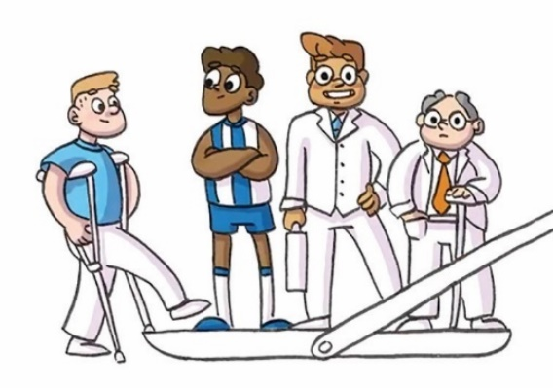

Action 1 – Address the underlying social context that gives rise to violence against women and girls with disabilities
For a long time, disability was understood through the medical and charity models.
These models made people think negatively about disability, perpetuating disability as something that needed to be fixed or cured, and people with disabilities should be pitied and hidden away or removed from society completely. These models influenced people’s beliefs and resulted in discrimination and stigmatisation of people with disabilities. The adoption of positive models of disability, like the social model and human rights model, have empowered people with disabilities. These models are about providing everyone with the same opportunities and privileges and urging society to adapt rather than focusing on those with impairments.
The social model recognises that disability inequality does not result from impairment alone but is created by a social environment that excludes people with disabilities from full participation in society due to attitudes, and environmental, communication and institutional barriers. If focuses on the ways society can adapt to achieve equitable choices, opportunities, and participation of people with disabilities.
By addressing these barriers and discrimination, people with disabilities will experience more equitable access, opportunities, and participation.
The Human Rights Model of Disability extends from the social model and tells us that disability cannot be used as an excuse to discriminate or deny access and opportunity. It recognises that enabling people with disabilities to live freely and independently requires more than just removing barriers in society’s mainstream. This model focuses on people with disabilities being active participants in all matters that affect them as they are the experts in their own lives.
“[The ideal future is] Where people like me (disabled, female, queer, artistic, neurodiverse) are visible and heard, in community and media, government, etc., so I don’t have to feel like I have to speak up, or feel guilty for not being able to speak up.” – Woman with a disability

Action 2 – Challenge the acceptance and normalisation of violence against women and girls with disabilities
Use anti-violence messaging:
Reduce victim blaming: Women with disabilities have a right to safety, respect & equality.
Perpetrator accountability: Lots of carers experience stress without becoming violent.
There is no justification: It’s not ok, ever.
Name the problem: This is family violence. This is sexual assault. This is abuse.
Systems of accountability: This is unlawful.
Challenge minimising: It’s a big deal, and it’s wrong.
Reduce victim blaming: It’s not her fault.
Perpetrator accountability: Violence is a choice. He chose to use power over her.

Frame disability using a strengths-based model:
Use factual language that doesn’t reinforce stereotypes, imply weakness, alienate women or suggest disability is a reason for violence.
Women with disabilities aren’t ‘vulnerable to violence.’ Women with disabilities are targeted for violence.
She isn’t ‘bound to a wheelchair’. She is enabled by it. She uses a wheelchair.
She doesn’t have the mentality of a 3-year old. She’s an adult woman with an intellectual disability.
She isn’t ‘suffering from’ or ‘struggling with’ a disability. She has dementia.
She isn’t ‘dependent’ on her partner. All relationships involve inter-dependence. Her partner provides her with support.
She doesn’t need others to do everything for her. If she needs help, she’ll ask for it.
She doesn’t have a ‘lower quality of life’. The presence or absence of disability is not what predicts uality of life.
She does not ‘have difficulty remembering’. She has a brain injury and understands information best when a written summary is provided.

“I have a physical disability which affects my mobility so when I am required to walk long distances, I use a wheelchair. While I was at Disneyland, every time I wanted to get on a ride the attendant would ask the people I was with “can she walk” rather than asking me if I was able to transfer. Asking if I was able to transfer would have suggested that using a wheelchair isn’t an automatic barrier for participation.” – Woman with a disability

Action 3 – Improve attitudes towards women and girls with disabilities by challenging ableist and sexist stereotypes

Challenge ableist and sexist stereotypes within the community:
- Promote gender and disability equality and the rights of women and girls with disabilities.
- Recognise the skills, talents and contributions of women and girls with disabilities.
- Challenge negative stereotypes about the capacity of women with disabilities.
- Provide opportunities for parents and families of a child with disabilities to build knowledge about disability rights and violence against people with disabilities.
- Address any attitudes by healthcare professionals that could lead to the dismissal of health concerns of women with disabilities.
- Work with children and young people with disabilities to promote gender equality, human rights and respect to prevent the development of sexist and ableist views.

Promote and celebrate diversity and difference amongst women and girls with disabilities:
Stereotypes rely on portraying people as being all the same, but women and girls with disabilities are a diverse bunch. They have different disabilities, opinions, cultures, and beliefs.
When these differences are celebrated, promoted and represented, people are less likely to make stereotypes, and this opens up more opportunities.

Promote positive representation of women and girls with disabilities by workplaces:
Create training opportunities for workers that promote gender and disability equality and build understanding of negative attitudes and stereotypes and their impacts.
Utilise language and imagery that is inclusive of people of all genders and abilities in internal and external communications.
Promote workplace culture where negative stereotyping and prejudice against women with disabilities is never tolerated.

Promote disability pride:
Women with disabilities drive our own culture – one where we are proudly visible, where we know our own worth, and where we live in plain view. Disability equality is about more than just inclusion: it is about honouring and celebrating our culture and our contributions.

“All the information allowed me to have more knowledge that I didn’t know about women/men with disabilities in Victoria. It allows me to have a different mindset and thoughts towards those with a disability.” – WDV training participant

“I will be looking at what I do through the lens of gender equality especially with disability.” – WDV training participant

Action 4 – Promote the inclusion of women and girls with disabilities in all aspects of life

Promote inclusion of women and girls with disabilities in political, public and community life
Support opportunities for women and girls with disabilities to develop social and peer connections.
Encourage and support political participation by women with disabilities.
Advocate for the right of women and girls with disabilities to participate equally in the community.

Ensure equitable access to all forms of education for women and girls with disabilities
Ensure women and girls with disabilities have access to equal primary, secondary, tertiary and vocation education..
Flexible teaching and learning environ-ments where reasonable adjustments are offered to support students with disabilities to fully participate.
Provide high quality sexual health and respectful relationship education that promotes gender equality and prevention of gendered violence, using an intersection lens to respond to the needs of women and girls with disabilities.
“I imagine a future where all people are encouraged to live their best, and healthiest lives. I’d love to be able to walk on my local beach without the need for extra assistance, walk around the local streets without worrying if I can get out of the way of traffic quick enough, if I can join choirs, craft/art groups, maybe even work a little to help with the bills. I want to be able to give an opinion and not have my broken body looked at, rather have my words heard.
Have doctors available, physios, pools, all within a short drive/walk. I would like to be healthy, emotionally fulfilled, and be financially secure.” – WDV Program participant

Facilitate the equal employment and economic participation of women with disabilities
Create inclusive and safe workplaces by removing barriers to participation, eliminating workplace discrimination and improved monitoring of equality in the workplace.
Create diverse, permanent roles with career progression opportunities for women with disabilities.
Increase access to open employment through meeting access requirements, reviewing ableist recruitment processes, create avenues to promotion and offering ongoing professional development and training opportunities.

Access to safe, non-segregated living arrangements and an adequate standard of living
Enable the right for women with disabilities to live independently, make meaningful community connections, and enjoy a good standard of living.
Access to appropriate, safe and affordable housing that enables independent living, with a focus on non-segregated options.
Ensure women with disabilities can make genuine choices about their living situation (where they live, who they live with) by addressing the sexist and ableist views that exclude women with disabilities from private rentals.

Action 5 – Promote women and girls with disabilities’ independence, agency and participation in leadership and decision-making
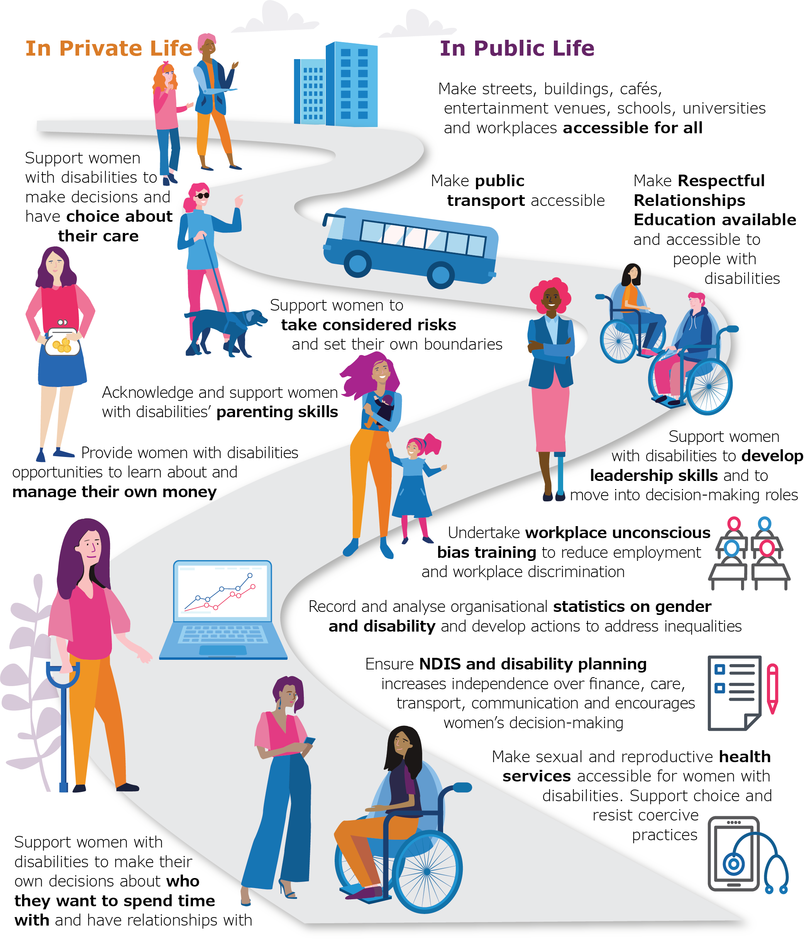

Action 6 – Engage men and boys to challenge controlling, dominant and aggressive forms of masculinity
While violence against women and girls with disabilities can be perpetrated by people of all genders, certain forms of violence, such as sexual assault, rape, and intimate partner violence, are overwhelmingly perpetrated by cisgender men. Therefore, it is imperative for prevention strategies to engage men and boys to challenge the ideals, norms and behaviours that contribute to violence against women.
Strategies should:
Engage men to challenge rigid attachments to ideas of masculinity as controlling, dominant or aggressive.
Promote positive male peer relationships and challenge male peer group cultures that disrespect women and emphasise aggression.
Challenge justifications for men’s violence and aggression.
Encourage an understanding of sex and gender that does not limit people to two rigid categories.
Promote a range of alternatives to the dominant norms of masculinity rather than reinforcing existing norms.
How and where to engage men and boys:
Strengthening individual knowledge and skills – aims to increase capacity of individuals to prevent violence against women.
Promoting community education – aims to shift public awareness, attitudes and norms relating to gender inequality and violence against women.
Education providers – educating health, social and community service professionals so they can educate, support and engage others.
Engaging, strengthening, and mobilising communities – structural and institutional change promoting economic and social empowerment and community mobilisation for prevention of violence for women using an intersectional lens.
Changing organisational practices.
Influencing policies and legislation.

Supporting actions
On their own, these supporting actions are not sufficient, however, they can make an important contribution to the prevention of violence against women and girls with and without disabilities.

Supporting actions for violence against women and girls:
SUPPORTING ACTION 1: Challenge the normalisation of violence and aggression as an expression of masculinity.
SUPPORTING ACTION 2: Reduce the long-term impacts of exposure to violence and prevent further exposure.
SUPPORTING ACTION 3: Strengthen prosocial behaviour.
SUPPORTING ACTION 4: Plan for and actively address backlash and resistance.

Supporting actions for violence against women and girls with disabilities:
SUPPORTING ACTION 1: Tackling both gender and disability related employment opportunities for people with disabilities; ensuring that employers meet the access requirements of people with disabilities.
SUPPORTING ACTION 2: Increasing economic equality and financial independence for people with disabilities.
SUPPORTING ACTION 3: Reducing poverty and increasing the economic security of people with disabilities, including ensuring that financial constraints are not a barrier for women with disabilities to live independently.
SUPPORTING 4: Improve access to housing, transport, education, and other public services for people with disabilities.

Principles for prevention in practice

Prevention principles to stop violence against women and girls with disabilities
- Centre the input of women and girls with disabilities
- Ensure autonomy, community ownership and control
- Co-design
- Use a strengths-based approach
- Build partnerships and opportunities for collaboration
- Be respectful and authentic
- Ensure the physical, emotional and cultural safety of women and girls with disabilities
- Ensure accessibility and inclusion
- Ensure prevention work is informed by critical frameworks
- Contribute to the evidence base.

Actions for prevention
- Use all available policy, legislation and regulatory mechanisms
- Use the essential actions detailed in Change the story to address the gendered drivers of violence against women
- Combine techniques across multiple settings and sectors to make changes ‘stick’
- Work at multiple levels to transform social norms, structures and practices
- Be explicit about the intended audience, and design or tailor approaches to suit each setting and audience, rather than applying a one-size-fits-all model, in order to respond to the diversity of the Australian population
- Apply a specific gender analysis and a specific disabilty analysis
- Take an intersectional approach – that is, address the intersections between multiple forms of oppression, rather than only considering gender and disabilty
- Take a gender transformative approach – that is, transform the harmful gender roles, practices and norms and unequal power relations between men and women
- Draw on a range of appropriate evidence and expertise
- Ensure specific, intensive effort with communities affected by multiple forms of oppression, with additional resourcing in these contexts
- Build partnerships across sectors and communities, and between violence prevention and gender equality specialists and other organisation
- Work across the life course, including with children, young people and adults
- Challenge harmful ideas about masculinity
- Develop reflective practice (where practitioners reflect on their own social position, values and assumptions, and those of the organsation in which they work)
- Follow a program logic approach (identifying the sequence of steps required to achieve the intended outcome)
- Scale up what works and ensure the long-term sustainability of effective initiatives
- Evaluate and innovate to continually build evidence and promote learning
- Connect prevention activity to the response sector, and establish mechanisms to respond to disclosures from victim-survivors and perpetrators which may arise through their engagement with a prevention initiative.

From: Our Watch and Women with Disabilities Victoria (2022)

Glossary of terms

Ableism The unfair treatment of people because they have a disability. The belief that people with disabilities are less important than people without disabilities.
Disability There is no single definition of disability. This document defines disability as a long-term physical, cognitive, sensory and psychosocial impairment, that when combined with a number of barriers can impact community and social participation.
Drivers of Violence The factors that cause violence against women.
Femininity The roles, behaviours, activities and attributes that society assigns to women.
Gender Gender is a socially constructed concept that sets out how men and women have specific traits and roles according to their biological sex. A person is not born with a gender. Gender can be changed.
Gender-based violence Violence towards a woman because she is a woman or towards a man because he is a man. The most common type is Violence Against Women (VAW).
Gender diverse People whose gender identity is different to what is socially expected. Also see non-binary.
Gender Equality When men, women, boys, girls and gender diverse people enjoy the same right, opportunities and outcomes and hopes and needs are equally valued.
Gender equality does not mean that men and women become the same; but they have access to opportunities that is not based on their sex or gender identity. Gender equality is achieved through gender equity.
Gender equity The process of being fair to women and men and recognises the differences in women's and men's lives. Gender equity addresses this differences and is the process of levelling the playing field.
Gender identity The gender identity spectrum recognises that gender identity is made up of more than two genders. Instead, it is a spectrum, spanning from masculine to feminine with many gender identities in between, including people who identify as gender diverse or non-binary.
Gender inequality When there is unequal division of power, resources, opportunities and values given to men, women and gender diverse people in a society.
Inclusion Diverse groups of people being valued and respected who are given equitable access to opportunities to participate in society.
Intersectionality Describes how overlapping types of structural or systemic discrimination and privilege shape how individuals experience the world.
Lived experience The knowledge and expertise a person obtains from what they have lived through.
Masculinity Roles, behaviours, activities and attributes that society assigns to men.
Medical model
of disability Views disability as a ‘problem’ and places the responsibility of ‘managing’ disability on the individual, suggesting people with disabilities should seek treatment and try to conform within society.
Non-binary A person who does not identify as either of the socially expected categories of sex (male/female). Also see Gender diverse.
Primary prevention Stopping violence before it starts.
Reinforcing factors Factors that do not drive violence but influence the likelihood of violence.
Segregation Certain groups being kept separate from the dominant group.
Sex The biological and physiological characteristics that define whether someone is male, female or intersex.
Sexism The claim that one sex is superior to the others.
Social model of disability Contrasts with the medical model of disability, suggesting disability exists as the result of the combination of a person’s impairment/s and an inaccessible environment. Responsibility of increasing accessibility is placed on society rather than the individual.
Social norm Unspoken rules that define acceptable and expected behaviours within society.
Socio-ecological model A model that explains how the causes of any social or health issue sits at various levels of the society.

Support referral services

Victorian Services

Violence against Women
Safe Steps: Family Violence Response Centre
Safe Steps provides 24/7 specialist support services for anyone in Victoria who is experiencing or afraid of experiencing family violence. Services include:
Information and referral
Crisis response
Specialist family violence risk assessment
Safety planning
Access to supported crisis accommodation
T: 1800 015 188 (24 hours, 7 days a week)
E: safesteps@safesteps.org.au
W: safesteps.org.au

Sexual Assault Crisis Line
Confidential, telephone crisis counselling service for people who have experienced both past and recent sexual assault.
T: 1800 806 292 (24 hours, 7 days a week)
W: sacl.com.au

Centre Against Sexual Assault (CASA)
Provides trauma informed counselling, advocacy and support for people who have experienced a recent or past sexual assault. CASA also offers specialised advocacy, secondary consultation, community education and professional training within the community and across the sector. For people who have experienced a recent sexual assault we provide 24-hour crisis care that includes counselling, support, information and advocacy for medical care and legal options.
T: 03 9635 3600 (24 hours, 7 days a week)
E: casacr@casacv.org.au
W: casacv.org.au

The Orange Door
The Orange Door is a free service for adults, children and young people who are experiencing or have experienced family violence, and families who need extra support with the care of children. Visit The Orange Door website to find which of their fifteen locations across Victoria is closest to you.
W: orangedoor.vic.gov.au/contact

Project Respect
An intersectional feminist, non-faith based specialised support service and peer community for women and gender diverse people with experience in the sex industry, including those who have experienced trafficking for sexual exploitation.
T: 03 9416 3401 (Mon to Fri, 9am-5pm)
E: info@projectrespect.org.au
W: projectrespect.org.au

WIRE (Women’s Information Referral Exchange)
WIRE provides free information, support, and referrals, and has links to women’s services and support.
T: 1300 134 130 (Mon to Fri, 9am-5pm)
E: support@wire.org.au (Mon to Fri, 9am-4:30pm)
W: wire.org.au

Disability Services
Disability Advocacy Resource Unit (DARU)
DARU is a state-wide service established to resource the disability advocacy sector in Victoria. This organisation develops and distributes resources and provides training opportunities to keep disability advocates informed and up-to-date about issues affecting people with disabilities in Victoria.
T: 03 9639 5807
E: admin@daru.org.au
W: daru.org.au

Disability Services Commissioner
Disability Services Commissioner works with people to resolve complaints about Victorian disability service providers. Services are free and confidential and provide information on avenues available for making complaints about other services.
T: 1800 677 342
E: complaints@odsc.vic.gov.au
W: odsc.vic.gov.au

Association for Children with a Disability (ACD)
ACD is an advocacy and information service for families of children with any type of disabilities living in Victoria.
T: 03 9880 7000 (metro) or 1800 654 013 (regional) (Monday to Friday, 9am-5pm)
E: mail@acd.org.au
W: acd.org.au

The Disability and Family Violence Crisis Response Initiative (DFVCRI) assists women and children with a disabilities who are experiencing family violence to access the services and supports they need to stay safe. Through the initiative, short-term funds can be provided for up to 12 weeks, to a maximum of $9,000 per person, while the woman and her family violence worker develop a longer-term plan. Please visit the Families, Fairness and Housing (DFFH) or Safe Steps websites for more information about this initiative.

Multicultural Services
InTouch Multicultural Centre Against Family Violence
Specialist family violence service that works with women from migrant and refugee backgrounds, their families, and their communities in Victoria. InTouch provides case management to women, training, conducts research, and runs community-based projects to address the issue of family violence in the community.
T: 1800 755 988 (Mon to Fri, 9:30am-4:30pm)

If you are experiencing abuse and need a translator, please call:
TIS on 131 450 and ask them to call 1800RESPECT on 1800 737 732, or Safe Steps on 1800 015 188.
E: admin@intouch.org.au
W: intouch.org.au
Australian Muslim Women’s Centre for Human Rights (AMWCHR)
Provides support for women in family violence situations, including risk assessment, safety planning and case planning. Services also provide help understanding the Child Protection system, policing and courts, support with Early Forced Marriage or Islamic Divorce, information and referral for migration issues, outreach services, cultural and emotional support, and access to emergency relief and crisis services, housing, legal, health, mental health, material, and financial aid.
T: 03 9481 3000
E: reception@amwchr.org.au
W: amwchr.org.au

LGBTQIA+ Services
Switchboard
Switchboard provides peer-driven support services for the lesbian, gay, bisexual, transgender, and gender diverse, intersex, queer and asexual (LGBTIQA+) people, their families, allies and communities. Switchboard’s peer-led services include Rainbow Door and QLife.
T: 03 9663 2474
E: admin@switchboard.org.au
W: switchboard.org.au

Rainbow Door
Specialist LGBTIQA+ helpline providing information, support, referral, and short-term case management. We support people of all ages and identities with issues including family and intimate partner violence (including elder abuse), relationships, mental health, and wellbeing.
T: 1800 729 367 (Monday to Sunday, 10:00am-5:00pm)
E: support@rainbowdoor.org.au
W: rainbowdoor.org.au

QLife
A service is for LGBTIQA+ identifying people and those who have questions or concerns about LGBTIQA+ issues, including referrals, community connections, thoughts, and feelings around sexual orientation and/or gender identity.
T: 1800 184 527 (Monday to Sunday, 3pm-midnight)
W: qlife.org.au

Thorne Harbour Health (THH)
Thorne Harbour Health (THH) offers counselling in family violence for LGBTIQ women in a safe environment where they can be open about their gender, sex, sexuality, and a whole range of issues impacting them.
T: 1800 134 840
E: enquiries@thorneharbour.org
W: thorneharbour.org

Aboriginal Services
Djirra
Djirra provides both telephone and face to face legal and non-legal support to Aboriginal people who are experiencing or have experienced family violence. Support services Djirra can arrange include:
Counselling sessions
Aboriginal workers to accompany Aboriginal women to appointments
Safety planning discussions and follow up support
Financial assistance to people experiencing family violence through Flexible Support Packages
Personalised referrals to specialist support services with issues such as housing and homelessness, drugs and alcohol, parenting, debt and employment.
Djirra’s Aboriginal Family Violence Legal Service is dedicated to supporting Aboriginal people who are experiencing or have experienced family violence (women and men). They also assist non-Aboriginal people experiencing family violence who are parents of Aboriginal children.
T: 1800 105 303
E: info.afvls@djirra.org.au
W: djirra.org.au

Elizabeth Morgan House
Elizabeth Morgan House provides culturally safe, holistic family violence support for Aboriginal women and children as well as parents of Aboriginal children, partners, and ex-partners of Aboriginal people in Victoria. They can assist with housing, financial difficulties, Child Protection concerns, and school matters; as well as referrals and advocacy to services such as legal, medical and health services, drug and alcohol counselling, financial counselling, and children’s services.
T: 1800 364 297 (24 hours, 7 days a week)
E: info@emhaws.org.au
W: emhaws.org.au

Senior’s Services
Seniors Rights Victoria
Provide free information, advice, referral, and support to older people who are either at risk of or are experiencing elder abuse or to other people, such as family members and friends, who are concerned that someone else may be experiencing elder abuse.
T: 1300 368 821 (Mon to Fri, 10am-5pm)
E: casework@seniorsrights.org.au
W: seniorsrights.org.au

Men’s Services
No to Violence
No to Violence supports men who have or are still behaving abusively, family members who are impacted by a man’s abusive behaviours, people who wish to understand how to support their friends, family, or colleagues, and professionals wishing to support a client who is using or experiencing family violence.
T: 1300 766 491 (24 hours, 7 days a week)
W: ntv.org.au

Interstate Services

ACT
Domestic Violence Crisis Service (DVCS)
Crisis intervention and counselling, family violence intervention program, education, and information for the community.
T: 02 6280 0900 (24 hours, 7 days a week)
W: dvcs.org.au

New South Wales
NSW Domestic Violence Helpline
Provides telephone counselling, information and referrals for women and same-sex partners who are experiencing or have experienced domestic violence.
T: 1800 656 463 / TTY: 1800 671 442
(24 hours, 7 days a week)
W: community.nsw.gov.au

Northern Territory
Dawn House (Darwin)
Crisis accommodation and support services for women with children who are experiencing or escaping domestic or family violence.
T: 08 8945 1388 (24 hours, 7 days a week)
W: dawnhouse.org.au

Darwin Aboriginal and Islander Women’s Shelter (DAIWS)
Support, referral, outreach, and domestic violence crisis accommodation for Aboriginal and Torres Strait Islander women who are homeless or escaping family violence.
T: 08 8945 2284 (24 hours, 7 days a week)

Sexual Assault Referral Centre
Free 24-hour emergency service that provides crisis counselling and other support needs to both adult and children who have experienced any form of sexual assault or sexual abuse, either recently or in the past.
T: 08 8922 6472 (24 hours, 7 days a week) (Darwin)
T: 08 8955 4500 (24 hours, 7 days a week) (Alice Springs)
W: health.nt.gov.au/sexual_assault_services

Queensland
DVConnect
DVConnect exists to help Queenslanders escape domestic, family and sexual violence
by providing crisis helplines, as well as emergency transport and accommodation away from violence. DVConnect is a not-for-profit organisation that has provided state-wide specialist domestic, family and sexual violence crisis counselling, intervention, information, safety planning and pathways to safety.
Women line
T: 1800 811 811 (24 hours, 7 days a week)
DVConnect Sexual Assault Helpline
T: 1800 010 120 (7.30am-11.30pm, 7 days a week)
W: dvconnect.org

South Australia
Women’s Safety Services SA
A statewide service offering assistance to women experiencing domestic violence in South Australia by providing information, counselling, and safe accommodation options.
T: 1800 800 098
W: womenssafetyservices.com.au

Western Australia
Women’s Domestic Violence Helpline
Statewide service providing support and counselling for women experiencing family and domestic violence.
T: 1800 007 339 (24 hours, 7 days a week)
W: 1800respect.org.au/service_state/wa

Tasmania
Safe at Home Family Violence Response and Referral Line
Tasmanian information and referral service where callers can access the full range of response, counselling, information, and other support services provided by Safe at Home.
T: 1800 633 937 (24 hours, 7 days a week)
W: safeathome.tas.gov.au

National Services
Police
If you’re in immediate danger, call the Police, ambulance and fire emergencies. For non-urgent crimes and events, call the police assistance line, or find your local police station online.
T: 000
T: 131 444 (Police Assistance Line)
W: police.vic.gov.au

1800RESPECT
24-hour national sexual assault, family and domestic violence counselling line for any Australian who has experienced, or is at risk of, family and domestic violence and/or sexual assault.
T: 1800 737 732 (24 hours, 7 days a week)
W: 1800respect.org.au
Lifeline
National charity providing all Australians experiencing emotional distress with access to 24 hour crisis support and suicide prevention services
T: 13 11 44 (24 hours, 7 days a week)
W: lifeline.org.au

National Disability Abuse and Neglect Hotline
Independent and confidential service for reporting abuse and neglect of people with disability. Anyone can contact the Hotline, including family members, friends, service providers or a person with disability.
T: 1800 880 052 / TIS: 13 14 50 / NRS: 1800 555 677 (9am to 9pm weekdays and 10am to 4pm weekends and public holidays)

Further information and resources

For more information and resources, or to download a copy of this resource, visit www.wdv.org.au where you will find:
A publications and resources library
Fact sheets and statements
Information about how to consult our Experts by Experience Advocates and access our workforce development training.

This resource is an adaptation of the Changing the landscape and Changing the story national frameworks. To access Changing the landscape and Change the story, visit www.ourwatch.org.au

For more information about how you, or your organisation, can take action to prevent violence against women with disabilities, or to consult with the Experts by Experience Advocates, contact Women with Disabilities Victoria.

Wurundjeri Country
Postal: PO Box 18314, Collins Street East, VIC 8003
Phone: 03 9286 7800
Email: wdv@wdv.org.au
For more information visit https://www.wdv.org.au/

References

Woodlock Delanie, Healey Lucy, Howe Keran, McGuire Magdalena, Geddes Vig and Granek Sharon: Voices Against Violence Paper One: Summary Report and Recommendations (Women with Disabilities Victoria, Office of the Public Advocate and Domestic Violence Resource Centre Victoria, 2014).
UN General Assembly, Declaration on the Elimination of Violence against Women, 20 December 1993, A/ RES/48/104.
Cussen, T., & Bryant, W. (2015). Domestic/family homicide in Australia (Research in practice, no.38). Canberra, ACT: Australian Institute of Criminology.
Our Watch, & Women with Disabilities Victoria. (2022). Changing the landscape: A national resource to prevent violence against women and girls with disabilities.
Australian Bureau of Statistics. (2017). Personal Safety Survey, Australia, 2016 (Cat. No. 4906.0). See also: Ayre et al. (2016). Examination of the burden of disease of intimate partner violence against women in 2011. Sydney: ANROWS.
Cussen, T., & Bryant, W. (2015). Domestic/family homicide in Australia (Research in practice, no.38). Canberra, ACT: Australian Institute of Criminology.
Commonwealth of Australia (2009), Shut out: the experience of people with disabilities and their families in Australia, Commonwealth of Australia, Canberra, and in, Frohmader, C. (2014), ‘Gender blind, gender neutral: the effectiveness of the National Disability Strategy in improving the lives of women and girls with disabilities’, Women with Disabilities Australia, Hobart.
State of Victoria, Department of Health, and Human Services. (May 2016). A discussion paper of the Victorian State Disability Plan 2017–2020. 17 Camilleri, M. (2008), ‘Enabling justice: New ways forward – pathways to change’, paper presented at National Victims of Crime Conference, Brisbane; Camilleri, M.(2010),‘[Dis]Abled justice: Why reports of sexual assaults made by adults with cognitive impairment fail to proceed through the justice system’ (Doctoral dissertation), University of Ballarat, Victoria; Robinson, S. (2012), ‘Enabling and Protecting: Proactive approaches to addressing the abuse and neglect of children and young people with disability (Issues Paper) cited in Victorian Health Promotion Foundation, (2011), ‘Preventing violence against women in Australia: Research summary’, cited in Maher, J. M., Spivakovsky, C., McCulloch, J., McGowan, J., Beavis, K., Lea.
WWDA on behalf of Disabled People’s Organisations Australia (DPO Australia). (2017), Submission to the United Nations Special Rapporteur on violence against women, its causes, and consequences: Country Visit to Australia.
Healey, L. (2015), ‘Briefing paper on violence against women with disabilities in disability care’, prepared for Women with Disabilities Victoria. See also: Australian Institute of Health and Welfare. (2019). Family, domestic, and sexual violence in Australia: continuing the national story 2019. Cat.no. FDV 3. Canberra: AIHW.
Leonard, W., Mann, Dr. R., (2018). The everyday experiences of lesbian, gay, bisexual, transgender, and intersex (LGBTI) people living with disability, No.111 GLHV@ARCSHS, La Trobe University: Melbourne.
Healey, Lucy. (2013). Voices against Violence: Paper 2: Current Issues in Understanding and Responding to Violence against Women with Disabilities. Women with Disabilities Victoria, Office of the Public Advocate, Domestic Violence Resource Centre Victoria. See also: Camilleri, M. (2019). Disabled in rural Victoria: Exploring the intersection of victimisation, disability, and rurality on access to justice. International Journal of Rural Criminology, v5, n1 (November 2019), p. 88-112.
Human Rights Law Centre, (2014) Joint NGO report to the United Nations Committee Against Torture; Torture and cruel treatment in Australia, Human Rights Law Centre: Victoria.
Australian Woman Against Violence Alliance (AWAVA) (2022). Young Women’s Report. Canberra, WESNET.
Faye, B. & Sellick, M. (2003) ‘Advocare’s Speak Out Survey “S.O.S” on Elder Abuse’, Advocare Incorporated, Perth, cited in Women with Disabilities Australia (WWDA), Submission to the Committee on the Elimination of Discrimination against Women (CEDWA), Draft General Recommendation No. 19 (1992): accelerating elimination of gender-based violence against women, September 2016. See also: Centre for Research Excellence in Disability and Health (2021) ‘Nature and extent of violence, abuse, neglect, and exploitation against people with disability in Australia.’ Research Report for the Royal Commission into the Violence, Abuse, Neglect and Exploitation of People with Disability. Melbourne.
National Ethnic Disability Alliance (NEDA), People with Disabilities Australia (PWDA), Federation of Ethnic Communities’ Councils of Australia (FECCA) (2021), ‘The Experiences & Perspectives of People with Disability from Culturally and Linguistically Diverse Backgrounds’. NEDA, PWDA and FECCA’s joint submission to the Royal Commission into Violence, abuse, Neglect and Exploitation of People with Disability. See also: Dowse, L. et al (2013) OpCit; See also: Women with Disabilities Australia (WWDA), University of New South Wales (UNSW), and People with Disabilities Australia (PWDA) (2013) Report of the Proceedings and Outcomes of the National Symposium on Violence against Women and Girls with Disabilities. Hobart: Women with Disabilities Australia; Multicultural Disability Advocacy Association of NSW (MDAA) (2010) ‘Violence through Our Eyes: Improving Access to Services for Women from non-English Speaking Backgrounds with Disability and Carers Experiencing Violence Project Report.
Camilleri, M. (2008), ‘Enabling justice: New ways forward – pathways to change’, paper presented at National Victims of Crime Conference, Brisbane; Camilleri, M. (2010), ‘[Dis]Abled justice: Why reports of sexual assaults made by adults with cognitive impairment fail to proceed through the justice system’ (Doctoral dissertation), University of Ballarat, Victoria; Robinson, S. (2012), ‘Enabling and Protecting: Proactive approaches to addressing the abuse and neglect of children and young people with disability (Issues Paper) cited in Victorian Health Promotion Foundation, (2011), ‘Preventing violence against women in Australia: Research summary’, cited in Maher, J. M., Spivakovsky, C., McCulloch, J., McGowan, J., Beavis, K., Lea, M., Sands, T. (2018), ‘Women, disability and violence: Barriers to accessing justice: Final report’, (ANROWS Horizons, 02/2018).
Our Watch, & Women with Disabilities Victoria. (2022). Changing the landscape: A national resource to prevent violence against women and girls with disabilities. Melbourne, Australia: Our Watch.
Australian Bureau of Statistics. (2016). Personal Safety Survey. https://www.abs.gov.au/statistics/people/crime-and-justice/personal-safety-australia/latest-release
Violence against People with Disability Fact Sheets, Centre of Research Excellence in Disability and Health (CRE-DH), 2020. Data source: ABS (Australian Bureau of Statistics) Personal Safety Survey, Australia, 2016. Note: These statistics refer to men and women, and not to other gender identities. This is because of the way gender is labelled in the data sources.
Our Watch & Women with Disabilities Victoria. (2022) Changing the landscape: A national resource to prevent violence against women and girls with disabilities. Melbourne, Australia, p.19.
Image: Our Watch & Women with Disabilities Victoria. (2022) Changing the landscape: A national resource to prevent violence against women and girls with disabilities. Melbourne, Australia, p.36.
Our Watch, ANROWS and VicHealth (2015) Change the story: A shared framework for the primary prevention of violence against women and their children in Australia, Our Watch, Melbourne, Australia, p.5-6.
Our Watch, & Women with Disabilities Victoria. (2022). Changing the landscape: A national resource to prevent violence against women and girls with disabilities. Melbourne, Australia, p. 64-65.

