# LGBTQIA+ flagAboriginal and Torres Strait Islander flagsWomen with Disabilities Victoria - Empowering WomenParticipants Wanted

**Youth Leadership Program**

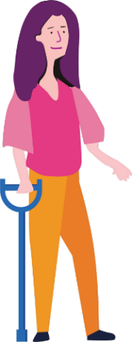

### Do you want to become a better leader? Are you someone who identifies as a woman or non-binary person with disability, aged 18-25? Are you connected with the state of Victoria?...

### Come join us for the Enabling Young Women Leadership Program!

##### You will:

##### explore who you are

##### reflect on your strengths (the things you’re good at)

##### learn more about your human rights

##### practise speaking up

* work with a mentor to achieve a leadership goal
* become a better leader in your community.

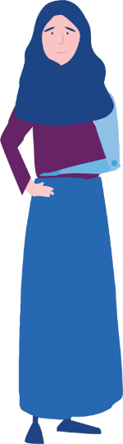

**Where:** Online via Zoom - If you need support with participating online just let us know.

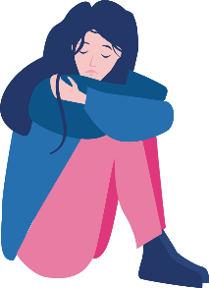**When:** The day and time will be decided when we know everyone’s availability.

**Sessions:** There will be 7 weekly 4-hour sessions. Plus, we’ll have a Graduation Celebration.

### 

### Included in the Program:

##### All materials like books, craft supplies, online resources, etc.

##### Supports if you need them

##### Food/snacks will be delivered each week



### To find out more, register for the information session or apply for the program:

### Visit our [website](https://www.wdv.org.au/our-work/our-work-with-women/enabling-women-leadership-program/) (including for various accessible application forms).

### A group of diverse young women and non-binary people with disabilitiesTo ask questions, or to get help completing the application form, please contact Bridget via email [Bridget.Jolley@wdv.org.au](mailto:Bridget.Jolley@wdv.org.au) or phone 03 9286 7813.