Experts in
Our Health

Project

Phase 1 Evaluation Report
August 2023
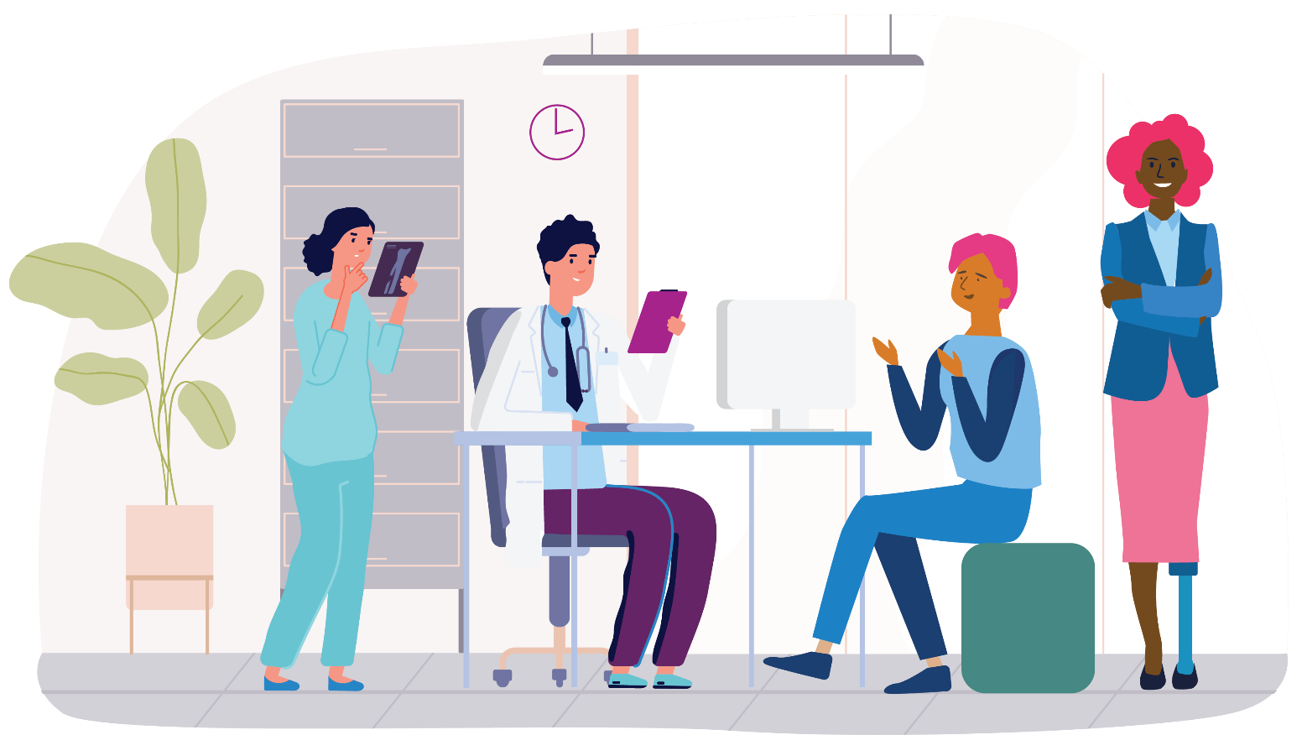

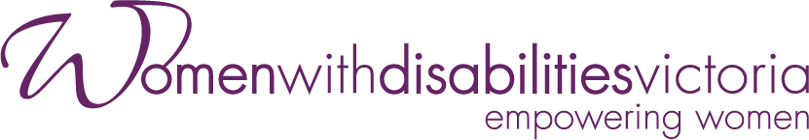

Acknowledgements
We would like to acknowledge all those who participated in the Experts in Our Health Project detailed in this report, and everyone who contributed to this report’s preparation. First and foremost, we recognise the contribution of women with disabilities, including the 12 lived experience Health Experts who co-designed resources and training. We also recognise the contribution of women with disabilities from across Victoria who attended Experts in Our Health Workshops. We value your experiences, expertise and advocacy. We acknowledge the support and participation of disability self-advocacy organisations and groups, including Women with Disabilities Victoria’s Leadership Hubs.
The project team would also like to thank health services staff who supported the Experts in Our Health workforce training and promoted the resources across the health and community services sectors. In particular, we acknowledge the support of our Women’s Health Service partners Multicultural Centre for Women’s Health, Women’s Health in the North and Women’s Health Loddon Mallee. We also acknowledge the work of our Project Advisory Group members, who have provided valuable input, guidance and expertise throughout Phase 1 of the project. At the centre of the Experts in Our Health Project are the experiences of women with disabilities. The Health Experts and workshop participants generously shared their lived expertise, and provided valuable insights and ideas about how we can make healthcare more accessible. The Experts in Our Health resources, training and evaluation report are a unique contribution to the evidence-base supporting accessible, safe and inclusive healthcare for women with disabilities.

Acknowledgement of Country
Women with Disabilities Victoria recognises the history, culture, diversity and value of all Aboriginal and Torres Strait Islander peoples, and acknowledges their Elders past, present, and emerging. WDV acknowledges that sovereignty has never been ceded, and supports reconciliation, justice and the recognition of the ongoing living culture of all Aboriginal and Torres Strait Islander peoples.

Acknowledgement of Funders
Women with Disabilities Victoria acknowledges the support of the Australian Government Department of Social Services.

Suggested Citation
Women with Disabilities Victoria (2023) Experts in Our Health Project Phase 1 Evaluation Report. Women with Disabilities Victoria: Melbourne
Contents

Executive Summary 5
1. Background and Context 13
1.1 Women with Disabilities and Access to Health Services 13
1.2 Covid-19, Women with Disabilities and Health Access 14
1.3 Policy Context 15
2. The Experts in Our Health Project 16
2.1 Overview of the Project 16
2.2 Health Experts Learning and Co-Design Program 17
2.3 Experts in Our Health Workshops for Women with Disabilities 18
2.4 Experts in Our Health Training for Health Workforces 19
2.5 Leadership and Women with Disabilities 21
2.6 The Experts in Our Health Resources 22
2.7 Experts in Our Health Video 25
3. Evaluation Approach 27
3.1 Evaluation Outcomes 27
3.2 Evaluation Purpose and Audience 28
3.3 Evaluation Questions 28
3.4 Evaluation Methods 28
3.5 Participants 30
3.6 Data Collection and Analysis 30
3.7 Limitations 31
4. Evaluation Findings 32
4.1 The Health Experts Learning and Co-Design Program 32
4.2 Experts in Our Health Workshops for Women with Disabilities 35
4.3 Experts in Our Health Training for Workforces 38
4.4 Partnerships and Collaboration 40
4.5 Women with Disabilities and Leadership 42
5. Discussion 44
5.1 Project Achievements, Quality and Value to Stakeholders 45
5.2 Project Sustainability 47
6. Recommendations 48
References 50
Appendices 52

Abbreviations and Acronyms
CRPD United Nations Convention on the Rights of Persons with Disabilities
CI & WEP Community Inclusion and Women’s Empowerment
MCWH Multicultural Centre for Women’s Health
NDIS National Disability Insurance Scheme
PAG Project Advisory Group
WHIN Women’s Health in the North
WHLM Women’s Health Loddon Mallee
WDV Women with Disabilities Victoria

Glossary
Ableism – Discrimination toward and prejudice against people with disabilities.
Empowerment – Enhances the self-determination and active participation of women with disabilities by offering useful and accessible information, removing barriers to engagement and promoting and celebrating women’s capacities and inner strengths.
Disability – Persons with disabilities include those who have long-term physical, mental, intellectual or sensory impairments which in interaction with various barriers may hinder their full and effective participation in society on an equal basis with others (United Nations, 2006).
Health Service – A health service helps an individual or group assess, maintain, improve or manage their physical or psychological health.
Intersectionality – is an approach that analyses social inequality and the ways a person’s race, gender, sexuality, age or disability intersect and can contribute to discrimination and oppression. Intersectionality asks us to see that sexism and ableism always intersect and interact with other forms of oppression.

Executive Summary
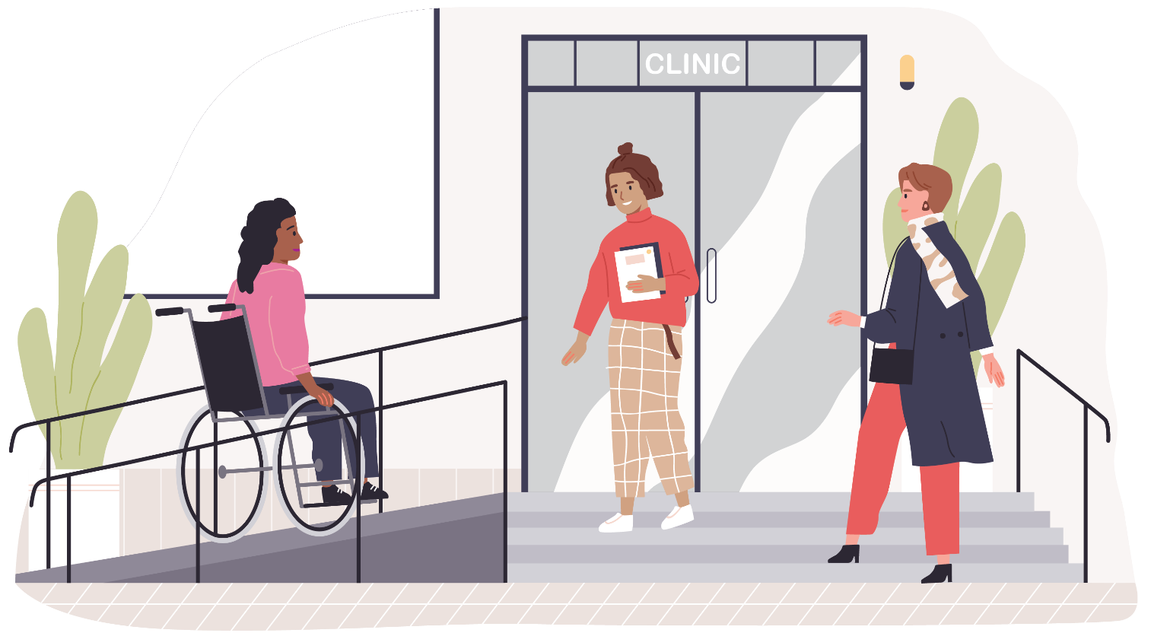

The Experts in Our Health Project
The barriers to accessing healthcare for women with disabilities in Victoria are many. The United Nations Convention on the Rights of Persons with Disabilities states that all people have a right to equal and timely access to healthcare (United Nations, 2006). Yet women with disabilities in Victoria describe continually having to advocate for access to the services they need. Women with disabilities tell us they are still regularly unable to access care from health services that are physically inaccessible. They describe having to repeatedly request health information in accessible formats. Women with disabilities have told us they have had to advocate for inclusion in women’s health initiatives such as screening programs and for equal access to community-based health resources including gyms. Women with disabilities describe often feeling unsafe and disrespected in healthcare settings, with lack of disability knowledge amongst healthcare staff being a significant barrier to access. Challenging inappropriate assumptions is an experience women with disabilities tell us they repeat over and over in health settings. Women with disabilities need knowledge about their health rights, and support to navigate and advocate for themselves when using health services. Healthcare providers need to make access, inclusion and safety a priority and take action to ensure their services are accessible for women with disabilities. The voices and experiences of women with disabilities need to be at the centre of resource development and organisational change, and the Experts in Our Health Project provides a guide for how this can be achieved.
In 2010 Women with Disabilities Victoria commissioned a report into health access for their members and other women with disabilities across the state (Petrony et al., 2010). The report aimed to identify barriers to health access and featured lived-experience stories and case studies. The report described barriers across many different services including hospitals, Primary Health, Community Health, Allied Health, and screening programs. The Experts in Our Health Project aims to increase access to health services by building the capacity of women with disabilities, workforces and organisations. Resources including the Experts in Our Health Guide and Video have been produced, and workshops for women with disabilities have been held in different regions of Victoria. The resources and workshops support women with disabilities to learn about their health rights, navigate health systems and advocate for themselves. Health professionals and staff are supported to make services accessible through workforce training sessions and resources including the Factsheets.
The centre of the program is the Health Experts group, who are a diverse group of women with lived experience of disability. The Experts in Our Health resources, workshops and training all centre lived expertise and each have been co-designed by the group. A best-practice, end-to-end co-design process has been used so that the resources and training sessions truly reflect the experiences and values of women with disabilities. A co-facilitation model was used in the delivery of training, allowing the Health Experts to purposefully describe their own experiences when speaking to communities of women with disabilities and health workforces. Each Health Experts group member played a role in the production and promotion of the resources, from appearing in the Video to consulting on social media strategy. In centring the expertise of women with disabilities across all activities, the project provides an example to organisations in how to support and promote the leadership of women with disabilities.
The COVID-19 pandemic and subsequent social distancing measures in place throughout 2021 and 2022 have influenced the scope and implementation of the Experts in Our Health Project. The Covid-19 pandemic and measures including prolonged lockdowns have had a profound effect on the lives and work of project participants and staff. Members of the Health Experts group, workshop attendees and health services staff have described experiencing additional barriers to accessing or providing healthcare due to Covid-19 restrictions. Many women with disabilities reported that the pandemic had adversely affected their health and wellbeing. All project activities have been impacted by the pandemic and modified, with most activities occurring online or being delayed to minimise risk to participants’ health.

The project’s activities during the first phase of implementation:
The recruitment of 12 women with diverse lived experience of disability to make up the Health Experts co-design group.
The delivery of a professional learning and development program to Health Experts group members, building knowledge and skills in Human Rights, advocacy, communication, and co-design.
Completion of a best-practice co-design process which produced the Experts in Our Health resources for women with disabilities and health workforces including the Guide, Factsheets, Posters and Video.
Co-design and co-facilitation of training sessions including workshops for women with disabilities and training sessions for health and community services workforces.
Presentations and online events promoting the Experts in Our Health resources, raising awareness about barriers to health access faced by women with disabilities.
Engaging in consultations with WDV staff on projects related to Women’s Health and supporting employment of women with disabilities.
Communication to stakeholders including social media campaigns designed to raise awareness of barriers to health access and promote the resources.
Collaboration with project partners and other organisations across Victoria, in order to provide workshops and training to women with disabilities and networks of health professionals.
Evaluation of the effectiveness of resources and training through surveys, focus groups, interviews and review of notes and documents, with the quality of processes, activities and cross-sector collaboration being measured.

About the Evaluation
This report evaluates Phase 1 of the implementation of the Experts in Our Health Project in Victoria and provides recommendations for further work towards making health services accessible, safe and inclusive for women with disabilities. The evaluation was informed by participatory and inclusive approaches.
The evaluators utilised a Project Activity Work Plan, which was developed by the Program Manager in collaboration with WDV management and staff, and approved by the project’s funders. The Project team, including the Health Coordinator, Resource Development Officer, and Project Officer, implemented the project activities and collected data using accessible tools. These consisted of surveys, meeting notes, focus groups, interviews and the review of documents including email correspondence and the Experts in Our Health Resources. The Health Experts Project Evaluation Framework describes 6 objectives, each with indicators of success. The project objectives described in the evaluation framework consist of project governance, individual capacity building for women with disabilities, health sector and stakeholder capacity building, resource development, organisational capacity building and evaluation.

Indicators of Success
As described in the Experts in Our Health Project Evaluation Framework, the indicators of success are:
An increase in cross-sector collaboration and valuing of lived-experience.
An increase in knowledge and awareness amongst women with disabilities about human rights and health.
An increase in the confidence and skills of women with disabilities to take control of their own health decisions, self-advocate and navigate the health service system.
An increase in knowledge and skills amongst women with disabilities in co-design of resources, training, and delivery.
Improved knowledge of accessible health service provision amongst health stakeholders.
Increased skills, knowledge, confidence, and capacity of women with disabilities to engage in leadership on boards and committees.
An increase in intent of women with disabilities to represent their communities by participating in boards and committees.
The identification of opportunities to continue to promote accessible and inclusive health service provision.

Synopsis of the Key Findings
Women with disabilities participated in and engaged with the Experts in Our Health Project in multiple ways. 12 women with disabilities were employed as lived-experience Health Experts. 135 women with disabilities attended Experts in Our Health workshops and 33 participants completed a workshop feedback survey. 17 organisations hosted Experts in Our Health Workforce training, and 77 participants completed the training feedback survey. The Experts in Our Health resources were disseminated to 1100 workforce contacts in the disability, health, family violence and university sectors as well as government agencies.

Across the six project objectives evaluated, key findings were:
The Experts in Our Health Project has reproduced and extended the successful Experts by Experience model piloted by WDV through the Gender and Disability Program. The members of the lived-experience Health Experts group have developed as effective advocates and leaders during the course of the project. Through participating in a learning program, co-design process, and co-facilitation of training, the team have developed into confident advocates who can articulate clearly about rights-based values, principles and practices. Their expertise is now based in both professional knowledge and lived experience, which they use skilfully and purposefully to build the capacity of women with disabilities and health workforces.
The Health Experts learning and co-design program and the workshops for women with disabilities were primarily conducted online due to Covid-19 restrictions being in place during much of Phase 1 of the project. The Health Experts and workshop participants reported that they felt safe and supported in online spaces. The success of online learning shows online environments can be safe and accessible for diverse communities and can support challenging discussion. The project has also demonstrated that genuine co-design practice, inclusive of diverse points of view, can be successfully achieved in an online environment when supports are in place.
The Experts in Our Health Project has collaborated with a number of disability self-advocacy organisations and groups. The Health Experts as co-facilitators have received excellent feedback on workshops both online and in-person. This demonstrates that women with disabilities want to speak up about barriers to health access. Women with disabilities who have attended the workshops have said that talking with peers made them feel confident and supported. They said this support would help them advocate for themselves in healthcare settings in the future. Women with disabilities said they valued resources that provide information and ways to access support, and that they needed assistance finding their way around health systems.
The Project centred lived expertise in the development of it’s workforce training sessions, and feedback from health and community services staff indicated that this was a key strength of the project. Training sessions were attended by a diverse mix of health service leaders, health practitioners and administrative staff. Attendees valued having the time and space to speak about access and inclusion. In particular, members of the health workforce found that hearing lived experience perspectives helped them to understand that listening to women with disabilities and valuing their voices was key to supporting access.
The Project produced a package of high-quality resources designed for both women with disabilities and health workforces. The resources include a video featuring the Health Experts, as well as a Guide, Factsheets and posters. The resources have been produced in multiple accessible versions including Plain Language, Easy English, Braille including BRF (Grade 1 and Grade 2) and audio (Mp3), as well as in multiple community languages. The resources have been integrated into the training and workshop sessions and have been adapted for social media campaigns including 16 Days of Activism. The versatility and accessibility of many of the resources have allowed them to be used across WDV programs and events.
Throughout the life of the project, the team have been supported by collaborative partners and members of the Project Advisory Group. The allyship and expertise offered through the PAG was invaluable as it helped project staff produce accessible resources and tailor training to the needs of clinical staff. These cross-sector collaborations also enabled health services to build awareness of access and inclusion as an issue amongst their staff. As a result of participating in the PAG, members said they were able to reflect on the accessibility of their organisation's resources and services. PAG members said they actively advocated for the recruitment of women with disabilities to advisory roles with health services.
Experts reported their voices were heard and their contribution was recognised in the co-design sessions. They can see this demonstrated in the development of the resources, highlighting the key messages the Health Experts feel strongly about communicating to their peers as well as healthcare workforces.
The Health Experts reported also feeling a sense of pride and ownership of the resources, workshops and training content thus giving them the confidence to speak about the resources, workshops and training to external parties.
PAG members also provided input into the design of the resources as well as the design and delivery of the training for workforces. From their feedback, we can see they too feel a sense of pride when promoting our program.
Workforces from health, government, disability and social services sectors in attendance at the WDV 'Our Voice, Our Future’ Co-Design Symposium demonstrated through feedback they are keen to learn more about co-design and how to make their services more accessible and gender inclusive for women with disabilities. The event aimed to support organisations to incorporate lived expertise into their work. The symposium highlighted the importance of amplifying the voices of women with disabilities through collaboration.

Discussion
This final evaluation of the Experts in Our Health Project has highlighted the expertise and resilience of women with disabilities, and in particular the Health Experts group members. The team used their lived and professional experience to design and deliver an innovative package of resources that placed the expertise of women with disabilities at the centre. The learning and co-design process was conducted in a challenging Covid environment, with illness and natural disaster also impacting the work of the team. The findings in the report show that WDV is a respected organisation and has a key role in amplifying the voices of women with disabilities as well as advocating for inclusive and accessible service provision. The Experts in Our Health workshops and training were made possible with the cooperation of self-advocacy groups and health services across Victoria. The project has benefited from collaborative relationships with Women’s Health Services and other stakeholders. In turn, the project team have played a significant role in educating health and community services organisations about the intersection of gender and disability discrimination and the impact on health access for women with disabilities.
The Experts by Experience model, whereby lived-experience Experts are employed to engage in consultation and co-design activities, is a way WDV ensures that lived expertise informs the work of the organisation. The centring of the voices of women with disabilities through best-practice co-design was a key part of the Experts in Our Health Project. Involving diverse women with disabilities from the beginning of the project and taking time to develop and review resources and training with the group, resulted in the production of high-quality resources. The Health Experts learning and development program took into account the needs of the project and the strengths and aspirations of group members. This approach ensured that the project developed and promoted community and individual leadership. Members of the Health Experts group have taken on leadership roles within and outside the organisation during the life of the project, including community and consumer advisory roles with local councils, regional health services, universities and major metropolitan hospitals.
Women with disabilities who participated in Experts in Our Health workshops created spaces where they could discuss their own experiences and be empowered to take action. Workshop participants listened to peers talk about advocating for access and reported that it helped them feel confident. Health services staff, including hospital staff, also reported that having presenters with lived expertise was valuable. The training assisted them to work in accessible ways and increased their knowledge of the barriers faced by women with disabilities. There is wide-spread interest in accessible and inclusive service provision and co-design processes amongst health providers. This report seeks to highlight the benefits of continued engagement with service providers, as feedback consistently indicates that the Experts in Our Health Project has assisted organisations to understand and meet the needs of women with disabilities. This report recommends that training of health workforces continue, with a focus on pre-service and graduate learning programs, as well as ongoing learning for health service leaders in a community of practice setting.
Ensuring that the Experts in Our Health resources are known and available to women with disabilities should be a priority in Phase 2 of the project. It is important to increase knowledge about health rights and advocacy amongst women with disabilities through awareness-raising activities and the dissemination of the resources to all women with disabilities across Victoria.
Women with disabilities who attended Experts in Our Health workshops spoke about the challenges faced by those who experience multiple forms of marginalisation. Indigenous women with disabilities, migrant women and women living in rural Victoria all described significant additional barriers to health access. Women with disabilities in every Victorian community want to feel safe and respected in healthcare settings and be able to access all the services they need in an equal and timely way. The report notes that the project has established and extended WDV's relationships with self-advocacy organisations and recommends that the project continue outreach and collaboration in order to support those facing the most barriers to healthcare.

Recommendations
A total of 8 recommendations have been put forward in order to continue to support access to health services for women with disabilities. The recommendations were developed by the project team in consultation with the Health Services Program Manager. These recommendations should inform decision-making about future actions aimed at increasing health access for women with disabilities.
The following recommendations have been made by the Experts in Our Health Project team based on the evaluation findings and conclusions.

Recommendation 1
Health access for women with disabilities from diverse communities across Victoria should be supported with appropriate co-designed resources. Indigenous women, LGBTIQA+ people, rural women and women from culturally and linguistically diverse backgrounds should have access to relevant health information in a range of accessible formats.

Recommendation 2
Health Service Providers, including Victoria’s Women’s Health Services, should create partnerships, collaborate and engage in meaningful ongoing ways with disability self-advocacy organisations in order to promote and embed practices that increase health access for women with disabilities.

Recommendation 3
Health service providers, including Victoria’s Women’s Health Services should engage women with disabilities in meaningful co-design processes and develop resources that empower women with disabilities to make informed decisions about their healthcare, promoting respect, dignity, choice and control.

Recommendation 4
Women with disabilities should have access to peer learning and support programs such as Communities of Practice that are co-designed and facilitated by lived-experience advocates.

Recommendation 5
Health service providers, including Victoria’s Women’s Health Services, should identify access for women with disabilities as a priority in strategic planning and resource initiatives that increase access including co-design programs.

Recommendation 6
Higher education providers should collaborate with disability self-advocacy organisations in order to embed lived experience perspectives into the education of health and community services professionals.

Recommendation 7
Health service providers, including Victoria’s Women’s Health Services, should aim to increase the participation and employment of women with disabilities in the design and delivery of services. They should collaborate with disability self-advocacy organisations to create inclusive co-design processes and accessible workplaces.

Recommendation 8
Health workforces, including health services staff in leadership roles, should engage in ongoing professional learning such as Communities of Practice that focus on disability access and centre lived experience.

Background and Context
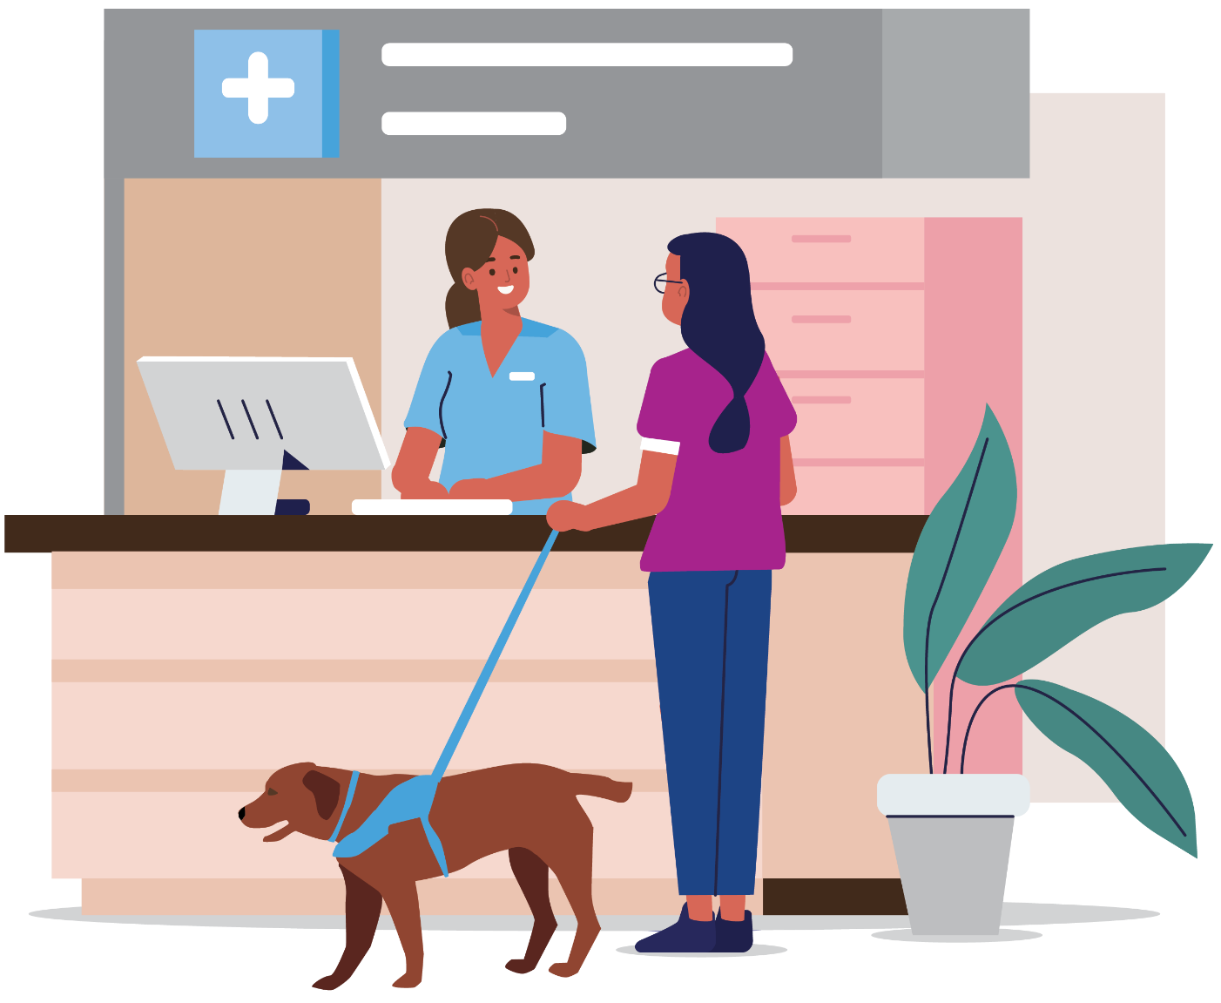

Women with Disabilities and Access to Health Services
In the area of health and wellbeing, significant disparities exist between disabled and non-disabled people in Australia (Australian Institute of Health and Welfare [AIHW], 2022). Much of the health inequality experienced by people with disabilities may be attributed to barriers to access and participation experienced by the disability community (Aitken et al., 2022). The right of people with disabilities to equal healthcare is described in Section 25 of the Convention on the Rights of Persons with Disabilities (United Nations, 2006) and is reiterated in the Australian Charter of Healthcare Rights (Australian Commission on Safety and Quality in Healthcare, 2019). However, only 24% of people with disabilities in Australia describe their health as very good, compared with 65% of Australians without disability (AIHW, 2022). For women with disabilities, ableism and gender discrimination intersect, so that women with disabilities experience multiple forms of disadvantage at the same time (Women with Disabilities Victoria, 2022). Women with disabilities may also identify with other different marginalised communities including LGBTIQ+, Culturally and Linguistically Diverse and Indigenous communities. Intersectional disadvantage needs to be address in order for health rights to be upheld (Petrony et al., 2010).
Women with disabilities experience higher levels of socio-economic disadvantage than other groups in the community (Petrony et al., 2010). The cost of medical treatment is a barrier to access for a significant number of women with disabilities (Brophy, 2018). Rural women often experience a scarcity of specialist services, and inaccessible transport is a significant barrier to care (Brophy, 2018). Lack of disability knowledge amongst service providers and inaccessible health information are commonly experienced barriers to health access (Petrony et al., 2010). When interacting with health professionals, women with disabilities are often faced with inappropriate assumptions and the need to advocate to have health concerns investigated (Brophy, 2018). Accessible health services are ones that are low-cost or free, physically accessible, and have knowledgeable staff who take a holistic view of the health of women with disabilities (Petrony et al., 2010). Health information that is readily available and accessible for women with disabilities is one of the keys to achieving quality care and outcomes for this group of Australians (Brophy, 2018).

Covid-19, Women with Disabilities and Health Access
The Covid-19 pandemic disrupted access to services and support for people with disabilities in Australia, profoundly impacting the health, safety and wellbeing of members of the disability community (People with Disabilities Australia [PWDA], 2022). Lack of service availability and concerns for safety meant that many women with disabilities had reduced support during the pandemic (PWDA, 2022).
Social distancing measures also meant that the support available to people with disabilities when accessing health services was sometimes restricted (Kavanagh et al., 2021). Covid-19 was a health emergency, but also caused social and economic hardship for people with disabilities who disproportionately experienced financial hardship and housing insecurity (PWDA, 2022). The Covid-19 pandemic exposed and exacerbated existing barriers to health access for women with disabilities (Kavanagh et al., 2021).
The Covid-19 pandemic disproportionately impacted the mental health and wellbeing of women generally, with many women managing additional unpaid household labour, caring responsibilities and/or work during this time (Gender Equity Victoria, 2022). However in some ways, the Covid-19 pandemic may have improved health access and community and economic participation for women with disabilities. As remote work and education options became more widely available, access to these services for women with disabilities increased as it became easier to balance the demands of travel, caring responsibilities and work (PWDA, 2022). The introduction of broadly accessible telehealth made it easier for women with disabilities to access primary specialist healthcare, which resulted in better health outcomes for women with disabilities (PWDA, 2022). Ongoing access to telehealth, along with the extension of pandemic programs designed with and tailored to the needs of people with disabilities, have the potential to increase access to health services for women with disabilities in the longer-term (Kavanagh et al., 2021).

Policy Context
The Experts in Our Health Project is very timely in the current policy context. Co-design of services, programs, resources, and policies is now firmly embedded as policy in order to promote the Human Rights of people with disabilities and ensure ‘nothing about us, without us’ (State of Victoria, 2022). For women with disabilities in particular, meaningful engagement has the potential to reduce ablism and gender discrimination that underlies marginalisation.
The Experts in Our Health Project activities and outcomes are aligned with policy documents and frameworks at the national and state level. Many of these documents now recognise women with disabilities as a priority group and identify barriers to service access as a key issue to be addressed. Supporting policy documents include Inclusive Victoria: State Disability Plan (2022-2026), which promotes inclusion of people with disability through embedding of co-design practice and supports disability leadership on boards and committees (State of Victoria, 2022).
The project is also consistent with Safe and Strong: A Victorian Gender Equality Strategy, as the Health Experts challenge stereotypes and promote respect and safety for women with disabilities (State of Victoria, 2016). The Victorian Public Health and Wellbeing Plan 2019-2023 encourages an intersectional approach to health promotion and identifies discrimination as a risk to the health of Victorians with disabilities (State of Victoria, 2019). Australia’s national disability framework, Australia’s Disability Strategy 2021-2031, supports the outcomes of the Experts in Our Health Project with its emphasis on creating and supporting employment of people with disabilities and improving health outcomes through increasing access to quality care (Department of Social Services [DSS], 2021). As the recommendations of the Royal Commission into Victoria’s Mental Health System are implemented, the Experts in Our Health Project is a resource for health service providers supporting members of the lived-experience workforce.
The implementation of co-design and consumer engagement activities feature as a priority in many framework documents including Australia’s Disability Strategy 2021-2031 (DSS, 2021). Co-design is a way to bring together service providers and consumers in order to improve understanding, service design and delivery (Agency for Clinical Innovation [ACI], 2019). Co-design and consumer advisory programs fit into a spectrum of participatory policy and practice which ranges from information-giving to consumer leadership (ACI, 2019). Co-design means that service-users are involved in the design process from the beginning and have time to share their experiences and collaborate with organisations (ACI, 2019). Co-design is a process intended to make service-users equal partners in the development of products, resources and services (ACI, 2019). When co-design is done well, it can be a process that not only produces quality services and resources, but also enables change in the ways service providers and communities relate to each other (McKercher, 2020).

The Experts in Our Health Project
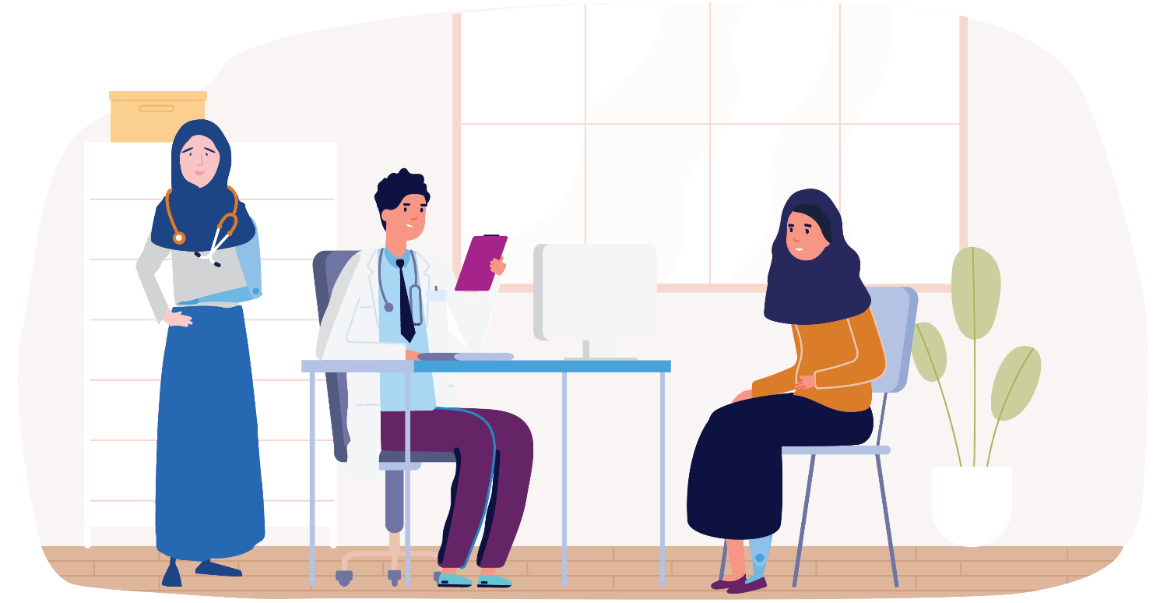

Overview of the Project
The Experts in Our Health Project promotes the empowerment of women with disabilities through self-advocacy and urges organisations to drive lived experience perspectives and accessible practices. In developing the Experts in Our Health resources, WDV recognised the expertise of women with disabilities and aimed to place this expertise at the centre of the design and content of the resource package. The resources were co-designed by a group of women with diverse backgrounds and experiences, and they aim to communicate six key messages. The resources say that:
women with disabilities are experts in their own health.
women with disabilities should be listened to
accessibility is everyone’s business.
women with disabilities should be partners in decision-making.
- the voices of women with disabilities should be valued.
In order to remove barriers to women’s engagement with the project, the resources were created in multiple accessible formats. Creating safe and accessible spaces, both in person and online, has also been a priority for the project team. The project aims to equip service providers in the health and community services sectors with the knowledge to make health services accessible. Workforce training and professional resources focus on rights-based practice that involves women with disabilities in decision-making and respects lived-experience as expertise.
The Experts in Our Health resources can be found on the Women with Disabilities Victoria website: https://www.wdv.org.au/our-work/our-work-with-organisations/experts-in-our-health/
Overall, given the Covid-19 environment in which the project and evaluation were conducted, there was a good level of engagement from both women with disabilities and local health service providers across Victoria. 135 women with disabilities participated in online and in-person workshops, 17 organisations hosted online or in-person events, 33 workshop participants responded to the workshop survey and 77 participants responded to the workforce training survey. This section describes the Experts in Our Health Project activities and achievements.

Health Experts Learning and Co-Design Program
The Health Experts learning and co-design program utilises the unique Experts by Experience model pioneered by WDV and the Prevention of Violence Against Women (PVAW) sector in Victoria. The model had been developed and refined as a way to incorporate diverse lived experiences into the work of organisations in the PVAW sector and support intersectional practice. The Health Experts are a group of women with lived experience of disability employed on a casual or part-time basis. The group has been engaged to co-design resources and training, offer internal consultation and facilitate sessions and events. Professional development covering health promotion principles, professional skills and leadership training is offered as part of the program. List 1 describes both knowledge and skills-based learning activities offered by the program. Having been introduced by WDV as a PVAW sector development initiative, the Experts by Experience model has now been successfully implemented to transform the health sector and has produced confident and skilled health advocates.

List 1: Health Experts Learning and Development Opportunities 2021-2022

Knowledge-based Learning
Human Rights, Disability and Health
Public Health Messaging
Intersectionality and Social Determinants of Health
The Co-Design Process
Facilitating with Professional Groups
Facilitating with Diverse Groups
Disability Leadership
Joining Boards and Committees
Engaging in Consumer Advisory Processes
Engaging in Disability Advocacy
Storytelling Masterclass with Women’s Health Victoria
Disability, Human Rights and the Law in Australia
Engaging in Media Advocacy

Skills-based Learning
Co-design of workshops, training and resources.
Planning and co-facilitation of workshops, training sessions and presentations.
Co-design of communications plan and materials.
Co-production of promotional materials including social media posts and newsletter articles.

Experts in Our Health Workshops for Women with Disabilities
The effects of the Covid-19 pandemic had significant impact on the way the Experts in Our Health project was implemented. The Project Staff and Health Experts adjusted to the uncertain environment and designed workshops for both in-person and online delivery. Designing of online workshops for diverse groups of women with disabilities required a focus on access and participant safety. Significant time and knowledge were put into developing safety plans and processes. This included identifying accessible and trauma-informed ways of communicating in an online environment and using digital means of providing support and referral for participants. The workshop was piloted in collaboration with the WDV Leadership Hub program in August 2021. The sessions included discussion about barriers to health access, navigating health systems, the health rights of women with disabilities and individual and systemic advocacy.
The reach of the Experts in Our Health workshop program is summarised in List 2. The project team facilitated 10 online Experts in Our Health workshops and presentations, and 3 in-person events in 2021 and 2022. Feedback from women with disabilities who attended the workshops overwhelmingly indicated that participants felt safe discussing health access online, and that they found the facilitation and environment supportive. Most of the workshops were supported by Women’s Health services or self-advocacy organisations, and participants often knew each other through regular meetings and events. A list of workshops has been compiled and includes the names of organisations who contributed to the planning, support and coordination of the sessions. The project team was able to reach women with disabilities through WDV networks and membership as well, offering online presentations with the support of WDV’s Communications and Operations teams.

List 2: Experts in Our Health Workshops and Events 2021-2022

Experts in Our Health Workshops
Barwon Workshop (Pilot) – 27 August 2021 (Online)
GenWest Sunrise Program – 8 November 2021 (Online)
Margins to the Mainstream, Women’s Health East (M2M) – 3 February 2022 (Online)
Murdoch Children’s Research Institute (MCRI) CP-Achieve – 16 February 2022 (Online)
Calendar Workshop – 31 March 2022 (Online)
Cobram Workshop – 17 May 2022 (In-person)
Reinforce Workshop – 25 May 2022 (In-person)
Blind Citizens Australia – 2 August 2022 (Online)
WDV Quarterly Conversations Member Event – 12 September 2022 (Online)
WDV Staff Presentation – 13 September 2022 (Online)
WDV Outer East Hub – 20 September 2021 (Online)
Bendigo - 19 October 2022 (Online)
Outer East Hub – 14 November 2022 (In-person)

Experts in Our Health Training for Health Workforces
Supporting health service providers to improve the accessibility of health services was a key aim of the Experts in Our Health Project. The success of the project’s workforce training program was due to the fact that it was co-designed and co-facilitated by women with lived expertise. The Health Experts group were involved in the development of the training from the beginning and constructed the key messages around which the training was built. A train-the-trainer co-facilitation model provided scaffolded opportunities for the Health Experts to develop facilitation skills and confidence. Each Health Expert was involved in tailoring the training for different health sector audiences. The Health Experts engaged in research and planned examples and case studies for each session. Importantly, the co-facilitation model placed women with disabilities in visible leadership roles and served to challenge stereotypes and biases.
The co-facilitation model supports organisational change in that it foregrounds women with disabilities as experts and leaders within the health sector.
The Experts in Our Health project team, including members of the Health Experts group, facilitated at least 1 Experts in Our Health workforce training session during Phase 1 of the project. List 3 describes the workforce training activities that were undertaken and has been created to measure the reach of the project within the health and community services sectors. In addition to presenting at the request of health service providers, the team presented to multi-disciplinary regional networks of professionals. The Health Experts team also planned and presented a session at WDV’s Our Voice, Our Future Co-Design Symposium. The team promoted the resources and described best-practice co-design based on their experiences. The project worked closely with Women’s Health Service partners, presenting as part of Women’s Health Loddon Mallee’s CARE Conversations series and also to GenVic’s Sexual and Reproductive Health Community of Practice members.

List 3: Workforce Development training sessions and events

Experts in Our Health Workforce Training
Alfred Health – 9 November 2021
Grampians Pyrenees PCP – 17 February 2022
Cancer Council Victoria – 22 February 2022
South Coast Service Providers Network – 3 March 2022
Murdoch Children’s Research Institute (MCRI) CP Achieve Project – 9 March 2022
Royal Women’s Hospital – 9 May 2022, 26 May 2022, 31 May 2022
Star Health – 19 May 2022
Women’s Health Grampians CoRE Partnership – 7 June 2022
Western Health Disability Liaison Team – 29 June 2022
Deakin University Workshop – 22 July 2022
Eastern Health Disability Liaison Team – 4 August 2022
Eastern Health Women’s Health Week – 7 September 2022
Women’s Health Loddon Mallee Care Network – 8 September 2022
Deakin University School of Psychology Seminar – 20 September 2022
GenVic Sexual and Reproductive Health CoP – 21 September 2022

Leadership and Women with Disabilities
A key objective and outcome of the Health Experts program was increasing leadership and influencing opportunities for women with disabilities. During the implementation of the project, members of the Health Experts group reported pursuing opportunities for employment, advocacy and leadership. These often took the form of consumer advisory roles, however a range of opportunities were pursued and taken by members of the group. These included opportunities to sit on public discussion panels and host podcasts promoting Women’s Health. Project staff regularly contacted members of the group with opportunities for professional development, and many of the Health Experts undertook learning on their own initiative. A list of paid and voluntary employment, learning, leadership and advocacy opportunities pursued by the Health Experts is provided in List 4.

List 4: Health Experts Leadership, Employment and Advocacy Opportunities

Paid Employment outside the Health Experts Group
Early Childhood Group Facilitator with a disability advocacy organisation
Engagement Coordinator at health sector peak body
Support Group Facilitator with Community Health organisation
Regional Carers Network Coordinator
Focus Group Facilitator for academic research project
Employment with National Disability Insurance Agency

Advocacy or leadership undertaken by the Health Experts
Local Council Disability Action Committee membership
Public Hospital Consumer Advisory Committee Member
Private Hospital Consumer Advisory Committee Member
Consumer representative on public panel discussion
Rural Health Service Consumer Advisory Committee Member
Podcast host for an episode of WDV’s Covid and Mental Health Podcast
Guest on a podcast produced by an Allied Health organisation
Project Advisory Group membership for WDV’s Enabling Women Program
Medical research co-design committee member
Focus group participant for academic research project
Presentation to Health Board Essentials course participants
Interviewee for ABC Catalyst program
Community Advisory Committee Member for national screening program

The Experts in Our Health Resources
As part of this project, Women with Disabilities Victoria co-designed a series of resources with the Experts by Experience Health group and these resources demonstrate best practice in co-design. The Health Experts group applied their lived experience to the co-design and promotion of these accessible health resources to women with disabilities across Victoria. They build the capacity of service providers to be more inclusive and accessible for women with disabilities.
The content and outline of subjects covered by the resources was determined by what the Health Experts group members identified as key messages they wanted to communicate to women with disabilities and healthcare workforces. These resources have been produced in a variety of accessible formats such as Plain Language, Easy English, Community Languages (Arabic, Traditional Chinese, Simplified Chinese, and Vietnamese), Braille Hardcopy (Grade 1 and Grade 2), Braille Readable File (Grade 1 and Grade 2), Audio (Mp3), Auslan, Audio Description and Closed Captioning.
For Women with Disabilities, these resources can be used as an advocacy tool for themselves and other women with disabilities to access appropriate and safe healthcare. The resources focus on gender and disability-sensitive health empowerment, control of personal healthcare, and access to services. Standard versions of each resource, as well as resources in accessible formats and community languages can be accessed on the WDV website at the following link: https://www.wdv.org.au/our-work/our-work-with-women/experts-in-our-health/
For Healthcare Workforces these resources demonstrate how best to engage with and support women in lived experience roles within healthcare settings who often feel powerless or devalued. They also highlight what staff can do in making their healthcare services sincerely responsive, inclusive, and welcoming to women with disabilities. Standard versions of each resource, as well as resources in accessible formats and community languages can be accessed on the WDV website at the following link: https://www.wdv.org.au/our-work/our-work-with-organisations/experts-in-our-health/

Factsheets
The first in this series of the Experts in Our Health co-designed resources are factsheets designed for everyone working in healthcare services including administrative staff, clinical and allied health professionals.
These factsheets are designed to increase awareness of challenges faced by women with disabilities receiving healthcare, and support healthcare staff to understand their roles and responsibilities in creating an accessible, safe, and welcoming healthcare environment for all. They are available on wdv.org.au – click on the image of the factsheet below to download.

Factsheet 1: Creating Accessible and Safe Healthcare Settings for Women with Disabilities
Factsheet 2: Your Role in Upholding the Rights of Women with Disabilities
Factsheet 3: Take an Active Approach to Understanding Gender, Health, and Disability
Factsheet 4: Your Roles and Responsibilities in Providing an Accessible and Inclusive Service
Factsheet 5: Working in Healthcare as a Woman with Disability

Factsheet 5 is designed for women with disabilities working in any role within healthcare services, including service provision, administration, management, governance and other paid or voluntary roles. The factsheet demonstrates the value of employing women with disabilities within the healthcare sector, what actions employers can take to be more inclusive, barriers women with disabilities may face in the workplace and tips for navigating the healthcare system as an employee who is a woman with a disability.

We Are Experts in Our Health Poster
This informative poster highlights five key actions for healthcare services to embed into their practice to demonstrate their commitment to providing equal, accessible and inclusive health services to women with disabilities. These five key actions have since been adopted by the Health Experts group as the core values which underpin the work of this project. The We are Experts in Our Health Poster can be found here 6-WDV-Experts-in-our-Health-A3-Poster-PRINT.pdf.
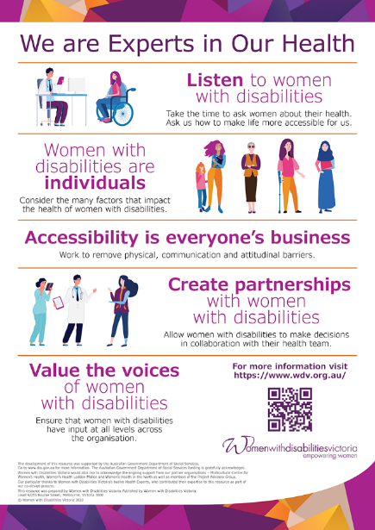

Inclusive Co-design in Practice Poster
This informative poster demonstrates the seven ways Women with Disabilities Victoria supports accessible and inclusive co-design of resources, services and programs. The Inclusive Co-Design in Practice Poster can be found here: Inclusive Co-Design in Practice.
As part of the social media campaign seven media tiles and postcards were also produced each highlighting one example from the poster. These were released via WDV’s social media channels one at a time over a three-week period. The Inclusive Co-Design in Practice postcard set can be found here WDV-ICD-A6-Postcards-PRINT.pdf.
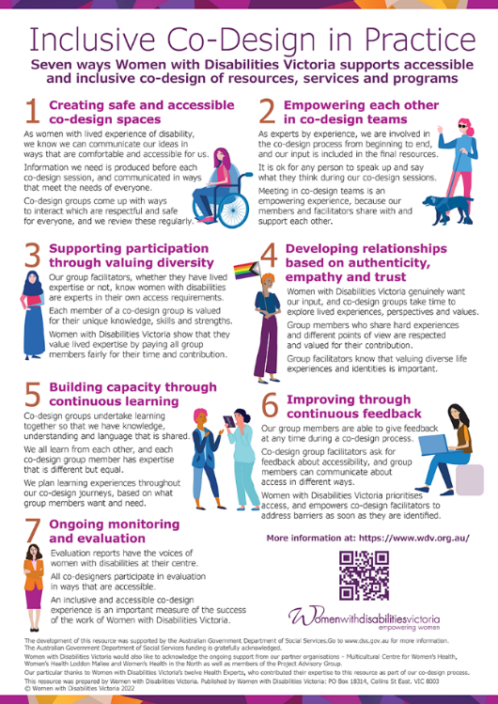

Experts in Our Health Guide
This Guide has been developed by and for women with disabilities to support our informed health choices. The information is included in the Guide under the chapters; Women with Disabilities and Health, Our Right to Health, Advocating for Our Health, Finding Your Way Around Health Systems and Places to Get Help. The Guide shows women with disabilities how they can navigate health systems and advocate for themselves and others in achieving optimal health. The Guide can be accessed here: Experts in Our Health Guide.
The format for the Easy English version was divided into five sections to reduce reader fatigue and to only include relevant information needed by the reader, which meant the Introduction, Acknowledgments, and Table of Contents were left out. The Audio (mp3) format of the Guide was also divided up into chapters to aid navigation within the text.

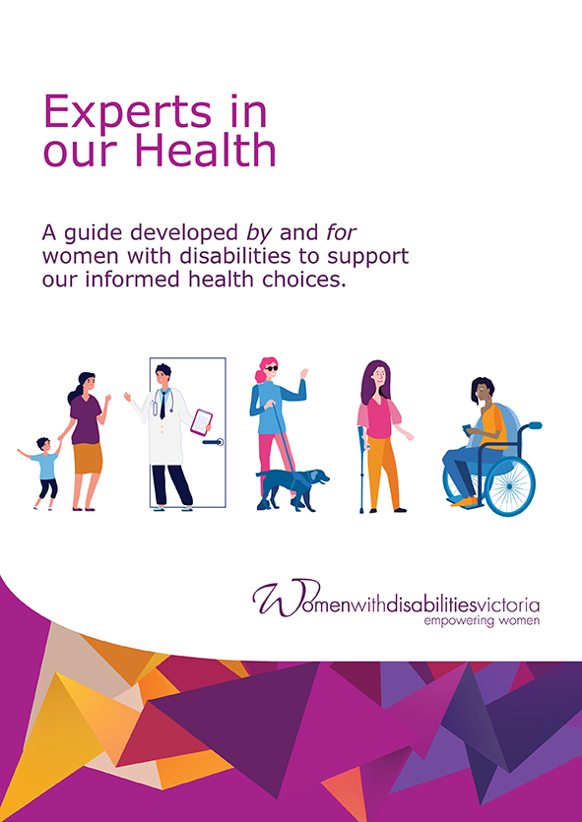

Experts in Our Health Video
The Experts in Our Health video is an informative video based on the Experts in Our Health Guide, co-designed and produced by the Experts in Our Health Project team. The essence of this video demonstrates best practice in co-design and how to do co-design well in healthcare settings.
The full-length version of the video can be found here: https://www.youtube.com/watch?v=8k91o7MKTp0&feature=youtu.be.
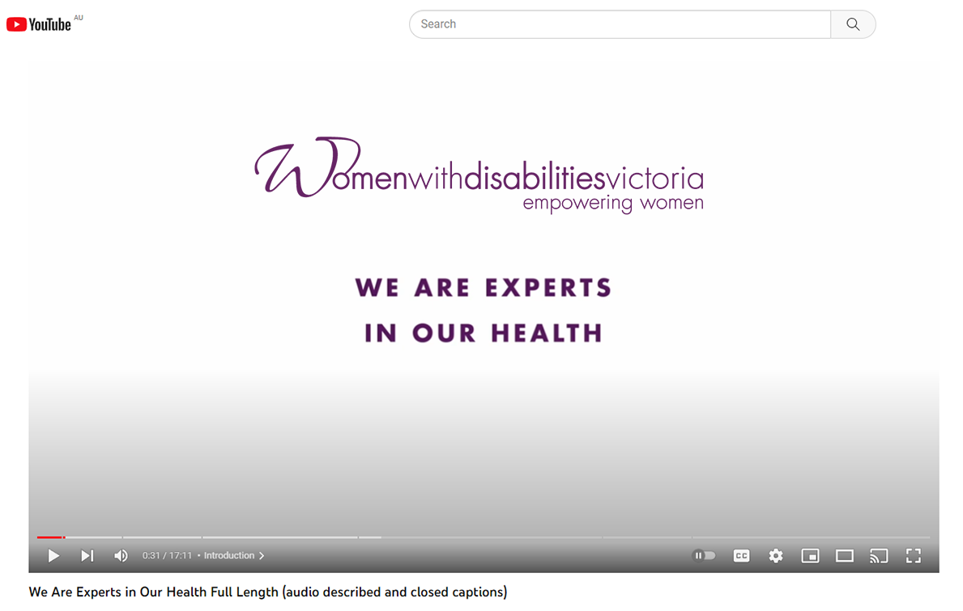

This video features six of the project’s twelve lived experience experts, sharing their experience accessing healthcare. The women talk about actions healthcare services can take to ensure their services and information are accessible, disability and gender-sensitive, inclusive and welcoming for women with disabilities. The video has been produced as a full-length video and chapters as well as a Trailer. Accessibility features include Auslan Interpreting, Closed Captioning and Audio Description.
The resource promotion and dissemination strategy was co-designed with the Health Experts group. The campaign included a clear strategy to promote the resources including objectives and how they were to be reached, a distribution list divided up into relevant categories targeting key audiences, a work plan that included activities and timeframes of milestones to be reached and who was responsible and what support was needed.
Promotional material was included in emails announcing the new resources sent out to key stakeholder groups, as well as social media posts for each resource and promotion via the PAG and Health Experts Group members. Other disability advocacy and Prevention of Violence Against Women sector organisations also advertised the resources in their own e-newsletters.
As there were many resources to promote, the timing of the campaign occurred over six weeks, releasing one to two resources at a time each week. The first release was to announce the new resources, promote the symposium and highlight the first lot of resources which were the Factsheets. The second lot of resources to be released were the We Are Experts in Our Health poster followed by Experts in Our Health Guide and Experts in Our Health video. WDV finished the campaign promoting the Inclusive Co-design in Practice poster using the social media tiles one at a time to highlight each of the ways WDV supports accessible and inclusive co-design of resources, services and programs.

Evaluation Approach
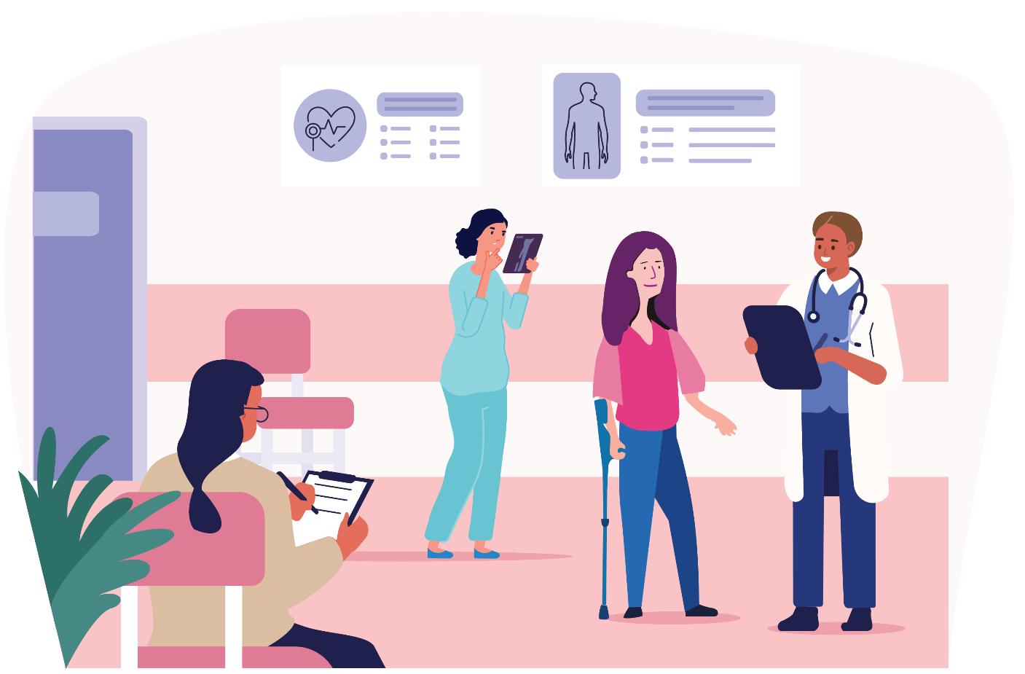
This evaluation report links closely to the Experts in Our Health Evaluation Framework, which outlines the project activities and expected outcomes of the project.
The Experts in Our Health Evaluation Framework was developed by the Project Team in conjunction with the Health Services Program Manager and with the guidance of an evaluation consultant. A participatory and inclusive evaluation approach was taken, with a focus on qualitative assessment approaches in order to centre the voices of women with disabilities.

Evaluation Outcomes
The Phase 1 evaluation reports on the two-year implementation of the first phase of the Experts in Our Health Project and aims to inform future directions and actions in the promotion of accessible healthcare and leadership of women with disabilities. As stated in the Evaluation Framework, indicators of success are:
An increase in cross-sector collaboration and valuing of lived-experience.
An increase in knowledge and awareness amongst women with disabilities about Human Rights and health.
An increase in the confidence & skills of women with disabilities to take control of their own health decisions, self-advocate and navigate the health service system.
An increase in knowledge and skills amongst women with disabilities in co-design of resources, training and delivery.
Improved knowledge amongst health stakeholders of accessible health service provision.
Increased skills, knowledge, confidence, and capacity of women with disabilities to engage in leadership on boards and committees.
An increase in intent of women with disabilities to represent their communities by participating in boards and committees.
- The identification of opportunities to continue to promote accessible and inclusive health service provision.

Evaluation Purpose and Audience
In line with the outcomes described in the Evaluation Framework, this evaluation intends to:
Describe the activities, achievements and challenges of the implementation of the Experts in Our Health Project Phase 1 2021-2022.
Assess the quality and value of the activities to participants and stakeholders including women with disabilities, health workforces and project partners.
Draw conclusions about the project and make recommendations for future work supporting access to health services for women with disabilities.
- Communicate the outcomes of the project to Department of Social Services.

Evaluation Questions
How has the project supported health access for women with disabilities?
What was the quality of learning and co-design experiences for participants including the Health Experts, workshop and training participants?
What has been the value of the project to women with disabilities, health workforces, project partners and stakeholder organisations?
What are our conclusions and next steps in supporting access to health services for women with disabilities?
- What are the recommendations arising from the evaluation?

Evaluation Methods
The principal theories and methodologies informing the Experts in Our Health evaluation are participatory and inclusive evaluation, which are both collaborative and potentially transformative approaches.
Participatory evaluation is an approach that engages project stakeholders in order to support community ownership and decision-making, and to ensure that research is useful and relevant (Cousins and Whitmore, 1998). A feature of participatory evaluation is the inclusion of project participants in all phases of the evaluation (Cousins and Whitmore, 1998). Participatory evaluation is a type of collaborative inquiry, which aims not only to solve problems and produce valid knowledge, but also ensure that the voices of marginalised people are heard in policymaking and program design (Weaver and Cousins, 2004). Transformative theory assumes that knowledge is reflective of power in social relationships, and that the construction of knowledge should go towards creating a more equal society (Mertens, 1999). Participatory approaches to project evaluation have the potential to be transformative when they empower those the project is intended to benefit (Cousins and Whitmore, 1998).
Inclusive evaluation is an approach that engages project beneficiaries in the evaluation process, with project participants involved in the planning and implementation of evaluation activities (Robinson et al., 2014). In the context of disability research, the inclusion of lived-expertise advisors and evaluators can result in more accessible evaluation tools and mechanisms (Robinson et al., 2014). Limited representation of people with disabilities amongst professionals, policymakers and researchers can mean that the priorities and lived expertise of people with disabilities are disregarded (Fisher and Kayess, 2019). Inclusion of people with disabilities in evaluation can be transformative, as it promotes critical examination of programs and systems from a lived experience perspective and supports change through empowerment (Robinson et al, 2014).
This evaluation of the Experts in Our Health Project utilised mixed methods to measure the impact and quality of activities using both quantitative and qualitative data. Indicators of success were designed to align with the project activities and measures of success described in the Activity Work Plan. Impacts and program quality were measured using accessible evaluation tools, which were designed and implemented with reference to the requirements and feedback of project participants. Evaluation tools included review of documents including meeting notes, resources and correspondence. Feedback surveys, focus groups and interviews were also used. Consistent with participatory and inclusive approaches, the project evaluation activities were designed to centre the experiences and perspectives of the project’s primary beneficiaries, women with disabilities.
In order to measure the reach of the project, quantitative data was collected on the number of project activities delivered and the number of participants and stakeholders engaged. Qualitative analysis techniques were used to identify themes of discussion in co-design sessions, workshops and trainings. Survey feedback, focus group and interview responses were also analysed. Results of surveys were tabulated, and thematic coding was used to analyse responses. All identifying information from individuals or organisations was removed from participant quotes.
The Experts in Our Health Evaluation Framework covered activities across six objectives:
- Project Governance focusing on cross-sector collaboration through partnerships.
- Building the individual capacity of women with disabilities through learning and development, co-design and participation in peer-led workshops.
- Building the capacity of health sector stakeholders through resource dissemination and workforce training.
- Resource development using quality co-design processes.
- Building the capacity of organisations to support the participation and leadership of women with disabilities.
- Evaluation and identification of further opportunities to promote accessible health service provision.

Participants
The Experts in Our Health Project engaged 12 lived-experience Health Experts who participated in an online learning and development program, as well as co-design and production of the Experts in Our Health resources. The Health Experts provided regular feedback through surveys and a focus group designed to evaluate the program overall. In-person and online Experts in Our Health workshops were planned as part of the project, and it was anticipated that at least 150 women with disabilities in regional and metropolitan Victoria would participate. However, the Covid-19 pandemic interrupted the facilitation of in-person events, and most workshops and events were held online. In all 13 sessions for women with disabilities were held, three of them in-person. 135 women with disabilities attended in-person and online Experts in Our Health workshops and presentations. Themes discussed within each workshop were recorded by the Project Team, and each workshop participant was invited to complete a post-event survey. The Experts in Our Health workforce training for health and community services staff was delivered during the project period, reaching at least 150 individuals across 17 events. Training participants included clinicians, nursing and Allied Health staff, researchers, health service managers and students. Workforce training participants and Project Advisory Group members provided feedback on the value of the project and increase in skills, knowledge and confidence through feedback surveys and focus groups.

Data Collection and Analysis
Each project participant was asked to complete participant surveys with ratings statements designed to measure increase in skills, knowledge, motivation, and confidence against the measures of success described in the Evaluation Framework. Project participants who completed surveys included the Health Experts, workshop attendees, workforce training attendees and resource users. Focus groups were conducted with the Health Experts and Project Advisory Group in order to collect data on the quality of the co-design process and collaborative partnerships. Document review of meeting and workshop notes, including zoom chat discussion, as well as review of the resources and participant correspondence were also conducted. Thematic coding of survey feedback was used to identify themes.

Limitations
Social distancing measures introduced in response to the Covid-19 pandemic were in place for much of the implementation phase of the Experts in Our Health Project, delaying and limiting the number of in-person events that could be held. The limited number of in-person events may have restricted the amount and quality of feedback received through surveys. Event participants are generally less likely to complete post-event feedback surveys if attending online. Online feedback surveys may have been inaccessible to some online workshop participants. The in-person workshops for women with disabilities provided the option of completing paper surveys with WDV staff support, an option which some participants may have found more accessible.
Production of the Experts in Our Health video was also delayed due to Covid-19 restrictions and concerns for the health and safety of the Health Experts and project staff. As a result, the release of the Experts in Our Health resources was delayed until September 2022.
Though the resources were promoted to more than 1,100 project participants and health stakeholders, the delayed release impacted the collection of feedback data. Effective tools for evaluating the resources include follow-up interviews and focus group sessions with women with disabilities and other health stakeholders. The short-term nature of the project has meant that evaluation of the resources will need to be undertaken in Phase 2.

Evaluation Findings
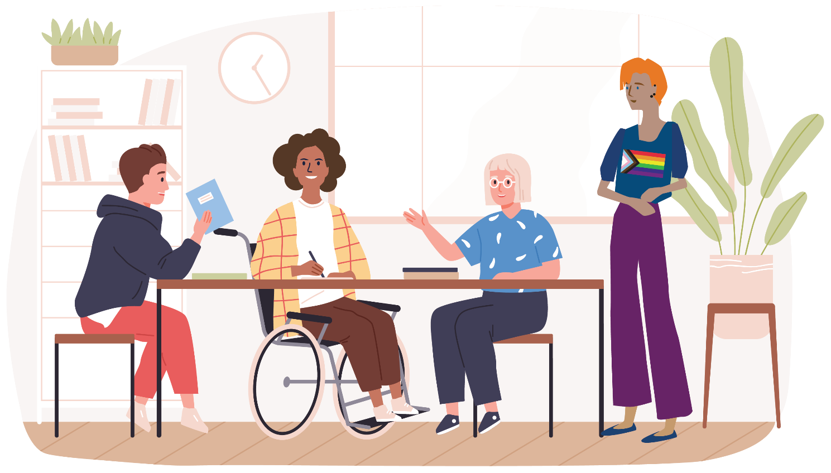
The findings of the Experts in Our Health project are drawn from the experiences and perspectives of project participants and stakeholders, including the Health Experts, women with disabilities, health and community services staff, project partners and Project Advisory Group members. The findings are presented in sections, and each section identifies several key themes that emerged in feedback and discussion. The themes identified in each section are supported by quotes from individual participants and stakeholders. The experiences and perspectives of each participant and stakeholder group are presented separately. This is in order to specifically identify and highlight the unique lived experience of women with disabilities, who are the primary beneficiaries of the Experts in Our Health Project. An inclusive evaluation approach acknowledges that historically the views of research beneficiaries, including women with disabilities, have not been sought and presented (Mertens, 1999). Highlighting and centring the lived-expertise of women with disabilities has the potential to reveal important new insights and bring depth of understanding to the evaluation of the project (Mertens, 1999).

The Health Experts Learning and Co-Design Program
The Health Experts group identified many things they had learned through the professional development and co-design program. Members described how the program had broadened their understanding of what access means beyond access to the built environment. Members said that focusing on power dynamics and relationships is important to understanding access and inclusion. Other learnings described by the group included the nature and scale of ableist discrimination and the importance of consumer voice in healthcare. The Health Experts said they had built their vocabulary around health advocacy and had developed confidence as advocates. The Health Experts reported that their individual skills, understanding and confidence around health rights, decision-making and advocacy increased as a result of the program.
Members of the Health Experts group described the importance of accessible co-design spaces. Group members were asked about their access needs at the beginning of the project, and this became a dynamic process informed by ongoing feedback. Flexibility was identified as a key enabler of access, as program materials were produced in different formats and the sessions were structured to suit multiple communication styles and preferences. Access was explicitly identified with inclusion and a sense of belonging.
“I found the accessibility of the session to be very inclusive.”
– Health Expert

Members of the Health Experts group said that discussion about access and inclusion was a valuable learning opportunity. The Health Experts group identified practices such as sign-posting activities and topics, structuring sessions and limiting time in online meeting spaces as enabling access to the co-design process. Members of the Health Experts group identified equality and respect as part of access, inclusion and belonging. For example, members said that being an employee with an email address and title helped them to feel equal to WDV staff.
“I really found the session very accessible. I really think that
having small break-out rooms is a great idea as it gives more opportunity for people to speak.”
– Health Expert

The Health Experts described a journey towards learning how to use their lived experience in a purposeful way in order to make an impact. Throughout the co-design process, the group members grew in confidence as trainers and resource designers. This growing confidence included telling stories based on lived experience in safe and effective ways. Group members identified the powerful impact they believed storytelling can have on a health sector audience. Group members described learning how to be discriminating when using their experiences in training and resource-design.
The Health Experts said that being a part of a group with their peers and learning about other disabilities was valuable. They valued collaborating and hearing from women of different ages and with diverse life experiences. The group felt that they could explore topics together without judgement and appreciated a supportive online environment. Members identified both personal and professional benefits of the program, particularly in the area of lived-experience leadership. Group members reported that a sense of community supported the development of a positive identity and confident self-expression.
Having peers there to listen to experiences encouraged group members to want to offer mentorship to other women with disabilities in their community.
“The information shared today not only made me feel valuable and knowledgeable, it gave me a strong sense of being able to develop my existing skills to be a great trainer and advocate.”
– Health Expert

Members of the group described the co-design process and co-facilitation model as supporting collaborative ways of working. Although the collaborative model required considerable time and effort, group members said that it was worth it to produced resources representing diverse views and experiences. Collaboration also supported intersectional ways of working, as group members reported that they had gained insights into the needs and experiences of people with diverse access requirements and also speakers of English as an additional language.
“It is very valuable to have info around many different
life experiences.”
– Health Expert

Members of the Health Experts group reported that co-design was new to them and that they had learned about the process as part of the program. Group members reported that one key learning was the difference between consultation, which was familiar to many participants, and end-to-end co-design. Group members identified ways to make the process more accessible and effective. Involving the group in the earliest stages of resource development, providing enough time for review and transparency around decision-making were all identified as important. Group members commented on the lack of knowledge about co-design amongst health providers, and that the skills and knowledge they had developed during the project would be valuable in their work with other organisations.
“Being able to (contribute) directly to the format & content
of a valuable resource for women with disabilities is a privilege
that I am relishing.”
– Health Expert

99% of Health Experts session feedback form respondents reported their knowledge of at least one session topic had increased.
99% of Health Experts session survey respondents reported their confidence and motivation to support women with disabilities had increased.
98% of Health Experts session and program survey respondents stated that they felt their contribution was valued.
99% of Health Experts survey responses indicated that Health Experts believed they had a say on issues that are important to them.

Experts in Our Health Workshops for Women with Disabilities
Feedback from women with disabilities who attended the Experts in Our Health Workshops indicated that attendees valued the opportunity to talk broadly about access to health services. Workshop participants spoke about their experiences in a wide range of healthcare settings, from hospitals to Primary and Allied Health services. Many participants commented that the workshops were the first time they had had a chance to talk about these things in an environment where they were listened to and validated. Feeling safe and supported to talk about what were often difficult experiences was linked to the fact that the workshops were peer-led spaces. Facilitators and participants were often able to empathise with each other even in complex situations where there was no immediate solution. Just knowing that others had been in similar situations was often valuable to women with disabilities who attended the workshops.
“It was good to meet with other women and discuss issues we face when attending medical appointments. It is good to know we are not alone and could discuss our experiences in a supportive environment.”
– Workshop Attendee

“I really liked the scope that was covered, the shared experiences, the new info and the supportive environment thank you.”
– Workshop Attendee

The workshops featured the Experts in Our Health resources in different formats, including the Experts in Our Health Guide in Plain Text, Easy English, Braille and MP3. The Guide includes a resource list so that women with disabilities can find information, support and advocacy services that meet their needs. Lack of information in accessible formats was a major barrier to health identified by many women who attended the workshops. They said health services often failed to offer information in ways they could use and were often inflexible when asked to reformat documents, send them electronically or communicate in alternative ways. Feedback from workshop attendees indicated that women with disabilities have need of health resources, and that a lot of health information is currently not accessible. Women who attended the workshops said they needed information about who to contact to get information about healthcare. They also said they needed information about advocacy services and generally finding their way around health systems. Women with disabilities said that providing health information in accessible ways was important. They gave feedback on how information could be presented in ways they can access and use.
"Workshop was valuable for mentioning different health organisations to hook women up to.”
– Workshop Attendee

In relation to improving workshop delivery, one participant suggested “Make it more simple. Show videos with demonstrations.”
– Workshop Attendee

A key message of the workshops was that women with disabilities have the right to equal and timely healthcare as described in United Nations Convention of the Rights of Persons with Disability. Participants in the workshops often described not being able to access services or waiting because providers could not meet access needs. They described going through frustrating complaints processes in order to get the supports they needed. The workshops were a forum where women with disabilities could share their experiences and encourage each other. Women with disabilities who experience multiple barriers to health access, including Indigenous women and women from culturally and linguistically diverse communities, said that change was needed in the way healthcare staff interact with them, so that they felt safe and respected. Many participants said that it was important to teach healthcare staff about the needs of women with disabilities and other marginalised people.
“It reminded me that I should not feel bad when I am not catered for, and that I am within my rights to get a service like
everybody else.”
– Workshop Attendee

“Make that doctors and nurses have patience for people with disability and Aboriginal people.”
– Workshop Attendee

The Experts in Our Health workshops were a forum for sharing information and resources and building the confidence of women with disabilities. Many of the workshop attendees were experienced community leaders and advocates. Women with disabilities appreciated being able to listen and learn directly from others who had similar experiences. The workshops were a community-building opportunity, allowing women with disabilities to connect with and gain support from each other. Participants said it was important to have supportive spaces where women with disabilities could talk together about challenging systems that exclude and marginalise them. Much of the information offered in the workshops was provided by participants who had experience or knowledge of local service providers.
In this way, the workshops acted as a mutual aid network where women could benefit from hearing about the challenges and successes of others.
“I appreciated and found it helpful when the presenters shared some of their lived experiences with what was being presented.
I find this helps me to understand context of the information presented. I have trouble retaining dry information/statements: lived experience enables me to connect it to something so it’s meaningful and I can retain it.”
– Workshop Attendee

92% of workshop survey respondents felt their contribution was valued.
88% of workshop survey respondents reported increased knowledge and skills.
82% of workshop survey respondents reported increased motivation and confidence.
93% of workshop survey respondents who were asked felt they had a say on issues important to them.
68% of workshop survey respondents were NDIS participants.

Experts in Our Health Training for Workforces
Health and community services staff who engaged in the Experts in Our Health training for workforces said they valued time and space for discussion about access and inclusion. They commented that conversations around accessibility are often limited to physical access, and that the sessions supported a broader understanding of what access can mean. Many of the staff who attended the training sessions reported feeling more confident and empowered to speak to others about access and inclusion. They reported that the session had given them some practical ways to improve access for their patients and service users.

“I appreciate the conversation about sensory barriers. I find that conversations around accessible built environments often centre around ramps and elevators, rather than take into account the breadth of enablers that ought to be included. Also thought the discussion around barriers for people with invisible illnesses was really important to highlight.”
– Training Attendee

“This session reinforced my knowledge of the barriers women with disabilities face when accessing healthcare, and also introduced a few new concepts. I feel more empowered and informed to have these discussions when engaging in health settings with my work in clinics and pharmacies etc.”
– Training Attendee

Training participants said that they came away from the sessions with a better understanding of the barriers to healthcare faced by women with disabilities. They said that having lived-experience facilitators who were willing to share their experiences in health settings helped them to understand the needs of women with disabilities.
Many participants praised the resources used in the presentation and said that the resources helped them understand ableism and recognise how biases impact service users. Having training sessions facilitated by women with disabilities reinforced the key message that it is important to listen to women with disabilities and value their voices at all levels of the health system.
“Making assumptions of what WWD need and actually asking “what do they need” was such an important statement.”
- Training Attendee

Participants commented on the value of hearing lived-experience perspectives to their professional development. Feedback from the sessions described the way hearing from women with disabilities themselves helped them to reflect on their practice and gain insight into what actually meets the needs of service users. Training sessions were attended by a diverse range of health services staff and practitioners, including hospital leaders, nursing and administrative staff. Members of hospital Family Violence response and People and Culture teams also engaged in the training and said they found it relevant and impactful for their work. Attendees said that the central message, that access and inclusion must be a focus across the whole workforce, resonated as being key to organisational and sector change.

“It was valuable for a few reasons. First, hearing from women with lived experience provided a lot of insight into experiences and barriers in a human way, rather than from research or other ways. Understanding the intersections of discrimination was explained really clearly. Finally, the model explaining that accessibility is everyone’s business, valuing voices, partnerships and listening and treating people as individuals was great.”
– Training Attendee

Approaching access and inclusion using an intersectional lens was an important message of the workforce training, and attendees found value in discussing the multiple ways women with disabilities experience disadvantage. Facilitators were able to provide insight into the experience of having to advocate for access in many areas of their personal and professional lives, and the impact this has on health and wellbeing. Having a diverse team of facilitators meant that participants heard a Culturally and Linguistically Diverse perspective as well as a rural perspective on access to health. A key part of the training that resonated with many participants was the fact many women with disabilities have experienced violence, abuse, neglect and discrimination in their lifetime. Training participants wanted to discuss the importance of trauma-informed approaches to care and recognised the need to integrate this approach into their practice.
“It was so valuable to think about intersectionality of marginalisation for women with disability, and also start thinking about important it is to have these conversations as they help to overcome attitudinal barriers and create workplaces that are healthy and accessible for women with disability.”
– Training Attendee

“Extremely valuable for reflection on nursing practice for
women with disabilities and what I can do better. Trauma informed practice critical.”
– Training Attendee

Partnerships and Collaboration
The Project Advisory Group brought together practitioners from Victorian Women’s Health Services, Victoria’s Royal Women’s Hospital, the Health Issues Centre and health service provider Star Health. WDV’s Leadership Hub program was represented, along with the Health Experts group.
Members of the PAG report that:
Participation in the project has increased awareness and knowledge of the accessibility needs of women with disabilities and has improved understanding of the barriers to healthcare they face.
Being involved in the PAG has supported organisations to be continuously self-reflective about how they support access and inclusion.
Having a representative on the PAG and collaborating with the project meant that conversations about access and inclusion were more likely to be sustained within organisations.
PAG participation also provided learning opportunities relating to the creation of accessible health resources.
- Participating in the project allowed PAG members to share knowledge about access and inclusion with other organisations, helping to build networks of allies across the health sector.
The PAG representative from the Royal Women’s Hospital reported recognising that it is important to have clinicians attend the PAG to expand their learning and offer some of their knowledge. She explained that her engagement with the PAG and the Experts in Our Health training with staff had been very influential on the work they do. The women who engage with the Women with Individual Needs (WIN) Clinic at the Royal Women’s Hospital and those who participate in the Disability Action Plan Advisory Committee have been positively impacted. Participation has also had positive impacts operationally and from a service provision perspective. During their involvement in the project, The Royal Women’s Hospital reported having just signed off on their new Disability Action Plan and are focusing on employment and leadership for women with disabilities.
“The more we can bring awareness to it, especially with people without disabilities to the issues women with disabilities face is so important. To decrease barriers, we need to employ more WWD so we can normalise it.”
– Project Advisory Group Member

The Project’s Women’s Health service partners also described collaboration and knowledge sharing as beneficial to their communities. Women’s Health Loddon Mallee’s CARE Conversations collaboration was identified as valuable for its capacity to strengthen relationships between organisations and promote the work of WDV across sectors. The event helped organisations based in Loddon Mallee become more connected. Engagement in rural areas was highlighted as being important for inclusion.
A PAG member from Multicultural Centre for Women’s Health highlighted the work their Communications team did with WDV to prepare posters in community languages. They reported it as being a mutually beneficial collaboration, as the organisation has identified access as a priority within their Strategic Plan. As a result of participation in the Experts in Our Health Project access for women with disabilities from migrant and refugee communities is being considered across all projects. A PAG member representing Women’s Health in the North said that WDV’s presentation to the GenVic Sexual Reproductive Health Community of Practice strengthened their capacity to build disability awareness and embed accessibility into their work.
All members of the PAG agreed that centring the lived experience of women with disabilities is vital. It was emphasised that narratives have power in promoting empathy in others. A PAG member reflected on the processes of their organisation’s Disability Action Plan (DAP) Advisory Committee, and how they have been able to identify areas that are good and areas that need improvement as a result of participating in the project. They stated that many people who are unfamiliar with disability access have gained knowledge from the lived experiences of members of the DAP Advisory Committee, specifically in learning terminology and increasing their understanding of the importance of co-design and employment of women with disabilities.
“It was not just listening to women with disabilities share their stories and or identity, this project was more than that. It was drawing attention to the systems and barriers – politicising – centring lived experience stories.”
– Project Advisory Group Member

All PAG members identified further opportunities to promote health access, and each had ideas for supporting organisations to increase leadership and participation of women with disabilities. PAG members described how they intended to incorporate the values of the project into their professional learning programs, including conference presentations and health sciences courses at universities. They noted that the inclusion of lived experience perspectives in the education of health professionals could contribute to attitudinal change. Building relationships with the disability advocacy sector was identified as important, as was encouraging organisations to move beyond the consumer advisory model to employment of lived experience staff, for example as peer navigators. In order to increase participation and employment of women with disabilities, more conversations about access should be had at leadership and board level, and disability inclusion should be included in strategic planning and allocated budget accordingly.
“…it is a whole of organisation approach, and it must come from management, so it is embedded and operationalised. There also needs to be more cross-sector collaboration so we can see where the gaps are. Increase funding for organisations so they can do this work. Use the (Health Experts Program) evaluation report as an advocacy tool to do this.”
– Project Advisory Group Member

Women with Disabilities and Leadership
In feedback sessions the Health Experts group identified the program as being a contributing factor in developing as a leader in the advocacy space. Group members described leadership capacity and opportunity opening up alongside their work with the program. Members emphasised the value of lived experience in leadership, and accessibility as an important understanding for leaders and organisations to have. This was a direct outcome of their learning and participation in the Experts in Our Health Project. Members of the group also described their increased expectations around employment and advocacy opportunities as a result of project participation. In particular, group members expected to be paid for advisory work as a result of their participation in the project. At least one group member undertook paid employment for the first time during the project, and feedback indicated that members planned to pursue voluntary opportunities alongside paid employment. At least two Health Experts group members undertook consumer advisory roles with major hospitals during the project, and one project staff member joined the board of a Victorian Women's Health Service.

“I have had job opportunities and have increased my roles
and responsibilities in other work. I have had the chance to
speak at advocacy events and feel my influence is growing in women’s health.”
– Health Expert

The Experts in Our Health Workshops became forums for discussion and information sharing about leadership and advocacy. Workshops were attended by a mixture of experienced advocates and women with disabilities engaged in individual advocacy. Facilitators ensured that all types of leadership, including advocating for one's own right to access, was valued and acknowledged. Younger workshop participants in particular expressed keenness to have more discussion and resources available in support of employment and opportunity for women with disabilities. Participants described significant barriers to employment and were interested in developing and using resources such as the Experts in Our Health Factsheet 5 Working in the Health Sector as a Woman with Disability.
“Focusing on workplace barriers and how we can navigate these as individuals. A lot of people do not feel confident speaking up or don’t know their rights.”
– Workshop Attendee

“Group discussions were valuable, learning to self-advocate would have worked better in a separate workshop so more time could have been devoted to it.”
- Workshop Attendee

Supporting women with disabilities to be part of the health workforce was found to be a repeated topic of interest in workforce training sessions. Leaders in the health sector said they wanted to increase the number of women with disabilities who were employed in lived-experience and other roles, and were looking for resources to assist them in providing accessible and inclusive work environments. During these discussions, the project team heard from women with disabilities who were already employed by major Victorian health services, and they described feeling supported in their workplace because their colleagues valued their contributions and strengths.

Discussion
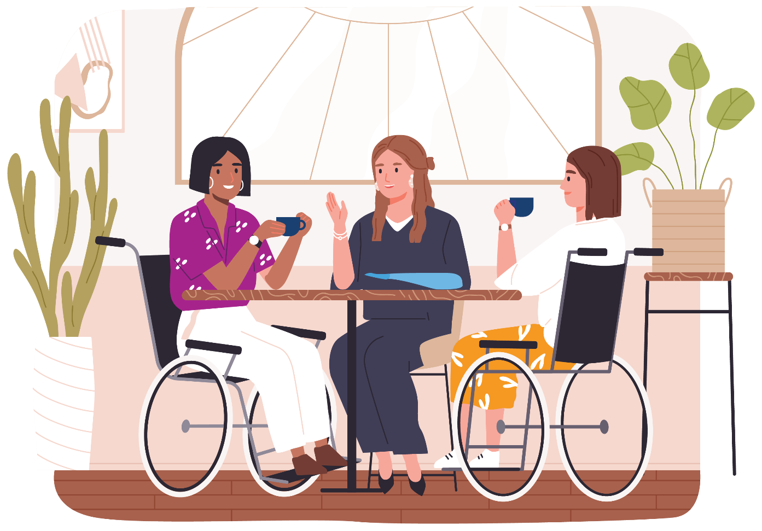
The data analysed in the findings section of this report allows us to draw conclusions about the quality of the project and the value the activities have brought to participants and stakeholders. Discussion of the findings will attempt to answer the evaluation questions before making recommendations for future work. The evaluation questions are:
What has been the value of the project to women with disabilities, health workforces, project partners and stakeholder organisations?
How has the project supported health access for women with disabilities?
What was the quality of learning and co-design experiences for participants including the Health Experts, workshop and training participants?
What are our conclusions and next steps in supporting access to health services for women with disabilities?
- What are the recommendations arising from the evaluation?

Project Achievements, Quality and Value to Stakeholders
The evaluation has found that the Experts in Our Health Project was valuable to groups of participants and stakeholders in the following ways.

Health Experts Group
The Health Experts learning and co-design program, delivered online, increased the skills and knowledge of group members and supported them to become confident health advocates. The co-design process was genuine, thorough and effective as the group maintained a respectful and productive meeting space and felt safe expressing diverse points of view. The co-design process was an empowering experience and the values and perspectives of women with disabilities were centred in the final resources and training sessions. WDV can attest that these resources were co-designed and developed consistent with disability equity and accessibility, co-design, and health promotion principles. The train-the-trainer model of co-facilitation was a valuable skills-based learning program, as were discussion-based professional development sessions and consultations. The Health Experts program has given many members confidence, skills and support to pursue advocacy, employment and leadership outside WDV.

Women with Disabilities
The project has encouraged women with disabilities to connect with and support each other through facilitation of regular Health Experts sessions and workshops. The sessions helped women with disabilities to know about their health rights, navigate health systems and make decisions about their health. Women with disabilities valued learning together, sharing knowledge, and hearing from experienced disability advocates. The sessions and workshops were a source of knowledge and support during Covid-19 lockdowns, a time of uncertainty, confusion and isolation for many women with disabilities in Victoria. The findings of this report highlight the importance of community-building and peer-led programs in supporting the health of women with disabilities. Project participants reported that listening to the experiences of other women with disabilities led them to feel less alone and develop confidence and a positive self-identity within the disability community. The resources meet a need for accessible health resources and information identified by women with disabilities. The resources have lived expertise at the centre, and support what women with disabilities say they need in order to access health services. The resources support women with disabilities to know about and advocate for their right to be heard, to have their lived expertise respected and to make decisions about their health.

Health Workforces
Experienced healthcare staff and emerging health professionals told us that they value lived-experience perspectives in their professional development and education, and that hearing these perspectives will assist them to meet the access needs of women with disabilities. The Experts in Our Health workforce training sessions broadened understanding of disability, access and inclusion and encouraged health services staff to take an intersectional approach to supporting women with disabilities. The resources, including the Experts in Our Health poster, articulate values and practices that underlie accessible service provision and assist practitioners to be person-centred, relational and flexible in their approach. Many health service providers are engaged in consultation with women with disabilities through consumer advisory committees and disability action planning activities. The Experts in Our Health resources and training meet a need for resources that support organisations to implement accessible consultation and co-design processes and support lived experience workforces.

Project Partners and Stakeholders
Members of the Project Advisory Group including the project’s Women’s Health Service partners found lived experience perspectives valuable to their own work and the work of their organisations. Collaborations with health services meant that the Experts in Our Health training and resources were disseminated across Victoria and throughout metropolitan and regional professional networks. Engagement with the project has ensured accessibility has remained a priority for organisations who participated. Reviewing the accessible Experts in Our Health resources has encouraged staff in women’s health services to reflect on the accessibility of their resources and activities. As a result, access for women with disabilities is more likely to be considered in the planning and implementation of women’s health initiatives in Victoria.
Women with disabilities who participated in the Experts in Our Health Project, including the Health Experts and those who attended workshops, created spaces where they could discuss their own experiences and be empowered to take action. Project participants gained knowledge and confidence from listening to peers talk about their own advocacy experiences. The Experts in Our Health workshops provided information and resources to assist women with disabilities to find their way around health systems and advocate for their rights. The workshops supported sharing of local knowledge, experience and resources between experienced advocates and those still building knowledge and confidence. Importantly, the workshops helped create and strengthen peer support networks for women with disabilities. This was also the case for the Health Experts group. The Health Experts learning and co-design program developed strengths of individual women with disabilities and produced a group of knowledgeable and confident health advocates. Members of the group have designed and produced resources that can be accessed by diverse women with disabilities across Victoria. They have each taken on leadership roles beyond the project, educating communities and organisations about the barriers to health access faced by women with disabilities.
The Experts in Our Health Project also positively impacted health workforces. Leaders, professionals and staff from a wide range of health services and organisations said they valued the opportunity to talk in-depth about disability access and hear lived experience perspectives. They reported that the training increased their knowledge of the barriers faced by women with disabilities and supported them to approach their practice in rights-based, inclusive and accessible ways. From the findings, it appears there is wide-spread interest amongst service providers in improving access to health services for people with disabilities, and in taking an intersectional approach to this work. Organisations are seeking support to implement participatory design processes including co-design. They want to create accessible workplaces and increase the numbers of staff with lived experience working in the health sector.
The Experts in Our Health resources and training programs have allowed health service providers to hear and benefit from diverse lived experience perspectives. The training and resources have offered practical and actionable ideas for improving access, as well as encouraging organisations to reflect on the underlying values and assumptions that inform their practice.

Project Sustainability
In the next phase of the Experts in Our Health Project, the project team have the opportunity to reach more communities of women with disabilities across Victoria. Partnering with regional health and disability sector stakeholders will be key to disseminating the resources in regional and rural communities. Continuing to partner with Women’s Health Services and developing relationships with organisations representing and supporting marginalised women in the Victorian community will further enhance the reach of the project. There is also opportunity to reach a broader section of the health and community services workforce, and relevant training institutions. The project has yet to achieve the desired reach with Primary Care providers, Specialists and Public Health professionals. This will require networking, engagement with representative bodies and the continuation of targeted workforce training designed to meet the needs of busy health professionals.
The lived-experience Health Experts group will remain at the centre of the project. The Health Experts will continue to be supported in their advocacy work with professional learning opportunities. The Project staff, together with the Health Experts, will plan ongoing promotion and dissemination of the resources, workshops and training. This will include identifying opportunities to present the resources and evaluation findings to the health and disability sectors through conferences and events. The project will continue to engage in best-practice, end-to-end co-design of resources and training. Women with disabilities and health workforces will continue to be supported in their advocacy and allyship through Communities of Practice. The poster resource Inclusive Co-Design in Practice, along with Factsheet 5: Working in the Health Sector as a Woman with Disability, will assist organisations to implement accessible co-design and support the leadership and development of lived-experience workforces.

Recommendations
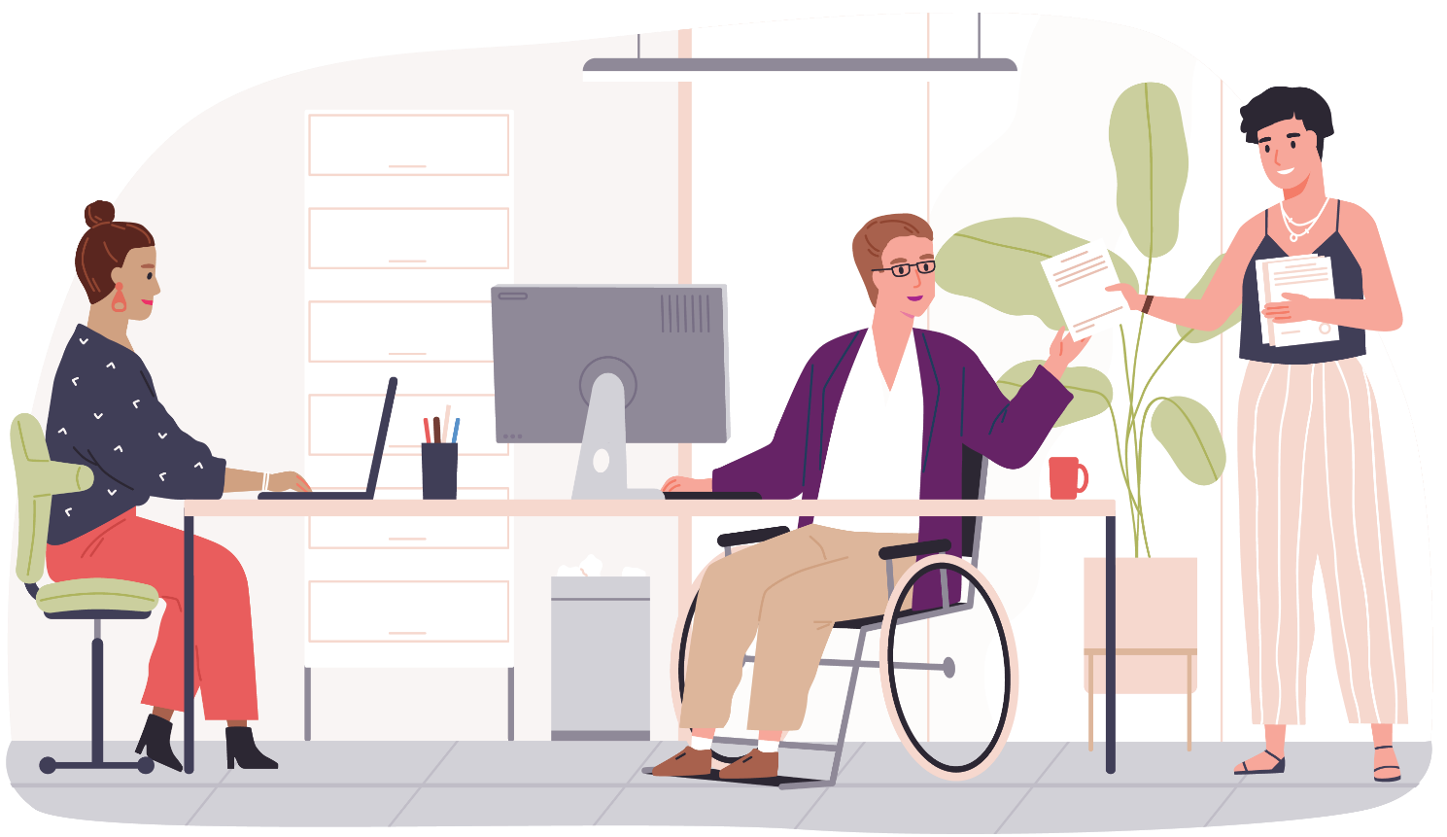
The following recommendations have been made by the Experts in Our Health Project team based on the evaluation findings and conclusions.

Recommendation 1
Health access for women with disabilities from diverse communities across Victoria should be supported with appropriate co-designed resources. Indigenous women, LGBTIQA+ people, rural women and women from culturally and linguistically diverse backgrounds should have access to relevant health information in a range of accessible formats.

Recommendation 2
Health service providers, including Victoria’s Women’s Health Services, should create partnerships, collaborate and engage in meaningful ongoing ways with disability self-advocacy organisations in order to promote and embed practices that increase health access for women with disabilities.

Recommendation 3
Health Service Providers, including Victoria’s Women’s Health Services should engage women with disabilities in meaningful co-design processes and develop resources that empower women with disabilities to make informed decisions about their healthcare, promoting respect, dignity, choice and control.

Recommendation 4
Women with disabilities should have access to peer learning and support programs such as Communities of Practice that are co-designed and facilitated by lived-experience advocates.

Recommendation 5
Health service providers, including Victoria’s Women’s Health Services, should identify access for women with disabilities as a priority in strategic planning and resource initiatives that increase access including co-design programs.

Recommendation 6
Higher education providers should collaborate with disability self-advocacy organisations in order to embed lived experience perspectives into the education of health and community services professionals.

Recommendation 7
Health service providers, including Victoria’s Women’s Health Services, should aim to increase the participation and employment of women with disabilities in the design and delivery of services. They should collaborate with disability self-advocacy organisations to create inclusive co-design processes and accessible workplaces.

Recommendation 8
Health workforces, including health services staff in leadership roles, should engage in ongoing professional learning such as Communities of Practice that focus on disability access and centre lived experience.

References
Australian Commission on Safety and Quality in Healthcare. (2019). Australian charter of healthcare rights. https://www.safetyandquality.gov.au/consumers/working-your-healthcare-provider/australian-charter-healthcare-rights
Aitken, Z., Bishop, G. M., Disney, G., Emerson, E., & Kavanagh, A. M. (2022). Disability-related inequalities in health and well-being are mediated by barriers to participation faced by people with disability. A causal mediation analysis. Social Science & Medicine, (315), 115500. https://doi.org/10.1016/j.socscimed.2022.115500
Agency for Clinical Innovation. (2019). A guide to building co-design capability. https://aci.health.nsw.gov.au/__data/assets/pdf_file/0013/502240/Guide-Build-Codesign-Capability.pdf
Australian Institute of Health and Welfare. (2022). Health of people with disability. https://www.aihw.gov.au/reports/australias-health/health-of-people-with-disability
Brophy, C. (2018). Brief submission to the special rapporteur on the rights of persons with disabilities on the right of persons with disabilities to the highest attainable standard of health. Women with Disabilities Australia. https://wwda.org.au/wp-content/uploads/2016/01/3-WWDA_SR_Disability_HealthAccess_March2018_BriefReport.pdf
Cousins, J. B., & Whitmore, E. (1998). Framing participatory evaluation. In E. Whitmore, (Ed.), Understanding and practicing participatory evaluation: New directions for evaluation (p. 80), Jossey-Bass.
Department of Social Services. (2021). Australia’s disability strategy 2021-2031. https://www.disabilitygateway.gov.au/sites/default/files/documents/2021-11/1786-australias-disability.pdf
Fisher, K.R., & Kayess, R. (2019). Collaborative disability-inclusive research and evaluation as a practical justice process. In P. Aggleton, A. Broom and J. Moss (Eds), Practical Justice: Principles, practice and social change, (pp. 146-158). Taylor & Francis.
Gender Equity Victoria. (2022). This conversation is not over: Women’s mental health during the Covid-19 pandemic. https://www.genvic.org.au/focus-areas/genderequalhealth/this-conversation-is-not-over-womens-mental-health-during-the-covid-19-pandemic/
Kavanagh, A., Dickinson, H., Carey, G., Llewellyn, G., Emerson, E., Disney, G., & Hatton, C. (2021). Improving health care for disabled people in COVID-19 and beyond: Lessons from Australia and England. Disability Health Journal, 14(2), 101050. https://doi.org/10.1016/j.dhjo.2020.101050
McKercher, K. A. (2020). Beyond Sticky Notes: Doing co-design for real: mindsets, methods and movements. Beyond Sticky Notes. Sydney.
Mertens, D. M. (1999). Inclusive Evaluation: Implications of transformative theory for evaluation. American Journal of Evaluation, 20(1), 1-14.
Petrony, S., Horsley, P., & Kavanagh, A. (2010) Access to health services for women with disabilities. Women with Disabilities Victoria. https://www.wdv.org.au/documents/Access%20to%20health%20services%20-%20the%20issues%20for%20women%20with%20disabilities.pdf
People with Disabilities Australia. (2022). Pandemic project final report. https://pwd.org.au/wp-content/uploads/2022/10/PWDA-Pandemic-Project-Report-Final.pdf
Robinson, S., Fisher, K., & Strike, R. (2014). Participatory and inclusive approaches to disability program evaluation. Australian Social Work, 67(4) 495-508. http://dx.doi.org/10.1080/0312407X.2014.902979
State of Victoria. (2016). Safe and Strong: A Victorian gender equality strategy. https://www.vic.gov.au/safe-and-strong-victorian-gender-equality
State of Victoria. (2019). Victorian public health and wellbeing plan 2019-2023. https://www.health.vic.gov.au/publications/victorian-public-health-and-wellbeing-plan-2019-2023
State of Victoria. (2021). Royal commission into Victoria’s mental health system final report: Summary and recommendations. Parliamentary Paper No. 202, Session 2018–21 (document 1 of 6). https://finalreport.rcvmhs.vic.gov.au/wp-content/uploads/2021/02/RCVMHS_FinalReport_ExecSummary_Accessible.pdf
State of Victoria. (2022). Inclusive Victoria: State disability plan (2022-2026). https://www.vic.gov.au/state-disability-plan
Weaver, L., & Cousins, J. B. (2004). Unpacking the participatory process. Journal of Multidisciplinary Evaluation, 1(1), 19–40
United Nations. (2006). Convention on the rights of persons with disabilities. United Nations Department of Economic and Social Affairs. https://www.un.org/development/desa/disabilities/convention-on-the-rights-of-persons-with-disabilities.html
Women with Disabilities Australia. (2022). Towards reproductive justice for young women, girls, feminine identifying, and non-binary people with disability (YWGwD): Report from the YWGwD national survey. https://wwda.org.au/publication/youth-sexual-health-and-reproductive-rights-report-and-resources/
Women with Disabilities Victoria. (2022). Understanding disability guide. https://www.wdv.org.au/wp-content/uploads/2022/06/Understanding-Disability-June2022-PRINT.pdf

Appendices

Appendix 1 Project Logic Model
Appendix 2 Health Experts Learning and Co-Design Session Feedback Form
Appendix 3 Experts in Our Health Workshop Feedback Form
Appendix 4 Experts in Our Health Plain Language Workshop Feedback Form
Appendix 5 Experts in Our Health Workforce Training Feedback Form
Appendix 6 Health Experts Learning and Co-Design Program Phase 1 Evaluation Feedback Form

Appendix 1: Experts in Our Health Project Logic

Staffing and Resources
Health Services Program Manager
Health Coordinator, Experts by Experience Health Project
Health Experts Resource Development Officer
Health Experts Project Officer
Health Experts Group Members x 12
Evaluation Consultant
Department of Social Services Funding for External Resources and Activities
Established Peer Networks (e.g. Sunrise Program GenWest)

Enabling Policy Initiatives
Australia’s Long-Term National Health Plan 2019
Women with Disabilities Victoria Strategic Plan 2021-2024
Women’s Health Victoria Strategic Plan 2018-2023
National Disability Strategy 2010-2020
Absolutely Everyone State Disability Plan 2017-2020
Victoria’s 10-year Mental Health Plan 2015
Delivering for Diversity Cultural Diversity Plan 2016-2019
Safe and Strong: A Victorian Gender Equality Strategy

Frameworks for Action
Victorian Government Preventing Family Violence and Violence Against Women Capability Framework 2017
Our Watch - Change the Story 2015
Our Watch - Change the Picture 2018
National Primary Healthcare Strategic Framework 2013
Department of Health & Human Services Outcomes Framework 2019
Allied Health Capability Framework: Disability and Complex Support Needs 2020
Rainbow E-quality: LGBT-Inclusive Practice Guide for Health and Community Services
National Cultural Respect Framework for Aboriginal and Torres Strait Islander Health 2016-26

Evidenced-based Models/Methodologies
Women with Disabilities Victoria Enabling Women and Enabling Women-Youth Programs
Women with Disabilities Victoria Experts by Experience
Women’s Health Grampians Equality for All Program
Multicultural Centre for Women’s Health Family and Reproductive Rights Education Program
Youth Disability Advocacy Service Emerging Young Leaders Program

Activity 1 (there are 6 activities in the Project Plan)

Project Governance

Outputs
1 x project advisory group (PAG) with Terms of Reference and supporting documents

Short- and Medium-Term Changes
Improved collaboration between critical partners and stakeholders for health services access for women with disabilities.

Activity 2 (links to Activity 5)

Individual Capacity Building for Women with Disabilities

Outputs
1 x Health Experts induction session with accompanying materials
1 x Health Experts Professional Development package and schedule
8 x Health Experts Professional Development Sessions with processes in place for peer-to-peer learning
1 x Training Dissemination Network Plan and promotional calendar

Short & Medium-Term Changes
Individual Level
Increased knowledge and awareness of Human Rights and health of women with disabilities among Health Experts and women with disabilities.
Increased confidence & skills amongst Health Experts and women with disabilities to take control of their own decisions regarding their health.
Increased knowledge, confidence and skills (e.g. self-advocacy) in navigating the health service system among Health Experts and women with disabilities.
Increase confidence and skills in codesign of resources, training and delivery among the Health Experts.

Activity 3

Resource Design and Development

Outputs
1 x Scoping document with summary document
1 x Expert-designed training program developed over 8 sessions
1 x Set of resources including testing via focus group

Short- & Medium-Term Changes
Individual Level
Increased confidence and skill amongst Health Experts in codesign of training and resources.
Increased knowledge and awareness amongst Health Experts of Human Rights, health and women with disabilities.
Increased confidence and skills (e.g. self-advocacy) amongst Health Experts in navigating the health system.
Increased confidence and skills amongst Health Experts to take control of their own decisions regarding their health.
Organisational and Community Level
Improved quality and scope of resources on women with disabilities and health.
Strengthened critical partner and health stakeholder ‘buy in’ into the Project.

Activity 4

Health Stakeholder and Sector Capacity Building

Outputs
1 x Network Dissemination Plan
Up to 12 Expert-delivered trainings for health service providers.

Short & Medium Term Changes
Individual Level
Increased awareness and understanding among health service stakeholders about the Human Rights of women with disabilities to healthcare, health inequality and systemic ableism.
Increased confidence and skills in practices for accessible healthcare delivery.

Sector Level
Improved attitude towards inclusive health practices.
Demonstrated intent to change practices to increase accessibility of health services for women with disabilities.

Activity 5 (depends on Activity 2)

Organisational Capacity Building

Outputs
1 x Expert representation opportunities scoping report
1 x Expert nomination for WDV board
1 x Individual leadership and participation plan

Short & Medium Term Changes
Individual and Organisation Level
Increased confidence and skills among Experts to represent on organisational boards and committees.
Improved pathways or opportunities for Experts in leadership on organisational boards and committees.

Activity 6

Evaluation

Outputs
1 x Project Logic Model and Evaluation Framework.
3 x Progress Reports
1 x Final Report
1 x Dissemination and Sustainability Report

Short- & Medium-Term Changes
Individual and Organisation Level
Improved capacity of WDV and partners to share achievement and lessons learnt from the project and make sound decisions for what's next.

Longer-Term Changes
Women with disabilities are empowered with their voices and choices around health.
Women with disabilities are leaders and experts in the health system and accessible service delivery.

Appendix 2: Health Experts Learning and Co-Design Session Feedback Form

Question 1
As a result of today's session, my knowledge of the topic has increased.
Very much | A bit | Not sure | Not much | Not at all

Question 2
My confidence and motivation to support women with disability has increased.
Very much | A bit | Not sure | Not much | Not at all

Question 3
I felt my contribution was valued.
Very much | A bit | Not sure | Not much | Not at all

Question 4
I feel like I have a say on issues that are important to me.
Very much | A bit | Not sure | Not much | Not at all

Question 5
Are you an NDIS participant?
Yes | No

Question 6
Please comment on the accessibility and relevance of the session:

Appendix 3: Experts in Our Health Workshop Feedback Form

Question 1
This workshop was worth my time today.
Very much | A bit | Not sure | Not much | Not at all

Question 2
I felt my contribution was valued in this workshop.
Very much | A bit | Not sure | Not much | Not at all

Question 3
I feel that my knowledge and skills in the following areas have increased because of this workshop:
Finding my way around health services
Very much | A bit | Not sure | Not much | Not at all

Advocating for myself
Very much | A bit | Not sure | Not much | Not at all

Making my own health choices
Very much | A bit | Not sure | Not much | Not at all

Question 4
I feel that my motivation and confidence in the following areas have increased because of this workshop:
Finding my way around health services
Very much | A bit | Not sure | Not much | Not at all

Advocating for myself
Very much | A bit | Not sure | Not much | Not at all

Making my own health choices
Very much | A bit | Not sure | Not much | Not at all

Question 5
I feel I have a say about issues that are important to me after this workshop.
Very much | A bit | Not sure | Not much | Not at all

Question 6
We are planning to do more workshops for women with disability in Victoria. What should stay the same, and what could we do differently next time?

Question 7
Our funders would like to know how many people who access the NDIS have come to our workshops. Are you an NDIS participant?
Yes | No

Appendix 4: Experts in Our Health Plain Language Workshop Feedback Form

Did you think the workshop was valuable?
Yes / No

Why was the workshop valuable or not valuable?

I felt like my ideas were listened to in this workshop.
Yes / No

I know more about finding my way around health services.
Yes / No

I know more about speaking up for myself.
Yes / No

I know more about making health choices.
Yes / No

I feel more confident finding my way around health services.
Yes / No

I feel more confident speaking up for myself.
Yes / No

I feel more confident about making health choices.
Yes / No

How can we make the workshop better next time?

Do you use the NDIS?
Yes / No

Appendix 5: Experts in Our Health Workforce Training Feedback Form

Question 1
This workshop was worth my time today.
Very much | A bit | Not sure | Not much | Not at all

Question 2
Can you explain why this training was or was not valuable?

Question 3
As a result of this session, my awareness and understanding of health rights, health inequality and ableism in relation to women with disabilities has increased.
Very much | A bit | Not sure | Not much | Not at all

Question 4
As a result of this session, my confidence and skills in accessible healthcare delivery practices have increased.
Very much | A bit | Not sure | Not much | Not at all

Question 5
As a result of this session, I feel more positive about inclusive health practices, and intend to change practices in order to increase accessibility of health services for women with disabilities.
Very much | A bit | Not sure | Not much | Not at all

Question 6
We are planning to present more training sessions to health workforces in Victoria. What should be the same, and what could we do differently next time?

Appendix 6: Health Experts Learning and Co-Design Program Phase 1 Evaluation Feedback Form

Question 1
I felt my contribution was valued.
Yes | No

Question 2
I feel I have a say on issues that are important to me.
Yes | No

Question 3
I have increased knowledge, skills and confidence around Human Rights and health of women with disabilities.
Yes | No

Question 4
I have increased knowledge, skills and confidence around speaking up and out.
Yes | No

Question 5
I have increased knowledge, skills and confidence around taking control of my own health decisions, self-advocacy and navigating the health service system.
Yes | No

Question 6
I have increased motivation and confidence around taking control of my own health decisions, self-advocacy and navigating the health service system.
Yes | No

Question 7
I have increased knowledge, skills and confidence in the development of resources with and for women with disabilities.
Yes | No

Question 8
I have increased skills, knowledge and confidence in the development of resources for health services.
Yes | No

Question 9
I have increased skills, knowledge and confidence in the co-design and delivery of training.
Yes | No

Question 10
I have increased knowledge, skills, motivation and confidence to represent women with disabilities in leadership and on boards and committees.
Yes | No

Question 11
I have increased leadership and influencing opportunities.
Yes | No

Question 12
Can you describe your leadership and influencing opportunities?

Question 13
I am an NDIS participant.
Yes | No

Wurundjeri Country
Postal: PO Box 18314, Collins Street East, VIC 8003
Phone: 03 9286 7800
Email: wdv@wdv.org.au
For more information visit https://www.wdv.org.au/

