The WDV 2023 AGM
Zoom Guide for Attendees
This year, the Women with Disabilities Victoria Annual General Meeting will be held online. Please see the below guide for assistance.

Zoom Link
https://us02web.zoom.us/j/82459414918
You can join the Zoom meeting on:
- a computer
- laptop
- tablet
- mobile phone
- landline phone
Joining on a landline will give you sound only, and you won’t be able to vote. (You will have to appoint a Proxy to vote for you instead).
Zoom has a range of accessibility features and we will have both captioning and Auslan interpreting at the meeting.
We have an Accessibility Guide if you wish to read more on accessing these features.
The AGM will be recorded. There is a chance that in the recording, some Members’ faces might be visible. If you do not want to be photographed/filmed, please turn off your camera.
If you are planning to share a device with another Member/s and you all want to vote, please read the special instructions for this. One or more of you will have to appoint a proxy to be able to vote.
The following pages contain screenshots of what you might see on a device. Captions underneath describe the screenshots.

Contact us
If you have any questions or require any assistance with accessing the meeting, WDV staff are available to help! You can contact us on:
- Email: agm@wdv.org.au
- Phone: (03) 9286 7800.
Technical support will also be available during the meeting, but we will be limited in how many requests we can answer. It would be a good idea to keep this guide close-by.
We look forward to seeing you at our 2023 AGM!
Regards,
Women with Disabilities Victoria

Table of Contents
Zoom Link 1
Contact us 2
Part 1 – Joining the Meeting 4
Part 2 – Inside the Meeting 7
Turning off your video (if you don’t want to be seen) 7
Raising Your Hand 7
Speaking during the meeting 9
Asking a question during the meeting 9
Requesting technical support during the meeting 9
Moving and Seconding a Motion 10
Part 3 - Voting in the Board Elections 11
Voting for yourself – via survey monkey 11
Members Appointed as a Proxy 12
Part 4 - Accessibility Guide 13
Auslan Interpreter 13
Closed Captions 13
Audio Description 13
Keyboard Navigation 14
Screen Reader Support 14
Key functions to note if using Keyboard Shortcuts or a Screen Reader 14
Additional Accessibility Information 15
Part 5 – Accessing the Meeting – FAQs 16
I can’t access the meeting from my browser – how do I get in? 16
How do I join by phone? 16
Can I share my audio or video during the meeting? 16
I am having issues with Zoom or I can’t access the meeting 16
How do I appoint a Proxy to vote on my behalf? 16

Part 1 – Joining the Meeting

Step 1
Download Zoom if you have not already done so. You can download it here. Choose either “Zoom Client for Meetings”, or if you want to use it on a mobile, “Zoom Mobile Apps”.

Step 2
Click on the ‘Join Meeting’ button inside your confirmation email. Or you can copy and paste the link into your browser.
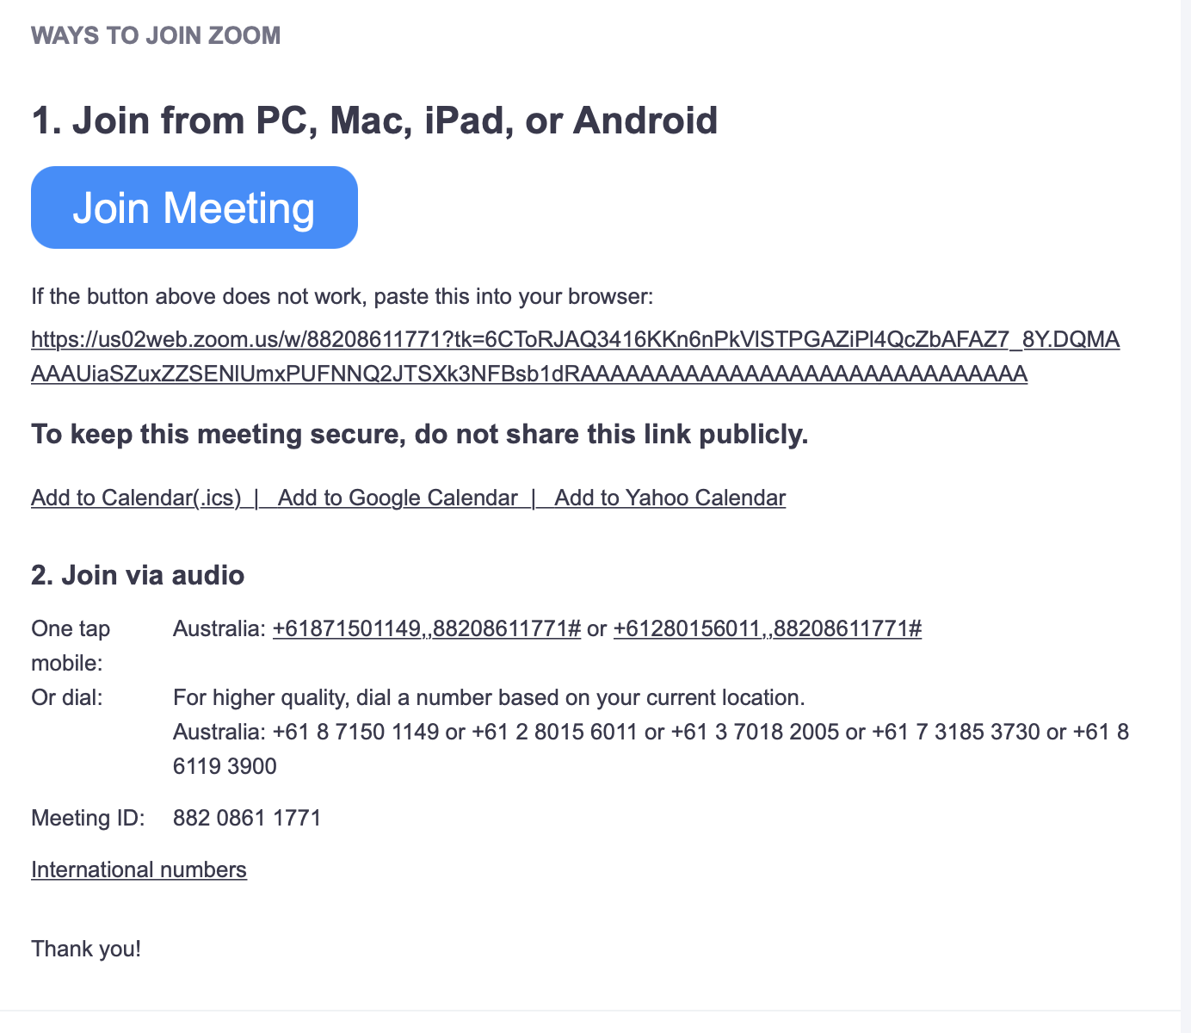
Caption: Registration confirmation email with the details to enter the meeting

Step 3
The Zoom application should then open and take you to the meeting waiting room.
Important: You may be given a warning box that asks you to ‘Open Zoom.us?’. Select ‘Open’ or ‘Allow’. If you do not allow access the meeting will not open for you.
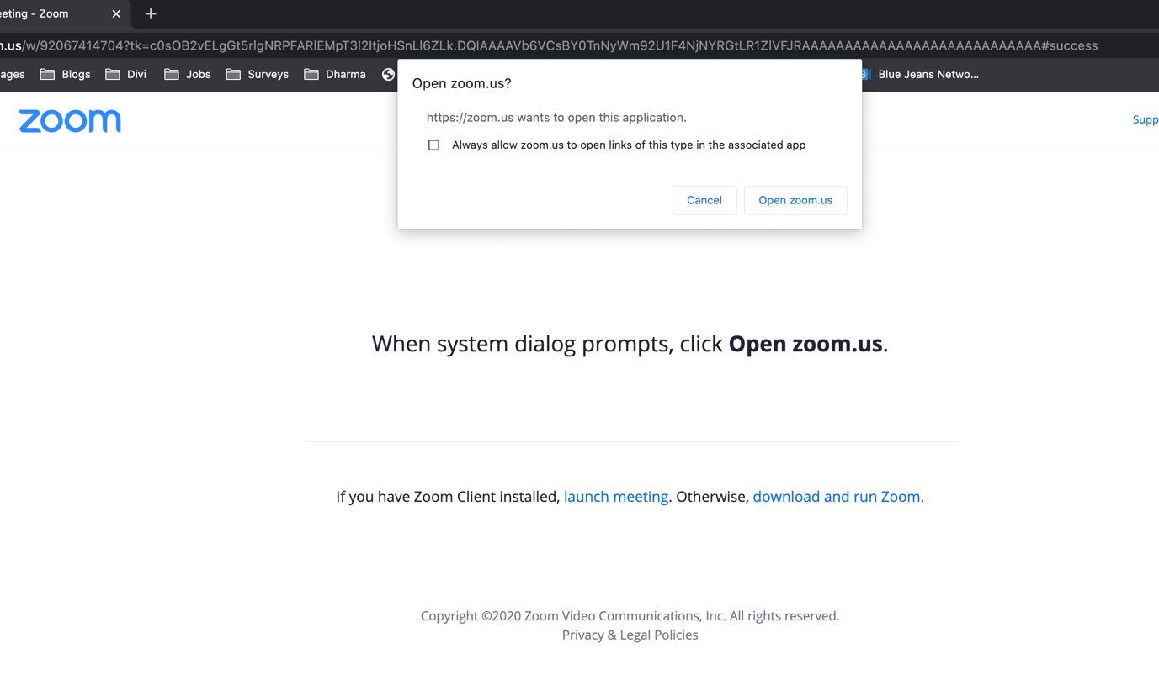
Caption: New page opened showing the ‘Open zoom.us’ box

Step 4
You will see a message saying “Please Wait, the meeting host will let you in soon” – this is the waiting room. Someone from WDV will let you into the meeting.
If we need any further information from you, you may be taken to a breakout room.

Step 5
Once you are checked in to the meeting, Zoom will open, asking you to select an audio option.
Select “Join with Computer Audio”.
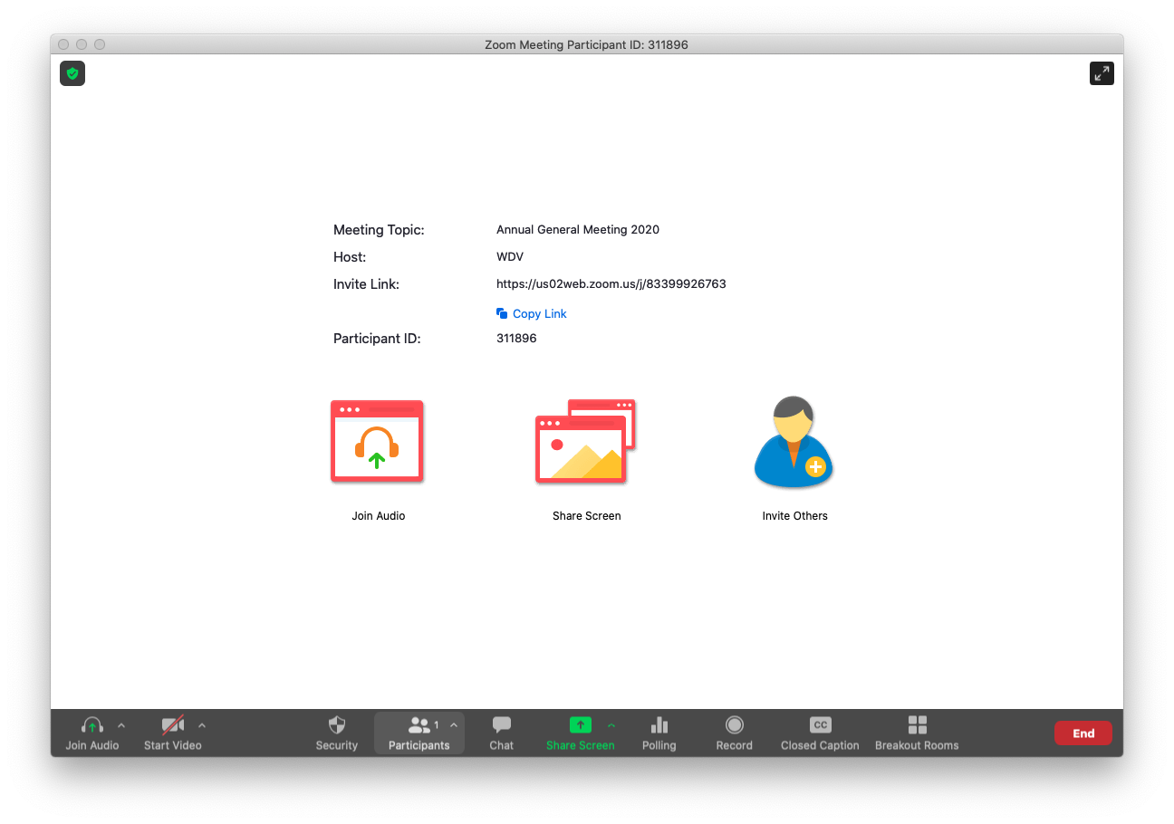
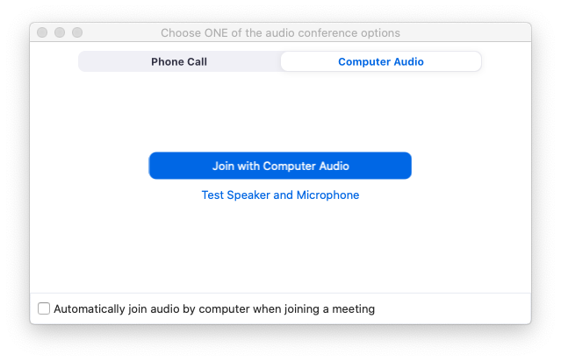
Caption: Zoom Meeting showing the audio selection options.

Part 2 – Inside the Meeting
Everyone’s microphone will be turned off. If you are due to speak, or if you raise your hand to ask a question, you will be asked to unmute your microphone.

Turning off your video (if you don’t want to be seen)
If you do not want to be photographed/filmed make sure that your video is turned off.
Click or tap on the ‘Stop Video’ icon.

Raising Your Hand
You may need to raise your hand during the meeting if you want to move or second a motion, or ask a question about the business of the meeting.
To do this:
On Computer
During the meeting, click on the icon labelled "Participants" at the bottom centre or top of your screen. In the window that opens on the right side of the screen, click the button down the bottom labelled "Raise Hand." Your virtual hand is now raised.
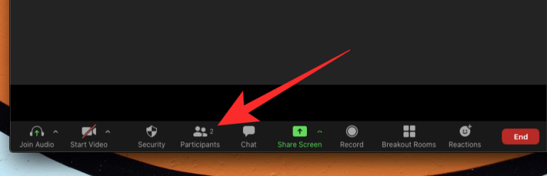
Caption: The Participants button on the bottom or top of your computer screen

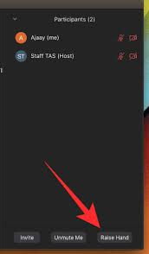
Caption: The Raise Hand button will appear when you select ‘Participants’

On Mobile (if using the app)
- In the Zoom toolbar, select Show Participants
- Select ‘More’
- Then select ‘Raise Hand’
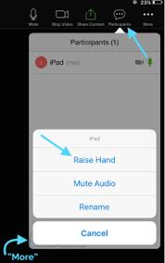
Caption: The Raise Hand button will appear when you select ‘Participants’ on your mobile

Speaking during the meeting
If you are scheduled to speak or are called on in the meeting you will need to have your audio and/or video turned on. You will receive a request inside Zoom, and you will need to select ‘Unmute’.
Caption: The request that shows on the screen if you are prompted to unmute your audio

Asking a question during the meeting
If you have a question during the meeting about the business of the meeting (not technical support – for this, see ‘Requesting technical support during the meeting’ below), you can ask this in two ways:
- Typing your question into the Chat box
  - Select ‘Chat’ and in the drop-down box next to ‘To’, select ‘Meeting Questions’ and send a message with your question.
- Raising your hand and asking the question verbally
  - The speaker will respond to you and you will be able to ask your question. Note that you will be asked to unmute your microphone (see ‘Speaking during the meeting’ above).

Requesting technical support during the meeting
WDV staff aim to provide some technical support during the meeting – but we will be limited in how many requests we can answer. You can contact us by:
- If you are already in the Zoom meeting: Select ‘Chat’ and in the drop down box next to ‘To’, select ‘WDV Support’ and send a message.
- Email: agm@wdv.org.au
- Phone: (03) 9286 7800

Moving and Seconding a Motion
During the meeting, members will be asked if they would like to move or second the motions put to the AGM. If you wish to move or second a motion you will need to raise your “virtual hand”.

Part 3 - Voting in the Board Elections

Voting for yourself – via survey monkey
- When it is time to vote in the Board elections, a link will be put in the chat box to take you to Survey Monkey where you will cast your vote.
- Once the link opens, you will choose your three CANDIDATES
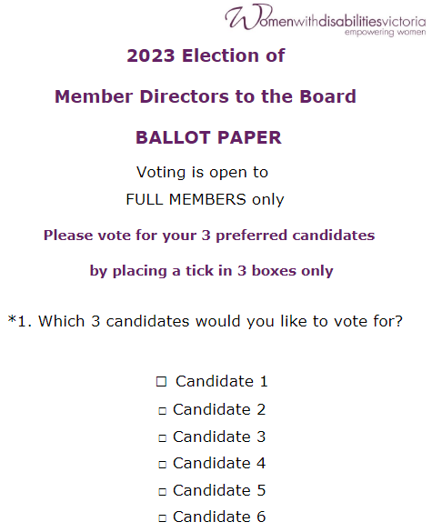
Caption: Image of online vote ballot within Survey Monkey

- Your vote will not be counted until you submit your vote.
- Once you have pressed DONE and your vote is submitted, close the Survey Monkey window to return to Zoom.

Members Appointed as a Proxy
If you have been appointed as a Proxy to vote on behalf of other Member/s you will cast your own vote using the Survey Monkey link first and then vote for your proxy.
For any proxy votes you hold, please follow these steps:
- Select the Chat function
- Choose ‘Proxy Votes’ in the drop down next to ‘To’
- In the message, please say who the member is you are the proxy for, and the name of the Nominees they are voting for. For example, “Proxy vote for Leah Smith, voting for Nominee number 1, 2, 3 and 5” (or the Nominees names).

Part 4 - Accessibility Guide
This section provides more information about the Zoom accessibility features. If you are using these features, we recommend you read this section.
We are using Zoom. Zoom has in-built support for keyboard navigation, screen readers and other technology.
We will have an Auslan Interpreter and Live Captioning provided. We will also be providing audio description for any video or slides on the screen.

Auslan Interpreter
The Auslan interpreter will be on the screen during the entire meeting.

Closed Captions
We also have live captions available. To access the closed captions, select the ‘Closed Caption’ button at the bottom or top of the screen.
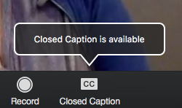
Caption: The Closed Caption button to turn on captions in the meeting

Audio Description
There may be slides or visuals during the meeting. We will be providing audio description The description will be the main audio coming through the meeting, so you will not have to enable it, just ensure your speakers are not muted.

Keyboard Navigation
Zoom supports Keyboard Shortcuts for easy navigation.
You can view the Zoom article on Hot Keys and Keyboard Shortcuts, for a full list.

Screen Reader Support
Zoom follows accessibility standards to make sure that it is fully accessible to screen readers.
Full details are available in these guides:
- Using Zoom with JAWS
- Using Zoom with NVDA
- Using Zoom with Voiceover on MacOS

Key functions to note if using Keyboard Shortcuts or a Screen Reader
The main functions you might want for the meeting are how to:
- Raise your hand (to move/second a motion, or ask a question about the business of the meeting)
  - Alt+Y (Windows)
  - Option-Y (Mac)
- Use Chat (to lodge a proxy vote, ask for technical support or ask a question)
  - Alt+H (Windows)
  - Cmd+Shift+H (Mac)

- Turn off your video (if you don’t want to be seen):
  - Alt+V (Windows)
  - Cmd+Shift+V (On Mac)

- Unmute your microphone (if asked to speak):
  - Alt+A (Windows)
  - Cmd+Shift+A (Mac)

To vote in a Zoom poll, your screenreader should be able to read down the list of names in the polling window. Use your keyboard to make your selection from the radio buttons.

Additional Accessibility Information
Zoom has created a set of FAQs about accessibility features including:
- Important accessibility keyboard commands for keyboard users
- High contrast support
- Larger font settings.
If you have any accessibility requirements that are not covered in the guides above, please contact us prior to the meeting.

Part 5 – Accessing the Meeting – FAQs

I can’t access the meeting from my browser – how do I get in?
This meeting cannot be accessed from your browser. Please download the Zoom application to your computer or mobile device.
If you haven’t done this and the meeting has already started, you might be better off just trying to join the meeting by phone.

How do I join by phone?
To join by phone, please contact us to register you. You will then be able to access the meeting with the details below:
- Dial: +61 3 7018 2005
- Meeting ID: 824 5941 4918
You will be asked to enter the Meeting ID, followed by the hash key. You don’t need a participant number, so if asked for this, simply press the hash key again.
If you join by phone, you will not be able to use the poll function, so it is recommended you appoint a proxy prior to the meeting.

Can I share my audio or video during the meeting?
Everyone but the host of the meeting and the active speakers will have their audio turned off. Your video may also be turned off.
If you are called on to speak, please see Speaking during the meeting.

I am having issues with Zoom or I can’t access the meeting
Please see Requesting technical support during the meeting.

How do I appoint a Proxy to vote on my behalf?
If you realise you will need to appoint a Proxy to vote on your behalf, and you haven’t done so already, please contact us ASAP and we will explain how to do so.

