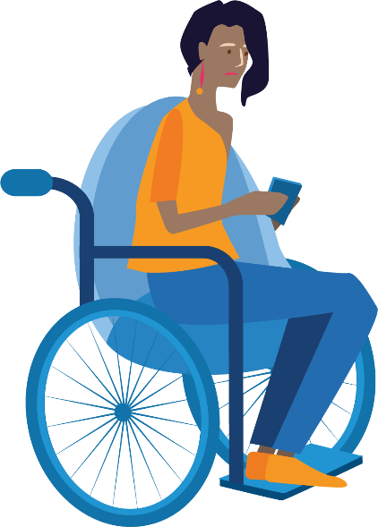

2023-2024
WDV Board

Nomination Guidelines

- All Full Members of Women with Disabilities Victoria are eligible to nominate themselves or another Full Member for a position as Director on the Board.
- Nominations for the position of Director must:
  - be made by submitting the completed Nomination Form.
  - include responses to the five (5) questions listed in the Nomination form. Responses will be compiled and presented as the Nominee’s nomination statement.
  - include the written consent of the Nominee (this can be an electronic or handwritten signature where marked).
- Nominees are encouraged to submit a photograph to be used to accompany their nomination statements.
- Nominations close at 5pm AEDT on Tuesday 31 October 2023. Late nominations will not be accepted.
- Nominations must be received by the Board Governance Officer by either:
  - Email: agm@wdv.org.au
  - Web page: https://www.wdv.org.au/agm2023/
  - Post: in the Reply Paid Envelope attached
    - If you misplace the envelope, please send the form to Board Governance Officer, PO Box 18314, Collins Street East, VIC 8003.
    - Note: if sending by post, please allow sufficient time for delivery (at least 4 business days) prior the date above.
- Nominations will be acknowledged via email within 7 days of the closing date.
- The written nomination statements provided by the Nominees will be sent in advance to all WDV Members and posted on the WDV website.
- Nominees will be required to submit a 60-second nomination summary recording to be presented to Members at the AGM. The video or audio recording may be made with a mobile device. If nominees require assistance with the recording, we will offer support to either record their statement via Zoom or do a recording on their behalf. Recordings must be submitted by email by 5pm AEDT on Tuesday 31 October 2023 to agm@wdv.org.au. Nominees can contact us for assistance by:
  - Email: agm@wdv.org.au
  - Phone: 0497 186 467
- If the number of nominations received is equal to the number of vacancies, the members nominated shall be deemed to be elected without a poll, otherwise an election will be conducted at the AGM.
- Women with Disabilities Victoria values diversity and particularly encourages young women, Indigenous & First Nations women, women from culturally and linguistically diverse backgrounds and people who are LGBTQIA+ who are Full Members to apply.
- If you have any questions regarding your eligibility for membership with Women with Disabilities Victoria or for your nomination to the WDV Board please contact us by:
  - Email: agm@wdv.org.au
  - Phone: 0497 186 467
- For further information regarding the role and responsibilities of the WDV Board please refer to the Board Position Description document.

