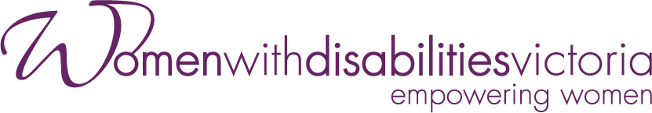

Annual Report
2022-2023
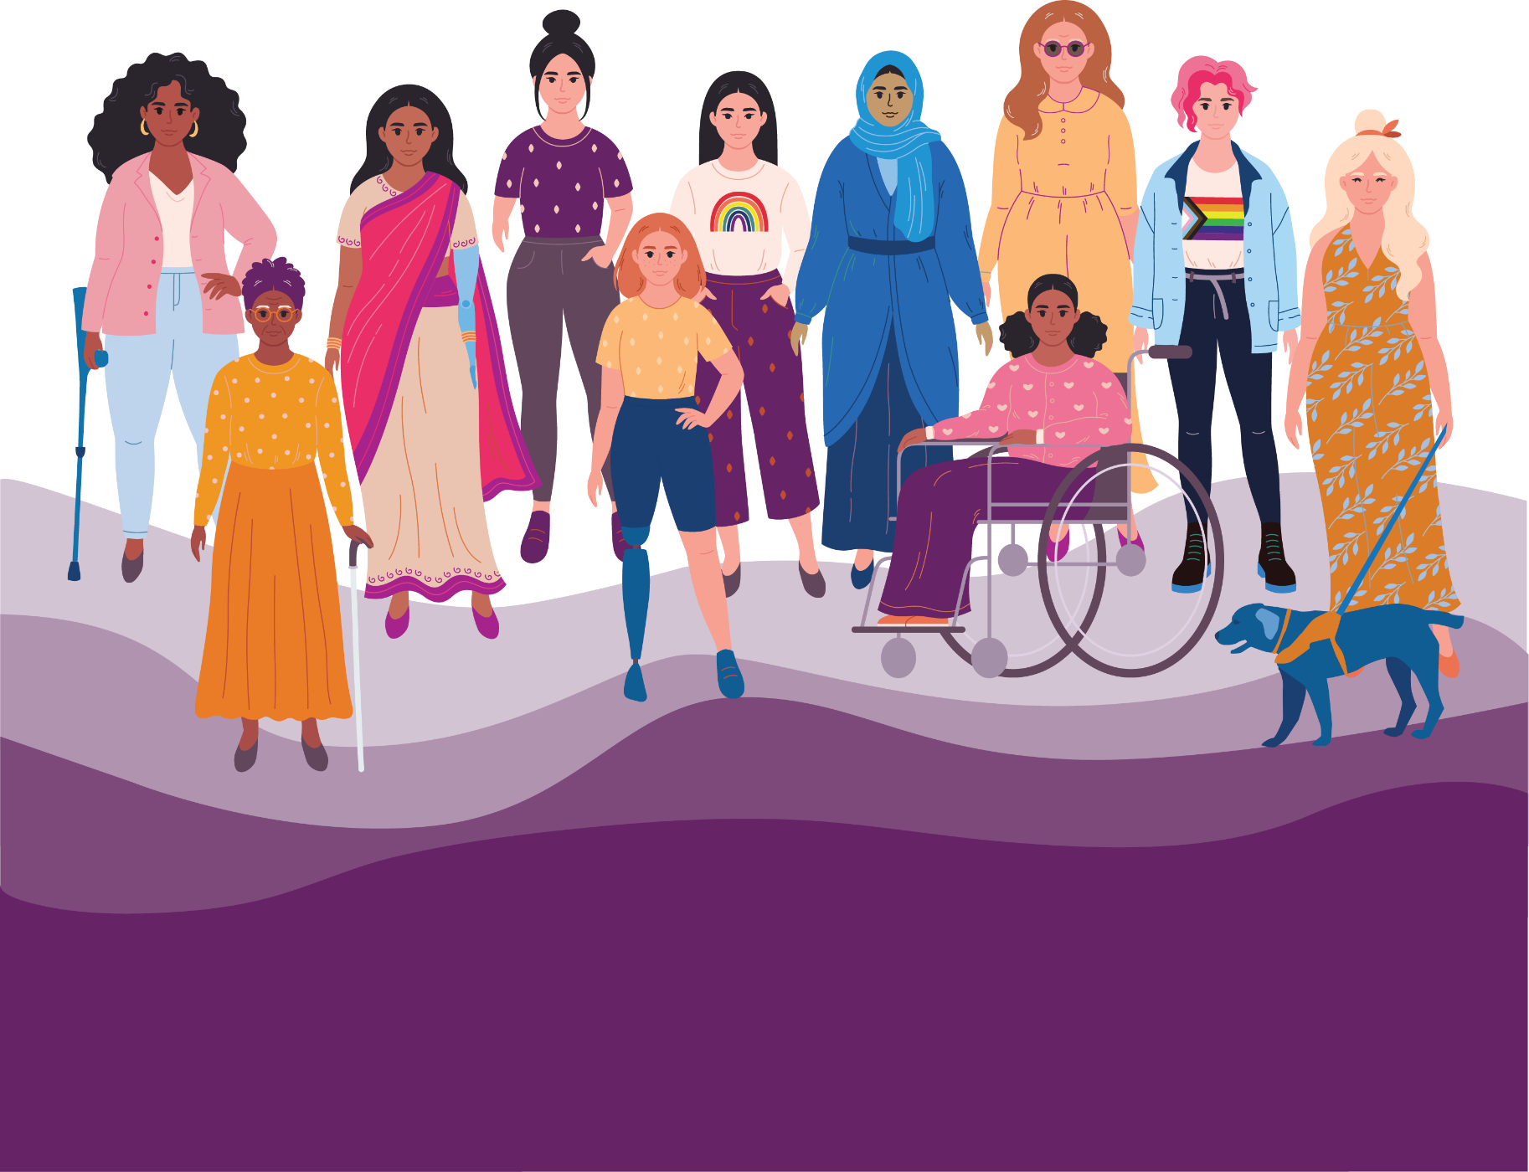

Our Vision
A world where all women are respected and can fully experience life.

Our Mission
To advance real social and economic inclusion for women with disabilities in Victoria, we will:
Be a voice for women with disabilities
Create opportunities for women with disabilities to be visible and to be heard in their communities
Build partnerships to deliver the best results for women with disabilities
Engage the community to challenge attitudes and myths about women with disabilities.

Our Values
Our values uphold human rights and social justice.
Equal Opportunity
Accessibility
Respect
Collaboration
Effectiveness
Creativity
Diversity
Accountability

Our Approach
We will:
Work with our members’ experiences as women with disabilities
Provide specialist policy advice and representation to government
Create opportunities for women with disabilities to realise their leadership and advocacy potential
Adopt a collaborative approach to government and community organisations
Build the evidence base to develop and share knowledge and resources to inform best practice
Monitor our work and report on outcomes.

Women with Disabilities Victoria (WDV) acknowledges Aboriginal and Torres Strait Islander peoples as the first inhabitants and traditional custodians of the lands on which we live and work. We pay our respects to ancestors and Elders, past, present and emerging.
The WDV Community is committed to honouring the unique cultural and spiritual relationship Aboriginal and Torres Strait Islander peoples have with the land and waters, and their rich contribution to society.

Chief Executive Officer (CEO) and Board Co-Chairs’ Statements
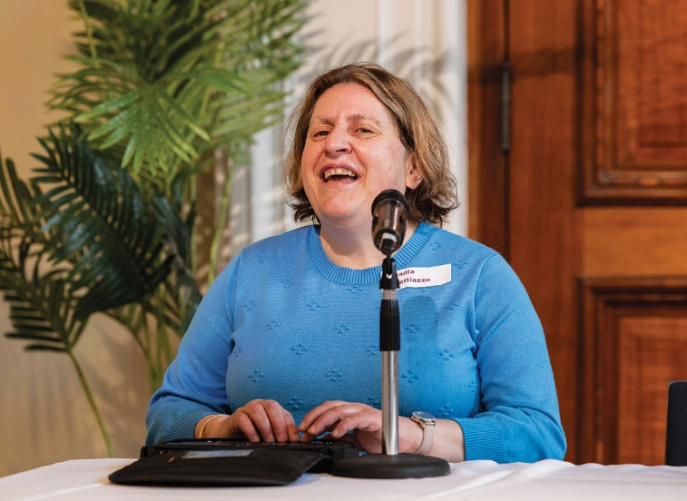

CEO Report
This year has delivered some exciting changes and achievements as well as continued to pose some enormous challenges, not just for WDV, but for everyone. After several years of working from home as a result of COVID, we embedded the idea of working in a hybrid world.
Earlier this year, after a long search, we relocated our office. Whilst it wasn’t a huge move in terms of location, our operations staff worked tirelessly to ensure a seamless experience for all.
We have continued to engage with our Lived Experience Experts to deliver outcomes for our Gender and Disability Program, our Health Services Program and our Enabling Women Leadership (Youth) Program.
For the first time this year, we were fortunate to receive funding within the future of public health work which the State Government is undertaking. This work will ensure that the women’s health sector can collaborate more effectively to adopt a more cohesive approach to our work across the State.
We have continued to work with Our Watch to support the translation of the ‘Changing the Landscape: A National resource to prevent violence against women and girls with disabilities’ into practice resources and a government action plan.
We continue to engage with government about the continuing effects of the pandemic on women with disabilities – both good and bad.
We would like to thank all of our project partners, state and federal government and those we work with in the community sector who have supported our work during this financial year.
Nadia Mattiazzo, CEO

WDV Board Co-Chairs’ Report

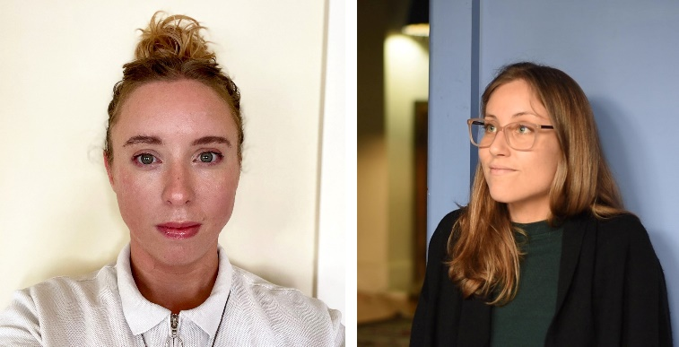
This year, the Board has made massive strides in our commitment towards an intersectional approach for self-advocacy and inclusion. While maintaining our day-to-day business of governance, strategic direction and oversight of the financial performance of WDV, the Board supported the organisation to continue to implement the 2021-2024 Strategic Plan with an intersectional focus on gender inclusion and anti-racism.
As we continue our review of WDV’s constitution, the Board is looking at the ways in which language includes and excludes our current and future member group. The gendered aspect of WDV’s work is fundamental to our mission and vision and we look forward to continuing this work with more breadth and nuance, which respects the fluid and diverse gender experiences of our members and community.
In August 2022, the Board undertook Financial Literacy training over two sessions with Non Profit Training. The training provided Directors with the skills to confidently read and understand, then interpret their financial information by helping to break down some of the ‘jargon’ used in these reports.
WDV held our first ever hybrid Members Event and AGM in November 2022. This was our first time using the stunning Isabella Fraser room at the State Library Victoria which our members reported to be accessible and welcoming. The event was very well attended in person and online and we will look to use a hybrid format again next year. Our guest speaker, Peta Hooke, Disability Advocate and Podcaster, provided an entertaining session.
At the 2022 AGM, WDV welcomed three new Directors to the Board: Marlena Raymond, Elyse Cox and Julia Manning. Crystal Bruton also joined the Board in January 2023 to fill a casual vacancy. Throughout the year, we have seen several significant departures from the Board of WDV, namely:
- Anaab Rooble, who served as Treasurer of the Board from 17 November 2020 to 29 November 2022
- Diana Piantedosi, who served as Co-Chair of the Board from 17 November 2022 to March 2023.
The Board extends its sincere gratitude to these skilled and generous people for their time, energy and mammoth contribution to the work of the Board, the organisation and women and gender-diverse Victorians with disability.

In exciting news, the new Director of Business Operations, Belinda Burns, and Director of Policy, Advocacy and Community Engagement, Diana Piantedosi, have been appointed. This signals a change to the organisational structure of WDV, with an additional layer in WDV’s executive leadership team. Belinda and Diana bring with them a wealth of knowledge and experience, and the Board looks forward to working with them.
The Board was fortunate to spend half a day with WDV staff at Melbourne Zoo for a staff development day. Board attendees found it an insightful day where both staff and Board Directors were able to hear from WDV’s Reconciliation Action Plan working group, and discuss feminist values and leadership, and gender diversity and inclusion.
We are also very proud that WDV members continue to provide strong representation on the Victorian Disability Advisory Council (VDAC). The Council provides independent policy and strategy advice to the Minister for Disability, Ageing and Carers.
The new WDV office opened in February 2023. To celebrate the opening, our CEO, Nadia Mattiazzo hosted the WDV Board and Committee members for an open afternoon. This casual event was a wonderful opportunity for Board Directors to chat with staff and to see WDV’s lovely new space.
The WDV Board is extremely grateful for the work and achievements of WDV staff this past year.
Elyse Cox and Marlena Raymond
Board Co-Chairs

WDV Goals

1. Visibility and voice
Engage women with disabilities, build our self-advocacy and strengthen our membership across Victoria

2. Pursue safety, wellbeing and connectedness for women with disabilities
Leverage government funded policy reform and programs

3. Create long term change through engagement, education and advocacy

4. Key enablers
WDV will ensure strong organisational infrastructure to enable our strategy

Goal 1: Visibility and Voice
Engage women with disabilities, build our self-advocacy and strengthen our membership across Victoria
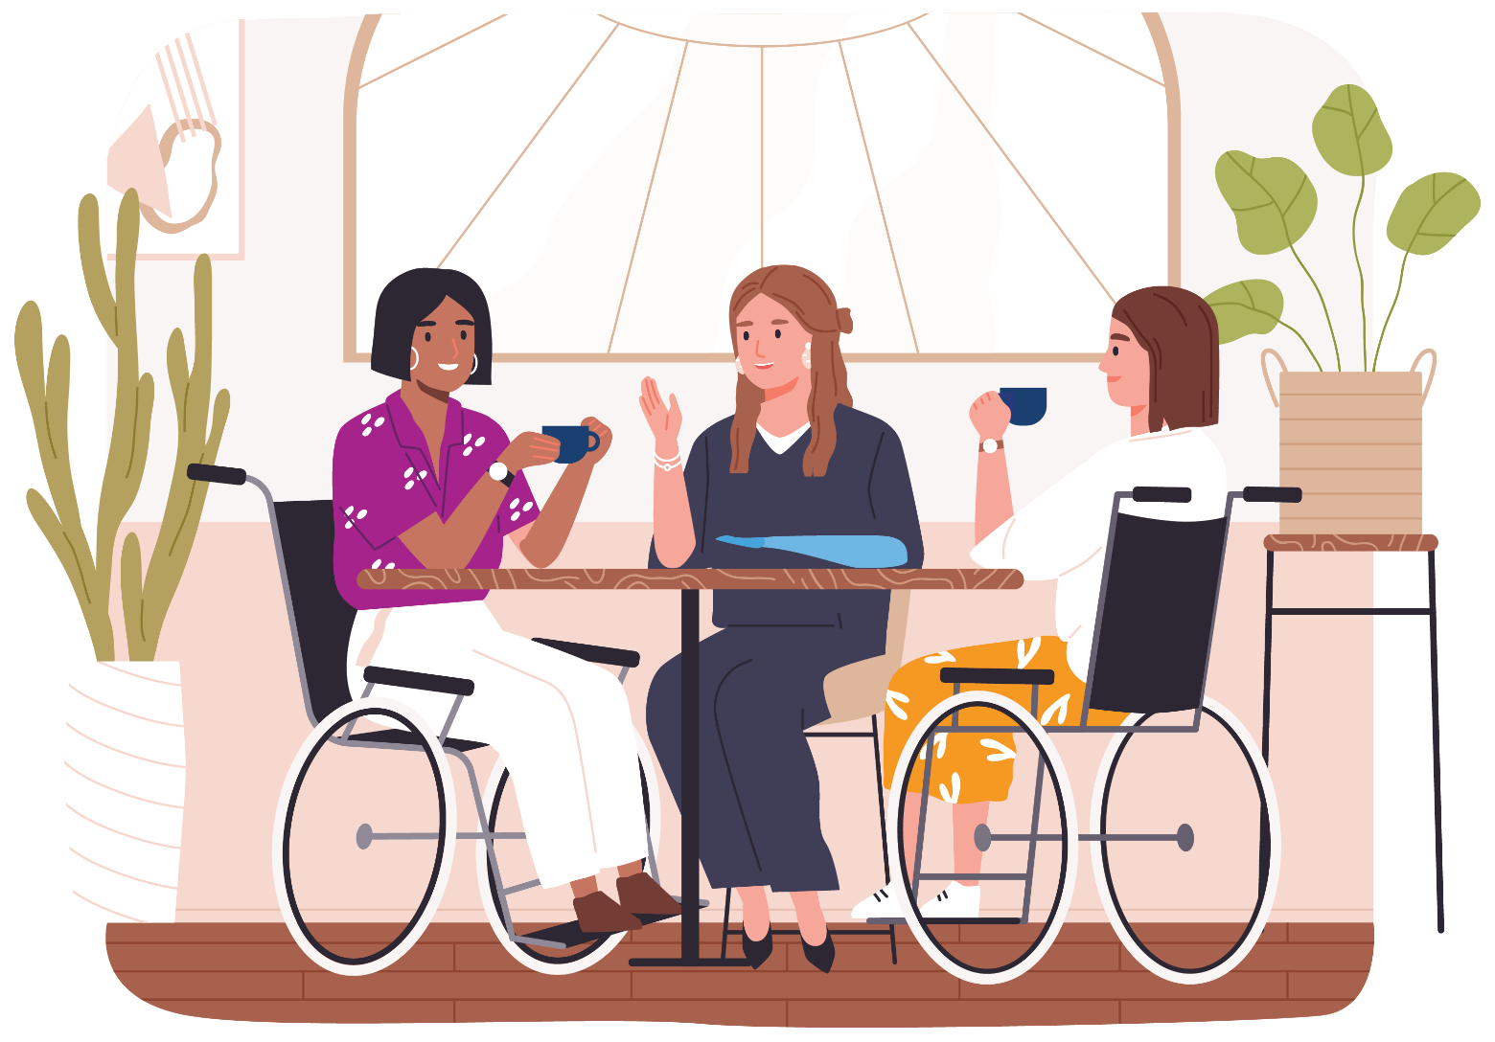

Community Inclusion and Women’s Empowerment Hubs
The Community Inclusion and Women’s Empowerment (CIWE) team works together with the community and the government. The program has a strong focus on regional women and maintains a presence in areas of Victoria where women face compounded risks of isolation due to lack of transport and accessible local services.
As a team, we feel empowered to create positive change through innovative ideas and bravery. Our goal is to be a source of knowledge and expertise that reaches out to the community. We believe in supporting each other as peers and expressing ourselves with kindness and determination. Our purpose is to raise awareness about problems faced by our community, both small and large. By sharing information well, we want to help everyone understand critical issues and encourage them to take action.
We do this in 2 distinct ways – our leadership programs and our regional Hubs. The leadership programs include both generalist and youth programs and include a ‘values’ workshop. The programs take place over 6-8 weeks and create an environment for lifelong specialist learning as well as friendship and peer support.

The Hubs, hosted in local regional venues, give members a space to discuss, plan and respond to critical issues in their local communities. Adopting an integrated approach, our Hub Liaison Officers utilise other teams (Health and Gender and Disability) to bring their expertise to the group along with other guest professionals as well as involvement in local forums, events, and activities. Collectively through both streams, women with disability can effect positive change.
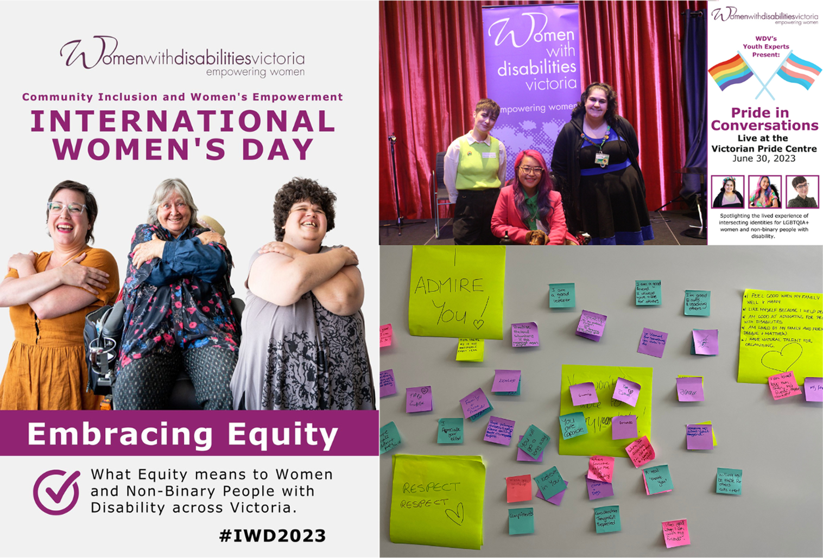
Community Inclusion and Women’s Empowerment Hubs image (above):
Photo 1 – Left hand side of page
Three members of the Bendigo Hub, Emma, Lorraine and Lou with their arms crossed over their chest embracing themselves. They are all smiling. This is from the International Women's Day Poster campaign - 'Embracing Equity.'
Photo 2 – Top right
Youth Experts and special guest at the 'Pride in Conversations' event. From left to right: Mon, Akii and Bell. They are all looking at the camera in front of a shiny red stage curtain.
Photo 3 – Bottom right
Members from the CIWE team and the Barwon Hub conducted an exercise with conference delegates that highlighted the power of positive messaging. First, they were asked to write or draw the negative things they've been told onto colourful sticky notes. These were then stuck to the wall. Next, the CIWE team led a conversation about affirmations, self-care and positive messages. The delegates then wrote or drew their positive messages and happily stuck these over the top of the negative messages. The photo shows the two layers of colourful sticky notes stuck to a wall with the positive messages on top.

Bendigo Hub member profile – Pam
Pam acquired disability late in life. She started coming to the Bendigo Hub a year ago. She was unsure about her disability identity and what she could offer the community. She is now proud of her disability identity. She regularly advocates for herself. She volunteers at St John of God by visiting patients with training support dogs. She has also started her own stoma support group. Pam has also joined the Disability Inclusion Reference Committee (DIRC). Quote from Pam:
“Before the Hub I didn’t know people like me existed, the Hub helped me realise I am not the only one living with disability, and that I can get out in the community and be useful. When I first became a wheelchair user, I was scared to leave the house. I started by short trips to the end of my road and back. I was scared about what people would think of me. Now I realise people are kind and make sure the path is clear for me on my route in my neighbourhood. Everyone knows who I am and makes sure I can access the footpath.”

Goal 1: Facts and Figures
14 editions of e-news published with an average open rate of 40%
26,948K per annum website sessions
951 WDV members = 904 Full Members and 47 Associate Members
Facebook: 5,571 followers = 7.4% growth
Instagram: 1,671 followers = 15% growth
LinkedIn: 1,167 followers = 28% growth

Policy - Violence Against Women with Disabilities
Partnerships to develop violence response service practice have featured in our policy work again this year. Here we will highlight two main streams of focus.
We commenced research on what supports recovery after sexual violence, in partnership with Sexual Assault Services Victoria and The University of Melbourne. We interviewed a range of survivors and specialist workers, with strong representation of people with disabilities themselves and people who work with them. A literature review is also underway. In 2024 we will deliver a report to WDV members and the project funder, Family Safety Victoria, in which we aim to inform improvement of recovery services in Victoria.
We have continued to partner with Safe and Equal and Sexual Assault Services Victoria on a governmental project coordination committee, project advisory groups, and various submissions inquiries and consultations on family violence service design, risk assessment, crisis brokerage guidelines, and the National Disability Insurance Scheme (NDIS). A key focus has been the relatively new Disability Family Violence Practice Leader roles about which we have had input into the program logic, evaluation framework and professional development. We have been immersed in learning from their practice and amplifying persistent systemic disability access barriers, such as family violence refuge buildings, and gaps in system interfaces which disadvantage women and other people with disabilities seeking safety from violence.

Health Services Program
The Health Services Program promotes the rights of women with disabilities to enjoy optimal mental, physical, social and community health. Our various projects seek to advance and advocate for the rights of women with disabilities to be free from violence and abuse and to receive inclusive access to health services.
The Health Services Program prioritises partnerships with a variety of sectors with a focus on women’s health. The goals of these partnerships are:
- To widen the reach of our work across Victoria, including in regional communities
- To support partner organisations in recognising the greater prevalence of violence against women with disabilities and ensuring their prevention activities are disability inclusive
- To produce resources supporting evidenced based practice according to frameworks such as Changing the Landscape.
A program priority is women’s access to support and information. This is critical to enable women to advocate for accessible health services that meet their needs. The program has developed resources and workshops to assist women to navigate Australia’s complex health service system, and to advocate for inclusive service provision for themselves and their peers.
Resources and training are also delivered to health service providers across acute, primary, community and allied health sectors, offering guidance regarding the implementation of inclusive service provision tailored to the individual needs of women with disabilities. All program resources, activities and training are co-designed with women with disabilities, whose collaboration is essential to program success.

Gender and Disability Workforce Development Program
The Gender and Disability Workforce Development Program (G&D), funded by the Office for Prevention of Family Violence and Coordination, aims to prevent violence against women with disabilities before it occurs. Established in 2014, the program has recently received another phase of funding.
The program aims to:
- Build and consolidate strategic positions, communications, representation and partnerships for preventing violence against women with disabilities
- Increase women with disabilities’ workforce engagement, leadership and representation in primary prevention and disability
- Build the capacity of women with disabilities and the prevention, disability and social services workforces to prevent violence against women with disabilities
- Build the evidence base for preventing violence against women with disabilities.
All program activities seek to build the capacity of the specialist and contributor sectors and workforces that have a role to play in preventing violence against women with disabilities and target the underlying causes of violence – also known as the drivers of violence – to transform them.
Program activities include:
- Experts by Experience advocacy, with a group of twelve women and non-binary people with diverse experiences of disability who support the work of WDV and other organisations by sharing their lived experience through consultations and awareness raising sessions
- Delivery of training sessions to practitioners and organisations and facilitation of a Community of Practice
- Development of resources.

Safe and Equal Partnership
Safe and Equal collaborates with WDV across several areas of work. A formal partnership was established in 2021-2022, enabling Safe and Equal to model and build our understanding and practice of inclusive and accessible primary prevention work. It also allowed us to work together in an open, authentic and transparent way. The learnings from the formal partnership continue to be invaluable and we actively seek to embed the practices, learnings and principles into the way we engage and work with WDV and contribute to the prevention of violence against women with disabilities.
Safe and Equal has really enjoyed participating in the G&D Program Advisory Group, a great space for sharing learnings and practice across the sector. WDV are a member of Safe and Equal’s advisory groups including the Prevention Strategy Advisory Group where they provide their expertise and advice on ensuring the disability perspective is consistently and continuously applied into broader strategic priorities.
As commitment to embedding meaningful consultation with women with disabilities, Safe and Equal engaged the G&D Experts by Experience Advocates for input into the access and inclusion component of our national prevention conference, PreventX. A case study was then co-designed to illustrate the value of consulting with lived experience to ensure the conference was trauma informed, accessible, inclusive and contained a strong and consistent disability lens.
Authors: Hannah Dwyer, Prevention Program and Campaigns Advisor and Amelia Ditcham, Prevention Practice and Workforce Development Manager, Safe and Equal
“I participated in the Prevention of Violence Against Women with Disabilities (PVAWD) credential pilot at the beginning of 2023. Not only did the pilot increase my knowledge and understanding of the intersecting drivers of violence against women with disabilities but was also a way for me to reflect on my own internalised ableism through the learning journey the pilot took us through. These learnings were applied both in my own practice and within the organisation: I established processes to regularly reflect and adapt ways of working to increase access and inclusion within primary prevention work and contribute to workplace inclusion systems and processes.”
– Hannah Dwyer, Prevention Program and Campaigns Advisor, Safe and Equal
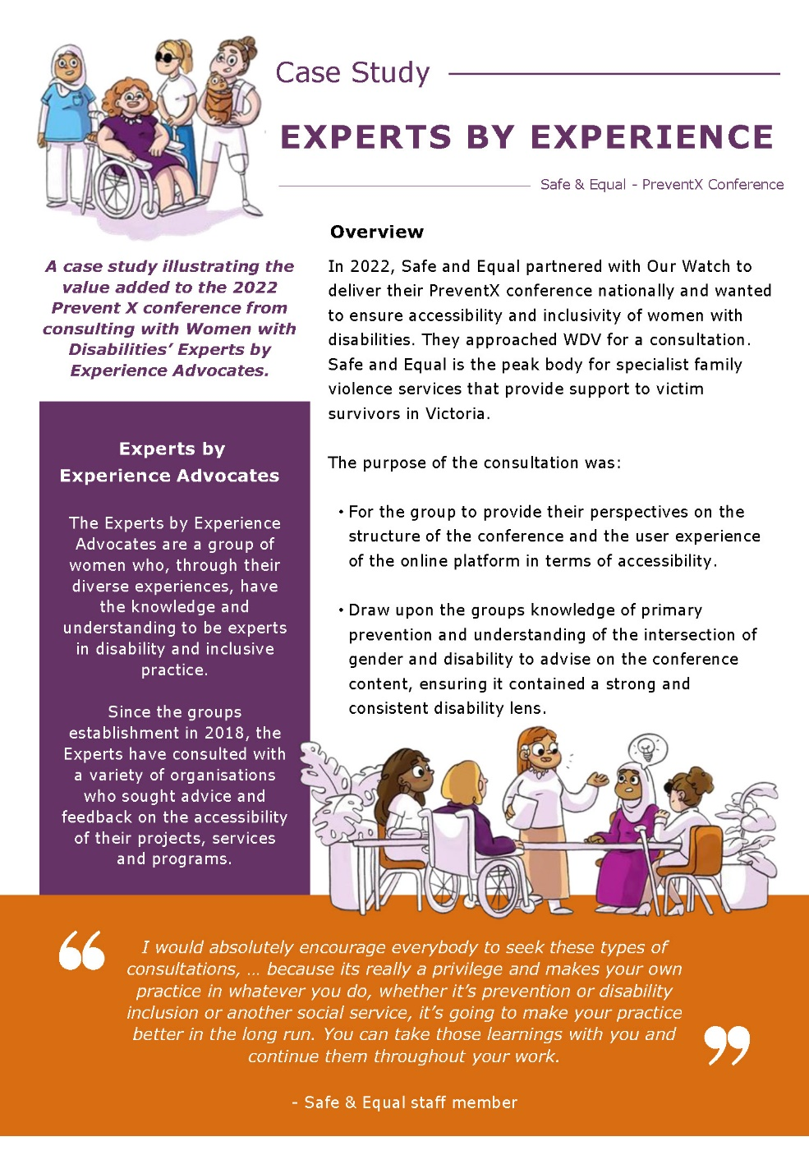

Image description: The first page of the Prevent X case study. Two columns of text with two images.
Image 1 – A diverse group of women with disabilities face forward proudly.
Image 2 – One woman leads a focus group of four women with disabilities around a table where thoughts, ideas, opinions, and experiences are being exchanged.

WDV Operations
WDV Operations is responsible for the day to day running of WDV by providing human resources, finance, membership and communications, marketing, IT and program support services to support the effective delivery of the WDV Strategic and Operational Plans. WDV Operations:
- Provides high-quality internal systems and processes to support delivery of the WDV Strategic Plan
- Provides advice to the Board, Treasurer and management team regarding WDV’s financial wellbeing and business performance
- Assists to develop, implement and review WDV’s community engagement activities
- Provides human resource management fostering a collaborative culture
- Provides strategic direction and support for WDV’s infrastructure and Information Communications Technology.

Increased Membership engagement and online presence
During the 2022-2023 year, WDV membership has increased by 18% and we have increased our engagement both with members and outside WDV. We have seen a significant increase in followers and engagement statistics across our key social media channels of Instagram and LinkedIn.

Increased access for Members
WDV Operations planned and delivered WDV’s first hybrid Members Event and AGM in November 2022. The event was held at the Isabella Fraser Room, State Library Victoria and online via Zoom. The hybrid model provided greater access to members. We received very positive feedback from Members about the venue, accessibility and the hybrid format of the event.
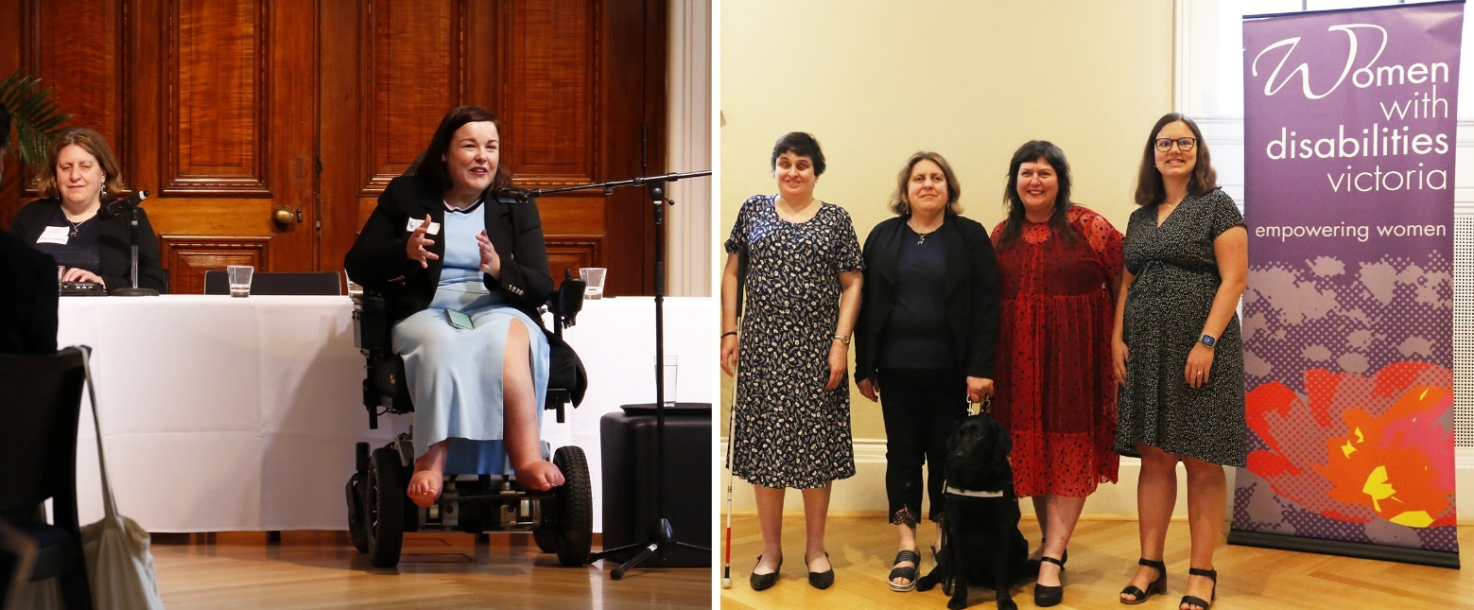
Image description:
Left: Peta Hooke, guest speaker at the WDV Members Event and AGM. Image description, Peta is wearing a light blue dress and black blazer and speaking into a microphone at the front of the room. Nadia Mattiazzo (WDV CEO) sits to the left of the image.
Right: Staff at the WDV Members Event and AGM. Image description: Helen Freris (Manager, Health Services Program), Nadia Mattiazzo (WDV CEO) and her Seeing Eye Dog Abbie, Liz Wright (Manager Community Inclusion and Women's Empowerment) and Soizic Brohan (Gender and Disability Workforce Development Program Manager). They are standing by a WDV banner and smiling at the camera.

Regular communication to WDV Members and supporters
Our eNews was published monthly and we introduced a mailout to members who requested communications by post. Our annual Member Survey confirmed that publishing monthly was the preferred frequency for our members.

Profile of Membership Engagement and Communications Officer, Jessica Celebi
“As the Membership Engagement & Communications Officer for WDV, I'm committed to creating connection between our organisation, our membership base, and the wider community. This role has allowed me to meet some incredible people and witness connections being formed.
Throughout the year, WDV has organised workshops, collaborative projects, and I have helped organise the Quarterly Conversations as well as the annual Members event and Brenda Gabe Leadership Award 2023.
In my personal time, I enjoy spending time with animals. I have a lovely French Bulldog named Hershey, and a horse named Remi. Animals can bring joy and happiness in various ways through the positive effects they have on our physical and emotional well-being.
Looking ahead, I'm excited to meet some new faces, re-connect with familiar ones, and work together to create a brighter future for women with disabilities. I’m very lucky to work with some wonderful people every day.”

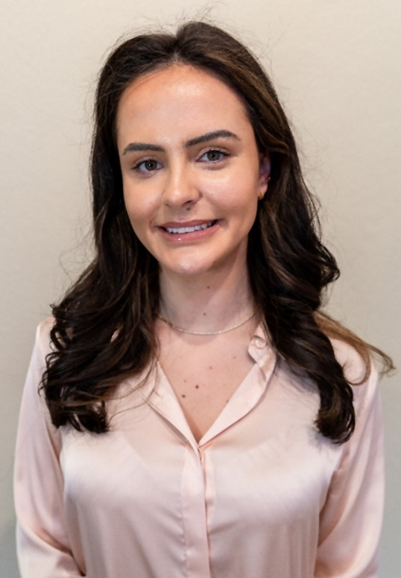

Goal 2: Pursue safety, wellbeing and connectedness for women with disabilities
Leverage government funded policy reform and programs

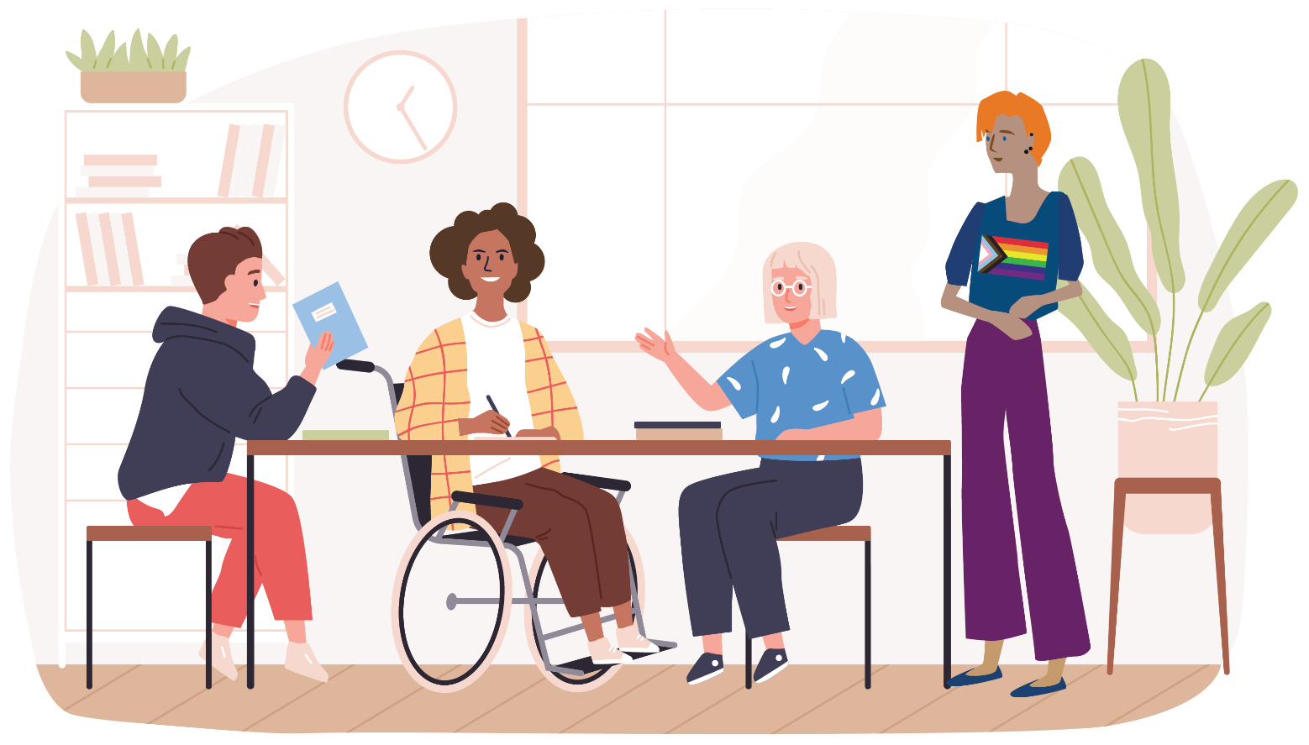

Advocating for Prevention of Violence Against Women with Disabilities (PVAWD)
Our programs have been actively engaged in advocating for the prevention of violence against women with disabilities across multiple governance bodies, including PVAW project and strategic advisory groups, local government prevention networks, disability committees, and state prevention Communities of Practice (CoP). This engagement ensures that the needs and challenges faced by women with disabilities are represented in policy discussions and decision-making processes.

Promoting Collaboration and Inclusivity
We believe in the power of collaboration. In 2022-2023, we convened four Violence Prevention and Disability Inclusion CoP meetings, bringing together 24 disability, social services, and prevention organisations. Over 50 disability service providers and prevention practitioners also attended our CoP meetings. These meetings serve as platforms for sharing knowledge, best practices, and strategies to address violence prevention and disability inclusion.

Empowering Through Resources
We recognise the importance of equipping practitioners and policymakers with evidence-based information and guidance. To this end, we have updated and developed seven PVAWD resources, drawing on lived experiences.
One noteworthy resource is the ‘Taking Action Guide’, designed to empower disability service providers and prevention practitioners with an intersectional perspective on preventing violence against women.
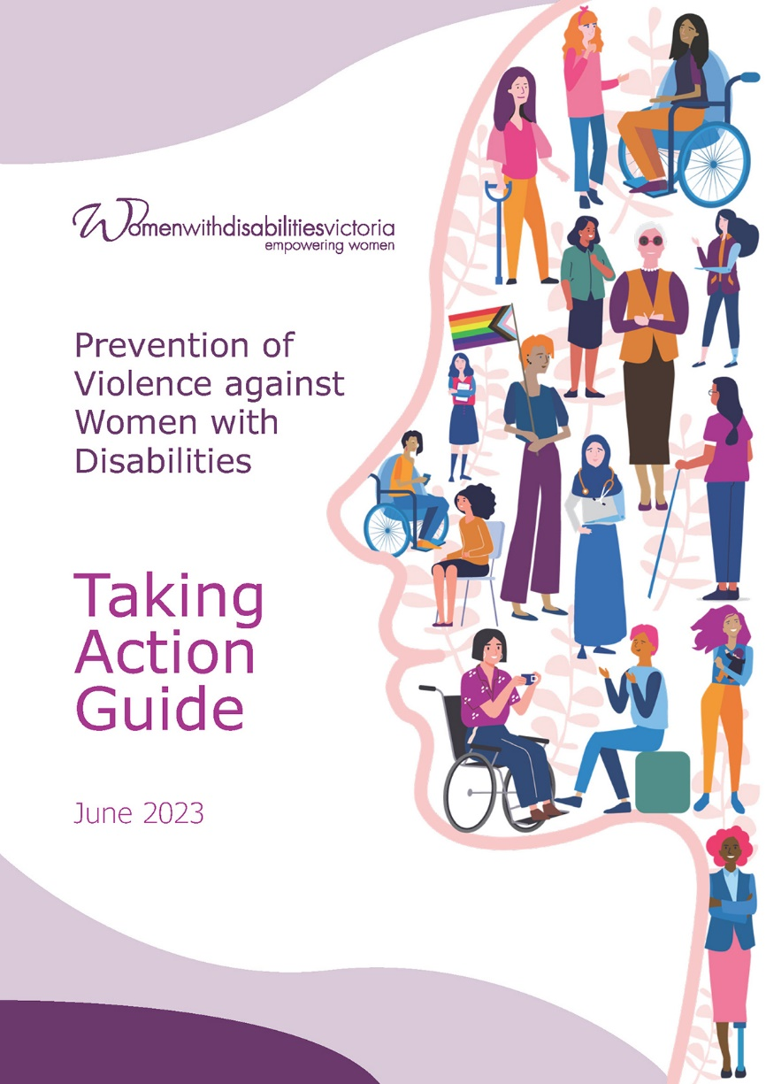
Image description: The front cover of the Taking Action Guide. Text reads ‘Prevention of Violence against Women with Disabilities – Taking Action Guide. April 2023’. Illustration of a woman's profile filled with drawings of women and non-binary people with various disabilities.
In addition, our "Experts in our Health Project" has been instrumental in resourcing inclusive health service provision. We've created materials such as posters, fact sheets, a guide for navigating health systems, and a video featuring the lived experiences of women with disabilities advocating for inclusive health services. These resources are available in various formats and community languages to ensure accessibility.

Advocacy Through Partnerships
Through strategic partnerships with Women's Health Gippsland and Women's Health in the North, we've continued to advocate for the prevention of violence against women with disabilities. By providing training and technical assistance, we've supported these organisations in enhancing accessibility and disability inclusion in their communications and violence prevention projects.

Promoting Co-design
The principle of co-design remains central to our approach in pursuing women's safety and wellbeing. In October 2022, we organised a successful symposium, highlighting resources co-designed by our lived experience experts. This event attracted over 80 participants from health and community sector agencies and is available as a recording on our website, ensuring wider dissemination of co-design strategies.

Policy Impact and Recognition
We are delighted to report that our policy advocacy efforts have yielded positive results. Following our submission and presentation to Victoria's economic equity inquiry, we were invited to progress significant funding allocation towards our Health Services Program. Our influence extended to a 2022 Victorian Government online seminar, where we presented on co-design, guiding the implementation of the State Disability Plan. The seminar was attended by 170 people.

Elevating Women's Mental Health
Our work with the Victorian Women's Mental Health Alliance has been impactful, elevating the profile of the need for safe, accessible, and gender-sensitive mental health services. Through media and policy representations, we continue to drive change in this critical area.

Effective Communication and Outreach
In order to maintain momentum and stay connected with our community and stakeholders, we employ a variety of means. We actively participate in networks, committees, and events important to women and women with disabilities. Our presence on social media, print media, and digital media channels ensures that our message reaches a wider audience.
Our commitment to pursuing safety, wellbeing, and connectedness for women with disabilities remains unwavering. We are dedicated to continuing our advocacy efforts, developing valuable resources, fostering collaboration, and ensuring that the voices and needs of women with disabilities are heard and addressed in policy reform and programs.
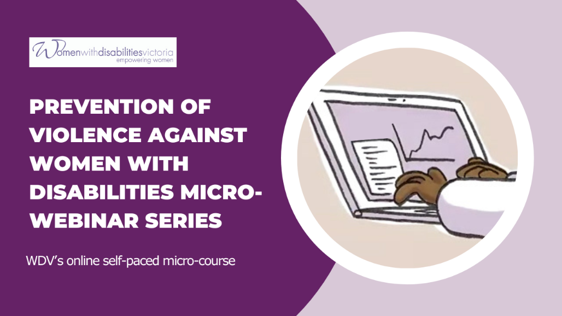
Image description: Front page of the Prevention of Violence Against Women with Disabilities micro-webinar series. Text reads ‘Prevention of Violence against Women with Disabilities Micro-webinar series. WDV’s online self-paced micro-course.’ Illustration of a hands typing on a laptop.
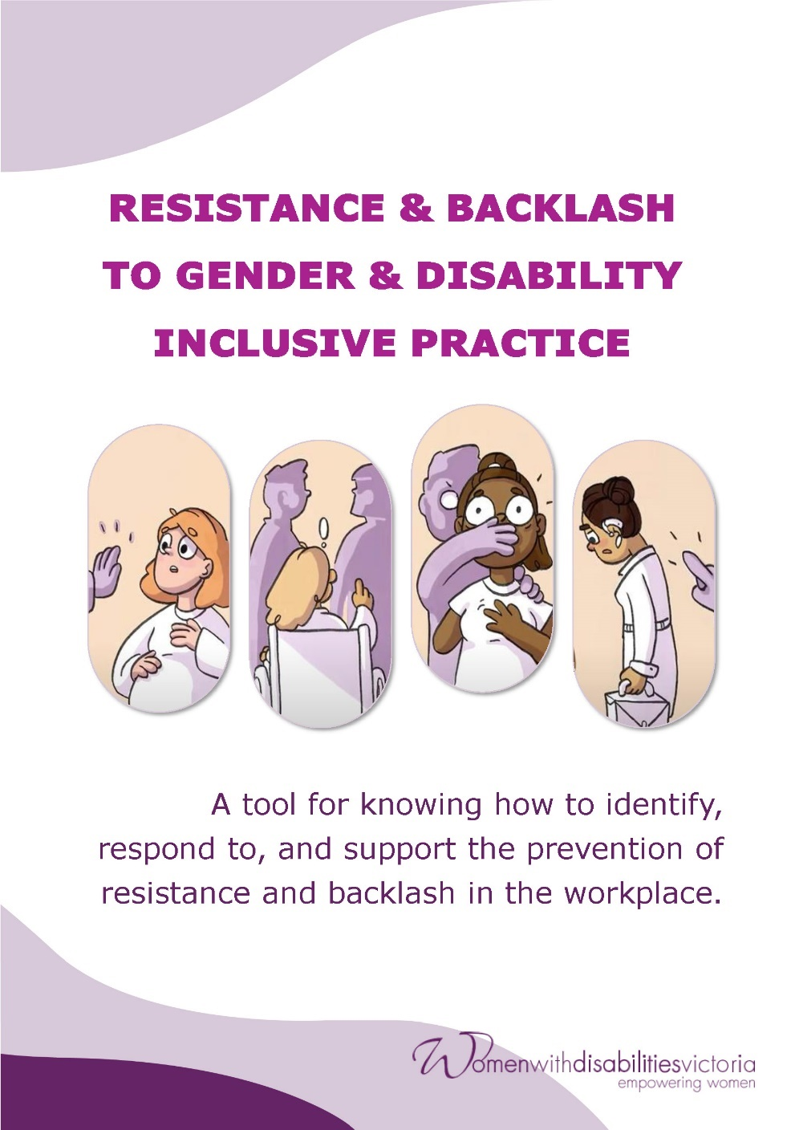
Image description: The front cover of the Resistance and Backlash to Gender and Disability Inclusive Practice resource. Text reads ‘Resistance and Backlash to Gender and Disability Inclusive Practice – A tool for knowing how to identify, respond to, and support the prevention of resistance and backlash in the workplace’.
A series of 4 images shows:
- A pregnant woman or non-binary person encounters a hand held out in front of them in a stop gesture. They look surprised.
- A woman or non-binary person in a wheelchair is trying to speak up and we see that others in the room are not paying attention and have their backs to them.
- A scared looking woman or non-binary person has their mouth covered by a figure behind them who has angry eyebrows. The figure also has a hand on the person’s shoulder, close to their neck.
- A woman or non-binary person is dressed professionally, holding a work bag and has a hearing aid. They are walking away and looking downcast as a finger gestures at them in a negative way.

Goal 3: Create long term change
through engagement, education and advocacy
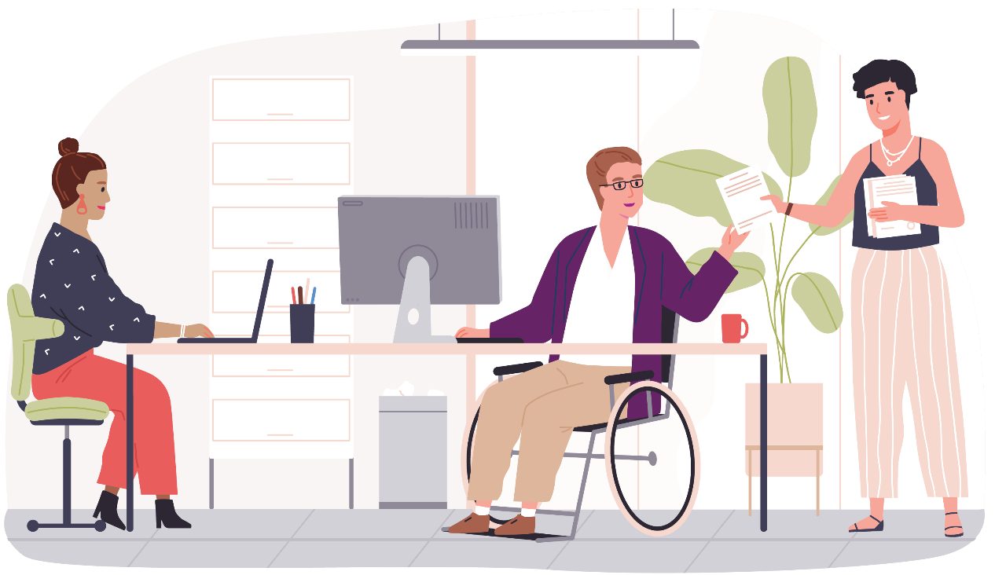

Creating Long-Term Change through Engagement, Education, and Advocacy
WDV is committed to creating long-term change through active engagement with our community, providing essential education, and advocating for meaningful reforms. We continue to maintain a strong regional presence through our Hubs. This work has been platformed in multiple interviews on Pulse FM, interviews with ABC Central Victoria for ‘Talking Disability’ and in presentations to the Mayor and Councillors of the City of Greater Bendigo.

Empowering Through Education
The Gender and Disability Program’s dedication to empowering individuals and organisations through education has been a cornerstone of our efforts. In the past year, we organised various training sessions, with a total of 385 participants attending our programs from disability, social services, and prevention workforces. Notably, 38 practitioners benefited from our open training sessions, while we tailored training programs for nine organisations, ensuring that our education initiatives reached a diverse audience.

Innovative PVAWD Credential Program
The Gender and Disability Program are proud to have initiated the PVAWD credential program. Seven disability service providers and prevention practitioners participated in this program, which included training, assessments, and practical steps to change practices. This credential represents a significant step towards raising awareness and improving practices in preventing violence against women with disabilities.

Amplifying Lived Experiences
During our Actions for Prevention resources launch event, we proudly showcased our latest PVAWD resources. What made this event truly special was our commitment to centring the voices of lived experience experts. The event was attended by 103 professionals from disability, social services, and prevention workforces. It served as a platform to showcase accessibility best practices and garnered positive feedback from attendees, such as their appreciation for closed captioning and the event's intersectional lens.

Recognition and Collaboration
Our Health Services Program's expertise in primary prevention of violence against women was recognised this year when we partnered with Our Watch to produce practice resources building on the ‘Changing the Landscape’ Resource. Through our program staff's involvement, we provided valuable insights into the contextual practice needs of disability service provider organisations and principles for producing accessible resources. These project resources are expected to be released in the second quarter of 2024.
Additionally, our Health Services Program actively shared its primary prevention expertise with organisations working on preventing and responding to violence against women. We delivered panel presentations on the Maram framework, an assessment tool used by organisations responding to violence against women. We also contributed to a panel session within the Fast Track violence prevention Leaders course convened by Safe and Equal.

Advocacy and Strengthening Representations
Our advocacy efforts have had a significant impact. We provided written evidence and appeared at Disability Royal Commission hearings, which led to an invitation to provide additional evidence to strengthen our recommendations. In partnership with key peak bodies such as SASVic and Safe and Equal, we have continued to advocate for greater disability inclusion in family violence response services. We remain influential in policy, with over 100 family violence practitioners attending Safe and Equal's 2022 disability inclusion online forum. Our representations span across government committees, inquiries, and forums and have been instrumental in driving positive change.

Promoting 'Changing the Landscape'
Since launching 'Changing the Landscape: A national resource to prevent violence against women and girls' in partnership with Our Watch, this resource has gained widespread recognition and reference. We have worked on further promoting this Resource with the support of DSS funding. Our Policy team has played an active role in developing a draft action plan for the implementation of the resource's recommendations by state and national governments.

REACH Initiative Progress
Our one-year investigation into what supports recovery after experiencing sexual violence, known as REACH, has made significant progress. We obtained ethics approval, established a Participant Advisory Group (PAG) with disability representation, created Easy Read materials and an information video for participants, and initiated interviews with people with disabilities, people without disabilities, and various workers, including those specialising in supporting people with disabilities.
Our concerted efforts in engagement, education, and advocacy have brought us closer to achieving our goal of creating long-term change. We remain dedicated to empowering women and non-binary people with disabilities, amplifying lived experiences, and advocating for inclusive policies and practices.

Goal 4: Key enablers
WDV will ensure strong organisational infrastructure to enable our strategy

Financial Sustainability and Policy Consultations
As part of our commitment to financial sustainability, the Policy team were engaged on a fee-for-service basis by state, national, and international organisations. They conducted reviews of papers and provided valuable advice on strategies for reaching, preventing, and responding to violence against women with disabilities. This collaboration not only supported our financial stability but also contributed to our mission of advocating for women with disabilities.

Advocacy for Funding
On a daily basis, our Policy team has advocated for funding that aligns with the needs and requirements of our valued members. These efforts were aimed at securing resources for WDV programs and initiatives, ensuring that we can continue to deliver essential services and support.

Active Engagement
Our Policy team actively engaged in meetings with WDV's leadership, managers, teams, and staff. They also played a crucial role in reading and contributing to both internal and external publications, further solidifying our commitment to transparency and informed decision-making.

Equity, Influence, and Positive Change
At WDV, we are committed to achieving equity and influence to create positive change for women with disabilities. We believe that by sharing stories and creating profiles for our members and participants, we can prioritise opportunities that will lead to sustainability.

Strategic Partnerships
We maintained our ongoing relationships with key organisations, including Women’s Health Goulburn Northeast, Centre for Non-Violence, and others, as outlined later in this report. These partnerships are essential in advancing our mission and strengthening our network of support.

Event Management and Promotion
Our CIWE team has developed an extensive event management guide, covering everything from risk assessment to access guides, promotion strategies, and marketing. We also utilise geographically specific forms of media to attract attention to our Hubs and leadership programs within the broader community.

Program Evaluation
In 2022, we launched the Gender and Disability Workforce Development Program evaluation report during the Co-design Symposium, attended by disability, social services, prevention, and health practitioners, as well as service providers. This event showcased co-design best practices, including co-designed evaluation. We continued this commitment with the development of two 2021-2023 program evaluation reports, which will inform the next stage of the Program, having secured funding for another four years.
Additionally, we developed program planning and reporting documents. Collaboration with the Office for Violence Prevention and Coordination was ongoing, leading to the development of accessible planning and reporting templates. These initiatives are crucial in ensuring accountability and transparency in our operations.

Relocation of the WDV Office
In early 2023, WDV moved offices from Level 9 to Level 1, 255 Bourke Street, Melbourne. The Operations team was responsible for negotiating our new lease, overseeing the design of the new office to provide an accessible and collaborative environment for WDV staff, managing the relocation of furniture, fittings and equipment and setting up the new workspaces and IT.
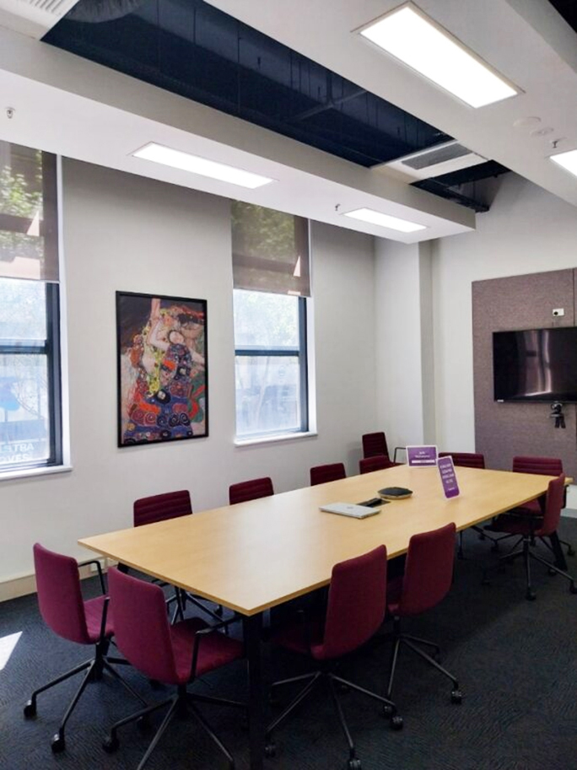
Image description: Photo of the completed boardroom in WDV’s new office. A long, woodgrain table sits in the middle of the room with 12 purple upholstered office chairs around it. There is a large TV screen on one wall and a painting set between two windows that look out over Bourke Street.

Thank you…
to the following funders, partners and supporters
Anglicare Victoria
Australian Multicultural Community Services
Berry Street
Better Health
BreastScreen Victoria
Brotherhood of St Laurence
Centre for Non-Violence
City of Casey
Cobram Community House
Commonwealth Department of Social Services
Coonara Community House
Eastern Community Legal Centre
Family Safety Victoria
Geelong Region Alliance G21
Health Issues Centre
Melbourne Polytechnic
Multicultural Centre for Women’s Health
Nillumbik Shire
Office for the Prevention of Family Violence and Coordination, Victorian Department of Families, Fairness and Housing (DFFH)
Our Watch
Rainbow Health Australia
Royal Women’s Hospital
Safe and Equal
Scope Australia
Sexual Assault Services Victoria
Victoria University
Victorian Aboriginal Child Care Agency (VACCA)
Victorian Department of Families, Fairness and Housing (DFFH)
Victorian Department of Health
Wellington Shire Council
WLK Consulting
Women’s Health East
Women’s Health Gippsland
Women’s Health Loddon Mallee
Women’s Health in the North
Women’s Health in the South East
Women’s Health Victoria

Donors who supported WDV
this year
Asma Chougle
Abbey Dalton
Molly Hoffman
Hardeep Singh
Jemma Swan

WDV Regional Hub Partners
Centre for Non-Violence
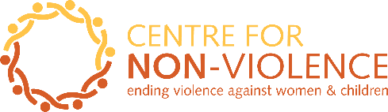

Cobram Community House
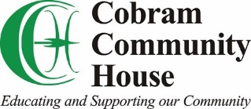

Coonara Community House
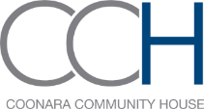

Geelong Region Alliance G21
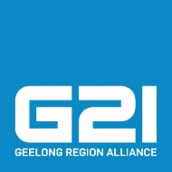

Southwest Advocacy Association
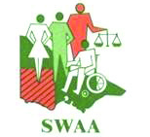

Financial Statements

The WDV Board and Finance & Risk Committee continued to strengthen WDV’s financial position.
WDV is in a strong financial position, and we are able to pay our debts if and when they are due.
The Profit and Loss Statement shows a surplus (gain) of $106,095 in the 2022/23 financial year.
Revenue (money coming in) for this year was $2,773,647, an increase of $446,837 from last year.
Expenses (money going out) for this year was $2,667,552, an increase of $475,266 from last year.
Equity (value of WDV) for this year was $2,015,375, an increase of $106,095 from last year.
This year Current Assets are $3,682,258, which is equal to 2.4 times our Current Liabilities of $1,540,810. This is a healthy position.
Cash Reserves increased this year to $3,603,799 an increase of $460,883 from last year.

Statement of profit or loss
and other comprehensive income for the year ended 30 June 2023

 | 2023  $ | 2022  $
Continuing operations
Revenue | 2,773,647 | 2,326,810
Expenditure
Depreciation expenses | (70,037) | (9,426)
Employee benefits expenses | (1,963,824) | (1,630,738)
Other expenses | (633,691) | (552,122)
Total expenses | (2,667,552) | (2,192,286)
Surplus (Deficit)  before tax | 106,095 | 134,524
Income tax expenses | – | –
Surplus (Deficit)  for the year | 106,095 | 134,524
Other comprehensive income | – | –
Total comprehensive Surplus/(Deficit)  for the year | 106,095 | 134,524

Statement of financial position
as at 30 June 2023

 | 2023  $ | 2022  $
ASSETS
Current Assets
Cash and cash equivalents | 3,603,799 | 3,142,916
Trade and other receivables | 4,035 | 4,504
Other current assets | 74,424 | 35,622
Total Current Assets | 3,682,258 | 3,183,042
Non-Current Assets
Property, plant & equipment | 24,074 | 11,486
Right of use asset | 426,588 | –
Total Non-Current Assets | 450,662 | 11,486
Total Assets | 4,132,920 | 3,194,528
LIABILITIES
Current Liabilities
Trade and other payables | 1,540,810 | 1,192,875
Total Current Liabilities | 1,540,810 | 1,192,875
Non-Current Liabilities
Provisions | 112,563 | 92,373
Right of use liability | 464,172 | –
Total Non-Current Liabilities | 576,735 | 92,373
Total Liabilities | 2,117,545 | 1,285,248
NET ASSETS | 2,015,375 | 1,909,280
EQUITY
Retained Earnings | 2,015,375 | 1,909,280
TOTAL EQUITY | 2,015,375 | 1,909,280

Statement of changes in equity
for the year ended 30 June 2023

 | Retained Earnings  $ | Total  $
Balance at 1 July 2021 | 1,774,756 | 1,774,756
Surplus/(Deficit) attributable to members | 134,524 | 134,524
Balance at 30 June 2022 | 1,909,280 | 1,909,280
Surplus/(Deficit) attributable to members | 106,095 | 106,095
Balance at 30 June 2023 | 2,015,375 | 2,015,375

Cash flow statement
for the year ended 30 June 2023

 | 2023  $ | 2022  $
CASH FLOWS FROM OPERATING ACTIVITIES
Receipts from customers | 2,754,819 | 2,321,549
Payments to suppliers and employees | (2,286,481) | (2,066,543)
Interest received | 18,828 | 5,261
Net cash provided by (used in) operating activities | 487,166 | 260,267
CASH FLOWS FROM INVESTING ACTIVITIES
Payments for plant and equipment | (26,283) | (16,390)
Net cash provided by investing activities | (26,283) | (16,390)
Net increase in cash held | 460,883 | 243,877
Cash at beginning of financial year | 3,142,916 | 2,899,039
Cash at end of financial year | 3,603,799 | 3,142,916

Get in touch
Keep up to date with WDV; join our community

https://www.facebook.com/womenwithdisabilitiesvictoria
https://www.instagram.com/womenwithdisabilitiesvic/
https://www.linkedin.com/company/womenwithdisabilitiesvictoria/
https://twitter.com/WDVtweet
https://www.youtube.com/user/WDVchannel

Wurundjeri Country
Level 1, 255 Bourke Street
Melbourne VIC 3000

Postal: PO Box 18314
Collins Street East VIC 8003

Phone: 03 9286 7800

Email: wdv@wdv.org.au
www.wdv.org.au

