Election of Member Directors to the Board of Women with Disabilities Victoria

Annual General Meeting, 14 November 2023

Board Nomination Statements

Anastasiia Berezikova

Asherly Bradac

Crystal Bruton

Julie Dickson

Mairead Foley

Claudia Forsberg

Tess Marotta

Sirani McNeill

Othilia Nguyen-Le

Trudy Ryall

Maggie Toko

Talitha Travers

Emily Unity
Board Nomination Statements
As part of their nomination statements, nominees were asked to provide information on their areas of expertise and their skills. They were also asked to select from the options below for Questions 3 and 4. The areas of expertise and skills they selected are included in their personal statements that follow.

Question 3: In which areas do you have expertise and/or experience you can offer the WDV Board?
- Advocating for my rights and/or someone else’s
- Understanding disability and human rights
- Understanding of disability policy areas (NDIS, transport, accessibility, justice etc.)
- Understanding of prevention and response to family violence
- Experience in community building and engagement
- Being part of other communities (Aboriginal and/or Torres Strait Islander, intellectual disability, LGBTQIA+, CALD, under 30 years old etc.)
- Lived experience (for example, being a person with a cognitive /intellectual disability, being involved in the justice or employment system etc.)
- Other

Question 4: What professional skills, experience and/or expertise can you offer the WDV Board?
- Previous board, employment, or community experience
- Governance
- Finance
- Risk management
- Networking with community partners
- Media, marketing, or public relations
- Fundraising
- Research, writing or policy development
- Other

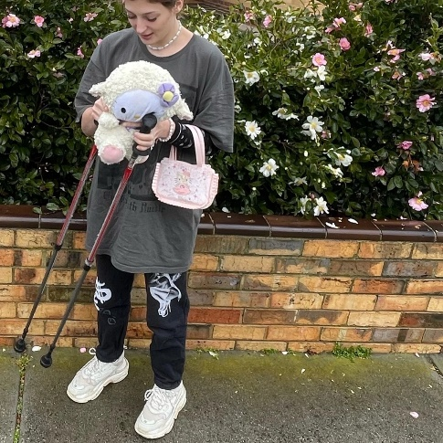
Board Nomination Statement:
ANASTASIIA BEREZIKOVA

Photo description: Young Caucasian woman in oversized T-shirt, sweatpants and sneakers standing on a sidewalk with hiking poles holding a toy.

1. Tell us about yourself. Who are you, what are you passionate about?

I’m a 24 year old queer refugee from Russia. I’m also an artist. I became disabled at 22 after 2 cardiac arrests. Since, I have realised the importance of having a voice and being heard for the disabled community. My perspective has changed and I’ve realised so many important things that I’m very keen to share with the world. My biggest values are knowledge, justice, freedom.

2. Why are you interested in being a Director on the WDV Board?

I would love to connect with my community and hopefully contribute to making an impact. I’m very young and I have a lot to learn. I would love to bring change into this world for a better healthier and happier environment.

3. In which areas do you have expertise and/or experience you can offer the WDV Board?
- Advocating for my rights and/or someone else’s
- Understanding disability and human rights
- Understanding of disability policy areas (NDIS, transport, accessibility, justice etc.)
- Understanding of prevention and response to family violence
- Being part of other communities (Aboriginal and/or Torres Strait Islander, intellectual disability, LGBTQIA+, CALD, under 30 years old etc.)
- Lived experience (for example, being a person with a cognitive /intellectual disability, being involved in the justice or employment system, etc.)

I’ve been disabled for only 2 years and have already gained plenty of experiences, hearing which can be of value to WDV Board. My education can be useful as well.

4. What professional skills, experience and/or expertise can you offer the WDV Board?
- Previous board, employment, or community experience
- Risk management
- Networking with community partners
- Media, marketing, or public relations
- Fundraising
- Research, writing or policy development
I have a bachelor’s degree in international tourism management. I have taken many valuable courses like research, marketing, management, statistics, economics, business ethics, workplace health and safety, etc. I believe all of these classes gave me knowledge that can be very useful for WDV.

5. What do you think are the most significant challenges and opportunities for women with disabilities in Victoria?
I think the most significant challenge for women with disabilities in Victoria is loneliness. There’s a lack of disability friendly social venues. There’s issues with transport so we’re scared to even attend events. Lack of education within the community. That’s just to name a few challenges. Opportunities for women with disabilities in Victoria are endless. We just need to be given those in an appropriate manner by the opportunity source.
Board Nomination Statement:
ASHERLY BRADAC

1. Tell us about yourself. Who are you, what are you passionate about?
I could say........I am a woman with a disability living in Victoria, a single mother to four young children, all with additional needs, I am a Forgotten Australian, past ward of the state, carer, fighter and survivor. I am the youngest of 3 girls to parents who fled from Laos after the Secret War and I was born in Australia and part of the Forgotten Australians.
But I am me. Asherly Bradac. As I am.

2. Why are you interested in being a Director on the WDV Board?
The strengths developed during childhood propelled me to excellence in high school and then in my professional career, which, out of necessity, began at the age of 16. From my first job in 2001 with the Victorian Equal Opportunity and Human Rights Commission, until today. My career has honed her skills in the areas that I values most – technology, data, people and overcoming prejudice.
My dream and passions are all driven by hope. To transform views, broken systems and all that creates and has shaped the world I have only ever known.
When we share our story and ourselves, we inspire and ignite action and positive change.
I want to help create a more inclusive and equal world where every person is able to feel safe, valued, heard, supported, connected, with a sense of purpose, acceptance and belonging within their community regardless of age, gender, race, status or ability.

3. In which areas do you have expertise and/or experience you can offer the WDV Board?
- Advocating for my rights and/or someone else’s
- Understanding disability and human rights
- Understanding of disability policy areas (NDIS, transport, accessibility, justice etc.)
- Understanding of prevention and response to family violence
- Experience in community building and engagement
- Being part of other communities (Aboriginal and/or Torres Strait Islander, intellectual disability, LGBTQIA+, CALD, under 30 years old etc.)
- Lived experience (for example, being a person with a cognitive /intellectual disability, being involved in the justice or employment system, etc.)
- Other
Asherly’s compassion and ability to make the complex simple have also been instrumental in driving her success, as demonstrated while working on projects such as the 2008 Homeless World Cup, Impact 2010: Engineers without Borders and Open House Melbourne, Playing Street Soccer in Prisons and many more.
Using her unique intellect, positivity, energy and vision, Asherly Bradac successfully inspires and impacts as many people, organisations and government bodies as she possibly can in order to bring about positive change in the world. While her influence to this point has been felt by thousands, with lived, living and life experience across:
- Public and private mental health systems
- Public and private mental health supports in the community
- Multiple insurance systems schemes and legislations
- Court processes and laws, legislations, gaps and needs
- Alcohol and other drugs
- Homelessness
- Domestic and family violence
- Community & mainstream supports
- An enormous network of trusted contacts

4. What professional skills, experience and/or expertise can you offer the WDV Board?
- Previous board, employment, or community experience
- Finance
- Risk management
- Networking with community partners
- Media, marketing, or public relations
- Fundraising
- Research, writing or policy development
Her engaging nature and ability to see things from others perspectives, has enabled Asherly to set new sales benchmarks across multiple industries throughout her 16 years in consulting, including in IT (Data Management Australia and West Corp), insurance (iSelect), recruitment (Hays Recruitment) and Energy (Origin Energy).
It was in 2012 that Asherly had her first experience as an advocate for Plan International Australia that set her on her path to actively represent underrepresented individuals, to help develop equal opportunity for all. Since speaking at the Inaugural International Day of the Girl, Asherly is a sought after ambassador, influencer, commentator and speaker by corporates, government agencies, media and sporting groups.

There’s no doubt that Asherly thinks big and is motivated by her life experiences.

5. What do you think are the most significant challenges and opportunities for women with disabilities in Victoria?
I think the most significant challenges for Women with a disability in Victoria is an answer that must come from the collective voices of every women living with a disability in Victoria, of every man and every other voice, not from mine.
The most significant challenges for myself as a women with a disability in Victoria, is feeling safe, supported and finding consistency, security and stability in life. Believing in myself, maintaining hope and finding the strength and will to never give up on the things I believe in.
First we must seek to understand by listening to everyone and then we can work to move forward as many, yet united as one, towards one common shared goal. That is where opportunity begins.

Board Nomination Statement:
CRYSTAL BRUTON

1. Tell us about yourself. Who are you, what are you passionate about?

My name is Crystal Bruton and I am a woman with lived experience of disability. I am passionate about driving equity and inclusion, and advocating for the safety and wellbeing of adults, young people and children in Victoria. I am passionate about social justice and ensuring an equitable society for all, including people with disability. This passion is reflected in my academic and professional background. My academic background is in the fields of criminology and psychology, including an honours degree in criminology and a Doctor of Philosophy focusing on women’s experiences of separating from an abusive, intimate male partner. I have extensive professional experience in the areas of family violence, violence against women and victims of crime in the context of health promotion, community development, advocacy, research and policy development at non-for-profit organisations, academic institutions, local government and state government. I was a Director on the WDV Board in 2023.

2. Why are you interested in being a Director on the WDV Board?

I want to positively contribute to the lives of Victorian women and non-binary people with disability. I believe my values align with those of WDV and feel my skill set would significantly contribute to the strategic priorities of the organisation. I am interested in further developing my leadership skills as a Director.

3. In which areas do you have expertise and/or experience you can offer the WDV Board?
- Understanding disability and human rights
- Understanding of disability policy areas (NDIS, transport, accessibility, justice etc.)
- Understanding of prevention and response to family violence
- Experience in community building and engagement
- Lived experience (for example, being a person with a cognitive /intellectual disability, being involved in the justice or employment system, etc.)

I have strong knowledge of the systemic barriers that women with disability experience in all areas of society. I have extensive experience in advocating for my own rights as a woman with disability in most areas of life. Through my professional experience, I have a comprehensive understanding of disability from a social model and human rights, underpinned by an intersectional approach. I also have a comprehensive understanding of key policy areas for women with disability, including family violence and justice. In my professional roles, I have focused on informing responses to family violence to ensure accessibility and inclusion for all, as well as improving outcomes for those who come into contact with the justice system including people with disability. I have also worked closely with the community to prevent violence against women through my work in local government.

4. What professional skills, experience and/or expertise can you offer the WDV Board?
- Previous board, employment, or community experience
- Governance
- Networking with community partners
- Research, writing or policy development

I have a range of skills that would be an asset to the WDV Board. Through my experience in local and state government over the past 9 years, I have engaged with key stakeholders from community and sector to inform policies and programs. I have demonstrated comprehensive engagement and consultative skills including an ability to build relationships, seek input and negotiate across a range of stakeholders from the community, sector organisations and government. I have extensive research, writing and policy development skills that I can bring to the WDV board. In my roles in state government, I have provided strategic advice and guidance to inform policy across human services, justice and equality portfolios. I have also managed complex policy issues and project in the space of equality, inclusion, family violence and justice. I have advanced written communication skills including an ability to produce comprehensive papers, reports and resources tailored to the audience. I have experience in establishing and leading governance and oversight mechanisms for key projects in my professional roles.

5. What do you think are the most significant challenges and opportunities for women with disabilities in Victoria?
The most significant challenge is still the safety of Victorian women with disability. We know that women with disability continue to experience violence at significantly high rates, for longer and by more perpetrators. A significant challenge remains in shifting societal attitudes that sit at the intersection of ableism and sexism that continue to underpin women’s experiences of violence and abuse. Ensuring women with disability receive appropriate, timely and responsive support also remains a challenging space.

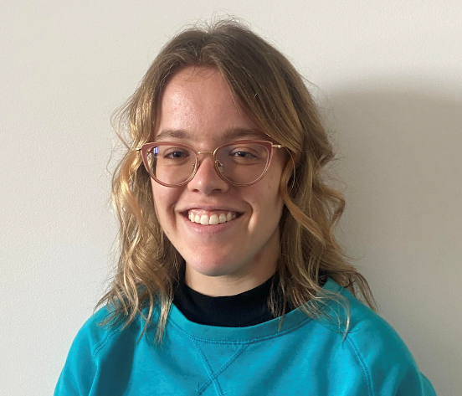
Board Nomination Statement:
JULIE DICKSON

Photo description: Julie, a Caucasian woman, is smiling at the camera. She has short wavy blonde hair and is wearing glasses.

1. Tell us about yourself. Who are you, what are you passionate about?

I have a few different casual jobs in areas I’m passionate in. I’m a writing mentor at Creative Write-it (CWI), where I mentor primary school and high school aged kids in creative writing. I enjoy creative writing so it’s rewarding teaching it and seeing the kids’ confidence grow. I’m also a member of WDV’s Youth Experts by Experience group. I enjoy being able to work on programs and resources which make the people with disabilities’ lives easier. I’m ageing out of that group, so being part of WDV’s board would be an excellent next step. I also work casually as an Electorate officer for state MP Mathew Hilakari, where I enjoy doing admin work and writing policies. I’m currently studying a Bachelor of Psychology (Honours) at Deakin University. I’m passionate about reading and writing novels in the contemporary romance and psychological thriller genres, particularly about protagonists who are short statured.

2. Why are you interested in being a Director on the WDV Board?

I’m interested in being a Director on the WDV board because I’m passionate about making a positive difference in people’s lives. For example, all jobs involve helping people in a different way. Through my role at CWI, I help kids feel more confident in their writing. Through WDV YEBE, I create resources to help young women with disabilities. And through my role working in Mathew Hilakari’s office, I collaborate on policies to make the lives of Victorians easier. Being part of the WDV board will allow me to continue my passion of helping people. I will be able to help women with disabilities in particular through a number of different ways, such as setting the strategic direction for WDV, making sure WDV complies with obligations, and working on a specific area such as policy.

3. In which areas do you have expertise and/or experience you can offer the WDV Board?
- Advocating for my rights and/or someone else’s
- Understanding disability and human rights
- Understanding of disability policy areas (NDIS, transport, accessibility, justice etc.)
- Experience in community building and engagement
- Lived experience (for example, being a person with a cognitive /intellectual disability, being involved in the justice or employment system, etc.)

I have lived experience with disability, in particular short stature. In my everyday life, I advocate for my rights (e.g., making sure my access needs are met when I go somewhere new) and often advocate for other people’s rights too (e.g., making sure the place is accessible for all disabilities). Through my work as part of WDV YEBE, we use our lived experience to advocate for our rights and those of other young people with disabilities. E.g., last year I collaborated with my colleagues to create and present workshops on identity/pride and internalised ableism. I also have experience in community building and engagement. I’m the editor of the Short Statured People of Australia (SSPA) Journal. I publish about four editions a year, and everyone in the SSPA community receives a copy. Each edition has information on upcoming member events and also reports on past events, keeping members connected and engaged.

4. What professional skills, experience and/or expertise can you offer the WDV Board?
- Previous board, employment, or community experience
- Media, marketing, or public relations
- Fundraising
- Research, writing or policy development

I have worked in a number of different administration jobs over the years, so I have administration experience in different areas such as making calls, sending emails, scheduling appointments, and website design. I have some experience in policy writing, as for my work at Mathew Hilakari’s office, I have drafted state based policies on different areas. In the past, I have also drafted welfare policies for the National Union of Students. I also have professional writing experience in other areas such as taking minutes for meetings, essay writing, blog writing, novel writing, and SEO writing. I also have fundraising experience. I recently went to Germany to participate in the World Dwarf Games as part of the Australian female basketball and soccer team, and we had to fund our way there. I organised and ran several different fundraisers such as raffles, a creative writing workshop, and a secondhand book sale.

5. What do you think are the most significant challenges and opportunities for women with disabilities in Victoria?
The most significant challenge is society’s lack of understanding. I believe majority, if not all, challenges women with disabilities face fall under the umbrella of society’s lack of understanding. As a short statured person, my friends, family, and peers all come to understand my short stature and are accepting of it and see me as who I am. However, there are people who have never met a short statured person who still think it’s okay to call out ‘Midget’ when they see me, or others like me, and there are many kids who are shocked at seeing me and stare. Similarly, employers are unlikely to hire a disabled person for a job, but those who have met me know that I can do basically everything an average height person can. The responsibility falls on the disabled person to do the educating and raise awareness which can be taxing. This demonstrates the need of education and awareness about disability.

Board Nomination Statement:  MAIREAD FOLEY  Photo description: a young white woman with light brown hair smiling. she is wearing a multicoloured tie dye shirt.  1. Tell us about yourself. Who are you, what are you passionate about?  I am a dedicated university student pursuing a Bachelor of Health Science with a major in Disability and Inclusion, as well as Exercise Science. My passion for advocating for the rights and needs of disabilities is deeply rooted in my personal | 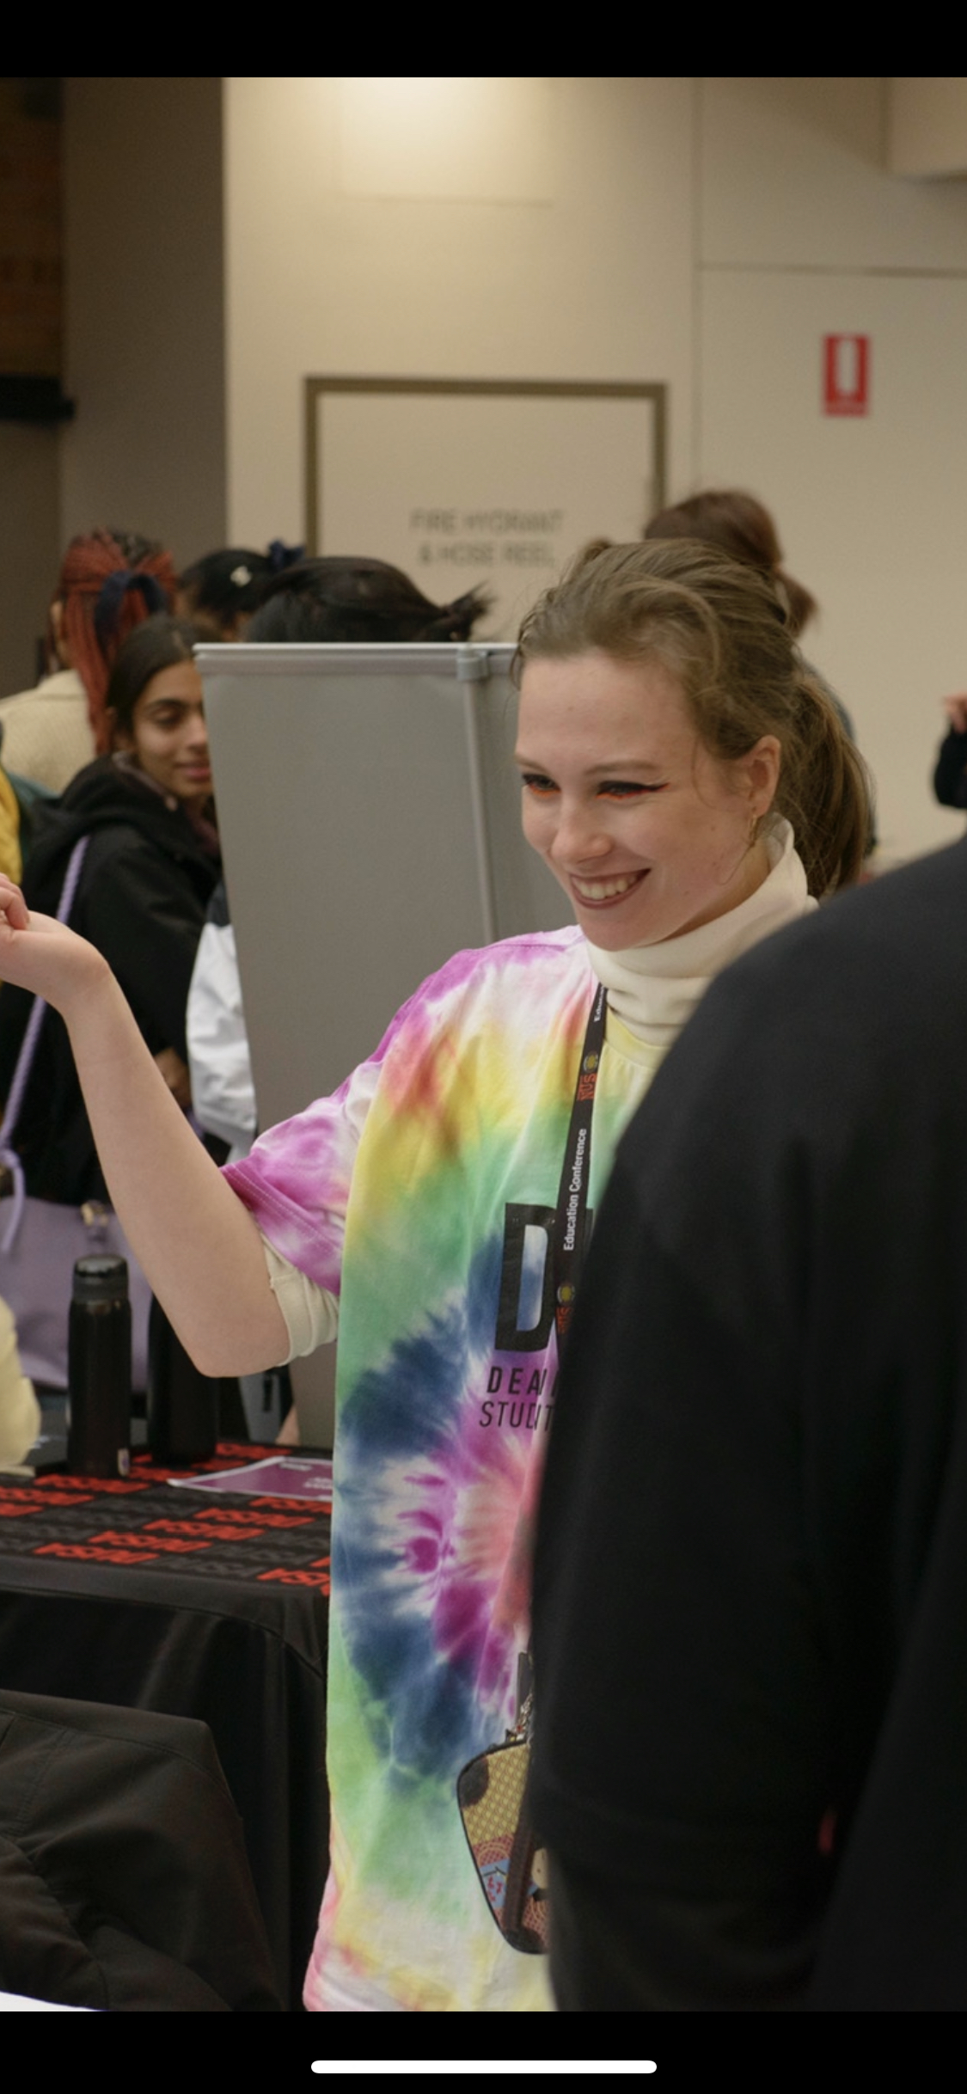
experience as a young advocate, student and queer person with ADHD, CPTSD, and hearing loss.
As a student advocate, I founded the Deakin University Disability Neurodiversity Association, I served as the Disability Officer on the board of the Deakin University Student Association and I currently chair the Victorian Student Disability Officer Network. Our focus is on fostering inclusivity and support for all students, partnering with diverse organizations to broaden opportunities. I’ve led awareness campaigns, advocated for a safe space, engaged with policymakers, mentored upcoming Disability Officers, and organized inclusive parasport games. I strive to make sports and education inclusive and accessible for queer and disabled women.

2. Why are you interested in being a Director on the WDV Board?
I am deeply committed to advocating for individuals with disabilities and seek to join the board of Women with Disabilities Victoria (WDV). My academic background in Health Science, majoring in Disability and Inclusion, along with personal experiences relating to ADHD, CPTSD and, and hearing loss, drive my passion for this cause. I have grown up surrounded by strong powerful women who have taught me that if I can’t see it, I need to be it. I didn’t see disable women in stem, I didn’t see disabled women competing in elite dance, I didn’t see disabled women in leadership – so that’s what I’ve strived to become. I’m ready to take the next step of my journey from a student advocate into bigger spaces. My lived experience as a young queer person with years of community engagement under my belt will provide a unique insight that is often missed when developing strategies and will benefits the WDV board.

3. In which areas do you have expertise and/or experience you can offer the WDV Board?
- Advocating for my rights and/or someone else’s
- Understanding disability and human rights
- Understanding of disability policy areas (NDIS, transport, accessibility, justice etc.)
- Experience in community building and engagement
- Being part of other communities (Aboriginal and/or Torres Strait Islander, intellectual disability, LGBTQIA+, CALD, under 30 years old etc.)
My technical experience includes influencing Deakin University student assignment extension and special consideration policies, writing submissions for the University Accords, writing student submissions for the Disability Royal Commission, and being a key adviser to the National Student Disability Officer. Engaging with key community influencers like Chloe Hayden, local autistic therapeutic practices and Cindy Liu to create resources and opportunities for D/disabled students to see representation and socialise. I have heavily engaged in community engagement including fortnightly pizza nights, a silent disco activation, meet and greets with Chloe Hayden, wheelchair basketball games, and para-volleyball activations. I have in depth knowledge of disability human rights, educational policy, NDIS and DSP implications for students and I have lived experience as a queer person and domestic violence survivor. I believe that lived experience must guide community engagement practices and policy information.

4. What professional skills, experience and/or expertise can you offer the WDV Board?
- Previous board, employment, or community experience
- Networking with community partners
- Media, marketing, or public relations
- Fundraising
- Research, writing or policy development
I have previously been employed on the board of the Deakin University Student association. Within my work I've established strong foundations with local disability groups to help connect students to their local communities and build a thriving disability pride community on campus. Through my advocacy work, I have written policy for the national union of students, specific policy regarding student extension and special considerations for Deakin university. To build support for the change we try to bring about I have engaged in media campaigns, interviews with journalists and marketing events towards a wide range of demographics.

5. What do you think are the most significant challenges and opportunities for women with disabilities in Victoria?
Women with disabilities face barriers due to intersectionality that often are unaddressed in targeted programs for women and those with disability. Intersectionality means that healthcare systems are inherently biased and inadequate, often not taking disability flareups and pain seriously. The lack of empowering supports for women are felt times over for women with disability. The stigma of being a woman in stem is exacerbated when you're a disabled person in stem, the ideology is that shouldn't we be trying to fix ourselves, are we even smart enough or deserving to be studying in the first place. The most significant challenges I believe women face are having dreams and aspirations crushed in youth due to the lack of representation, equal opportunity and support. By empowering women in university, to gain qualifications of any kind, to create tailored networking opportunities and job guidance that accommodates for disability fluctuations are the greatest opportunities we can create for empowering disabled women.

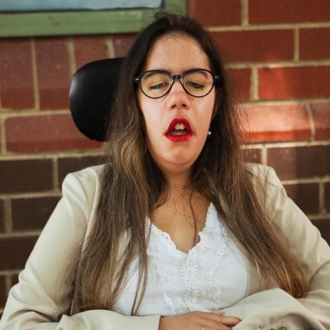
Board Nomination Statement:
CLAUDIA FORSBERG
Photo description: young woman with tan skin and long hair sitting in a wheelchair. She is wearing glasses, red lipstick and a beige blazer. Brick wall is the background.

1. Tell us about yourself. Who are you, what are you passionate about?
My name is Claudia Forsberg and I’m a journalist with ABC News Ballarat. I also happen to have a congenital physical disability which affects my speech, eyesight, hearing and mobility. What I am most passionate about is my job. I love getting to tell stories that affect the diversity of this country and giving a voice to the otherwise voiceless. I am in a unique position that I get to also shed light on issues affecting my community (disabled women). I’m passionate about giving fair and equitable access to all levels of education for all women with disabilities. Women with disabilities, for example, have been found to have higher drop out rates in tertiary education compared to non-disabled women. I’m also passionate about supporting more women with disabilities into gaining meaningful employment because I think that when women with disabilities succeed in any industry, so does the rest of society.

2. Why are you interested in being a Director on the WDV Board?
For the longest time I’ve tried to avoid putting myself forward for roles or joining community groups that were directly to do with disability, or the disabled community. I was scared I would be pigeonholed for the rest of my life. I felt like I had something to prove. But in recent years, I’ve discovered that I not only have so much knowledge and experience that is uniquely mine to share with the disabled community, I also have so much to gain from it as well. I love meeting new people and interacting with folks from the disabled community because I feel accepted, and that my experiences are validated. I believe I am not alone in this journey of self-discovery, which is why I want to be a role model for others like me. I want to show women with disabilities that it is possible to be a fearless advocate, as well as a fully-fledged human being outside your disability.

3. In which areas do you have expertise and/or experience you can offer the WDV Board?
- Advocating for my rights and/or someone else’s
- Understanding disability and human rights
- Being part of other communities (Aboriginal and/or Torres Strait Islander, intellectual disability, LGBTQIA+, CALD, under 30 years old etc.)
- Lived experience (for example, being a person with a cognitive /intellectual disability, being involved in the justice or employment system, etc.)
Having a lifelong physical disability has meant I’ve had to advocate for my rights throughout my whole life. In school, in employment, in healthcare and even the NDIS. I’ve learnt, from a strong network of family and friends, how to stand up for myself and identify what constitutes discrimination. I understand deeply the affects inaccessibility can have on an individual as well as on a community of people. I also have understanding in key policy areas such as transport and the NDIS both on a personal level and on a bureaucratic level through my work as a journalist. My lived experiences as an employee, a student, a healthcare recipient, a NDIS participant, a family member, as well as my identities as a young person, a person from a culturally diverse and low socio-economic background, and as a woman, are what make me most qualified to be on the WDV board.

4. What professional skills, experience and/or expertise can you offer the WDV Board?
- Previous board, employment, or community experience
- Media, marketing, or public relations
- Research, writing or policy development
- Other
Through my work as an ABC reporter, I’ve worked on stories that have exposed me to even more knowledge about key issues that affect the disabled community. For example, when working on a story about the lack of wheelchair taxis in regional Victoria, I got to speak to the minister for transport as well as gained a thorough understanding of transport policy and initiatives at the time. I’m currently working on a story around employment for women with disabilities in the healthcare workforce, something that through my research I’ve become even more passionate about. I’ve had experience in the advocacy and training space both officially through my work facilitating leadership workshops focused on disability inclusivity at the ABC, and unofficially through online activism and blogging. At work, I am a member of the ABC’s disability inclusive network and I currently serve as the co-secretary of the ABC’s gender diversity network.

5. What do you think are the most significant challenges and opportunities for women with disabilities in Victoria?
There are so many areas that need to be addressed to improve the experiences of women with disabilities. The first that comes to mind is employment. With the current cost of living pressures and sky- high rates of unemployment, it is no doubt that women with disabilities are affected tenfold. The common misconception that just because we receive NDIS funding or the DSP that we do not need to worry about getting a job is blatantly unacceptable. In fact, I would argue the opposite. Not only are these so-called ‘government benefits’ not sufficient to cover the cost of living, but they also don’t always address fundamental issues like quality of life or isolation. Providing women with disabilities access to meaningful employment does not just benefit them, but it also benefits workplaces and the economy in general.
Access to education opportunities should also be addressed with the same enthusiasm to improve employment outcomes too.

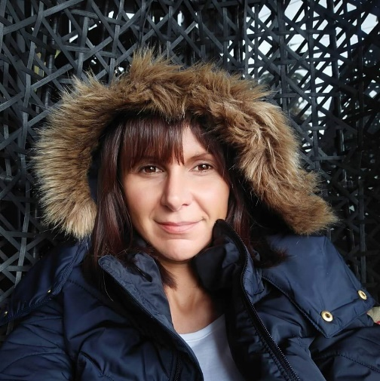
Board Nomination Statement:
TESS MAROTTA
Photo description: Tess is smiling at the camera, has brown hair and is wearing a black winter jacket with a fluffy hood.

1. Tell us about yourself. Who are you, what are you passionate about?

Hi folks! I always find these questions interesting, and complex. Perhaps it’s because they give rise to the complexity that makes up the 'who' or a human. To begin, I’m a daughter, a sister, a partner, a peer, a colleague, and a soul. My soul is my essence, the part of me that is unseen. Everything else is just a label that connects me to others, and helps me feel I fit in. Much like my soul, my disability is unseen. It also was the cause of great disconnect while growing up, and into my early adulthood. Which brings me to my passion. I’m passionate about connection, advocacy, and holding space for people (particularly people who have been marginalised) to be their wholesome selves. Whatever that means for the individual. I am passionate about community and creating a sense of belonging for all. I am also passionate about spirituality, purposeful living, and meaningful existence. Which will lead me into the response for your next question...

2. Why are you interested in being a Director on the WDV Board?

Because I feel it’s an opportunity to live my purposeful essence, and bring my insights, life experience, and learnings to a table that is shared by women who have a common value of equality for all. It’s also an opportunity for me to break down the barriers that holds back so many of us women with a disability, who doubt their worth, or question what value they bring. Being a director is an opportunity to be part of a group that sets the strategic vision for advocacy and representation of women with a disability, and to listen deeply to the needs of my vast network, so that I may better represent them in the shared vision of the organisation. I’m interested because its important, and it takes courage to apply for these roles. If I am to live the change I want to see, then I must take this opportunity now to have my voice heard, and work towards a more inclusive society.

3. In which areas do you have expertise and/or experience you can offer the WDV Board?
- Advocating for my rights and/or someone else’s
- Understanding disability and human rights
- Understanding of disability policy areas (NDIS, transport, accessibility, justice etc.)
- Understanding of prevention and response to family violence
- Experience in community building and engagement
- Being part of other communities (Aboriginal and/or Torres Strait Islander, intellectual disability, LGBTQIA+, CALD, under 30 years old etc.)
- Lived experience (for example, being a person with a cognitive /intellectual disability, being involved in the justice or employment system, etc.)
I have 4 decades worth of experience as a woman with a disability, and have spent most of my life advocating for my needs, my rights, and the needs and rights of so many other women, and people living with a disability both in this country and overseas. I understand the intricacies of disability, and the diversity within this community. I also identify as a lesbian, and have lived experience of that intersection, and the unique challenges faced by queer women living with a disability. I bring with me a wealth of experience as a community builder, having created networks and facilitated online support groups; as well as co-creating events for our community. I sit on a number of advisory groups and committees across State Government, Local Government, and community. I have extensive training in peer work, mental health, counselling, and prevention of family violence.

4. What professional skills, experience and/or expertise can you offer the WDV Board?
- Previous board, employment, or community experience
- Governance
- Networking with community partners
- Media, marketing, or public relations
- Other

I have experience as a board member and understand governance thanks to both training from a not-for-profit organisation, and also experience in a number of communities. I am a member of several networks, and currently sit on the Monash University Research and Education Network as the consumer representative. I have written articles for associations I am a member of, have worked in marketing in an industry separate to my current role (consumer consultant), and am trained as a peer worker, and mental health advocate.

5. What do you think are the most significant challenges and opportunities for women with disabilities in Victoria?
There are so many challenges, it would be negligent of me to assume I know which are most significant for all women in Victoria. But I can tell you which are significant to me, and I can vow to find out which are most significant to others in my work on this Board. A major challenge for me is discrimination and stigma. Self-stigma included. Discrimination in the workplace when flexibility is not available, or when I am not deemed as competent as others. Another challenge is the financial insecurity, as well as the violence and abuse we are at risk of. On the flipside, there are opportunities that WE can collectively create support networks, and resources to empower each other. The opportunities do depend on us speaking our voice, sharing our needs, and advocating for change so that the challenges diminish.

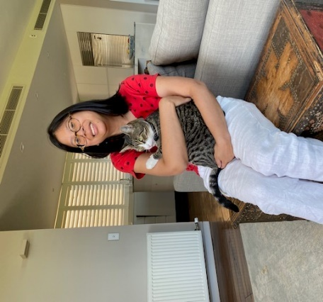
Board Nomination Statement:
SIRANI MCNEILL

Photo description: This is a photo of myself taken in 2023 with my new cat Bella. She’s the love of my life.

1. Tell us about yourself. Who are you, what are you passionate about?
I am Sirani McNeill, an aspiring Board Director with a lived experience of disability; autism spectrum disorder and hearing impairment.
In recognition of my achievements across advocacy, community involvement and a constant drive for personal development, I was selected as a participant in the augural Australian Network on Disability 2023 mentoring program. This program has enabled me to accelerate my understanding of the role of a director and focus my board applications on organisations that I believe I can add value through my skills and experiences.
My work experiences span event management, customer service, hospitality, office administration and information technology/cybersecurity.
I am a passionate advocate for people with disabilities and recently presented at a conference in Sydney sharing my experiences. I volunteer my time for community events and to teach young people with disabilities to become more proficient with the use of information technology.

2. Why are you interested in being a Director on the WDV Board?
I have been an WDV member since 2017. I strongly relate to the vision and mission of the organisation, and believe I align will all of WDV’s values. My governance journey has provided me with the confidence to put myself forward as ready to accept the challenges of a Board Director.
My specific experiences in aiming to achieve my leadership and advocacy goals, being vocal about my rights as a person with disabilities and involving myself in the community to change attitudes about disability provide me with tangible insights that can be leverage in assisting WDV achieve its objectives.
I am often praised for demonstrating leadership and entrepreneurial attributes and using these for constructive purpose to support advocacy to improve lives of people with disabilities.

3. In which areas do you have expertise and/or experience you can offer the WDV Board?
- Advocating for my rights and/or someone else’s
- Understanding disability and human rights
- Understanding of disability policy areas (NDIS, transport, accessibility, justice etc.)
- Experience in community building and engagement
- Being part of other communities (Aboriginal and/or Torres Strait Islander, intellectual disability, LGBTQIA+, CALD, under 30 years old etc.)
- Lived experience (for example, being a person with a cognitive /intellectual disability, being involved in the justice or employment system, etc.)
My lived experience of disability has provided me with expertise and experience in a number of the listed areas, especially advocacy, understanding of rights and policies and community participation and contributions.
I have experiences being the voice of people with disabilities, speaking with and for women with disabilities. I accept positions of advocacy and representation as a privilege and am diligent on successfully implementing commitments undertaken.
My positive approach lends itself to naturally being a voice to raise awareness about issues facing women with disabilities.
My education qualifications in information technology and cybersecurity also provide me with additional experiences that would be valued on the Finance & Risk Committee.

4. What professional skills, experience and/or expertise can you offer the WDV Board?
- Previous board, employment, or community experience
- Governance
- Risk management
- Networking with community partners
- Research, writing or policy development
Over ten years of experience as a community committee member and volunteer for community events and conferences. Three years of experience teaching children how to code software and learn front-end web development.
Practical governance learnings gained through the Australian Network on Disability mentoring program throughout 2023.
Information Technology work experiences over the past six years and advanced cybersecurity education qualifications provide me with unique insight on risk management considerations for Boards. Cybersecurity is consistently ranked in the top three risks on Board risk registers.
Networking proficiency, including four years of experience self-employed educating organisations about diversity and inclusion for people with disabilities.
Auslan proficiency.

5. What do you think are the most significant challenges and opportunities for women with disabilities in Victoria?
Through my lived experience of disability I have gained first-hand exposure to a range of issues facing women with disabilities. The most significant challenges include:
- Discrimination scope is not only based on disability but also other factors (e.g., gender)
- Government policies continue to lag in recognition within the community and services
- Social inclusion restrictions
- Statistics continue to highlight employment, income, housing and education gaps compared to people without disabilities
- Health care accessibility
The opportunities not only include overcoming the issues above, but continuing to strive for a future where the needs of women with disabilities are taken seriously:
- Overcoming the gender and disability stereotypes
- Being listened to about what will best meet our needs
- Enhance data insights to inform government policy and investment
Involving women with disabilities at all levels within organisations, from graduate through to the Boardroom.

Board Nomination Statement:
ORTHILIA NGUYEN-LE

1. Tell us about yourself. Who are you, what are you passionate about?

My name is Othilia and I currently work as an Innovation Policy Officer within the Victorian Public Service. I have a demonstrated passion for disability leadership and governance and driving inclusive impact through my previous experiences as a management consultant at a Big 4 Advisory firm, where I sat on the National Disability Committee, co-lead internal engagement to support with employee experience and build disability confidence and helped produce the inaugural Disability Inclusion Action Plan 2021-23. I have previously served on various committees and held various leadership roles on not-for-profits including through Rotaract, the youth branch of Rotary, and Enactus Australia, a social entrepreneurship not-for-profit.

2. Why are you interested in being a Director on the WDV Board?

I am genuinely passionate about disability inclusion and building a disability confident Victoria where women can leverage economic opportunities to be able to thrive and meaningfully participate in society. I see strengths in WDVs community engagement, policy and advocacy arm and its passion for upskilling individuals across Victoria. I have previously been a member of a grassroots disability not-for-profit, focussed on digital accessibility, and am a big advocate for universal design and intersectionality. I am interested in helping to shape and grow WDVs impact and agenda. I bring previous experience across various not-for-profits and a deep understanding of government and am also undertaking a course with the Australian Institute of Company Directors this year to build my governance knowledge.

3. In which areas do you have expertise and/or experience you can offer the WDV Board?
- Understanding disability and human rights
- Understanding of disability policy areas (NDIS, transport, accessibility, justice etc.)
- Experience in community building and engagement
- Being part of other communities (Aboriginal and/or Torres Strait Islander, intellectual disability, LGBTQIA+, CALD, under 30 years old etc.)
- Lived experience (for example, being a person with a cognitive /intellectual disability, being involved in the justice or employment system, etc.)

I have a strong understanding of disability rights and disability policy through my previous experiences on a law reform project and as a co-lead on my previous workplace’s national disability committee, where I helped draft and publish their Disability Inclusion and Action Plan and organised firmwide communications and events. I bring lived experience and deep knowledge of the disability sector and broader government policy.

4. What professional skills, experience and/or expertise can you offer the WDV Board?
- Previous board, employment, or community experience
- Governance
- Risk management
- Research, writing or policy development
I have previous experience across various not-for-profits and am well versed with governance and disability advocacy. I bring strengths in terms of the diversity of my previous experiences, fresh thinking being able to demonstrate inclusive economic growth and impact, and a strong background with policy development.

5. What do you think are the most significant challenges and opportunities for women with disabilities in Victoria?
Attitudinal factors continue to have a strong negative impact over engagement within the community and the workplace. I think there are still opportunities to challenge stigma, bias and discrimination to support women. There is an ongoing conversation around boosting disability employment and enabling women to find meaningful opportunities at work and as part of broader leadership structures. There is also an opportunity to continue delivering programs for individuals to share their lived experience to help shape policy reform and service delivery.
Board Nomination Statement:
TRUDY RYALL

1. Tell us about yourself. Who are you, what are you passionate about?
I am Trudy Ryall and the following points are about me:
1. Have been involved in disability advocacy over 20 years.
2. A co-founder of DeafBlind Victoria and been on all hats on the committee for over 18 years.
3. Passionate for equal access and human rights needs are met in all areas of human life participation and dreams.
4. Love to see women with disabilities get opportunities in jobs, education, health systems and all other areas that need to be met.
5. Always aim to see women are protected and free from any harm for example exposure domestic violence.

2. Why are you interested in being a Director on the WDV Board?
I have been on the WDV board before and served on many other boards and committees such as Melbourne Council Disability Advisory Committee. Currently I am President of DeafBlind Victoria. And through all my experiences I have a wealth of information to contribute to the WDV.

3. In which areas do you have expertise and/or experience you can offer the WDV Board?
- Advocating for my rights and/or someone else’s
- Understanding disability and human rights
- Understanding of disability policy areas (NDIS, transport, accessibility, justice etc.)
- Understanding of prevention and response to family violence
- Experience in community building and engagement
- Being part of other communities (Aboriginal and/or Torres Strait Islander, intellectual disability, LGBTQIA+, CALD, under 30 years old etc.)
- Lived experience (for example, being a person with a cognitive /intellectual disability, being involved in the justice or employment system, etc.)
- Other
Knowledge of disability accessibly issues e.g. housing and transport and to have access to health systems and achieve education goals and work force.

4. What professional skills, experience and/or expertise can you offer the WDV Board?
- Previous board, employment, or community experience
- Governance
- Finance
- Risk management
- Networking with community partners
- Media, marketing, or public relations
- Fundraising
- Research, writing or policy development
I have served in all areas above l believe that I will be valued highly with the wealth of knowledge and experience I have.

5. What do you think are the most significant challenges and opportunities for women with disabilities in Victoria?
The common challenges women with disability face are as follows:
Firstly I refer to the article
Facts on Violence against Women with Disabilities which states that women with disabilities experience higher rates of VIOLENCE.
1. Gender-based violence
2. Sexual abuse
3. Mistreatment is high (neglect, maltreatment and exploitation.)
4. Social exclusion and environmental barriers
5. Mental health issues.
6. Impacted by their status and are the vulnerable and marginalised groups.
7. Deprived of dignity and human rights
8. Threaten for their health, and well-being and quality of life

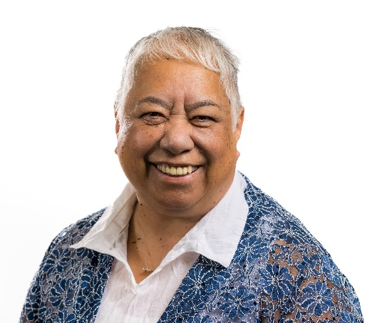
Board Nomination Statement:
MAGGIE TOKO

Photo description: Mental Health and Wellbeing Consumer Commissioner

1. Tell us about yourself. Who are you, what are you passionate about?
I am passionate about Human Rights. I am indigenous to Aotearoa and am of Ngati Whatua - Ngapuhi descent. I am the Consumer Commissioner for the Mental Health and Wellbeing Commission and am part of the LGBTIQ+ Community.

2. Why are you interested in being a Director on the WDV Board?

I believe I can add lived experience expertise to the Board as well as my experience in Governance. I was on the Board of Mental Health Victoria for 2 years and during that time was part of their finance and remuneration committees. My experience as CEO for VMIAC also assists me to understand how services operate. Also, my knowledge of the welfare sector is vast and I believe this will assist my role as Director.

3. In which areas do you have expertise and/or experience you can offer the WDV Board?
- Advocating for my rights and/or someone else’s
- Understanding disability and human rights
- Understanding of disability policy areas (NDIS, transport, accessibility, justice etc.)
- Understanding of prevention and response to family violence
- Experience in community building and engagement
- Being part of other communities (Aboriginal and/or Torres Strait Islander, intellectual disability, LGBTQIA+, CALD, under 30 years old etc.)
- Lived experience (for example, being a person with a cognitive /intellectual disability, being involved in the justice or employment system, etc.)

I believe that I can offer the Board an eclectic view of the world given that I am across a number of the above. I have always had to fight for my rights, it has taught me to be a human rights advocate in everything that I do.

4. What professional skills, experience and/or expertise can you offer the WDV Board?
- Previous board, employment, or community experience
- Governance
- Finance
- Risk management
- Networking with community partners
I am very good at networking with stakeholders and hold very good relationships with government and NGO's as well as clinical services. I have an interest in finances and I do not shy away from risk matrix's.

5. What do you think are the most significant challenges and opportunities for women with disabilities in Victoria?
Navigating a system which is gender driven. Women have to fight to be equal on every level, be that in personal or professional life. Disabilities should not be seen as a deficit, it does not make you less of a person but stigma and discrimination are a factor to be considered. Being differently abled should be celebrated, there are so many courageous champions out there already, let’s celebrate them.

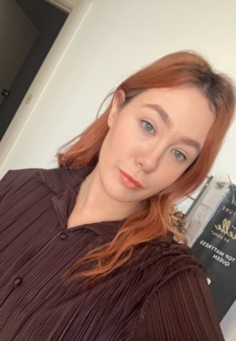
Board Nomination Statement:
TALITHA TRAVERS

Photo description: green eyes, orange lipstick, copper wavy hair wearing a brown button up shirt with a slight smile.

1. Tell us about yourself. Who are you, what are you passionate about?
I am a 29 year old, queer and proud disabled person. I am passionate about women’s empowerment and most importantly the empowerment of women with disabilities. I am passionate about creating a world for my Daughter to live freely and authentically. I have fought hard to challenge the attitudes and perceptions of women with disabilities and continue to work everyday to earn my seat at the table. I am also a competitive powerlifter who is passionate about breaking down the gender stereotype roles of women in sports and the gym.

2. Why are you interested in being a Director on the WDV Board?
I have spent the last 10 years advocating for change and equality for people with disabilities. I have experienced disempowerment and discrimination because of my disability and I have fought to be visible and heard and I now want to be able to continue this fight for other women who deserve their voice to be heard and to be seen.

3. In which areas do you have expertise and/or experience you can offer the WDV Board?
- Advocating for my rights and/or someone else’s
- Understanding disability and human rights
- Understanding of disability policy areas (NDIS, transport, accessibility, justice etc.)
- Understanding of prevention and response to family violence
- Being part of other communities (Aboriginal and/or Torres Strait Islander, intellectual disability, LGBTQIA+, CALD, under 30 years old etc.)
- Lived experience (for example, being a person with a cognitive /intellectual disability, being involved in the justice or employment system, etc.)
I am a staunch advocate for women with disabilities and constantly challenge ableism – in my workplace, in community, within my social and family settings and at a systemic level.
My lived experience of oppression and discrimination has made me passionate about ensuring other people can be empowered to make space for themselves and everyone who comes after them.
I have strong stakeholder connections within my region and believe the key to successful support and intervention is collaboration and co-design.
I work hard to ensure there is always a disability lens adopted to practice and ensure the voices of our community continue to be heard and recognised.

4. What professional skills, experience and/or expertise can you offer the WDV Board?
- Risk management
- Networking with community partners
I have worked in the disability sector for the last 10 years in various roles specific to disability – direct support work, NDIS support coordination, DRC/AAT appeals, Advocacy, specialist disability practice and now, I work as the Family Violence Disability Practice Leader at Centre for Non violence to strengthen responses to victim survivors with disabilities within the Family Violence, Sexual Assault and Disability sector. My work focuses on capacity building to all sector’s as well as secondary consultation at an individual level.

5. What do you think are the most significant challenges and opportunities for women with disabilities in Victoria?
Access and inclusion – in all contexts. Primarily I am focused on the systemic gaps and barriers for women with disabilities accessing and engaging in family violence and sexual assault services. The disability sector lacks understanding of family violence and violence prevention and the Family Violence and Sexual Assault sectors lack understanding in practice development and appropriate supports for women with disabilities.

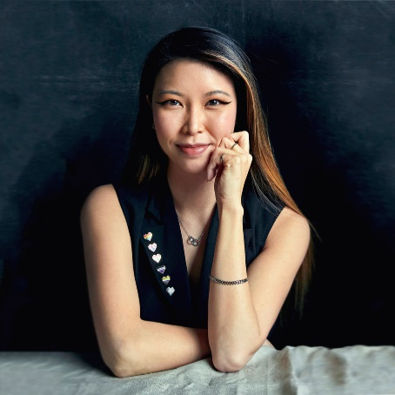
Board Nomination Statement:
EMILY UNITY

Photo description: a photograph of Emily Unity, a young, non-binary, Asian disabled person, pictured smiling wearing a black blazer with pride pins.

1. Tell us about yourself. Who are you, what are you passionate about?

I am an intersectional lived and living experience consultant who works across service design, research, education, policy, and transformation. In my work, I build platforms to amplify other people’s voices, whilst being informed by my own lived and living experiences with disability, mental ill-health, LGBTQIA+, neurodivergence, homelessness, family violence, and being a young carer from a refugee and migrant background. I believe that people with disabilities have a fundamental human right to be involved in decision-making that affects us. I’m passionate about ensuring that our lived and living expertise is meaningfully included at all levels, communities, and sectors. I endeavour to advocate for a future where disabled people are supported to live lives that we choose, not those that are chosen for us. I’m very excited to be applying for the WDV Board and I am looking forward to helping ensure that there is “nothing about us, without us.”

2. Why are you interested in being a Director on the WDV Board?

The WDV Board is an invaluable opportunity for us to actively contribute to positive change for wom*n with disabilities in Victoria. The intersection of gender and disability brings forth unique challenges, and I am deeply committed to addressing these issues. My own experiences as a non-binary and assigned female-at-birth person with disabilities have taught me the importance of representation and advocacy.

Additionally, my intersectional experiences of culture, queerness, homelessness, family violence, and more can help bring valuable insights to the board. Whilst I have my own personal experiences of disability, I believe that each person is the expert of their own experience. I believe in the importance of using my privilege to open the door and hold it open for others to walk through. It is my hope that together, the board can provide governance for WDV to dismantle barriers, promote understanding, and ensure that no voice goes unheard.

3. In which areas do you have expertise and/or experience you can offer the WDV Board?
- Advocating for my rights and/or someone else’s
- Understanding disability and human rights
- Understanding of disability policy areas (NDIS, transport, accessibility, justice etc.)
- Understanding of prevention and response to family violence
- Experience in community building and engagement
- Being part of other communities (Aboriginal and/or Torres Strait Islander, intellectual disability, LGBTQIA+, CALD, under 30 years old etc.)
- Lived experience (for example, being a person with a cognitive /intellectual disability, being involved in the justice or employment system, etc.)
- Other

Advocating for my rights and others': I have advocated for my rights and the rights of others since I was 12 years old, consistently using my privilege and positionality to amplify the voices of others.

Understanding disability and human rights: I have a deep understanding of the intersection of disability and human rights, informed by my own experiences and advocacy across service design, research, education, policy, and more.

Understanding of disability policy areas: I have a portfolio across policy areas such as the NDIS, accessibility, and support, effectively contributing to significant policy reform at local, state, and national levels.

Experience in community building and engagement: The majority of my work is building platforms to amplify the voices of marginalised communities through community engagement and empowerment.

Lived and living experience: As someone with intersectional lived and living experiences, I will ensure that diverse disabled people are heard and valued.

4. What professional skills, experience and/or expertise can you offer the WDV Board?
- Previous board, employment, or community experience
- Governance
- Risk management
- Networking with community partners
- Media, marketing, or public relations
- Fundraising
- Research, writing or policy development
- Other

Previous board, employment, or community experience: I have held several Board Director and Committee of Management Roles, including at disability, mental health, LGBTQIA+, and multicultural organisations.

Governance: I have a portfolio across governance areas, including completing my Company Director studies with the Australian Institute of Company Directors.

Risk management: I have experience in risk management principles in both organisational, environmental, well-being, and sustainability lenses, and understand the importance of transparency, accountability, and integrity in decision-making processes.

Networking with community partners: My work in community engagement has allowed me to build valuable partnerships and connections within diverse communities.

Research, writing, and policy development: I have a background in research, education, and policy development, which can contribute to evidence-based decision-making and impactful policy recommendations.

Media, marketing, and public relations: I have significant experience in media and public relations, with a demonstrated ability to effectively enhance outreach and advocacy efforts.

5. What do you think are the most significant challenges and opportunities for women with disabilities in Victoria?
The challenges for wom*n with disabilities in Victoria are multifaceted and intersectional, including barriers to healthcare, education, employment, family violence, and more. This is often systemic, fuelled by discrimination and stigma that create barriers to us choosing the lives we want to lead. However, there are also significant opportunities for positive change. Greater awareness of intersectional identities and the importance of inclusivity is growing. Advocacy and policy initiatives have shown progress in addressing systemic barriers and promoting equity. Empowering wom*n with disabilities to be active leaders and decision-makers in their own lives is a key opportunity. By fostering collaboration, creating space, and amplifying our voices, we can work towards a future where we have meaningful and equitable opportunities to thrive in a supportive and inclusive society. We are our greatest strength and I am confident that although the challenges are significant, together our passion will always be greater.

