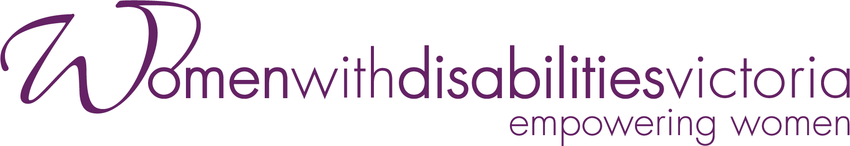

Experts in
Our Health Project
CASE STUDY
DECEMBER 2023
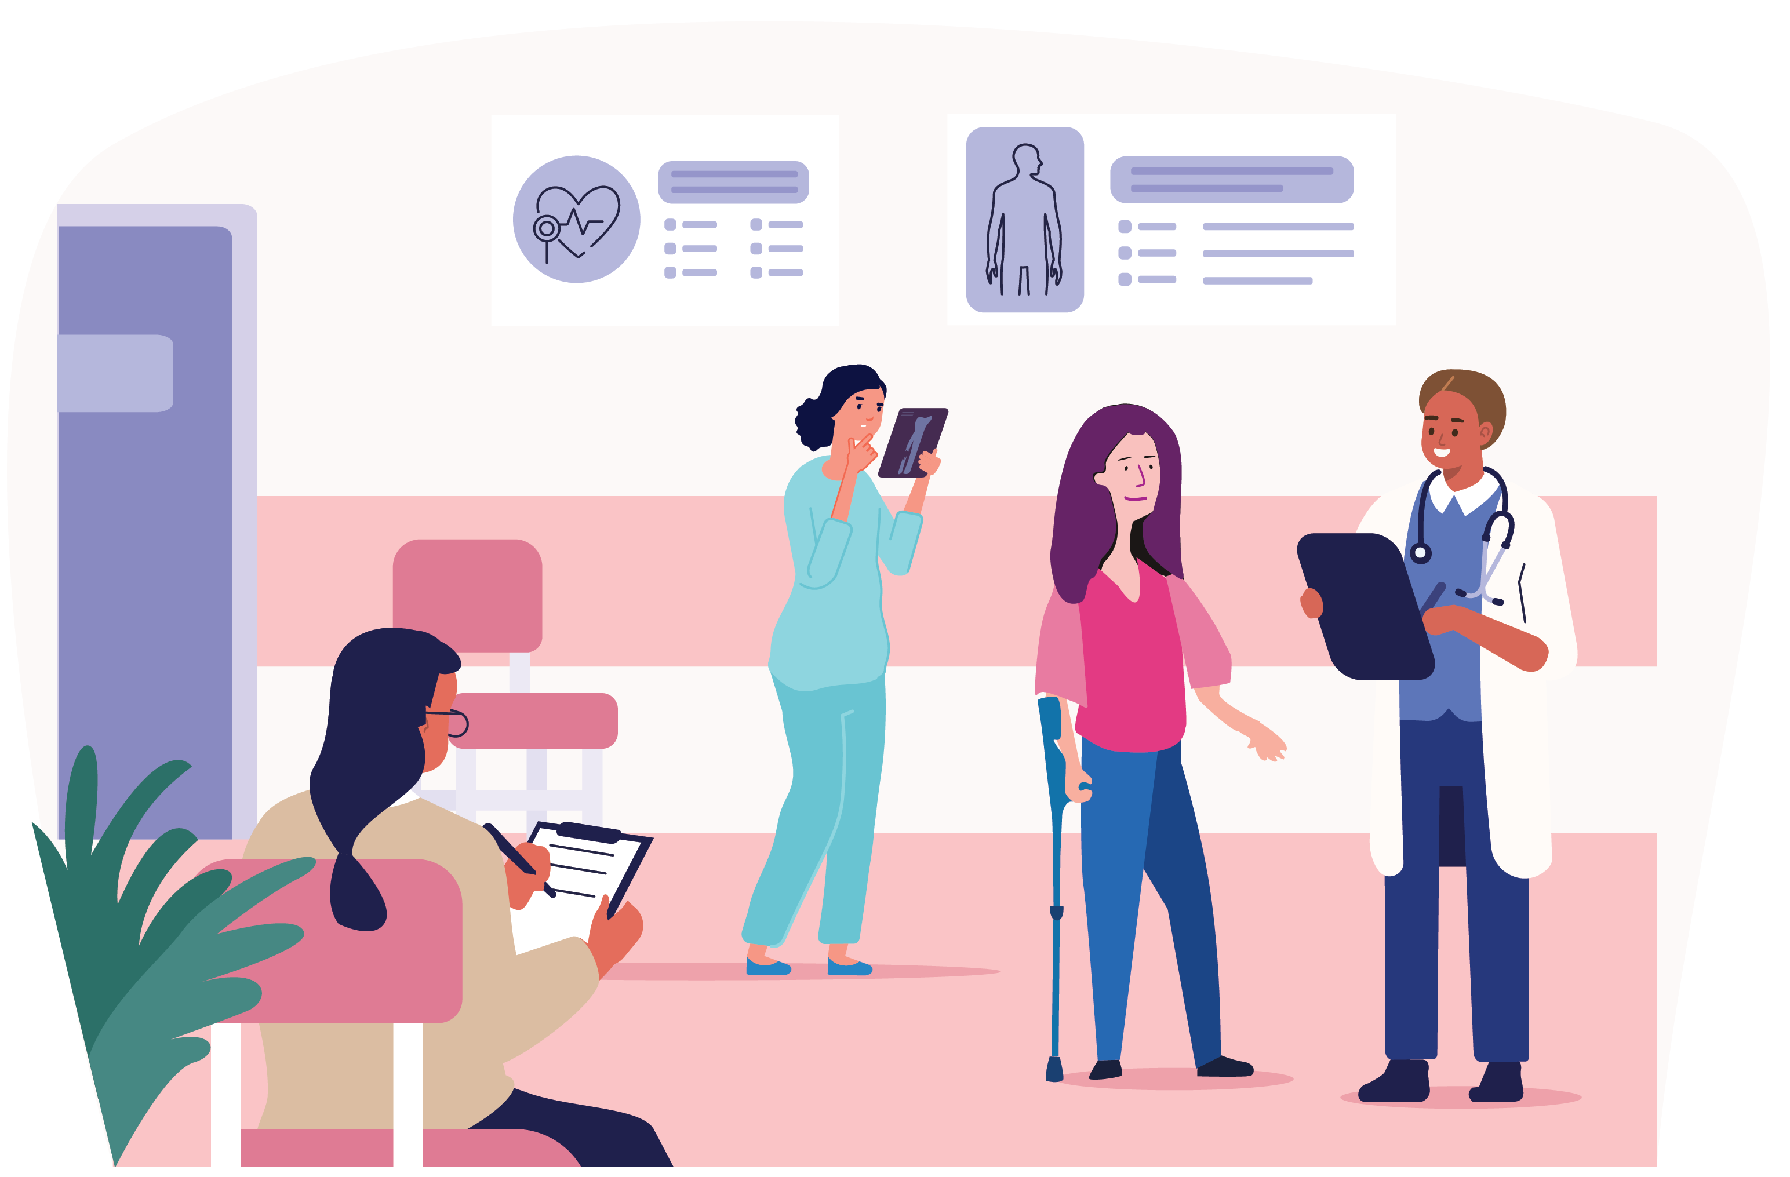

Background
In the area of health and wellbeing, significant disparities exist between disabled and non-disabled people in Australia (Australian Institute of Health and Welfare [AIHW] , 2022). Much of the health inequality experienced by people with disabilities may be attributed to barriers to access and participation experienced by the disability community (Aitken et al., 2022). The right of people with disabilities to equal healthcare is described in Section 25 of the Convention on the Rights of Persons with Disabilities (United Nations, 2006) and is reiterated in the Australian Charter of Healthcare Rights (Australian Commission on Safety and Quality in Healthcare, 2019).
A mere 24% of people with disabilities in Australia describe their health as very good, compared with 65% of Australians without disability (AIHW, 2022).
For women with disabilities, ableism and gender discrimination intersect, so that women with disabilities experience multiple forms of disadvantage at the same time (Women with Disabilities Victoria [WDV], 2022). Women with disabilities may also identify with other different marginalised communities including LGBTIQ+, Culturally and Linguistically Diverse and Indigenous communities. Intersectional disadvantage needs to be addressed in order for health rights to be upheld (Petrony et al., 2010).
Women with disabilities experience higher levels of socio-economic disadvantage than other groups in the community (Petrony et al., 2010). The cost of medical treatment is a barrier to access for a significant number of women with disabilities (Brophy, 2018). Rural women often experience a scarcity of specialist services, and inaccessible transport is a significant barrier to care (Brophy, 2018). Lack of disability knowledge amongst service providers and inaccessible health information are commonly experienced barriers to health access (Petrony et al., 2010). When interacting with health professionals, women with disabilities are often faced with inappropriate assumptions and the need to advocate to have health concerns investigated (Brophy, 2018). Accessible health services are ones that are low-cost or free, physically accessible, and have knowledgeable staff who take a holistic view of the health of women with disabilities (Petrony et al., 2010). Health information that is readily available and accessible for women with disabilities is one of the keys to achieving quality care and outcomes for this group of Australians (Brophy, 2018).
The evaluation of Phase 1 of the Experts in Our Health Project can be accessed on the WDV website here: Experts in Our Health - Women with Disabilities Victoria (wdv.org.au)

What is the Experts in Our Health Project?
The Experts in Our Health Project aimed to centre lived experience of women with disabilities through co-design of resources, peer-led workshops and training for health workforces across Victoria. The Experts in Our Health Project promoted the empowerment of women with disabilities through self-advocacy and urged organisations to include lived experience perspectives and accessible practices in their work. In developing the Experts in Our Health resources, WDV recruited diverse women with disabilities, training them in advocacy, resource design and facilitation. The co-design and co-facilitation model supports organisational change, in that it foregrounds women with disabilities as leaders and experts in their health.

How was the project developed?
A participatory and inclusive approach was employed (Cousins and Whitmore, 1998); (Robinson et al., 2014) for the implementation and evaluation of the project, with a focus on qualitative assessment approaches in order to centre the voices of women with disabilities. A best practice, accessible, end-to end co-design process was adopted for developing the content and design of the resources and training. Co-design is a way to bring together relevant stakeholders in order to improve understanding, service design and delivery (Agency for Clinical Innovation [ACI], 2019).
Co-design means that service-users are involved in the design process from the beginning and have time to share their experiences and collaborate with organisations (ACI, 2019). Co-design is a process intended to make service-users equal partners in the development of products, resources and services. Co-design when done well produces quality services and resources, but also enables change in the ways service providers and communities relate to each other (McKercher, 2020).
The Experts in Our Health Project promotes the empowerment of women with disabilities through self-advocacy and urges organisations to drive lived experience perspectives and accessible practices. In developing the Experts in Our Health resources, WDV recognised the expertise of women with disabilities and aimed to place this expertise at the centre of the design and content of the resource package. The resources were co-designed by a group of women with diverse backgrounds and experiences, and they aim to communicate key messages identified by the lived experience team members.
In order to remove barriers to women’s engagement with the project, the resources were created in multiple accessible formats. Creating safe and accessible spaces, both in person and online, has also been a priority for the project team.
The project aims to equip service providers in the health and community services sectors with the knowledge to make health services accessible. Workforce training and professional resources focus on rights-based practice that involves women with disabilities in decision-making and respects lived experience as an expertise.

What did the project do?
Women with disabilities participated in and engaged with the Experts in Our Health Project in multiple ways. 12 women with disabilities were employed as lived-experience Health Experts. 135 women with disabilities attended Experts in Our Health workshops and 33 participants completed a workshop feedback survey. 17 organisations hosted Experts in Our Health Workforce training, and 77 participants completed the training feedback survey. The Experts in Our Health resources were disseminated to 1100 workforce contacts in the disability, health, family violence and university sectors as well as government agencies. The Health Experts were involved in all phases of planning, design and development of the training materials for the health workforces. A train-the-trainer co-facilitation model provided scaffolded opportunities for the Health Experts to develop facilitation skills and confidence. The participation of the Health Experts in the learning program, co-design process, and train the trainer program resulted in the group becoming confident advocates.

What were the results?
Increasing leadership, advocacy and facilitation skills and enhancing opportunities for women with disabilities were key outcomes of this project. The success of this project was its unique and inclusive co-design process and the Health Experts group have reported the pursuit of opportunities for employment, advocacy and leadership during Phase 1. Members of the Health Experts group have engaged in consumer advisory roles, as members of public discussion panels and hosted podcasts promoting Women’s Health.
The Health Experts developed five key messages drawn from their diverse lived expertise.
- Women with disabilities are experts in their own health.
- Women with disabilities should be listened to.
- Accessibility is everyone’s business.
- Women with disabilities should be partners in decision-making.
- The voices of women with disabilities should be valued.
This table describes key activities undertaken during Phase 1 of the project, along with feedback shared by the Health Experts, training attendees and workshop participants.
Project Activities | Feedback from Participants
Experts in  Our Health Learning and Co-design Program  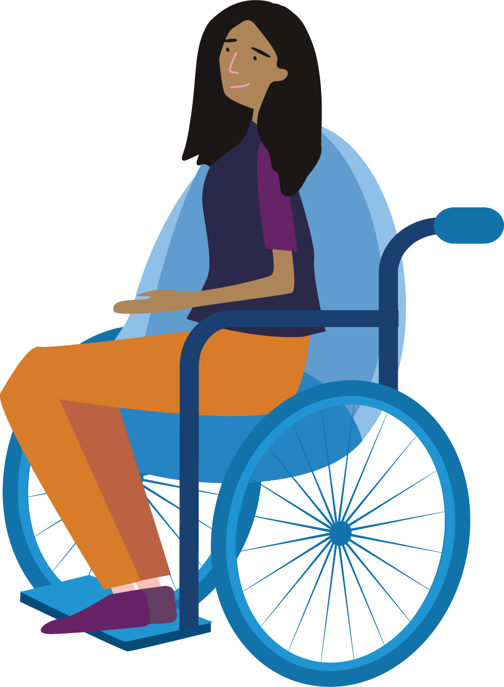 | “The information shared today not only made me feel valuable and knowledgeable, it gave me a strong sense of being able to develop my existing skills to be a great trainer and advocate.”  – Health Expert
Experts in  Our Health Workshops for Women with Disabilities  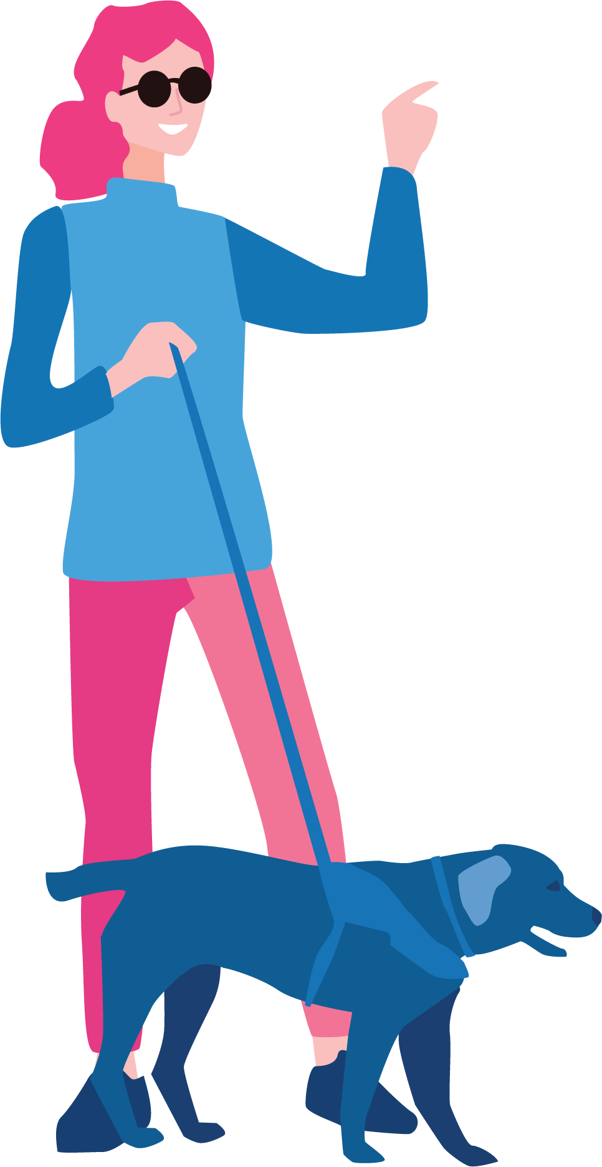 | “I appreciated and found it helpful when the presenters shared some of their lived experiences with what was being presented. I find this helps me to understand context of the information presented. I have trouble retaining dry information / statements: lived experience enables me to connect it to something so it’s meaningful and I can retain it.”  – Workshop Attendee
Experts in  Our Health Training for Workforces  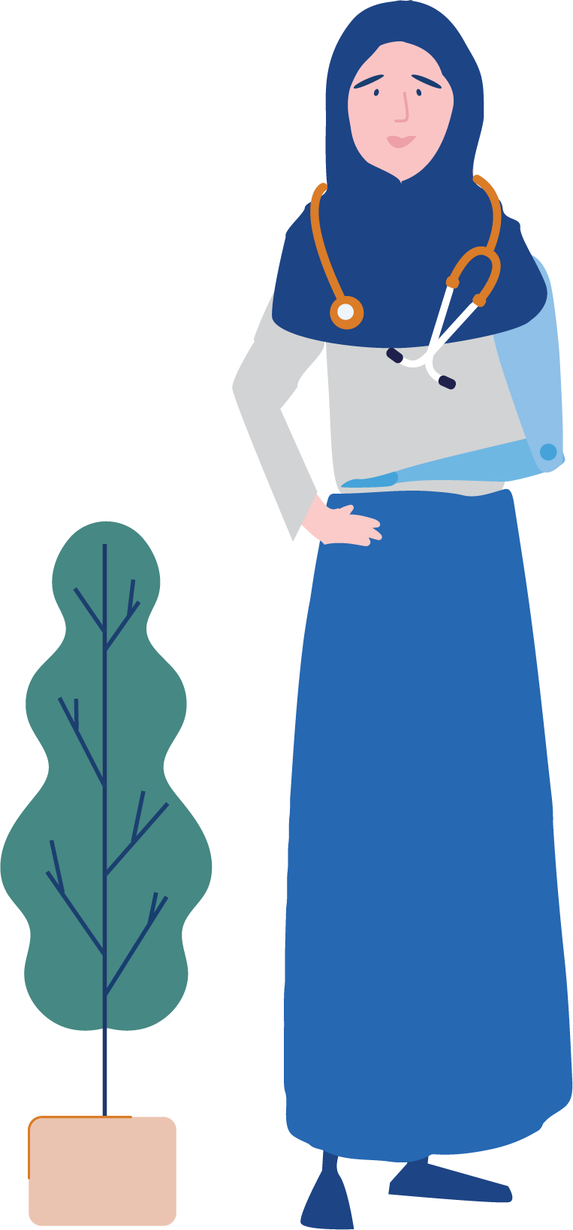 | “It was valuable for a few reasons. First, hearing from women with lived experience provided a lot of insight into experiences and barriers in a human way, rather than from research or other ways. Understanding the intersections of discrimination was explained really clearly. Finally, the model explaining that accessibility is everyone’s business, valuing voices, partnerships and listening and treating people as individuals was great.”  – Health Workforce Trainee
Partnerships and Collaboration  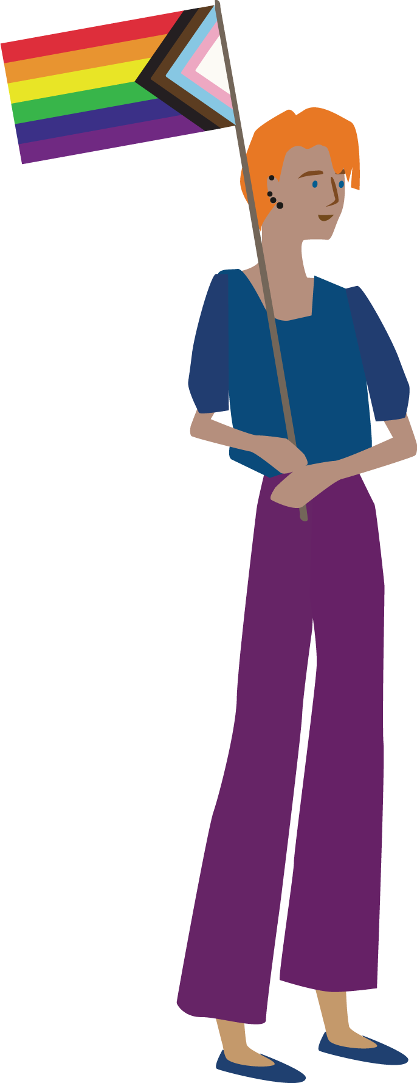 | “It was not just listening to women with disabilities share their stories and or identity, this project was more than that. It was drawing attention to the systems and barriers – politicising – centring lived experience stories”.  – Project Advisory Group Member
Leadership of Women with Disabilities  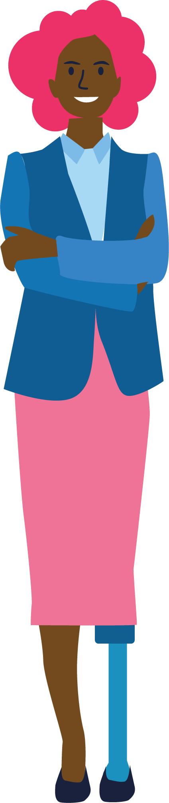 | “I have had job opportunities and have increased my roles and responsibilities in other work. I have had the chance to speak at advocacy events and feel my influence is growing in Women’s Health.”  – Health Expert
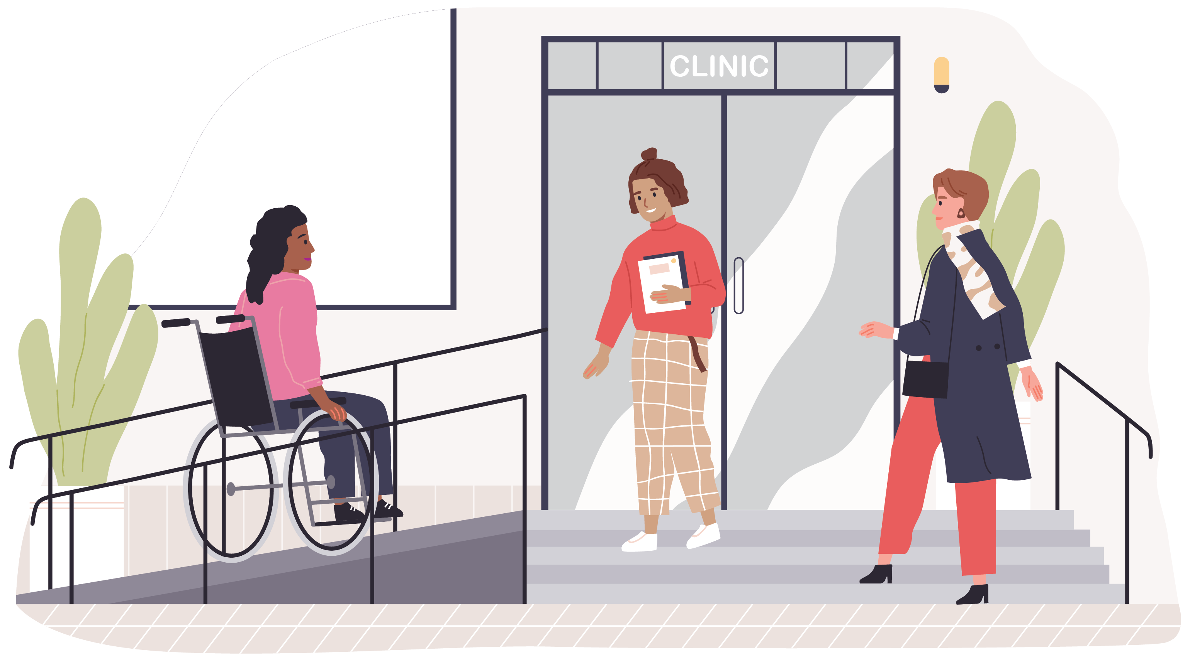

What would support systemic changes in future?
A total of 8 recommendations have been put forward in order to continue to support access to health services for women with disabilities. These recommendations should inform decision-making about future actions.
- Support healthcare access for women with disabilities from diverse backgrounds, through production of accessible co-designed resources.
- Collaborate with disability self-advocacy organisations, support co-design and embed practices increasing health access for women with disabilities.
- Engage women with disabilities in meaningful co-design and develop resources that empower women with disabilities to make informed decisions about their healthcare, promoting respect, dignity, choice and control.
- Support access by women with disabilities to peer learning and support programs such as Communities of Practice that are co-designed and facilitated by lived-experience advocates.
- Identify access for women with disabilities as a priority in strategic planning and resource initiatives that increase access including co-design programs.
- Collaborate with disability advocacy organisations to embed lived experience perspectives into the education of health and community services professionals.
- Increase the participation and employment of women with disabilities in the design and delivery of services. Collaborate with disability self-advocacy organisations to create inclusive co-design processes.
- Support health workforces to engage in ongoing professional learning such as Communities of Practice that focus on disability access and centre lived experience.

References
- Aitken, Z., Bishop, G. M., Disney, G., Emerson, E., & Kavanagh, A. M. (2022). Disability-related inequalities in health and well-being are mediated by barriers to participation faced by people with disability. A causal mediation analysis. Social Science & Medicine, (315), 115500. https://doi.org/10.1016/j.socscimed.2022.115500.
- Agency for Clinical Innovation. (2019). A guide to building co-design capability. https://aci.health.nsw.gov.au/__data/assets/pdf_file/0013/502240/Guide-Build-Codesign-Capability.pdf
- Australian Commission on Safety and Quality in Healthcare. (2019). Australian charter of healthcare rights. https://www.safetyandquality.gov.au/consumers/working-your-healthcare-provider/australian-charter-healthcare-rights
- Australian Institute of Health and Welfare. (2022). Health of people with disability. https://www.aihw.gov.au/reports/australias-health/health-of-people-with-disability
- Brophy, C. (2018). Brief submission to the special rapporteur on the rights of persons with disabilities on the right of persons with disabilities to the highest attainable standard of health. Women with Disabilities Australia. https://wwda.org.au/wp-content/uploads/2016/01/3-WWDA_SR_Disability_HealthAccess_March2018_BriefReport.pdf
- Cousins, J. B., & Whitmore, E. (1998). Framing participatory evaluation. In E. Whitmore, (Ed.), Understanding and practicing participatory evaluation: New directions for evaluation (p. 80), Jossey-Bass.
- McKercher, K. A. (2020). Beyond Sticky Notes: Doing co-design for real: mindsets, methods and movements. Beyond Sticky Notes. Sydney.
- Petrony, S., Horsley, P., & Kavanagh, A. (2010). Access to health services for women with disabilities. Women with Disabilities Victoria. https://www.wdv.org.au/documents/Access%20to%20health%20services%20-%20the%20issues%20for%20women%20with%20disabilities.pdf
- Robinson, S., Fisher, K., & Strike, R. (2014). Participatory and inclusive approaches to disability program evaluation. Australian Social Work, 67(4) 495-508. http://dx.doi.org/10.1080/0312407X.2014.902979
- United Nations. (2006). Convention on the rights of persons with disabilities. United Nations Department of Economic and Social Affairs. https://www.un.org/development/desa/disabilities/convention-on-the-rights-of-persons-with-disabilities.html
- Women with Disabilities Victoria. (2022). Understanding disability guide. https://www.wdv.org.au/wp-content/uploads/2022/06/Understanding-Disability-June2022-PRINT.pdf

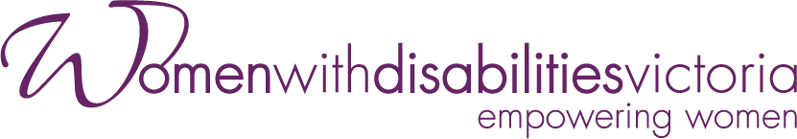

Wurundjeri Country
Postal: PO Box 18314, Collins Street East, VIC 8003
Phone: 03 9286 7800
Email: wdv@wdv.org.au

For more information visit https://www.wdv.org.au/

