MENTORS WANTED:

Enabling Young Women Mentor Program

We are looking for:

Women and non-binary people, aged 18+, with or without disability, to support and mentor one of our emerging leaders from the Enabling Young Women Leadership Program.
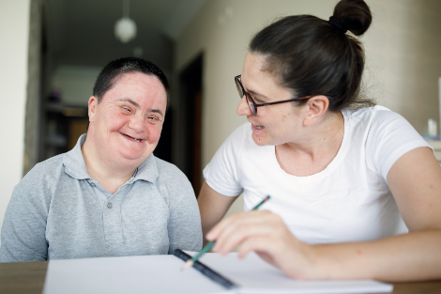
Mentors will utilise their knowledge and skills to support a mentee to achieve a leadership goal.
What is the Enabling Young Women Leadership Program?
Enabling Young Women is a Program ran by Women with Disabilities Victoria (WDV).
Over 7 sessions, 12 young women and non-binary youth with disabilities from across Victoria have come together to:

Explore self-identity.

Understand different models of disability.

Discover more about human rights.

Learn more about safety and respect, and the impacts of violence.

Practise being assertive and advocating.

Build self-esteem and confidence.

Reflect on and develop strengths.

Become stronger leaders in their communities.
What will mentors do?
Mentors will work in partnership with mentees, and provide support to the mentee as they work towards a leadership goal. Mentors may:
- Provide guidance on steps required to achieve a goal.
- Ask useful questions.
- Assist in identifying barriers and how to overcome them.
- Help extend the mentee’s network.
- Be a friendly face and provide encouragement.
- Work with and provide feedback on the mentee’s strengths.

Mentors will gain:
- Improved skills in listening, supporting, coaching and leadership.
- Better awareness and understanding of disability.
- Increased knowledge and comprehension off barriers faced by young women and non-binary youth with disability.
- Extended networks through connections made.
- Satisfaction and pride in assisting another to achieve a goal, and for giving back to their community.

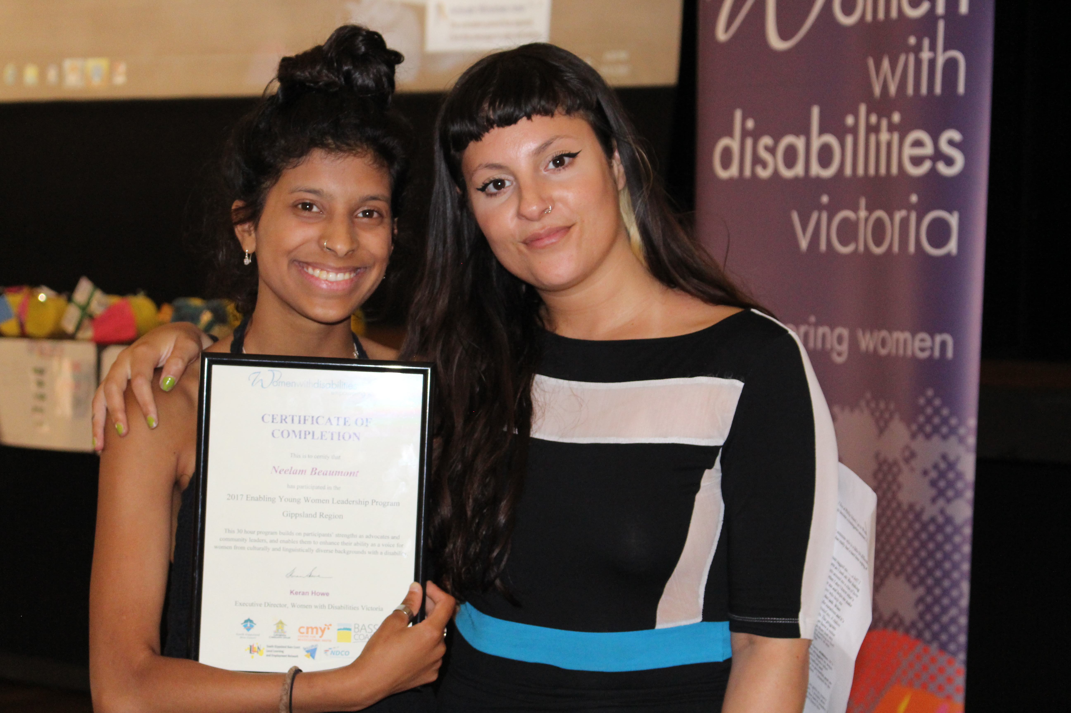
Details about the Mentor Program:
What: Meet 1 on 1 with a mentee (program participant) to encourage and support them in working towards a leadership goal.
How often: Mentors are asked to volunteer an equivalent of 5 x 1 hour sessions over a 6 week period (March - April). Mentors will also be invited to attend the Program Graduation Celebration.
Where: Online via Zoom, or in person.
Resources: WDV will provide resources on mentoring and working 1 on 1 with your mentee.
Access: WDV will work with individuals to support access needs.

To Apply:
Potential Mentors must complete and submit the Enabling Young Women Mentor Application Form.
Mentors will also need to consent to completing a Victorian Police Check.
***Applications close 11:59pm, Sunday 3rd March.***

For More Information:
To ask any questions about the Mentor Program or submitting your application, please contact WDV’s Youth projects team.
Phone: Bridget on 03 9286 7813
Email: youth@wdv.org.au

