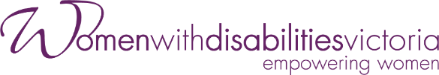
Enabling Women Leadership Program
Application Form
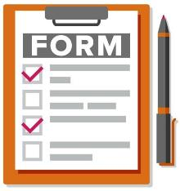

More information and help to apply
Do you want more information, or help to apply?
Go to WDV’s website.

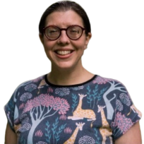
Or, you can contact Bridget Jolley at WDV.
- Email: bridget.jolley@wdv.org.au
- Phone: 03 9286 7813

Introduction to the Enabling Women Program

Women with Disabilities Victoria (WDV) is an organisation run for and by women and non-binary people with all kinds of disabilities.

Our members are people of all ages, backgrounds and lifestyles.
We are a proud LGBTIQA+ ally.
We want to be a safe space and to include all women and non-binary people with disabilities.

We focus on rights to safety and respect.
This includes being able to speak up for ourselves and being leaders.
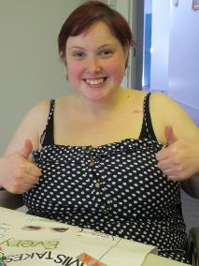
In The Enabling Women Leadership Program (also known as the Program) women and non-binary people with disability learn how to become stronger leaders.

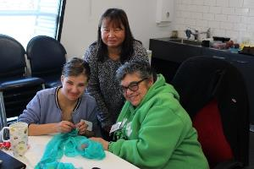
We do this in fun and meaningful ways.

The Program will be hybrid.
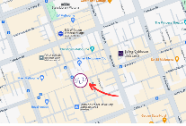
- This means you can attend in person at the WDV Office in Melbourne CBD
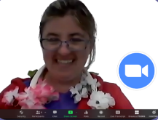
- Or online via Zoom.

There will be 8 Program sessions.

Program sessions will be on Wednesdays.

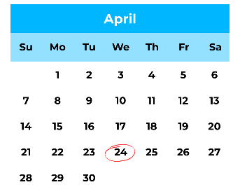
The Program will begin on April 24th.

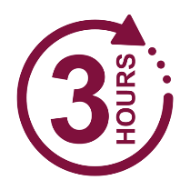
Each session will be 3 hours long.
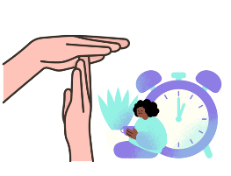
Sessions will include breaks.

The Program will have up to 12 participants.

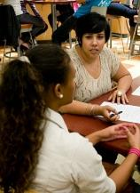
During the Program, participants will work with a mentor.
Mentors can support people achieve a goal.

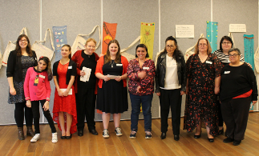
The Program will finish with a Graduation celebration.

The Program is for:

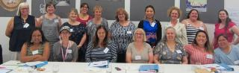
- Women and non-binary people,

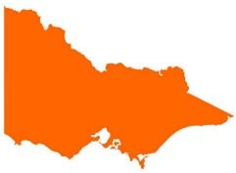
- who live, work, study, volunteer or play in the state of Victoria, and

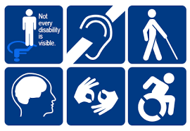
- who identifies as someone
- with disability (physical, sensory, intellectual, cognitive, etc.)
- who is Deaf / deaf / hard of hearing
- who lives with chronic illness, and/or pain
- who is neurodiverse, e.g. autistic, and/or
- who lives with mental health challenges.
Completing the Application Form
Applications close 11:59pm, Thursday April 11th

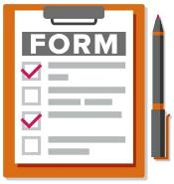
To take part in the Enabling Women Leadership Program you will need to fill out this Application Form.

You can ask someone you trust to help complete and send the form.

You can also contact Bridget Jolley at WDV for help.
          - Email: bridget.jolley@wdv.org.au

          - Phone: 03 9286 7813
You can fill out the form:
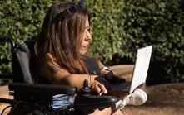
- on a computer,

- by hand,

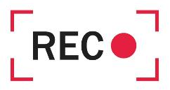
- or record your answers in a video or audio recording.

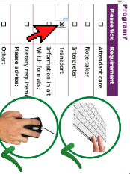
If you are using a computer to fill out the below form, click the mouse or use the spacebar key to select check boxes.

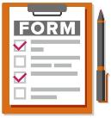
Email bridget.jolley@wdv.org.au with the completed form, or let Bridget know you have made a recording.
Application Form
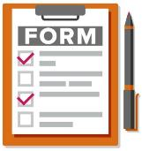

*Optional* = only answer if you want to

Your Details
Information required | Your response
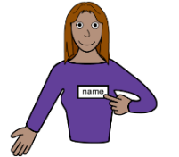
First and last name

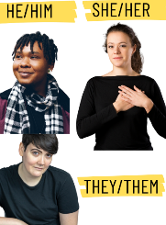  Pronouns  *Optional*  Example: Would you like people to refer to you and say “she”, “they”, “he”, or something else. | ☐ She/Her  ☐ They/Them  ☐ He/Him  ☐ Prefer not to say  ☐ Something else (Please tell us):
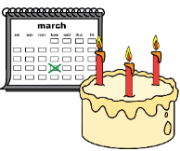
Year of birth

Street Address

Suburb
and
Postcode

Best contact phone number

Email address

Do you speak a language other than English at home? | ☐ Yes – what language/s?  ☐ No
Do you identify as Aboriginal and/or Torres  Strait Islander?  *Optional* | ☐ Yes – Aboriginal  ☐ Yes – Torres Strait Islander  ☐ No  ☐ Prefer not to say

Questions about you
Information required | Your response
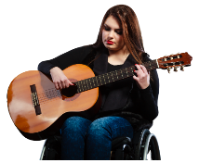
- What do you do for fun?

- Why do you want to do this Program?

- Has anything stopped you from doing activities and other things you want to?  Particularly because of your gender, or disability? | ☐ Yes  ☐ No  ☐ Not sure  If yes, what sort of things?
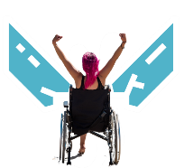  - Did you get through the problem?  If yes, how? | ☐ Yes  ☐ No  ☐ Not sure  If yes, how?
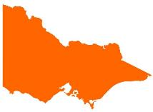  - What connection do you have Victoria? E.g. live, study, work, etc. | Examples: Live in Anglesea, study in Melbourne, grew up in Gippsland.
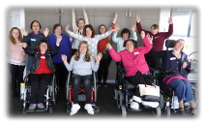  - Do you, or have you been part of any WDV programs or pojects? What were they? | Examples: Hub, attended a training, a leadership program.
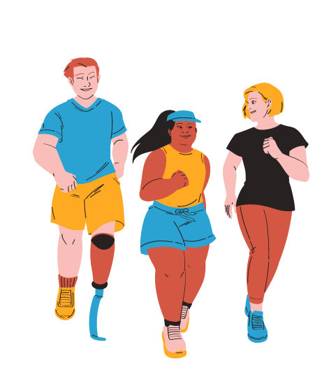  - What groups are you a part of now, or have been in the past? What do / did you do with these groups? | Examples: Peer group, sporting club, Church, community group.
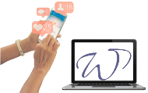
- How did you hear about the Enabling Women Program?

Participation Questions
Information required | Your response
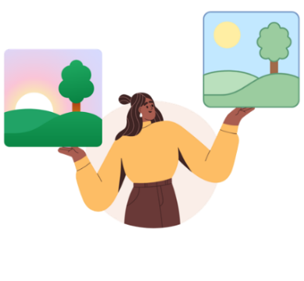  - What time or times are you available on Wednesdays? | ☐ 10am – 1pm  ☐ 1pm – 4pm
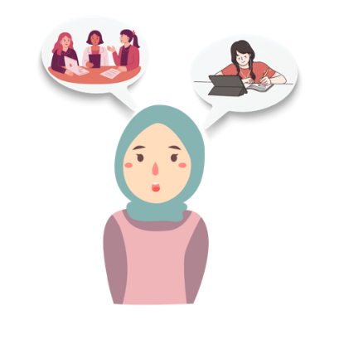  - Do you want to participate in person or online? | ☐ In person  ☐ Online  ☐ It depends / unsure
- Do you have a tablet or computer with internet at home? | ☐ Yes – computer  ☐ Yes – tablet  ☐ No
- Does the internet work well? | ☐ Yes  ☐ No  ☐ Sometimes / Not sure
- If you have a computer can you use these things with your computer? | ☐ Microphone  ☐ Headphones  ☐ Speaker  ☐ Webcam / camera
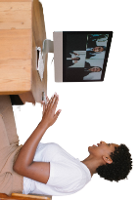  - Have you done an online video meeting before? | ☐ Yes - Zoom  ☐ Yes – Other. What did you use?  ☐ No
- Would you like any help to use Zoom? | ☐ Yes – Please tell us in what ways?  ☐ No  ☐ Not sure
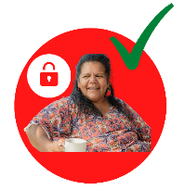  - Do you have a safe place at home to be alone and do the Program? | ☐ Yes  ☐ No  ☐ Not sure
- Do you feel comfortable doing the Program at home? | ☐ Yes  ☐ No  ☐ Not sure
- Are you NOT available any Wednesdays in April, May or June?

Access and Supports
Are there any access needs or supports that could help you to fully participate?
If you may need one of these supports, please tick the box and provide more information.
Information required | Your response
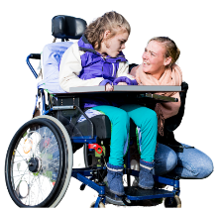  Attendant care | To help with eating, going to the bathroom, etc.  ☐ Yes - Tell us more:
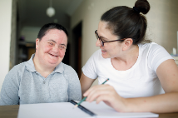  Note-taker | To help take notes of what’s said, your ideas, etc.  ☐ Yes - Tell us more:
Interpreter | ☐ Yes - Tell us more:
Wheelchair access | ☐
Dog guide or service animal facilities | For if we ever meet in person.  ☐ Yes - Tell us more:
Transport / accessing the venue? | ☐ If yes, what requirements?
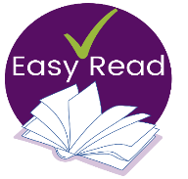  Information in other ways | Examples: Examples: Easy English, braille, audio, etc.  ☐ Yes - Tell us more:
Dietary requirements | Examples: Vegan, Halal, or soft foods, etc.  ☐ Yes - Tell us more:
Other  What else could help you to participate? | ☐ Yes - Tell us more:
Email bridget.jolley@wdv.org.au with the completed form

If you made a recording, email or call Bridget to discuss how to send the recording.
          - Email: bridget.jolley@wdv.org.au
          - Phone: 03 9286 7813

Applications close 11:59pm, Thursday April 11th

