Endometriosis Awareness Month
My experience as a young person diagnosed at age 18

By Teagan Mitchell (she/her)

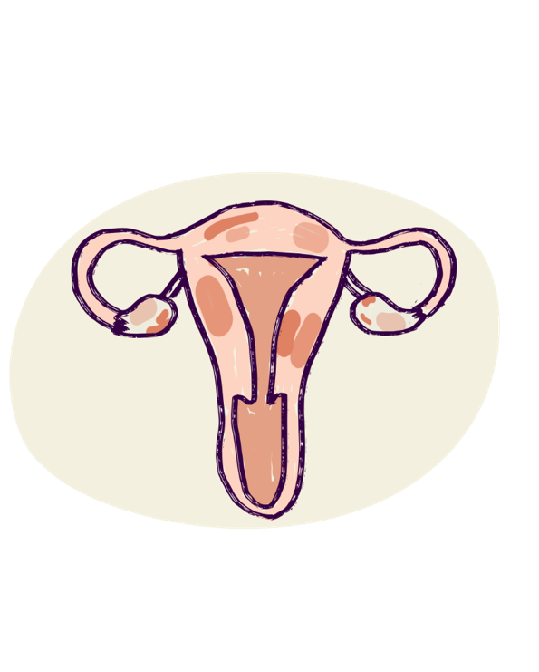
March is Endometriosis awareness month, which is dedicated to raising awareness to a disease that affects 1 in 7 people assigned female at birth. It takes an average of 7 years for a person to have a confirmed diagnosis of endometriosis.

Endometriosis, sometimes just called ‘endo’, is where tissue within the body, that is like the lining of the uterus, grows outside the uterus. It can be exhausting, tormenting and endless. Common symptoms of endometriosis include:

- Chronic pelvic pain
- Fatigue
- Heavy bleeding during your period or between your periods
- Bloating
- Pain when passing urine
- Issues with conceiving / staying pregnant
However, for some people, they have little or no symptoms and do not understand they have endometriosis until they stop using contraception or try to become pregnant. This is partly why Endometriosis is considered an invisible disability and is harder for people to recognise and understand the person who is diagnosed.

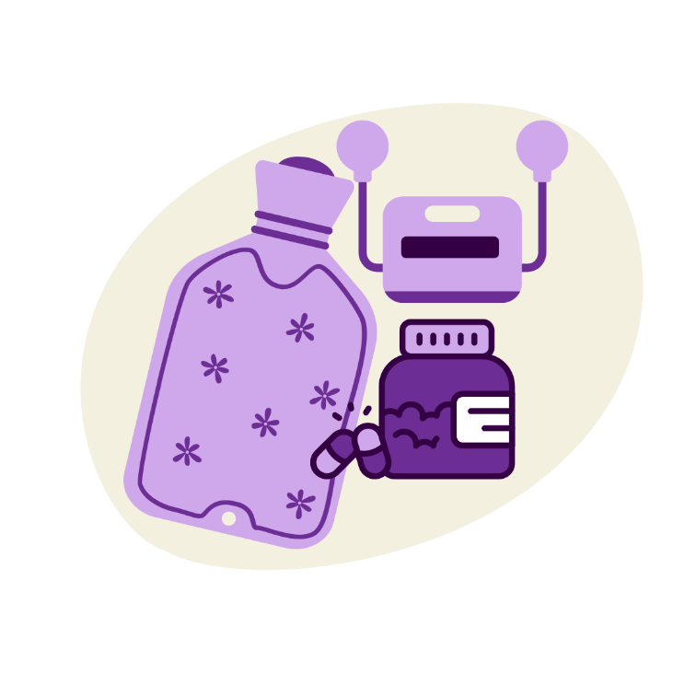
The cause of endometriosis remains unknown. Scientists are still trying to understand it. Some theories and ideas include genetic factors, such as your mother, aunty, sister or grandmother having endometriosis. Scientific testing has also shown 42 significant points in DNA that can be connected or associated with being diagnosed with endometriosis. It is important to note that having a risk factor does not mean that you will develop or have the condition.

There is no cure, but its symptoms can be treated. For general pain, medicines such as Nurofen, Panadol or Ponstan are often taken. And patients can also take some medication that can focus on reducing nerve pain, such as Amitriptyline or Duloxetine. Non-medical focuses on reducing pain include Transcutaneous Electrical Nerve Stimulator (TENS) machines and heat packs.

For me, the best thing I ever did was invest in a TENS machine - it gives me a non-medical option to focus on my day-to-day challenges and deal with keeping myself functioning. Pain is the most dehumanising and capacity reducing in my everyday life. Learning the best way to deal with it has helped my quality of life, but I know I will always be in some level of pain and some days are better than others.

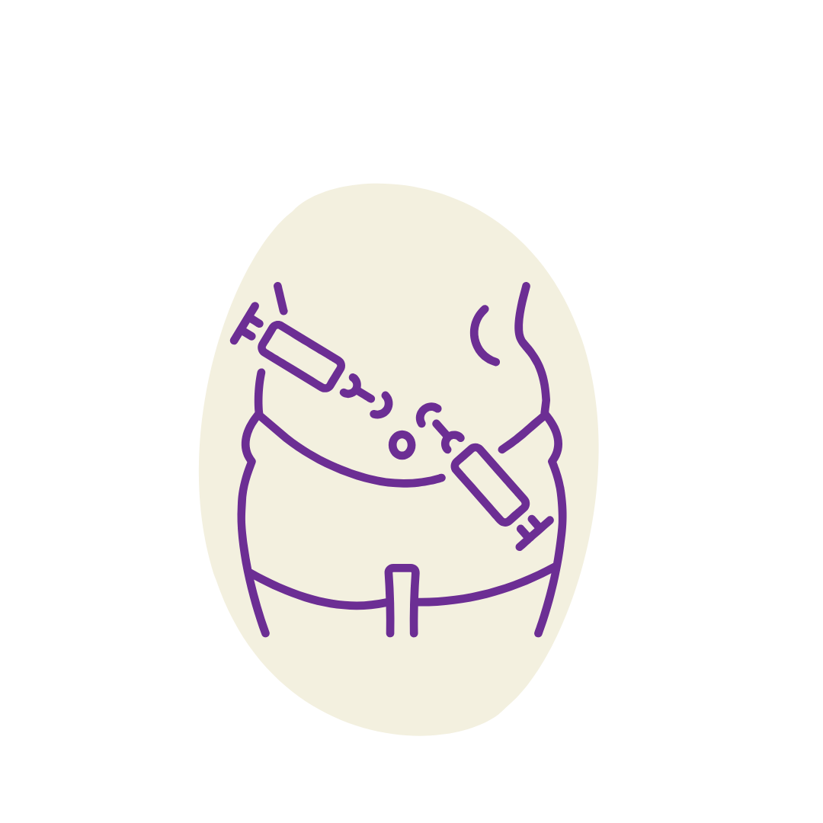
Medication needs are unique and mine do occasionally need to be changed, or adjusted. Using a combination of pain relief medications and non-medical treatments gives me the best quality of life. I can't say what works for me may work for everyone, but I encourage people to try everything and see what brings the most comfort under the guidance of a supportive medical care team.

In some cases, surgery is an option to help manage symptoms. This is a process called a laparoscopy. It is a thin tube with a camera that often goes into a small cut or through the belly button.

In total, there are often two or four incisions made where tools can be inserted to remove endometriosis away. Recovery from surgery is upwards of two weeks, but generally post-surgery, you should recover back into daily life and activities in eight weeks. I personally have had this operation once.

It was in the middle of 2021 - the day after my surgery we went into a stage four lockdown. While it was a challenge to heal while worrying about everything else around me. I was grateful to be in my home safe and did not have to worry about doing everything because my support system was around me.

The world was at a standstill and I was trying to process and accept my new normal and life adjustment now having formally been diagnosed with a disability, was nothing but overwhelming.

Whilst my specialist team try to reduce the number of surgeries I will have; we are planning for a second operation. This will require a secondary specialist as my endometriosis is partly in my bowel.
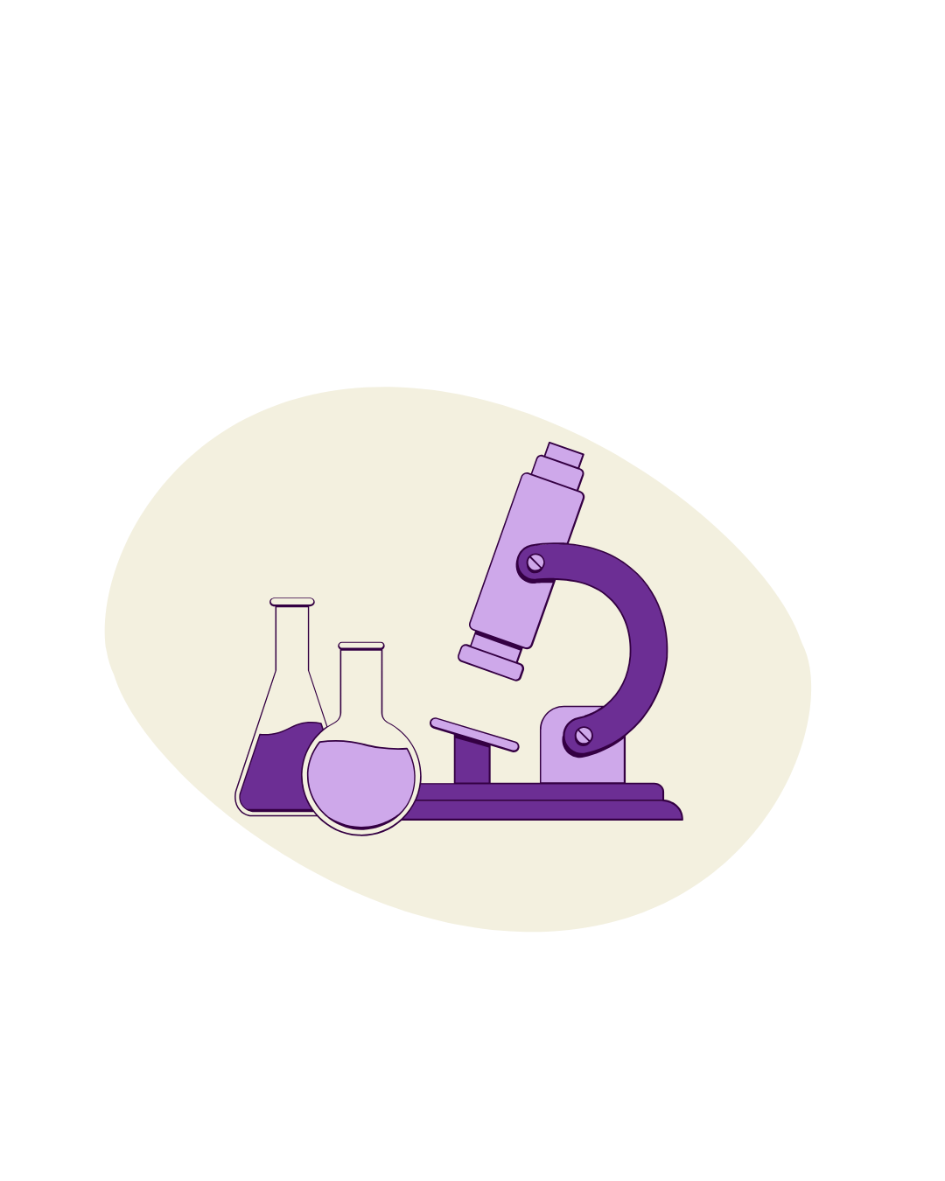
A laparoscopy is generally used to diagnose endometriosis, and remove lesions (the abnormal tissue). The removal of the tissue, has the benefit of providing confirmation it is endometriosis, because the tissue taken from the operation can be sent to a lab for evaluation.

While those of us who have this horrible disease wait for research and better diagnosis tools, we still live with its mammoth side effects. It has even been dubbed “the missed disease” because of its invisibility and challenges with researching its symptoms and effects on those who are battling

Historical links have been made between “hysteria”, which was previously specifically termed as a “woman’s only illness”, and what we now know as endometriosis. The term hysteria is now modernised and is more linked to mental health concerns such as bi-polar disorder, depression, anxiety and PTSD. Hysteria was linked to endometriosis and other medical conditions, with the view that those who have it are ‘crazy’, and the belief that they do not have anything physically wrong with them.

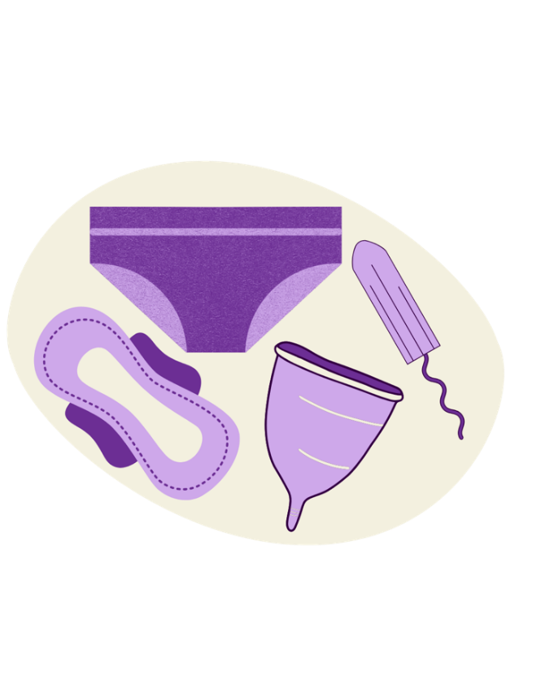
I can say my symptoms were very obvious to myself, but not to the people surrounding me. From my first period at 13, I knew something was not right. For example, I felt sick often, vomited regularly, had painful periods and even throughout my cycle there was always some form of pain. Taking pain relief every day became a dangerous habit. I also remember I used to get intense migraines and lose my vision for short periods of time.

The invisibility of this disease means that sickness is not obvious. While people could see me hunched over in pain or vomiting, they could not see the tearing and burning fire feelings, they could not feel how much self-doubt I put on myself, or the fear I had within. I was constantly questioning if something was wrong – if nothing was wrong with me was this as all just ‘normal for me to experience?’ And why didn’t others seem to be experiencing the same issues that I was? I also knew people around me thought there was something in my head, rather than looking at the physical issues.

I even had my GP tell me there was simply no way I could have it, and that I was kidding myself!

Many others also did not understand the other effects it had on me. It took away some of the things that brought me joy. I could not participate in sport as much as I used to, I struggled with worrying about what was wrong with me.
I worried about feeling isolated and alone as others kept moving on in their lives as normal.

I fell into a deep depression and at times I spent days on end in bed, assuming things would never get better, and this would be my life.
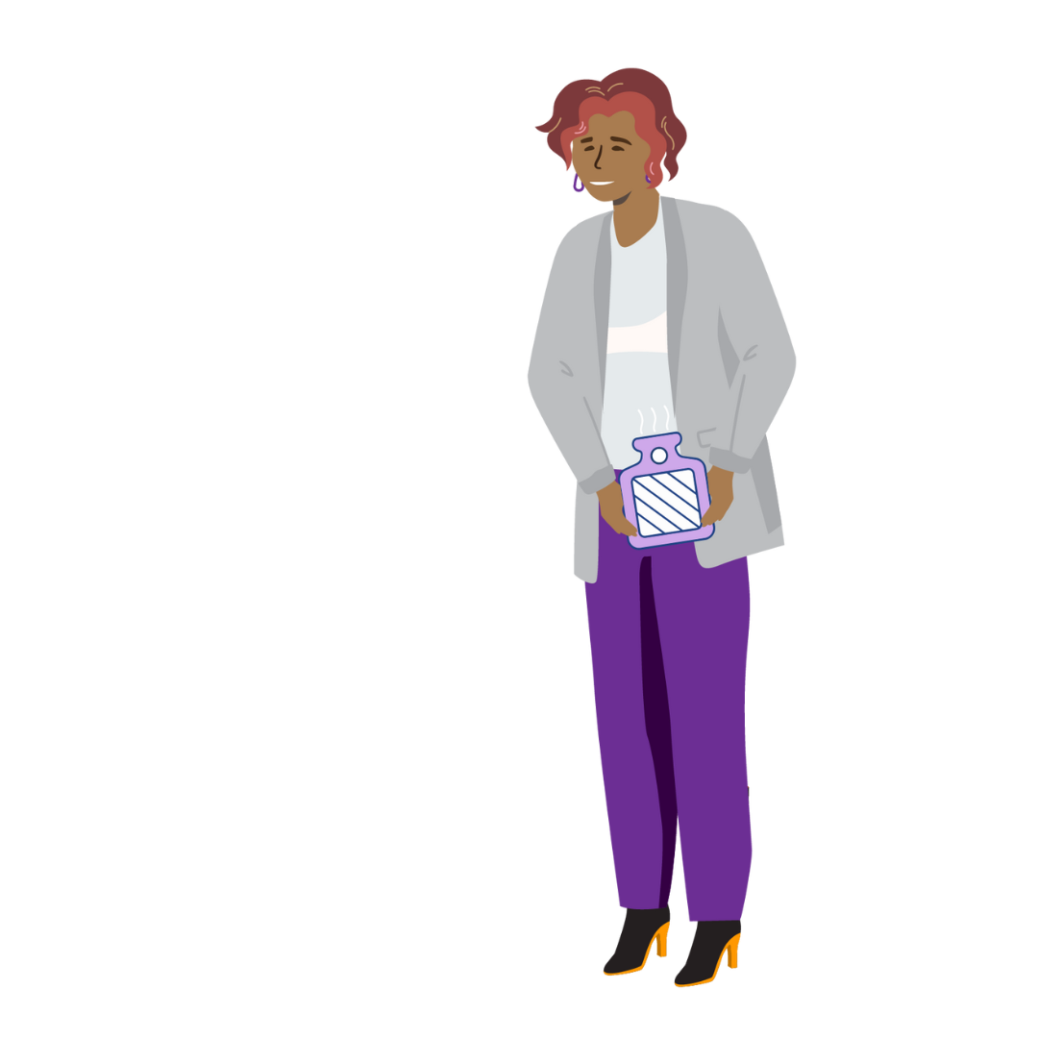
While my life is not perfect now, I have learnt how to manage and deal with my everyday challenges. Accepting my disability was also important to help me heal and grow, and become the person I am today.

With this endometriosis month, I hope you have a better understanding of invisible disabilities.

There are services available that can help if you are concerned you may have endometriosis or are curious about how to help someone who is diagnosed with it, or suspects they have it. A few of these services are listed below:

- Julia Argyrou Endometriosis Centre at Epworth
- The Royal Women's Hospital
- Got endometriosis? Experts answer your top questions
- Endometriosis - Easy Read
- Periods fact sheet

References
- Australian Institute of Health and Welfare, Endometriosis https://www.aihw.gov.au/reports/chronic-disease/endometriosis-in-australia/contents/about

- World Health Organisation, Endometriosis
https://www.who.int/news-room/fact-sheets/detail/endometriosis

- Endometriosis UK, Pain relief for Endometriosis
https://www.endometriosis-uk.org/pain-relief-endometriosis

- Bringham and Women’s Hospital, Surgical Treatment of Endometriosis: Excision and Destruction
https://www.brighamandwomens.org/obgyn/infertility-reproductive-surgery/endometriosis/surgical-treatment-of-endometriosis-excision-and-destruction

- Rahmioglu N, et al. The genetic basis of endometriosis and comorbidity with other pain and inflammatory conditions.

