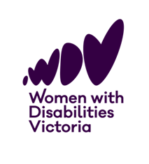



**Let’s talk about it:**

**Conversation Cards**

Talking about pleasure and consent with women and gender diverse people with disabilities.





Women with Disabilities Victoria acknowledges the Australian Aboriginal and Torres Strait Islander peoples as the first inhabitants and traditional custodians of the lands on which we live and work. We pay our respects to ancestors and Elders, past and present. The WDV community is committed to honouring the unique cultural and spiritual relationship Aboriginal and Torres Strait Islander peoples have with the land and waters, and their rich contribution to society.

Women with Disabilities Victoria receives support for the Victorian Women’s Health Project from the Victorian Government.

These documents and all their components are copyright. Apart from fair dealing for the purposes of private study, research, criticism or review as permitted under the Copyright Act 1968, no part may be reproduced, copied, transmitted in any form or by any means (electronic, mechanical, or graphic) without the prior written permission of Women with Disabilities Victoria.

Published by Women with Disabilities Victoria, 2025.

PO Box 18314, Collins Street East, VIC 8003

©Women with Disabilities Victoria 2025.

**Who are these cards for?**

This resource is for healthcare and gender-based violence practitioners who want to provide inclusive, informed guidance on sexual pleasure and consent for community members who are women and gender diverse people with disabilities

**Why talk about pleasure?**

Talking about pleasure with community members who are women and gender diverse people with disabilities can significantly improve health outcomes and contribute to violence prevention.

Having conversations about pleasure models better communication and consent, promotes safer sex practices, supports physical and mental wellbeing, and empowers women and gender diverse people with disabilities.

The voices of women and gender diverse people with disabilities are central to this resource, and all the work we do at Women with Disabilities Victoria.

**Getting Started**

Some women and gender diverse people with disabilities may have never spoken about sexual pleasure and consent with a practitioner before.

Before using the cards, we recommend watching our ‘Getting Into It’ video series, that aligns with these cards. The videos provide valuable insights into the lived experiences of women and gender diverse people with disabilities, highlighting the barriers they often face when accessing sexual and reproductive healthcare, and their own expertise.

**Consent is key** when bringing up this topic with your patients. A simple way to start is by asking, “Would you like to discuss your sexual and reproductive health today?”

Some patients may not be ready to talk about this topic and that is okay.

However, many of your patients will appreciate you acknowledging their sexuality and recognising this as an important part of their overall health.

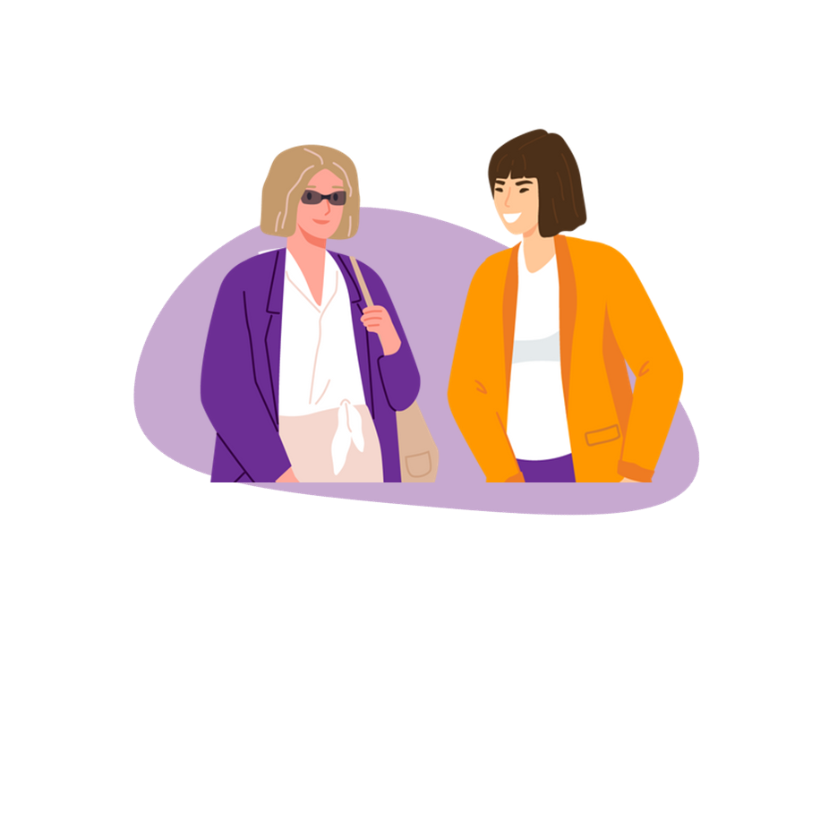

**Using the cards**

We have made these cards for practitioners to support professional development and ongoing reflection.

You might like to use these cards for reflective practice, to share with your colleagues, or keep them on your desk or in your break rooms.

Each card has a main idea, drawn from our consultations with WDV’s lived experience experts about what practitioners need to know.

The front of each card explains this idea and then provides a reflection question for you – the practitioner. The back of the card then provides some practical tips about how you can put this idea into work. You might like to practice these conversations with your colleagues.

WDV has also produced a training guide to support further use of these tools.

**The cards are categorised into four main themes:**

1. **Challenging gender and disability stigma**

This section of the card deck focuses on how practitioners can challenge gender and disability stigma to create an affirming and respectful environment. When healthcare practitioners break down these barriers, they help ensure that their patients feel seen, heard and supported in their right to sexual wellbeing. This section provides practical strategies for approaching these conversations in a way that supports and improves overall health outcomes for women and gender diverse people with disabilities.

1. **The power of pleasure**

This section of the card deck focuses on the powerful role sexual pleasure plays in promoting consent, health, and the prevention of violence against women and gender diverse people with disabilities. This section offers practical strategies for engaging in meaningful and empowering conversations with women and gender diverse people with disabilities.

1. **Having conversations about pleasure and consent**

This section of the card deck highlights the importance of having conversations about sexual pleasure and consent with your patients who are women and gender diverse people with disabilities and provides practical guidelines for doing so effectively.

1. **Building trust and respect**

This section of the card deck emphasises the importance of building trust and respect when engaging with women and gender diverse people with disabilities, both before and during discussions about sexual pleasure and consent.



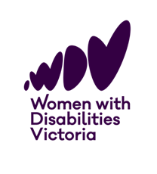

**For more information, visit the Women with Disabilities Victoria website** [**wdv.org.au**](mailto:wdv@wdv.org.au)