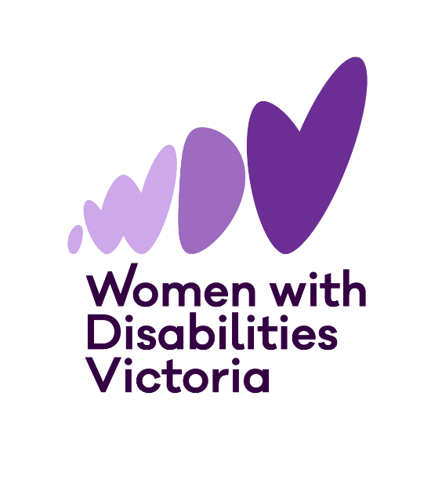

**Pleasure and Consent Resources**

Training Guide

May 2025

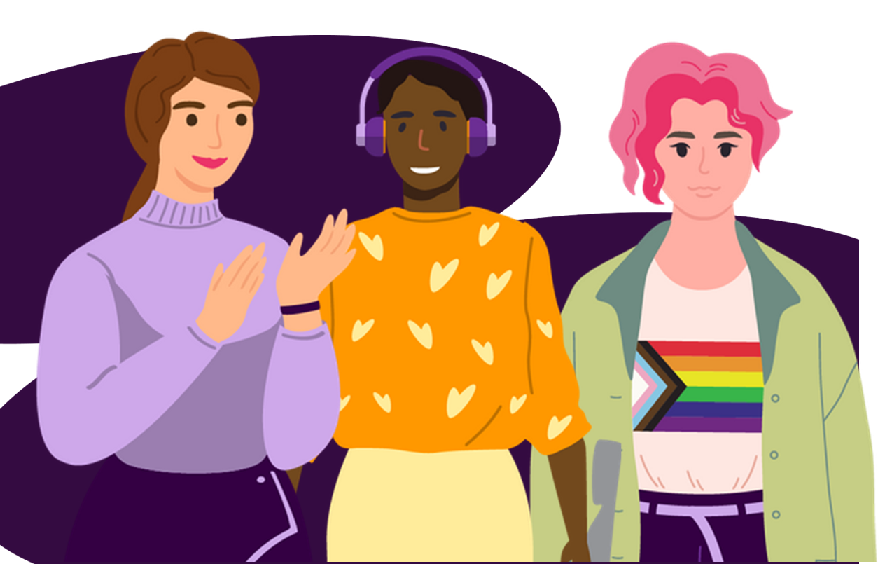

# Introduction

Women with Disabilities Victoria (WDV)’s Victorian Women’s Health Program (VWHP), in collaboration with the Gender and Disability Workforce Development Program (G&D), produced a suite of resources focused on how pleasure and consent relate for women and gender diverse people with disabilities.

The project intends to build the capacity of workforces across the healthcare and gender-based violence prevention systems in Victoria. It will also influence WDV’s ongoing and future work to prevent gender-based and ableist violence and promote better health outcomes for women and gender diverse people with disabilities.

We have designed this training guide to support services and individual practitioners in embedding the project's resources in their work and professional learning. It contains further information about the project, a glossary of terms used throughout the resources, tips for navigating and using the resources, suggested group training and professional development activities, and further reading and resources from WDV and other organisations.

### Project Background

The project aims to support practitioners working in healthcare and gender-based violence to be more gender and disability inclusive by taking a pleasure-centred approach to sexual and reproductive health (SRH).

Women and gender diverse people with disabilities experience higher rates of sexual and intimate partner violence than those without disabilities. They also face significant barriers to SRH. Experiences of ableism, sexism, racism, ageism, transphobia, and homophobia can make it even harder to access SRH, care, or support.

Trauma can impact a person’s ability to enjoy sex, feel safe, or express their needs, increasing the risk of experiencing harm again. On top of this, many women and gender diverse people with disabilities report lower sexual satisfaction, more sexual pain or dysfunction, and even chronic pain conditions after experiencing violence. But it is rare to talk about issues like sexual pain and dissatisfaction in an inclusive way, especially with people with disabilities. Professionals often dismiss pain as just “part of disability,” rather than something worth treating.

When sex is involved, assumptions that people with disabilities are not—or should not be—sexual can lead to neglect in healthcare and education. These attitudes create serious barriers to safety and wellbeing. That is why it is so important to shift the narrative.

### Why Talk About Pleasure?

Centring pleasure in conversations about SRH and violence prevention isn’t only about feeling good. These conversations can give people the tools, information, and confidence they need to lead safe, empowered, and connected lives.

Talking about pleasure with community members who are women and gender diverse people with disabilities can significantly improve health outcomes and prevent violence.

Conversations about pleasure can model better communication and consent. These conversations also promote safer sex practices, support physical and mental wellbeing, and can be empowering for women and gender diverse people with disabilities.

Understanding and discussing pleasure challenges the normalisation of violence. Integrating the topic of pleasure into healthcare approaches can provide essential support for many victim-survivors. Holding back information or education can be extremely harmful and can increase the risk of violence or ill health.

The approach we have embedded in these resources acknowledges that women and gender diverse people with disabilities engage in sexual activity for pleasure, enjoyment, and connection.

The voices of women and gender diverse people with disabilities are central to these resources and all the work we do at WDV.

# Definitions

Throughout the project’s resources, some of the words we use may require further explanation or may have different meanings from common usage. This list of definitions explains how we understand and use these specific terms.

* Assistive Devices – Tools and equipment that help people with disabilities do everyday activities more easily. For sex, these can include adaptive sex toys, positioning aids, and hands-free or easy-grip devices. They make sexual pleasure more accessible, comfortable, and enjoyable.
* Consent – Giving clear permission for something to happen. It must be freely given, enthusiastic, ongoing, and informed so a person can change their mind at any time. In Victoria, the legal definition of sexual consent requires that every person involved agrees to engage in the specific activity and agrees every time[1]. Affirmative consent means that each person involved in a sexual activity must communicate their willingness to continue and demonstrate that they understand that the other person is willing.
* Disability/Disabilities – There is no single definition of disability. At WDV, we use the social and human rights models of disability. This means that disability results from the long-term interaction between a person’s health condition or impairment and societal factors, including negative attitudes, inaccessible environments, limited social support, and lack of inclusive communication[2]. The social model of disability means that society has a role in creating and removing barriers for equal participation.
* Gender Diverse – This is a category used to describe a range of gender identities or expressions that do not fit into the traditional binary categories of woman or man. This can include people who are non-binary, transgender, genderfluid, agender or have other gender identities[3].
* Pleasure – The feeling of happiness, enjoyment, or satisfaction. Pleasure can come in many forms, like eating tasty food or spending time with loved ones.
* Sexual Pleasure – The enjoyment, satisfaction, or excitement that comes from sexual touch, intimacy, or arousal. Sexual pleasure can be experienced alone or with others, and it can feel different for everyone. Feeling safe, comfortable, and respected is important for pleasure.
* Sexual and Reproductive Health (SRH) – This is looking after your health, rights, and choices around things like sex, periods, contraception, pregnancy, and menopause. It includes access to inclusive and accessible care and support for your body, choices, safety, rights, and wellbeing in all parts of your sexual and reproductive life.
* Woman/Women – We use this term to include and refer to anyone who identifies as a woman. Our definition of women encompasses both cisgender and transgender women.

### Project Resources

The resources developed by WDV include:

* *Getting Into It* – A video series about better sexual pleasure and consent for women and gender diverse people with disabilities. The videos provide insights into the lived experience of women and gender diverse people with disabilities, highlighting common barriers to sexual and reproductive health.
  + <https://youtube.com/playlist?list=PLJ6qpBABpGNHXSUJXgpuaP1M68cHhCzg7&si=IAhz3p0gDLhCVILG>
* *Let’s Talk About It* – A collection of conversation cards that offer prompts for reflective practice. The resources are for healthcare, gender-based violence, or any practitioners who want to provide inclusive, informed guidance on sexual pleasure and consent for women and gender diverse people with disabilities.
  + <https://www.wdv.org.au/our-work/our-work-with-organisations/pleasure-and-consent/>
* Pleasure and Consent for Women and Gender Diverse People with Disabilities – A project background paper that provides a policy analysis, literature review, advocacy positioning, and an overview of best practices and evidence-based approaches.
  + <https://www.wdv.org.au/wp-content/uploads/2025/03/Pleasure-and-Consent-for-Women-and-Gender-Diverse-People-with-Disabilities_Discussion-Paper.docx>

These resources aim to:

* Promote strength-based practices that advance pleasure and sexual autonomy for women and gender diverse people with disabilities.
* Support practitioners and sexual health professionals to model consent and decision-making with women and gender diverse people with disabilities around contraception, sexual and reproductive healthcare, and relationships using lived experience.
* Promote the lived experience of women and gender diverse people with disabilities in the prevention of sexual violence through resources that challenge norms about sexuality, violence, and promote sexual wellbeing.

### Who Are These Resources For?

We have created these resources for healthcare, gender-based violence, and other practitioners who want to provide inclusive, informed guidance on sexual pleasure and consent for community members who are women and gender diverse people with disabilities. These resources are aimed at, but are not limited to:

* Allied Health Professionals
* Aged Care Staff
* Counsellors
* Disability Support Workers
* General Practitioners
* Gynaecologists
* Health Promotion Staff
* Interpreters
* Occupational Therapists
* Physiotherapists
* Psychologists
* Rheumatologists
* Sexologists
* Sexual Health Educators
* Sexual Health Nurses
* Social Workers
* Urologists

# Getting Started

Some women and gender diverse people with disabilities may have never spoken about pleasure and consent with a practitioner before.

Having these conversations, especially for the first time, can feel awkward and uncomfortable. WDV has designed these resources to support you and your colleagues in having these important conversations and to move past discomfort and uncertainty towards strength and evidence-based best practices.

Some women and gender diverse people may not be ready to talk about this topic, and that is okay.

However, many people will appreciate you acknowledging their sexuality and recognising this as an important part of their overall health.

Remember, consent is key when discussing pleasure. Always consider how accessible and inclusive you can be when sharing these resources with others.

We recommend you begin by watching the *Getting Into It* video series before using the *Let’s Talk About It* cards. You don't need to read the project's background paper to engage with the cards or videos. However, the background paper does provide further learning and an overview of current policy and research.

## Using the Resources Independently

### Using the Videos

The videos and conversation cards are organised into four key themes, drawn from our consultations with WDV’s lived experience experts about what practitioners need to know.

* Challenging gender and disability stigma
* The power of pleasure
* Having conversations about pleasure and consent
* Building trust and respect

We recommend that you watch the videos in this order, pausing to reflect on how the ideas and experiences might resonate with women and gender diverse people with disabilities in your community.

### Using the Cards

We have designed these conversation cards to support practitioners’ professional development and ongoing reflection.

The front of each card explains a key idea and provides a reflection question for you, the practitioner. The back of the card provides practical tips about embedding the ideas in your work.

You might like to use these cards as reflective practice, in your break rooms, keep them on your desk, or share the cards and practice conversations with your colleagues.  

## Using Resources in Workshops or Training

We strengthen this work by building on existing knowledge and using these resources to connect with colleagues and others in our professional networks.

These activities are suggestions you can tailor to suit your workshop delivery, training, or professional development. They can help to build understanding and confidence in gender and disability inclusive practice.

You might also find other ways to use the cards and videos within your teams—we would love to hear how you are using these resources!

### Suggested Activities

#### Icebreakers

Not everyone feels comfortable discussing pleasure and consent—in fact, most people don’t. To successfully run training that invites practitioners to reflect on their practice and engage in open conversations about pleasure and consent, you may first need to ‘break the ice’ to help participants start thinking and talking about these ideas. For example:

* Pleasure: Have practitioners describe the physical experience of eating their favourite food or an activity they enjoy in as much detail as they can. Ask the rest of the group to guess the food or activity.
* Consent: Ask the group to reflect on how they prefer to greet people: do they prefer a nod, wave, handshake, fist bump, hug, or kiss on the cheek? Do their preferences change based on how well they know the other person? How do they convey their preferences to others?

#### Watch-Pause-Reflect

The videos and conversation cards align with the same four key themes. This means you can run a training session that dives into just one topic, watching one video and exploring the corresponding conversation cards in detail. Alternatively, you may wish to look at the collection of resources together. Watching one video, then pausing to reflect using the corresponding conversation cards, before continuing with the next video.

### **Example Activities**

* Think-Pair-Share: Practitioners reflect on a card or video individually, discuss in pairs, and then share with the group. This is a simple way to build comfort and confidence and get the group used to talking about these topics.
* Snowball: Start in pairs, then join with other pairs to form larger groups. This lets ideas build gradually and encourages collaboration.
* Colour Match / Rainbow: In Colour Match, participants group with others holding the same-coloured card. In Rainbow, each group has members with each colour. This can get the group moving around and ensure that they listen to different voices. You can combine these activities by starting with Colour Match and then splitting into Rainbow to share how each colour groups’ conversation went. You could even assign participants coloured dots and bingo cards to encourage people to discuss different topics with different people.
* Listening Triangles: Participants take turns as practitioner, client, and ‘listener’. The listener observes a conversation between the ‘practitioner’ and ‘client’. The listener then describes what they observed and provides feedback. This helps build empathy, active listening skills, and reflective practice.
* Fishbowl: A small group role-plays a conversation using the conversation cards while others observe. Afterwards, the broader group reflects on what worked well and shares how one another handled different challenges.

#### Running Strength-Based Scenarios

Using strength-based scenarios in training helps shift the focus from deficits or challenges to the skills, values, and resilience that both practitioners and women and gender diverse people with disabilities bring to conversations about pleasure, consent, and sexual safety.

When creating or running scenarios, we recommend you:

* Start from what’s working – Frame the scenario around a practitioner trying to do the right thing, or who already has a strong relationship with the person they’re supporting. Focus on building moments of trust, curiosity, empathy, or openness.
* Highlight people’s strengths in each scenario – This might include their communication style, body awareness, self-advocacy, boundaries, or creativity. If a fictional person is navigating a complex or painful experience, avoid framing them as passive or helpless—centre their agency, even in small ways.

End each scenario with a strengths-based reflection, such as "What went well?" or "What values were being upheld?" Remember, the goal isn’t to “get it perfect” but to build confidence, openness, and a toolkit of approaches that feel authentic and inclusive.

### **Developing your own Scenarios**

The resources at the end of this document contain case studies that could be adapted into scenarios to model or use within your training. However, we strongly encourage practitioners to draw on their own practice to develop realistic examples. This approach means that you can ground your reflective practice in your local context.

The following reflections, prompts, and lived experience expertise may also provide support when developing your own scenarios.

WDV Lived Experience Experts have asked professionals to consider the following:

* “Consent is particularly important for disabled people because we don't often have it in our lives. Being disabled, especially being in a wheelchair or using a mobility aid, you will just be randomly touched by people. People haven't got a problem with just literally pushing you and moving you or treating you like an object….”
* “[Talking about pleasure] sort of busts the belief that people with disabilities don't use their sexuality or appreciate their sexuality or experiment with their sexuality or have a sexuality. Yeah, I think that's a bit of a myth that some practitioners may believe in. So, I think challenging those sorts of stereotypes is a really positive thing to do…”
* “Yeah, they didn't see me as a whole person. They saw me as an illness. I think most health professionals assume that you're a cis woman and you're straight, you're in a relationship or not... Yeah, no—they don't assume you're in a relationship, actually. They assume you live with your parents or something along those lines, maybe even supported accommodation.”

Ask your training participants to consider how these experiences relate to:

* Their professional understandings of how to challenge the drivers of violence, or the impacts on health outcomes.
* The assumptions they may be making about a person’s capacity, identity, or relationships.
* The ways in which power and control may show up in healthcare.
* The barriers that might prevent people with disabilities from disclosing violence or seeking support for their SRH.
* The role of affirming pleasure, identity, and lived experience in supporting safety, healing, and agency.

### Responding to Trauma

It’s important to acknowledge that these conversations can be deeply personal and may bring up past trauma—for training participants and for the people with whom they will eventually go on to have these conversations.

Let the group know it’s okay to opt out of any exercise or to step out of the training at any time without needing to explain why.

Have a list of support options available, including internal wellbeing contacts and external services like 1800RESPECT or Lifeline.

WDV’s list of support services is available here: <https://www.wdv.org.au/support/>

# Further Reading and Resources

Please reach out to the project team if you would like support embedding these resources into your healthcare or violence prevention services.

For more information from WDV about how to be gender and disability inclusive regarding sexual and reproductive health, please contact: [wdv@wdv.org.au](mailto:wdv@wdv.org.au)

For workforce development, lived experience consultations, and training and professional development on topics relating to preventing disability and gender-based violence, please contact: [GandD@wdv.org.au](mailto:GandD@wdv.org.au)

For more information and resources, or to download or request a copy of these resources, visit [www.wdv.org.au](http://www.wdv.org.au), where you will also find:

**AcceSex:**

<https://www.wdv.org.au/our-work/our-work-with-organisations/sexual-and-reproductive-health-2/>

Story snapshots from women and gender diverse people with disabilities about accessing sexual and reproductive healthcare. This Victorian Government-funded project provided training and developed videos and factsheets produced between 2019 and 2020 to promote a better understanding of how women and gender diverse people with disabilities engage with sexual and reproductive health services in Victoria. The developed resources support knowledge and challenge the common access barriers in service and clinical practice.

**Experts in Our Health:**

<https://www.wdv.org.au/our-work/our-work-with-organisations/experts-in-our-health/>

A co-designed suite of resources in multiple formats that women and gender diverse people with disabilities can use as advocacy tools for themselves and others to access appropriate and safe healthcare. The resources also demonstrate how healthcare workforces can best engage with and support women and gender diverse people with disabilities in healthcare settings. These resources support systemic advocacy to promote sincerely responsive, inclusive, and welcoming services across our network.

**Primary Prevention of Disability and Gender based Violence Resources:**

<https://www.wdv.org.au/family-violence-resources/>

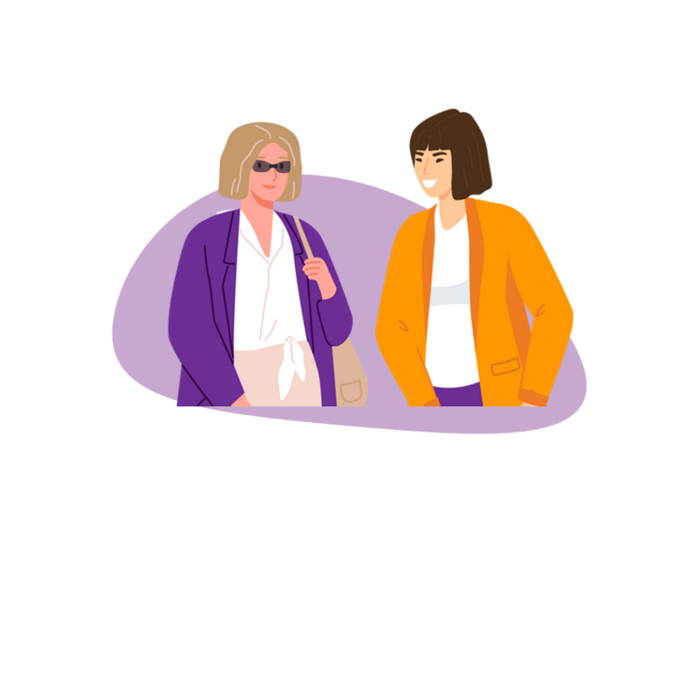Our workforce development team collaborated to build resources, learning from the workforces’ needs of primary prevention, and community organisations we support. These resources respond to the needs of our colleagues across the state who work with women and gender diverse people with disabilities to challenge gender and ableist barriers that create conditions where violence is more likely to occur. This list is continuously updating.

## **Resources from Other Organisations**

Many organisations have produced resources on similar topics with and for women and gender diverse people with disabilities to promote better understandings about sexual health, sexuality, and relationships. We have compiled this (non-exhaustive) list of resources to support your knowledge and the knowledge you can share with the women and gender diverse people with disabilities you work with.

**Sexuality Education Counselling and Consultancy Agency (SECCA):** Sexuality, Relationships and Your Rights Resource

<https://www.secca.org.au/resources/sexuality-relationships-and-your-rights-resource/>

SECCA are a specialist organisation based in Western Australia that supports people with disabilities to learn about relationships, sexuality, and sexual health. They produce free resources such as this booklet that describes information about sexuality and the law as it relates to people with all abilities.

**Women’s Health East (WHE) and Youth Disability Advocacy Service (YDAS):** Get the Go Ahead

<https://gtga.org.au/>

WHE and YDAS have co-designed videos and printed resources to promote a better understanding of the Victorian affirmative consent laws and different models of consent through the lived expertise of young people with disabilities. The resources are aimed at young people, community members, and workforces.

**Women With Disabilities Australia (WWDA):** Neve – Sexual health and Relationships

<https://www.neve.wwda.org.au/level-3-page/sexual-health-and-relationships>

WWDA have co-designed Neve as a safe and accessible website for women, girls, and gender diverse people with disabilities, as well as workforces who support our community to learn about our experiences and find useful information. This part of the website respectfully describes safe and healthy sexual practices, relationships, sexuality, and sexual health rights for people with disabilities.

**Women With Intellectual and Learning Disabilities (WWILD):** Consent, Contraception, Pregnancy Options, Reproductive Coercion

<https://wwild.org.au/easy-english-factsheets-consent-contraception-pregnancy-options-and-reproductive-coercion-and-abuse/>

WWILD are a Queensland-based organisation supporting people with intellectual disabilities who are victims-survivors of sexual violence or have been victims of crime or exploitation. These resources were co-designed between WWILD and Children by Choice to provide information in Easy English about consent, contraception, pregnancy options, and reproductive coercion and abuse.

1. Government of Victoria. (2022). Justice Legislation Amendment (Sexual Offences and Other Matters) Act 2022. <https://www.legislation.vic.gov.au/as-made/acts/justice-legislation-amendment-sexual-offences-and-other-matters-act-2022>
2. United Nations. (2006). Convention on the Rights of Persons with Disabilities. <https://www.ohchr.org/en/instruments-mechanisms/instruments/convention-rights-persons-disabilities>.
3. ACON. (2019). A Language Guide: Trans and Gender Diverse Inclusion. Accessed via: <https://www.acon.org.au/wp-content/uploads/2019/11/TGD-Language-Guide_2019_updated.pdf>