# **Getting to the office of**

# **Women with Disabilities Victoria**

### Contact Information

Phone: 03 9286 7813

Email: [wdv@wdv.org.au](mailto:wdv@wdv.org.au)

Street address: Level 1, 255 Bourke Street. (Please note someone with a lift security pass will meet guests in the building foyer and accompany them to level 1. See below for more information.)

Office Hours: 9:00am - 5:00pm, Monday – Thursday

### Location

We are located on the south (Collins Street) side of Bourke Street, to the east of Swanston Street, and west of Russell Street.

If walking along Bourke Street toward Russell Street, we are on the right-hand side. Our building is between a small mobile phone accessory shop (Dr Boom Communications) and a telecommunications/phone shop (Optus).

There are two steps and a wheelchair accessible ramp (on the left side of the stairs) which lead to the building entrance. Tactile Ground Surface Indicators (TGSIs) are located at the top of each. When coming up the steps, automatic doors to the building are directly in front of you.

Lifts are located, approximately 8 metres directly in front of the automatic doors.

Lift buttons are tactile and have braille and will light up when pressed.

We are on Level 1.

On Level 1, the entrance to WDV’s office is 1–2 metres directly opposite the lifts.

The doorbell is placed against a glass wall, approximately 1 metre in from the wall on the left, and 1.2 metres high.

Please press the doorbell to be let in.

Front of WDV's office.
Glass doors.
An orange strip of tape to help identify the door.
A banner is displayed behind a glass wall.


#### Map

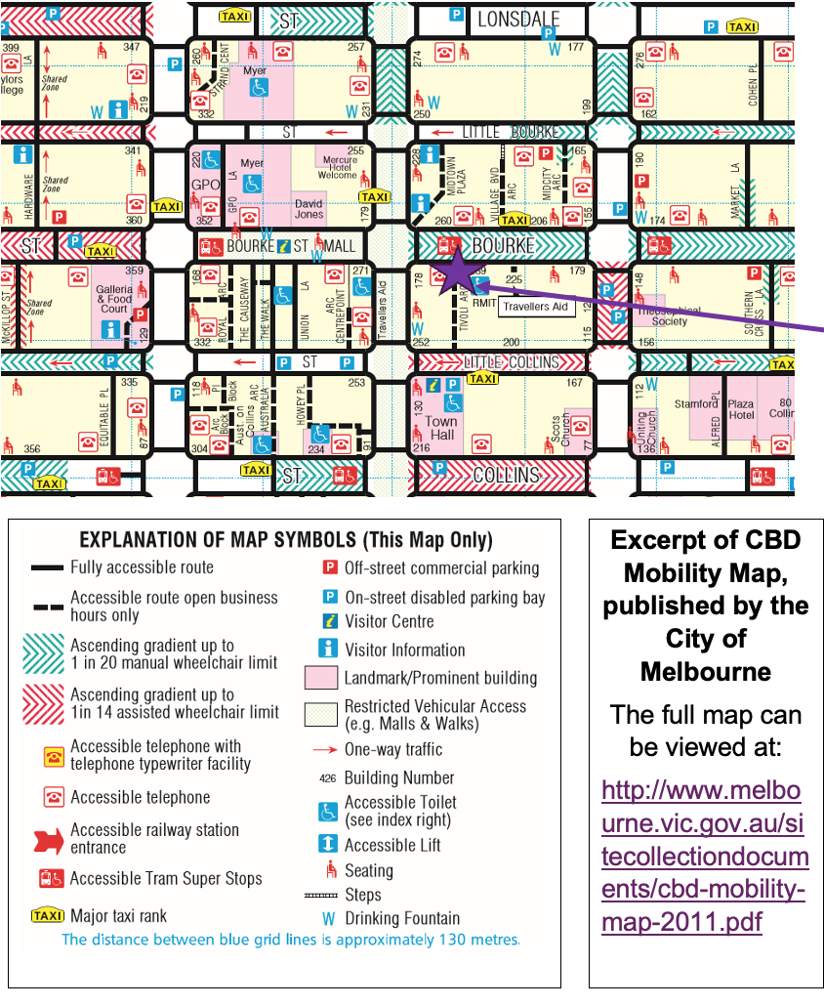

#### Public Transport

We are located on the south (Collins St) side of Bourke St, to the east of Swanston St, and west of Russell St.

Trains (nearest stations)

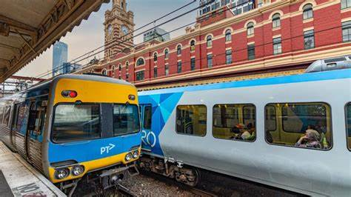

* Flinders Street Station – Corner of Flinders and Swanston Street (0.5 km)
* Melbourne Central Station – Swanston Street (0.6km)
* Parliament Station – Bourke Street (0.7km) or wheelchair access via Lonsdale Street (0.9km)
* Southern Cross Station – (1.2km).

V/Line train and bus (nearest station)

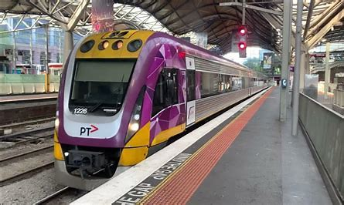 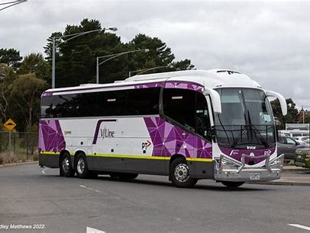

Southern Cross Station – (1.2km).

For V/Line passengers (train or bus), you can get any tram from Southern Cross Station that runs along Bourke Street. (See below for more information)

Trams

The two nearest tram stops are both accessible by wheelchair (However, not all trams are guaranteed to be low floor trams).

Stop No 6 – Swanston Street / Bourke Street is situated directly in front of our office building on Bourke Street, (tram routes 86 and 96).

If travelling by tram along Swanston Street, Stop No. 10 - Bourke Street Mall / Swanston St, stops in Swanston Street, just north of Bourke Street, (tram routes 1, 6, 16, 3/3a, 67, 64, and 5)

For all other information concerning public transport travel, including information in other languages, please contact Public Transport Victoria (PTV)

**Website:** <https://www.ptv.vic.gov.au/>

**Phone:** [1800 800 007](https://www.ptv.vic.gov.au/customer-service/public-transport-call-centre/) or TTY: 03 9619 2727 (6am – midnight daily, and all night Fridays and Saturdays)

#### Parking

The WDV office is located in an area of Bourke Street where cars cannot go.

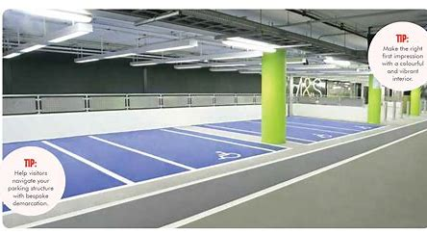For information about parking, and in particular parking for people with disability, please visit [Parking for people with disability | City of Melbourne](https://www.melbourne.vic.gov.au/parking-people-disability)

#### Getting dropped off

The WDV office is located in an area of Bourke Street where cars cannot go.

If getting dropped off, or picked up, we recommend giving the address for **Comedy Republic – 231 Bourke Street**. Near the corner of Bourke Street and Royal Lane.

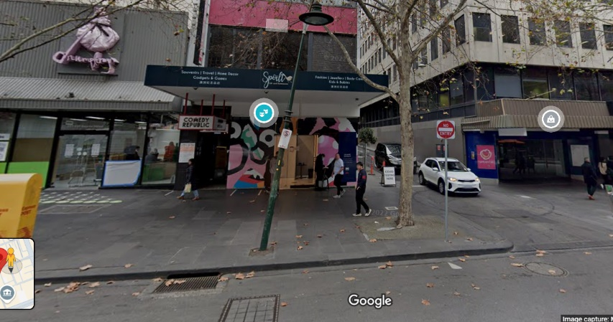This is approximately 100 metres from the WDV office. Once on the street, head west towards Swanston Street.

### Assistance animals

Assistance animals are welcome.

Please contact us (03 9286 7800 / [wdv@wdv.org.au](mailto:wdv@wdv.org.au)), if you have any specific questions in relation to your service animal.

### Wheelchair access

WDV’s office is wheelchair accessible, including our bathrooms.

### WDV staff members

If throughout the day you would like some support, or would like to learn more about WDV, please approach a WDV staff member.