**Where Identities Meet:**

**Belonging at the Intersections**

**By Husna Amani (she/her)**

What does it mean to belong? Specifically, what does it mean for those of us who have multiple marginalised identities? And, can we truly belong in one specific group, or to multiple?

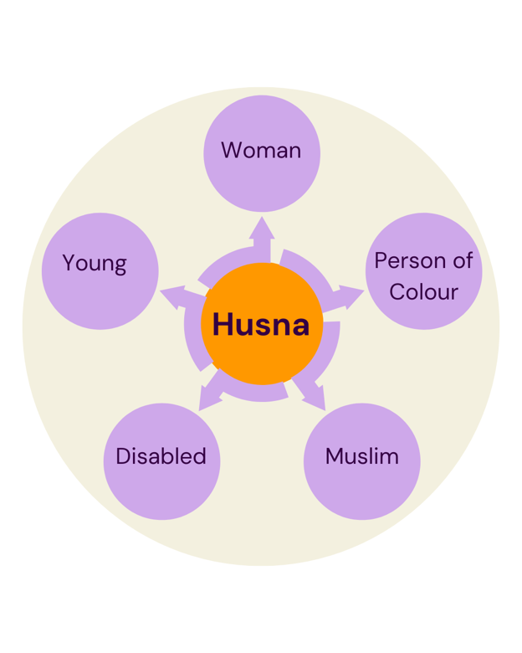

In theory, as a person of colour (POC) who is also a woman, Muslim, and disabled (and not forgetting, the other aspects that make up who I am), I should have a lot of spaces to belong. Recently, I have been reflecting on two key aspects of my identity in relation to belonging - my disabled identity, and my POC/multicultural identity.

Balancing these two identities and being comfortable with one of them, let alone both of them, has always been a struggle.

I grew up in a very white neighbourhood, and my name stood out as being different. My disability – made obvious by assistive technology, amplified by my use of a mobility aid, further added to this. In school, I could count the number of non-white students on one hand, and that number always included either an older or younger sister. Although I had friends in the disability community, their experiences were different from mine, and I felt like I didn’t quite fit in.

In retrospect, I feel like a large part of this was because the disability community around me was very white, and other than one of my sisters, I did not know other disabled people from multicultural backgrounds.

It wasn’t until during uni and work that I found more people who shared at least one of my identities. However, this is also where the gaps between my two experiences began to show, and the bridge became wider and wider.

In the workplace, I have often felt frustrated and dismissed. Like I was forced to choose which parts of my identity to bring to the table, and what to compartmentalise and keep separate.

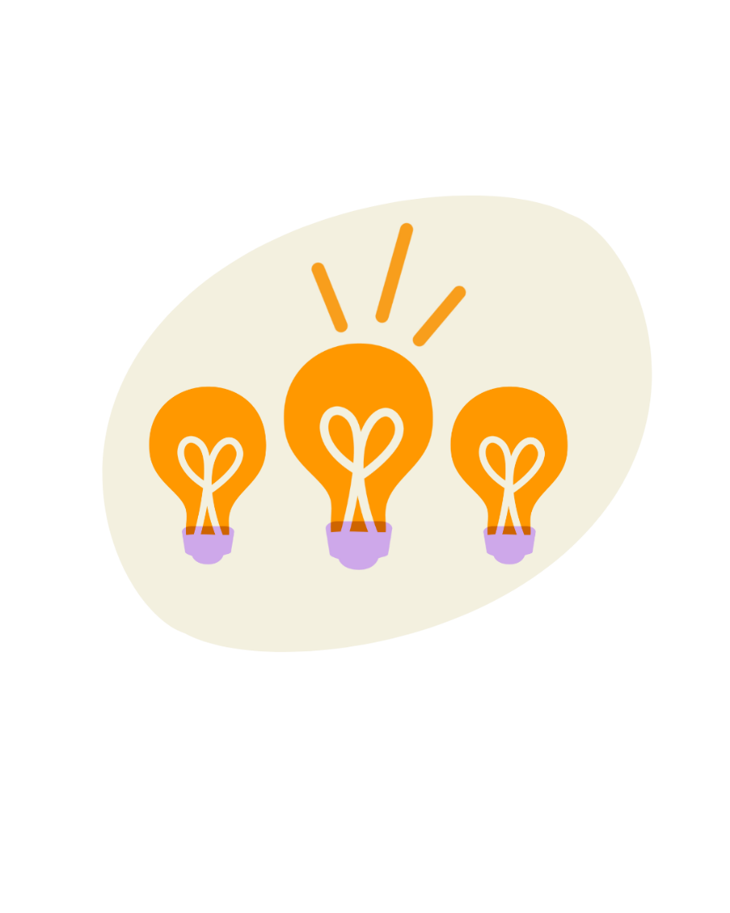It’s having my suggestions or notes ignored, to then having these same suggestions acknowledged when raised by others. Not knowing if this is due to me being the youngest person in the room, disabled, a woman, or the only person of colour adds to these feelings.

It is particularly challenging in situations where colleagues don’t understand that I may go into situations defensively, unsure, and with my guard up. Having these same people making assumptions about other people and themselves, such as a person who stated they can’t be racist, because their best friend is Asian.

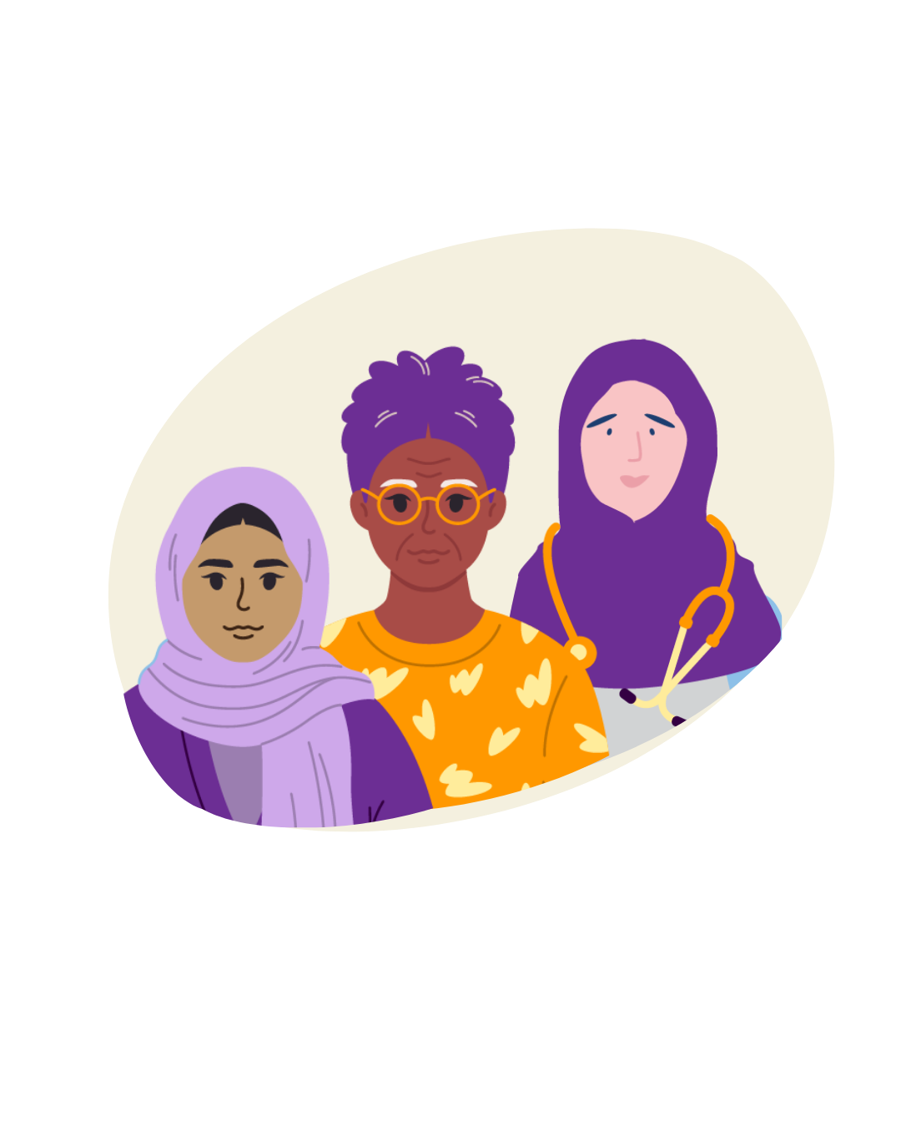These feelings also arise in situations where I have been tone-policed - by a white male no less, for calling out people and groups for using the buzzwords of ‘diversity, equity, inclusion and intersectionality’, but not putting in the work. And then I was told that it was hurtful to those who had been in spaces for a long time, whilst disregarding the reality of my concerns.

I experience even more barriers when my access needs are dismissed. Western and multicultural communities have different perceptions and understandings of disability and accessibility, with neither fully capturing the nuances of the disabled experience.

This is demonstrated by multicultural families having a more communal approach to care, but sometimes this means sticking to what is familiar, rather than accessing external supports that can be difficult (for anyone) to navigate, regardless of English proficiency.

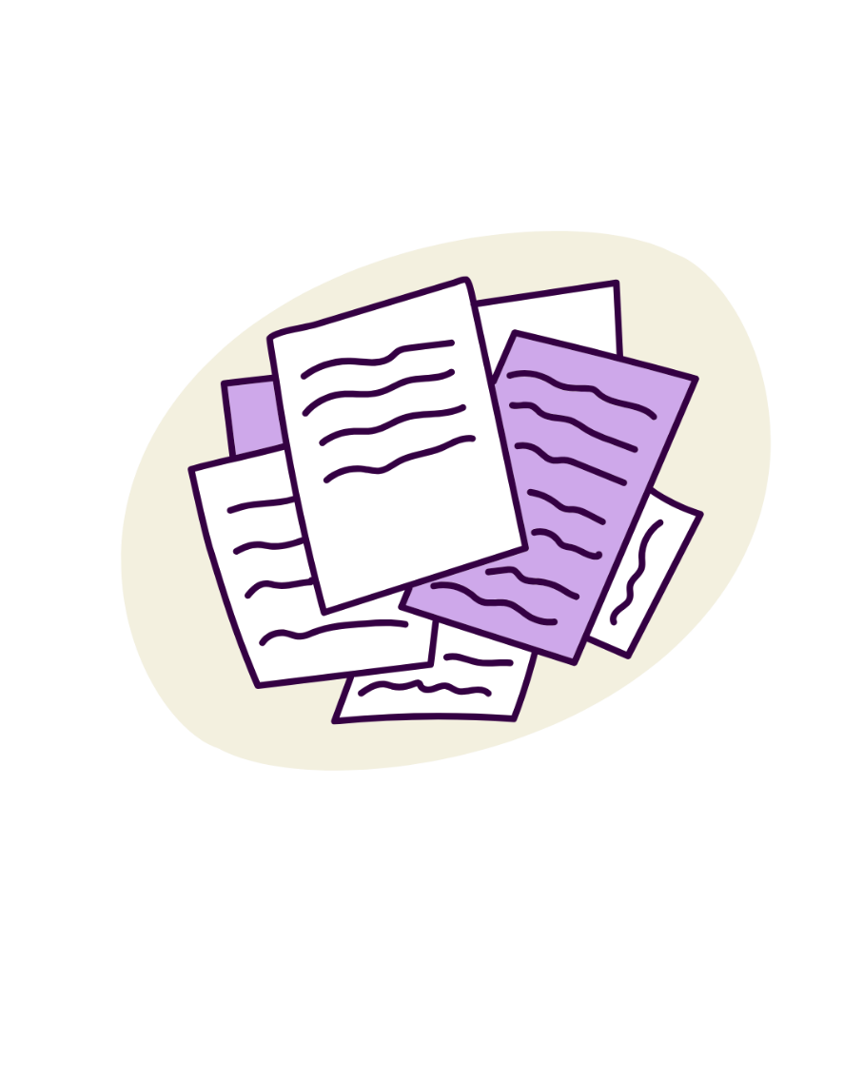Thinking about the experience of filling out forms, it is common for a child of an immigrant family to interpret / translate forms and information for their parents. However, this typical experience was complicated for me, by not being able to visually read the document in front of me due to my blindness. Therefore I was left without a clear, immediate idea of what was being asked. Many frustrating moments were spent with my parents slowly spelling out certain complex words to me while I tried to do my best to figure out what the letters were spelling and what the words meant. With time passing and my parents increased knowledge and familiarity of navigating different systems, plus with the rise of technologies, it is very rare that I assist in this area nowadays. Phone apps that have helped myself and my parents in different ways include ones that capture photos of text and can read them aloud, or translate them

Recently, while speaking on a panel, I stated that one of the first spaces where I felt accepted was within the multicultural and racial justice space. I will always stand by this statement. It is a space my experiences of subtle and overt forms of racism are understood, alongside the complex feelings of being from a refugee family whose country is experiencing ongoing war and watching mass genocide being livestreamed.

For me, it is also a space where my access needs are met without question. This may be because the spaces are being built from a newer / more contemporary base. Here, my experiences of dealing with ableism are also acknowledged, and I can take time out when the aspects of my identity become overwhelming, no questions asked.

This is not to say that POC and multicultural spaces have been perfect. I attended a networking event aimed at people of colour where, despite having specified my access needs in advance, they were not met. When I raised this issue, the excuse given was ‘technical issues’. I was left frustrated when this happened again by the same organisation at another training session. It seemed more like a lack of awareness and shifting of responsibility back onto me, or others. The fact it happened not once, but twice, despite the (free) advice and training I had provided them to improve their practise, meant nothing had been learnt.

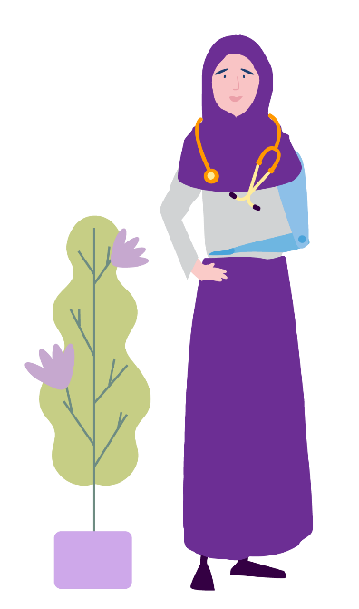Additionally, at another event in the multicultural space, when asked about a focus on diversity, equity and inclusion, a guest speaker dismissed discussions about people with disabilities, diminishing the experiences of those who are both people of colour and disabled.

Moreover, the host of this same event, when speaking on a panel stated, 'I’m not illiterate.' A statement that is not only harmful through a disability lens, but also lacks cultural sensitivity. Individuals from Culturally and linguistically diverse (CALD) communities may face challenges in relation to literacy due to various factors beyond their control, and the same can be said for those in the disability community.

The disability space is where I have struggled to find acceptance and belonging the most.

A purple megaphone with orange accents
It’s when in high school, people have their parents advocate for them in school and say, ‘why can’t your parents do that for you?’

A purple megaphone with orange accents
It’s when I was essentially told to portray my experiences in such a way to demonise my culture and religion’s perception of disability.

A purple megaphone with orange accents
It’s being the only POC and the youngest person within a large group at a disability organisation, and having my connections to multicultural spaces challenged.

A purple megaphone with orange accents
It’s in situations where disability advocates only advocate for disability as a singular issue, as if it’s the only issue to care about and that should be aggressively fought for.

A purple megaphone with orange accents
It's when prominent disability advocates operate in bubbles and remain silent on world events, even on mass disabling events such as the climate crisis and the Genocide in Palestine.

A purple megaphone with orange accents
And it is so much more, including the constant microaggressions, which can sometimes have more of an impact than the bigger, more obvious things.

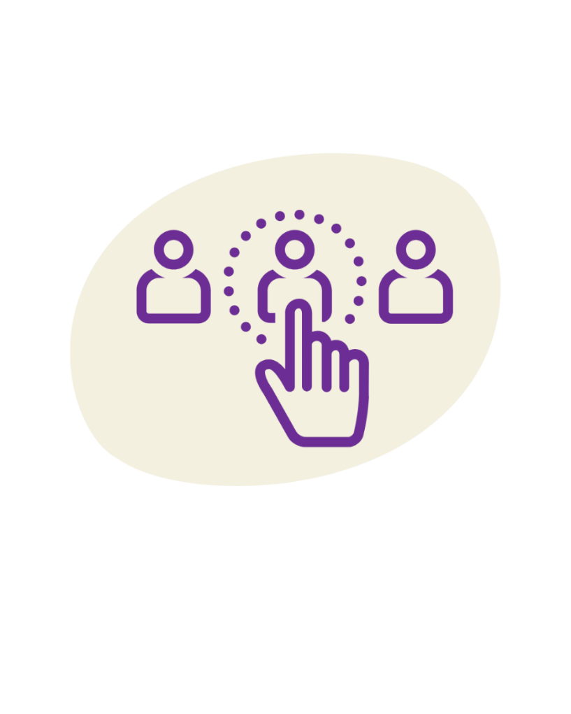People of colour in disability spaces are not truly being included, and often have their identities, activism, work ethic, and professionalism called into question. Those of us who fall into multiple intersections, are forced to pick and choose which parts of our identities are worthy causes to amplify and advocate for.

Disability representation is important, but the current representation in Australian media is narrow. It’s mostly made up of male athletes bordering on influencers, and white activists.

Similarly, the multicultural and racial justice spaces have issues with representation, in seeing all representation as good representation. Such as celebrating prominent political figures despite their complicity in marginalising their own communities, and their use of ableist slurs. Mirroring the same aggressive activism and support we see within the disability space.

I cannot separate my two identities; I cannot be put into one box of being disabled, and another box of being a person of colour / from a multicultural background. My experiences shape one another, and I cannot discuss one without mentioning the other.

My experiences of disability have been influenced by my multicultural identity, due to instances of racism, or simply a lack of understanding of my background and different experiences. Similarly, my experiences of being a person of colour have been influenced by my disability, due to ableism and access barriers.

These experiences also mean that I have been exposed to, and have had access to, two differing communities. I find ways of meshing differing aspects of these communities in a way that feels right for me. It means I have been able to meet and get to know people - people whom I can call friends, and take on opportunities that I wouldn’t have otherwise. I wouldn’t have built the confidence to speak up and challenge the status quo, in the ways that I have, I wouldn’t be passionate about the things that are core to me and my values. Basically, as cringy and cheesy as it sounds, I wouldn’t be the person I am today if it wasn’t for these two identities and both these communities.

I now am in a space where I am comfortable with embracing the different parts of my identities, and I feel like I can share my experiences relating to them. But it took a very long time to get here. And I do still face situations where others force me to choose which parts of my identity to bring to the table, where people ignore huge chunks of who I am, and my experiences. Navigating these situations - having to make myself smaller just to be somewhat understood, is exhausting.

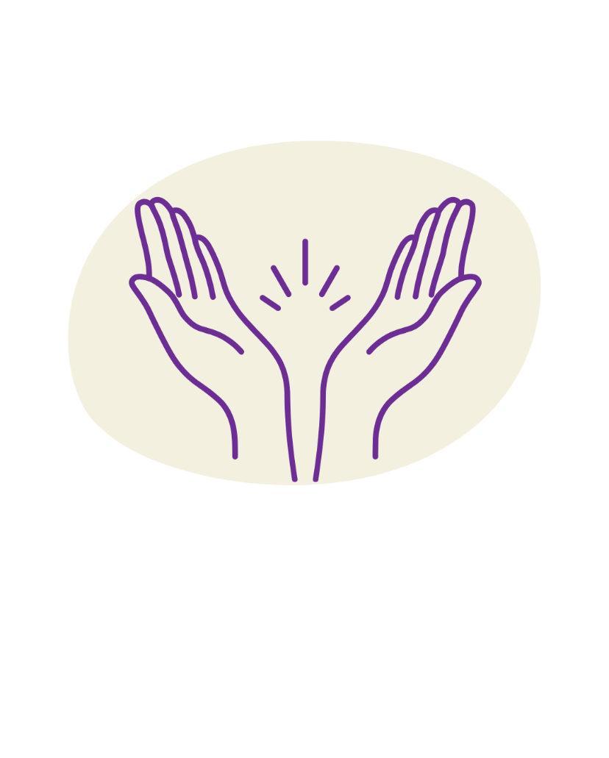

In the work that I am currently doing and that I will continue to do, my aim is to not only support those who have similar identities to myself, but to amplify the experiences of other marginalised communities, and to walk alongside them.