Community Inclusion Video 2025

Explainer and Visual Description

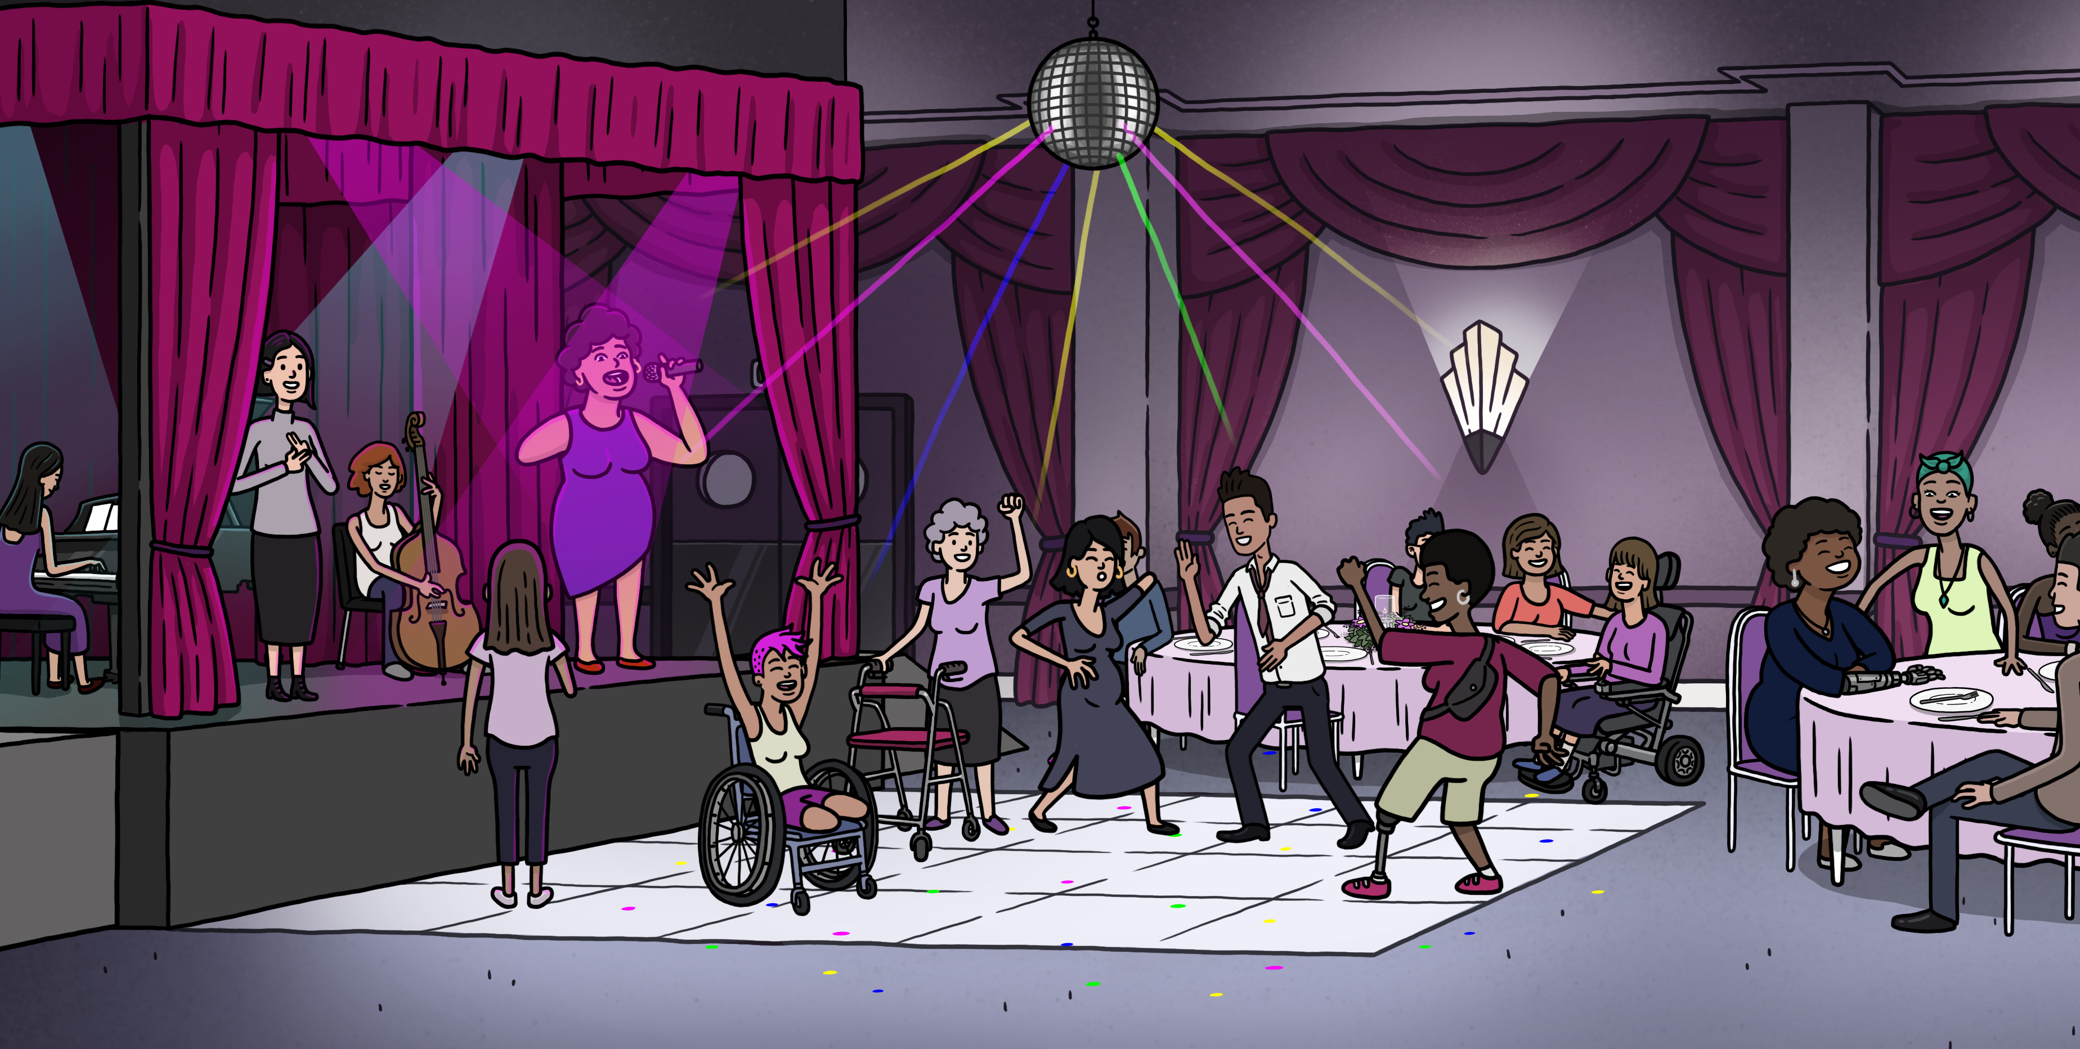
Created to celebrate the empowering potential of community inclusion, WDV’s animated video shows what can happen when women and gender diverse people with disabilities are included in their communities.

Image Description: Still shot from the Community Inclusion video. It features a lively event with women and gender diverse people with disabilities alongside people without disability dancing on the dancefloor and happily engaging with each other at surrounding dining tables. Onstage is a lead singer, she has limb difference. She is joined by other musicians and an Auslan Interpreter. A young woman also with limb difference stands in front of the stage, looking up at the singer. Ramps on either side lead to the stage.

Link: https://youtu.be/TDfOHLLg9xY?si=E99WS4Ho3RaStbBn
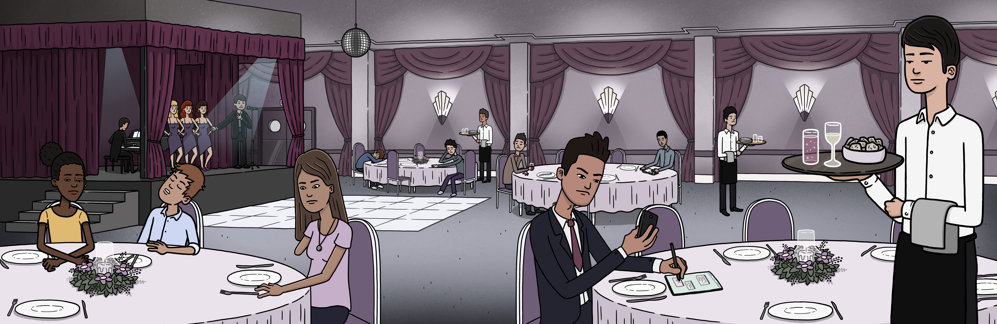
Communities often don’t include women and gender diverse people with disabilities.

Image Description: A still shot from the video. It features a young woman with limb difference sitting at an event. She looks sadly at her plate. A guy is asleep next to her. The dancefloor is empty and onstage is a man with a microphone and 3 female backup singers. There are stairs accessing the stage.

But when physical and social barriers are removed, wonderful things can happen.
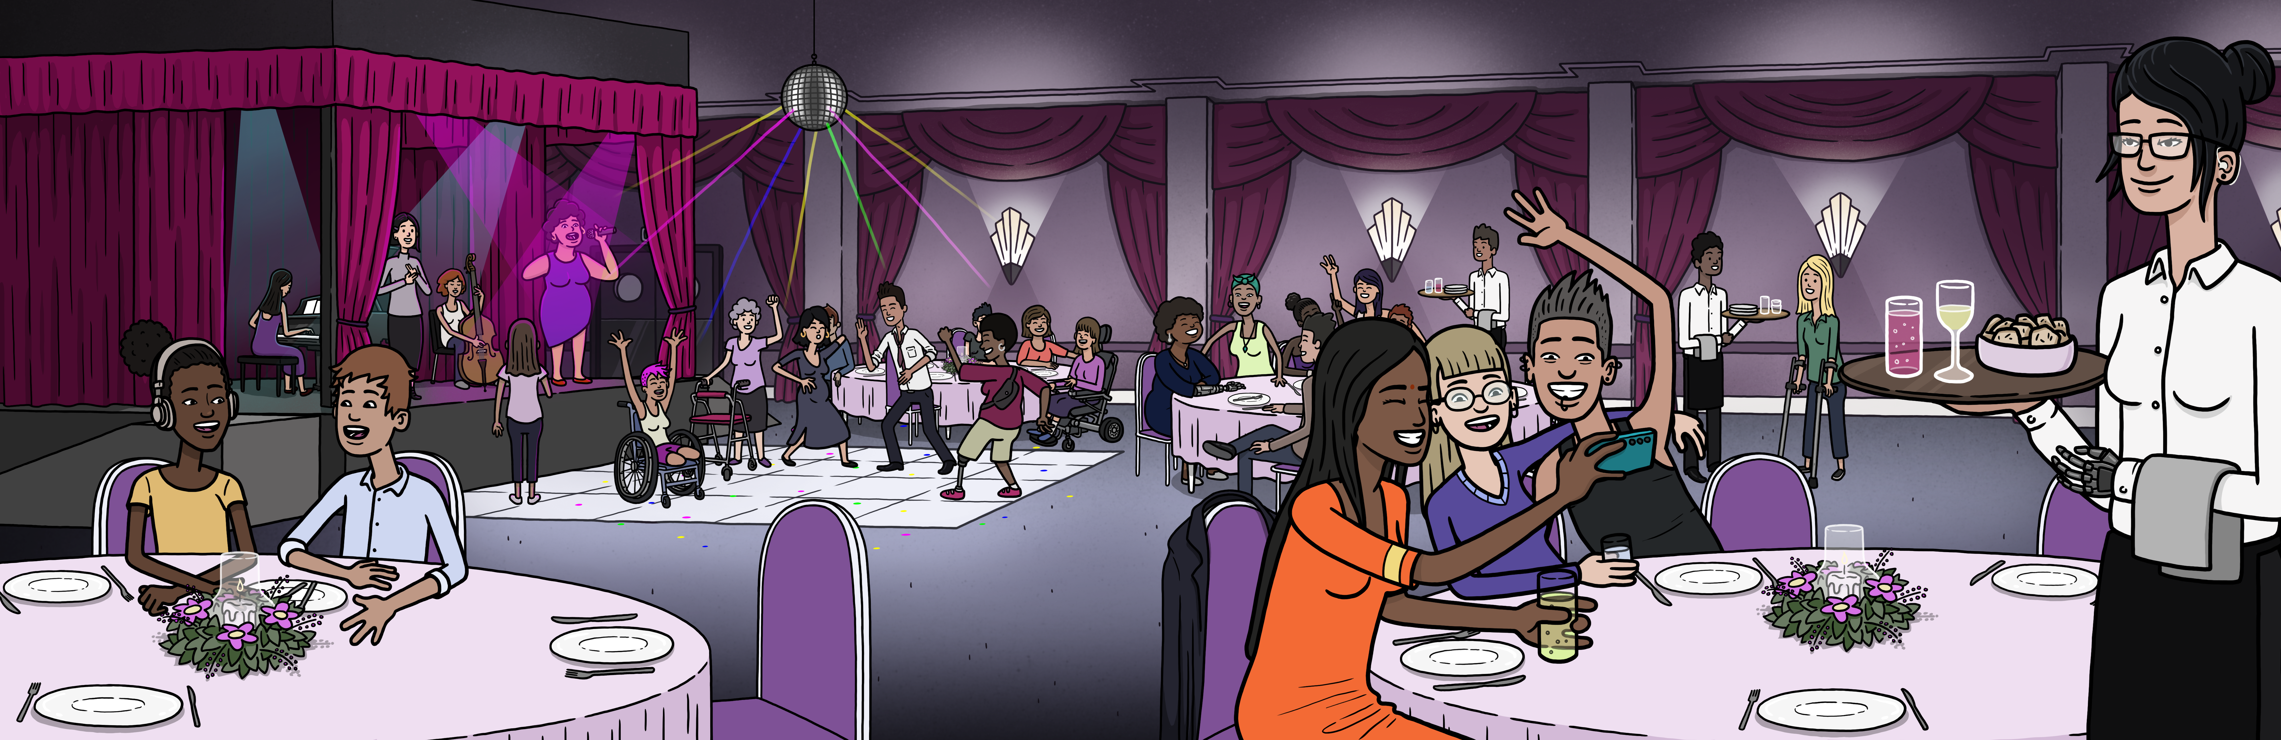

Image Description: A still shot from the video. It features the same shot, however, the young woman’s seat is empty. The guy next to her is now engaged in conversation. The dancefloor is populated with women and gender diverse people with disability and people without disability. Onstage is a lead singer, she also has limb difference. She is joined by other musicians and an Auslan Interpreter. The young woman with limb difference now stands in front of the stage, looking up at the singer. There is now a ramp accessing the stage.

WDV Community Inclusion Video Description 2025
00:00
The video opens at an event inside a large hall. Everything is black and grey. Lowkey music plays unremarkably in the background. There is a stage and dancefloor. There are stairs accessing the stage. Round dining tables line the room. Wait staff serve drinks and food. The dancefloor is empty. At the table’s guests, mostly males without visible disabilities look at their phones and appear bored. One man drifts off to sleep and another man works from a clipboard at the table

00:05
A young woman with limb difference sits at a large table. She looks down sadly at her plate.

Voiceover
Often communities don't include women with disabilities.

00:11
A powerful female voice starts to sing with a new upbeat track.

00:13
The video goes to full colour. The music gets louder. The voiceover continues.

Voiceover
But when the physical and social barriers are removed, wonderful things start to happen.

00:14
Upon hearing the singer, the young guest, looks up from her plate. She blinks. Her mouth drops.

00:15
The beat of the song kicks in and the shot shifts to the now full dancefloor. A ramp has replaced the stairs to the stage. Women and gender diverse people with disability dance alongside those without disability. There is a range of disabilities, appearances and age. The working man has loosened his tie and now dances along happily. As the shot pans through the room, women and gender diverse people with disabilities now occupy the previously empty tables. Everyone is happy and engaged.

00:19
On stage, with musicians and Auslan interpreter beside her, the singer is revealed. She is also a woman with limb difference.

00:21
Watching on from the front of stage the young guest looks up in total awe at the singer.

00:25
Shots show more of the hall where wait staff happily engage with guests while serving drinks and food. At one table two women and a man pose for a selfie. They are all smiling. The dancing continues behind them.

00:29
A closeup of the young guest now reveals tears welling in her eyes as she continues to watch the singer with a massive smile.

00:33
Fading to a white screen with text. The voiceover reads along with the text.

Voiceover
Community inclusion empowers women with disability and keeps the community interesting.

00:40
The WDV logo.

00:44
Video Ends
