Pain Takes. Disability Pride Gives.

A WDV peer article for National Pain Week 21-27 July 2025

Pain is important, it lets us know when something is wrong. A rusty nail in the sole of your foot or a festering cavity in that back corner of your mouth that dental floss refuses to reach. Here, the associated pain alerts us to issues that left untreated could be bad. Like sepsis bad.

Pain is the great protector, an early warning system for greater damage or disease. But what happens when the warning system goes rogue? Or the damage and disease set up shop and refuse to vacate? It is this type of chronic pain that impacts the lives of 3.6 million Australians, including many women and gender diverse people with disability in our WDV community.

Drawing attention to this persistent issue, Chronic Pain Australia are getting behind National Pain Week 2025 with their campaign Pain Takes a Nation. They say, ‘Pain takes options. Pain takes sleep. Pain takes action. Pain takes opportunity. Pain takes a nation.’ So what does that mean? It means we need better representation for people living with chronic pain in this country. We need better support. We need better access and better inclusion.

It is fantastic to have a national representative organisation like Chronic Pain Australia doing their thing. They are tackling the systemic issues that plague us. They are working towards greater understanding around things like medicinal cannabis and other “new” less conventional supports. Their work seeks to improve access and inclusion for us at those higher levels.

Those of us living with chronic pain conditions know pain is exhausting enough on its own. But, add to that the unavoidable demands of the systems and structures we live under, and well everything is so much harder than it needs to be. It is frustrating and needs to change. But as individuals how do we create that change when we are so bloody exhausted all the time!?

That is the thing about chronic pain – for lots of us it is just that, chronic. As in long-lasting, enduring – will never bloody stop! And that takes a toll.

I have lived with constant whole-body pain for 14 years this month. My body holds the memories of a traumatic car accident. The broken bones have healed and the extensive metalwork holding my lower lumbar spine together has become a part of me. But the scar tissue, the nerve damage, the post operative pain, the spinal injury, the loss of muscle tone and loss of control, the acquired brain injury and whiplash related migraines are some of the constant reminders of what my body went through. What it goes through every day and night.

The physical pain triggers the post traumatic memories, and these memories trigger physical pain. It’s a cycle that is nothing but vicious.

So when I say constant I mean like there is no respite. Pain takes time, money, resources and pain like this can take your spirit. The kernels of who you are can so easily get swamped by the pain itself, but we can also lose ourselves in the never-ending appointments, cancelled plans and the mental labour of managing life with chronic pain. It can become all consuming.

About 5 years after the accident, it became clear my pain wasn’t going anywhere. All the supports, all the meds and I was still going to be in pain. At 30 years old that’s a lot to take in. At any age really this knowledge is a lot to succumb to. Yet when I started to accept my pain, the reality of living with pain, that’s when things started to profoundly shift.

I started to finally see my post-accident self as worthy. Worthy of supports and understanding, access and inclusion. Worthy of being part of disabled community.

Acknowledging that my pain was a disability was like that light bulb moment. WDV Women’s Empowerment Officer, Bridget and I see this light bulb often when delivering the Enabling Women Program.

We will talk about the social model of disability, the idea that the systems and structures of the world are set up for people without disability and therefore make things harder, even impossible for people with disabilities, we will talk about the human rights model of disability that recognises disability as a natural aspect of human diversity and humanity and we can feel the light bulbs going on for so many participants.

This twinkle, that feeling is validation, and it is utterly vital as women and gender diverse people with disability to have. When we feel valid, we start to believe in our worth, in our value and in our rights. We start to feel part of a community and with that comes pride. When all these things start to coalesce, we may even start fighting for those rights. Action is easier when you have allies.

Just like other disabilities, when pain takes so much through its social and personal/physical impact, we must find ways to claw back these essential parts of being ourselves, of being human. For me that’s how I can make a change, a better world for people living with pain. I can fight, I can speak up, I can share my story and demand better. While pain takes so much, being a part of the disability community, celebrating disability pride, appreciating my life through the social model and human rights models of disability gives me so much more.

So here is your crossover National Pain Week and Disability Pride Month reminder that while pain takes, disability pride can give us back the right to take up space and demand better. We can share in that pride, and we can share in that power. We are worthy.

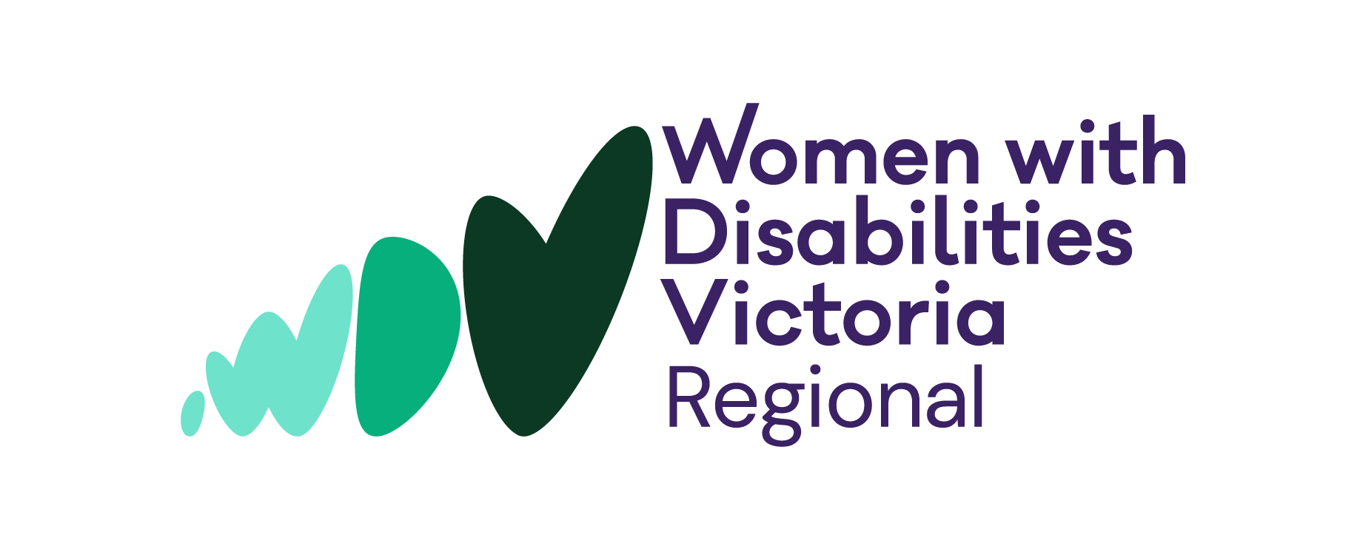

This peer blog was written by Brigitte Stone. Brigitte lives in regional Victoria and is passionate about increasing the voice and impact that women and gender diverse people with chronic pain, illness and disabilities have in their communities - including those who live regionally and face particular access and inclusion barriers.

