**Warm & Well in Winter**

### A peer guide to health and happiness for Women and Gender Diverse People with Disabilities over the *cold* Victorian winter.

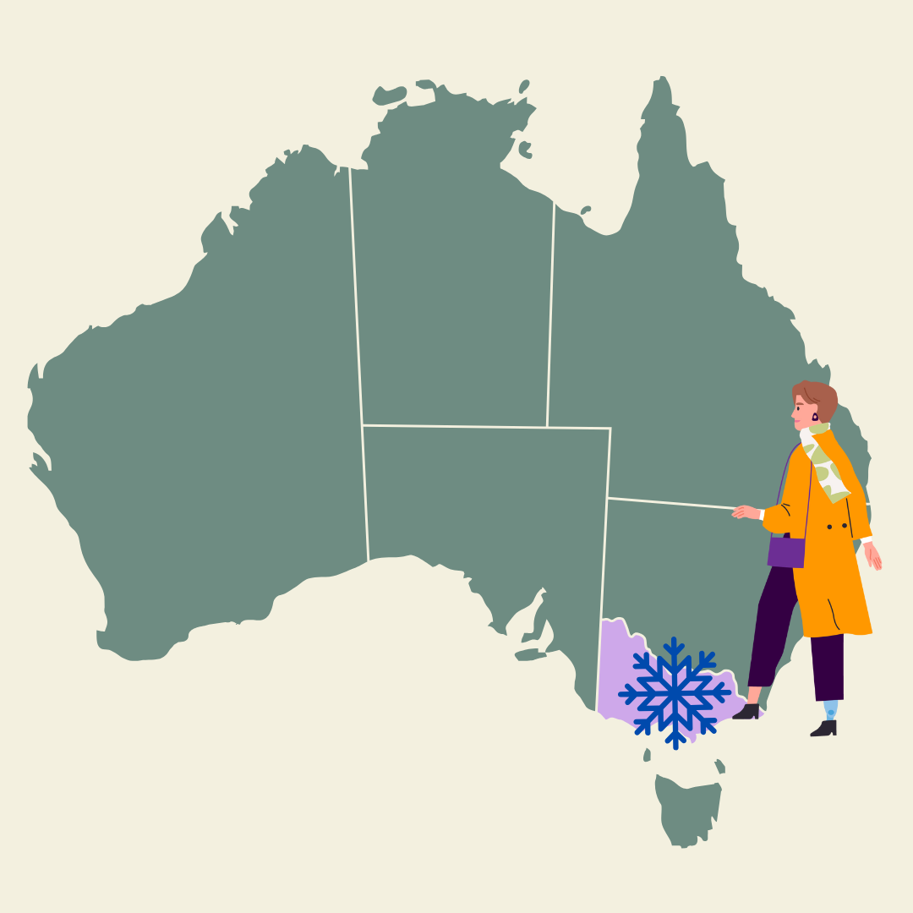Winter can be tough in Victoria. Especially for women and gender diverse people with disabilities.



The days are short and dark. It can be cold and rainy with not much sun.

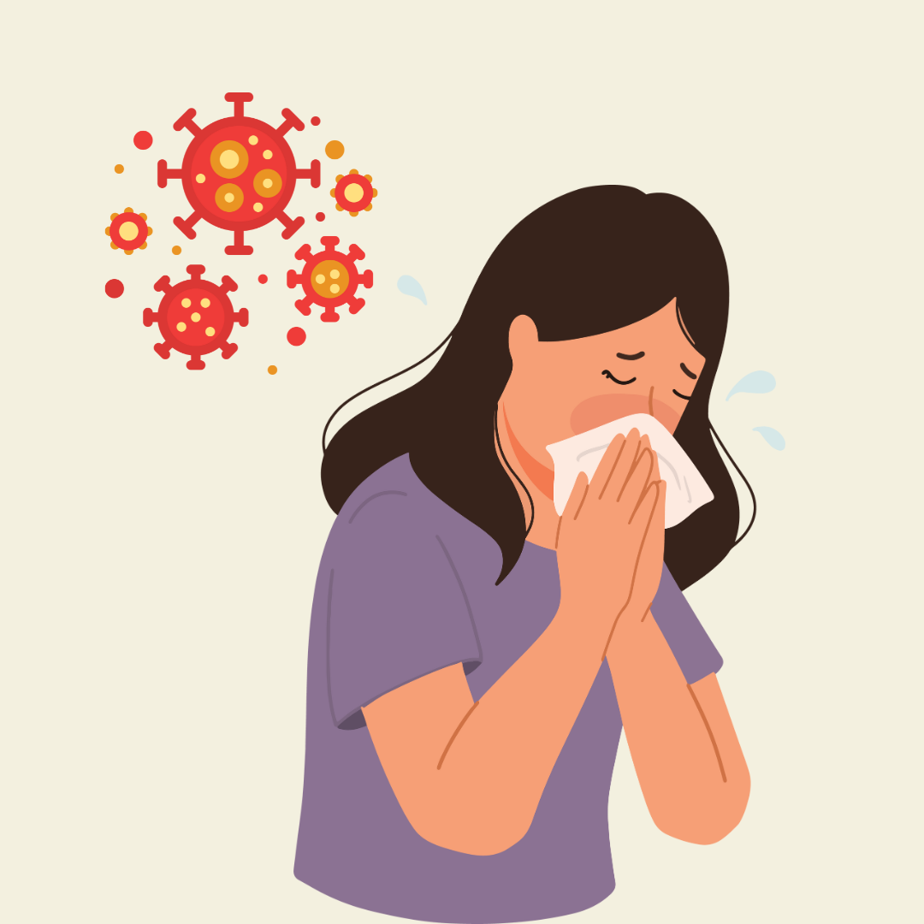

There are lots of bugs like colds, flues and Covid going around.

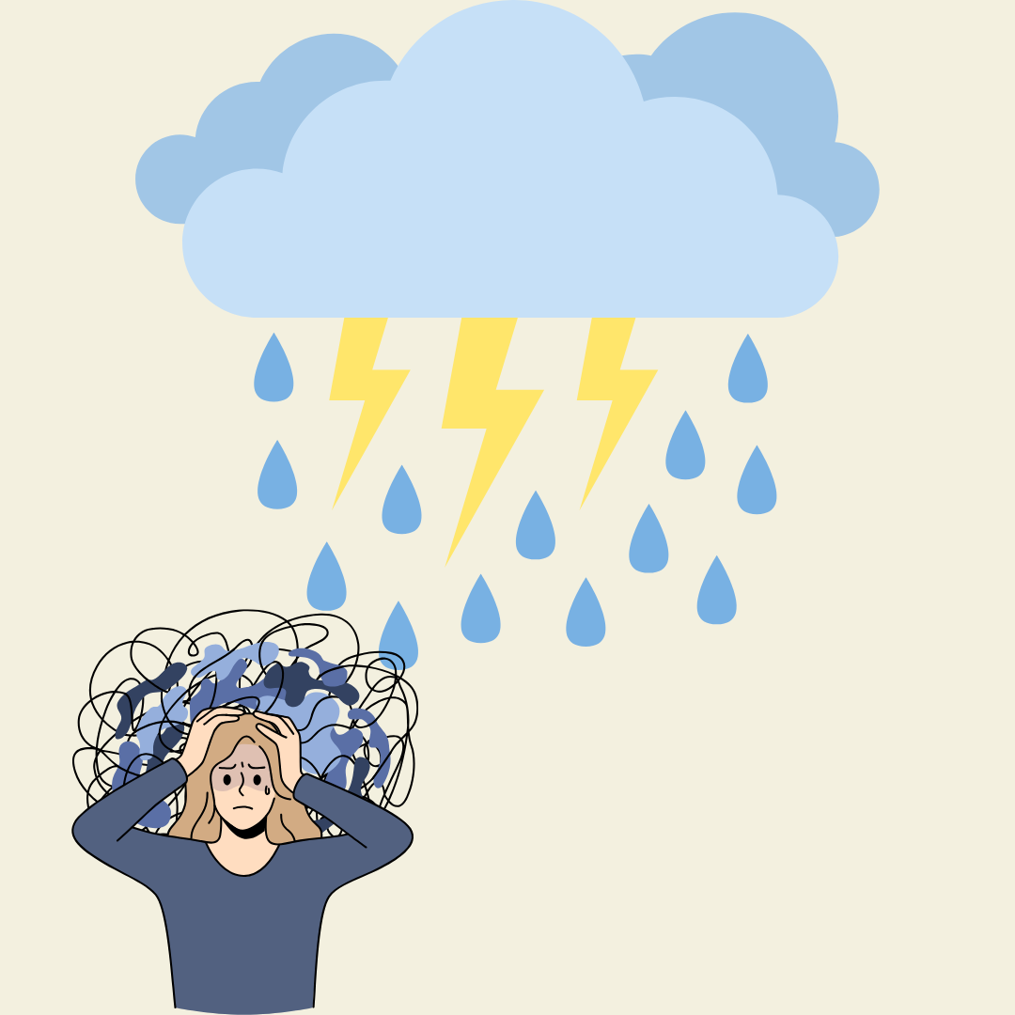

Conditions can make us sad and depressed.

Some days it can be hard to do anything. A person lying in bed with her hands on her head


**To help look after ourselves over winter we might like to:**

**Enjoy lots of good fruits and vegetables.**

Try them in soups and casseroles. Make extra for leftovers on low energy days.



**Get your vitamins.**

Seasonal fresh foods have great vitamins that help our bodies feel good. Some vitamins can also be taken as an extra to our diet in a pill, gummy or powder.

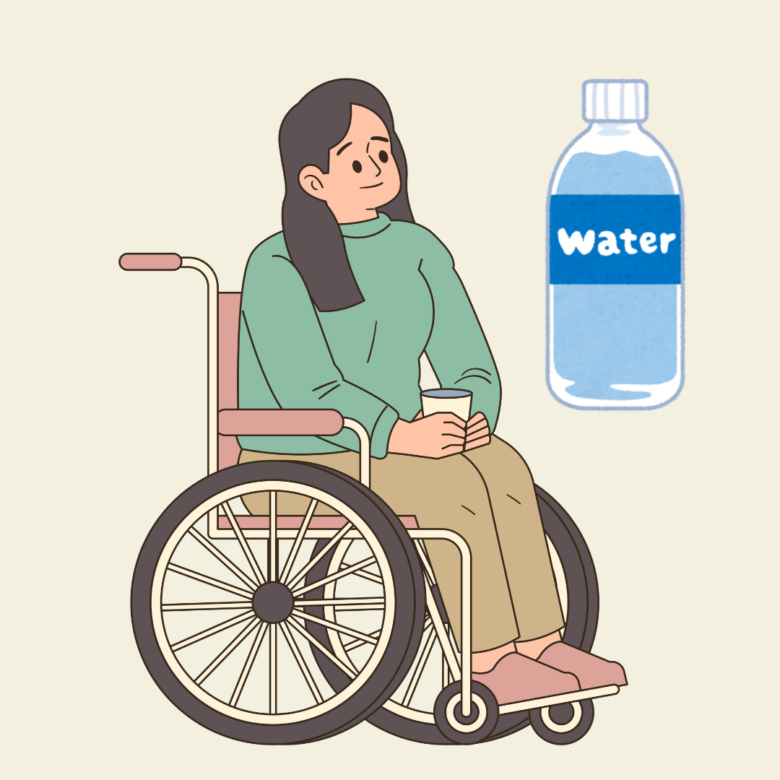

**Drink lots of water.**

We sometimes forget to drink water in winter, but our body still needs it.



**Move your body in ways that are comfy and safe for you.**

This might be a stroll or roll on a sunnier day or gentle stretches indoors.

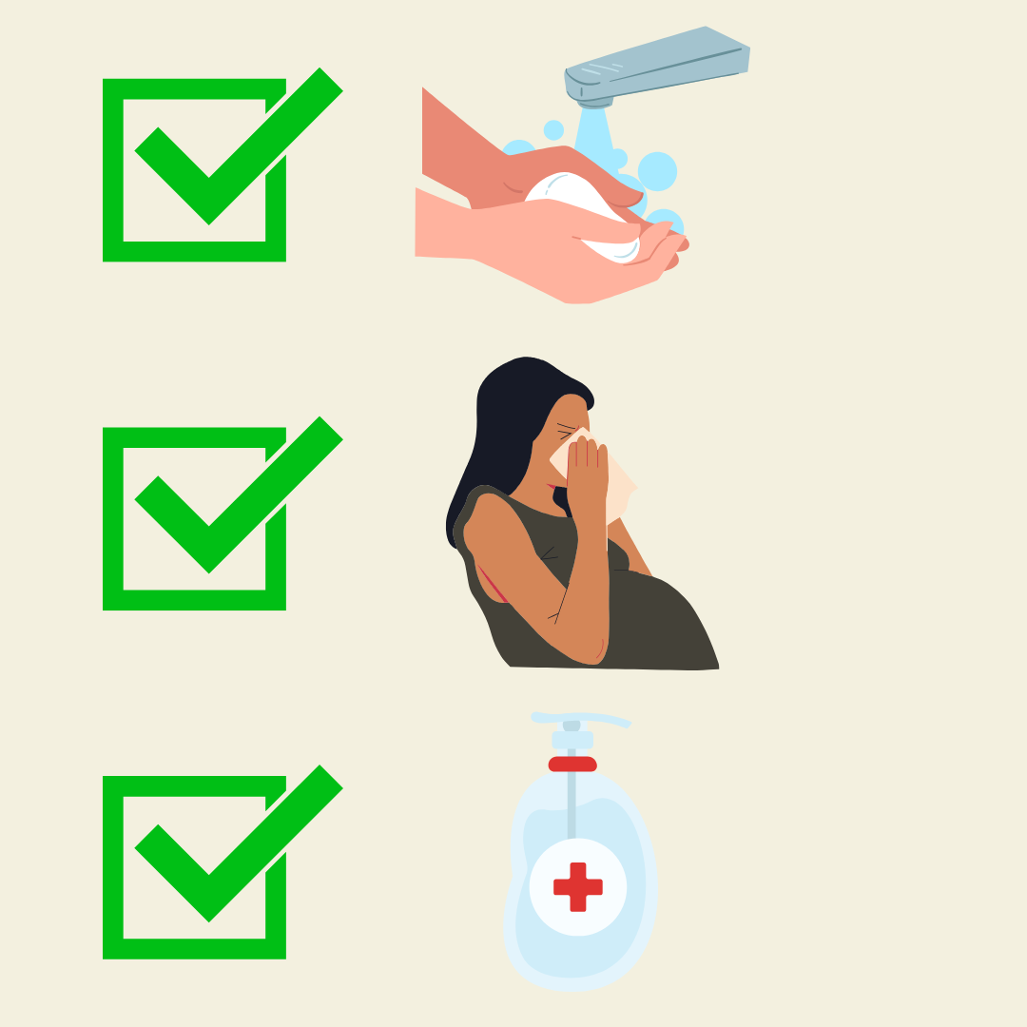

**Practice good hygiene.**

Wash or sanitise your hands often. If possible, cover your mouth and nose when coughing or sneezing.

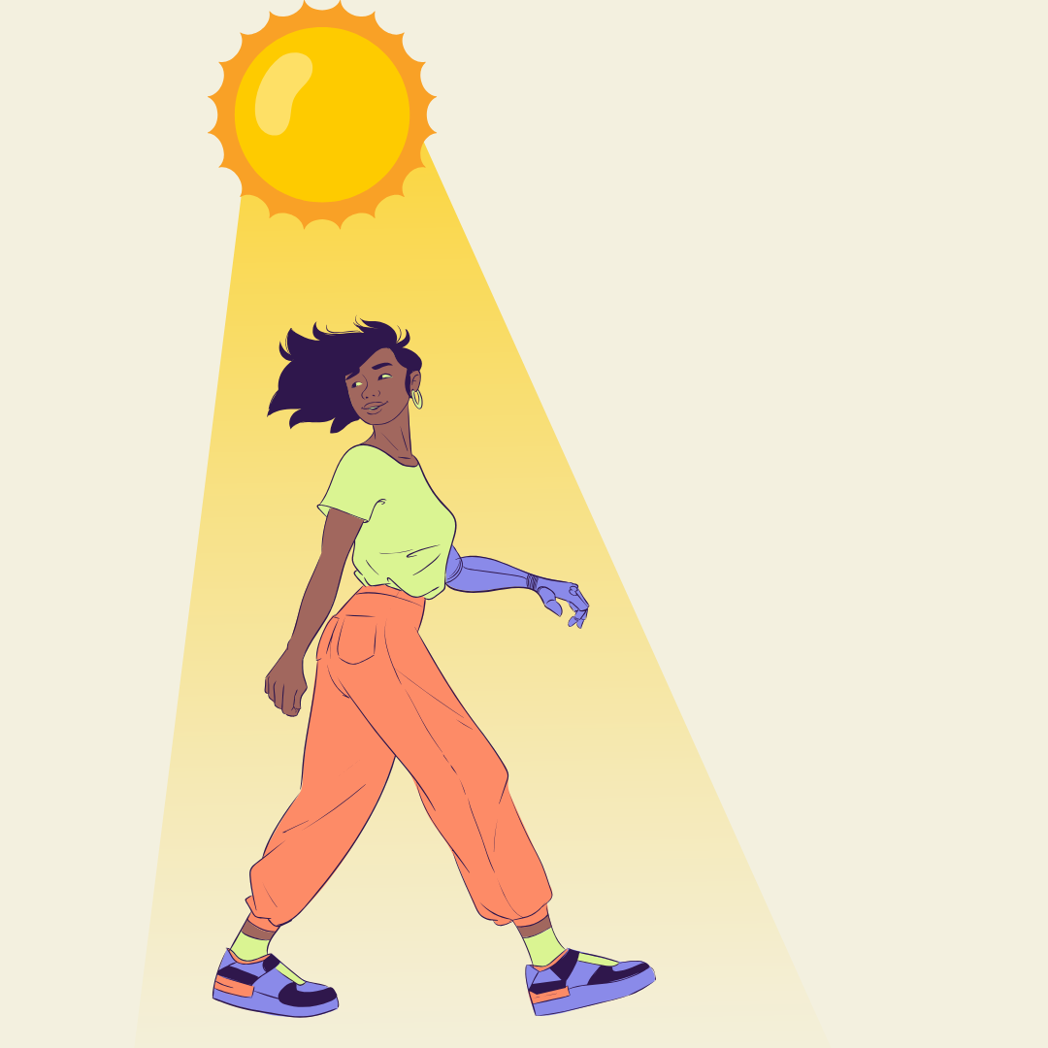**Get some sunlight**

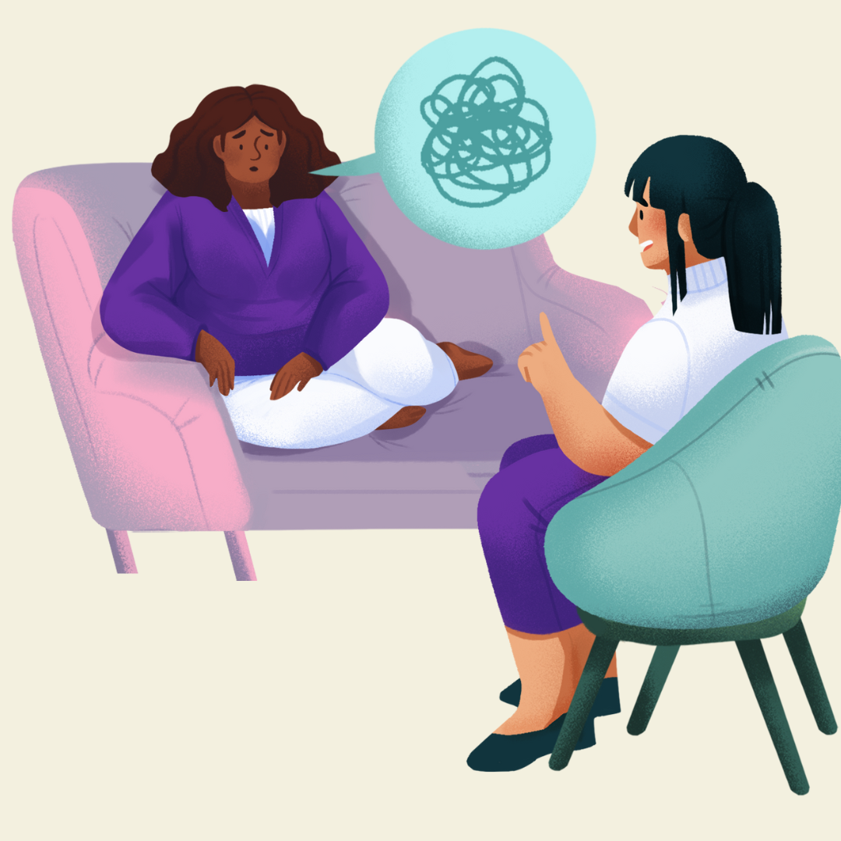We get less sunlight in winter. That can impact our mood and health. Sitting by a sunny window or getting outside even for a few minutes can help.

**Remember to check in with your mental health.**

There are lots of reasons we may have poor mental health over winter. Being sad is ok. But when you start to feel sad more often or more than you feel happy its important to tell someone.



**Sleep well**.

Increased pain in cold weather can make sleeping harder. Explore things that’ll make it easier like a hot water bottle or heat-pack. Get cozy and rest up.

**Stay Connected.**

Make time for people that make you happy. Online, in person, texting or talking, however you chose to connect, you don’t have to face the cold season alone.

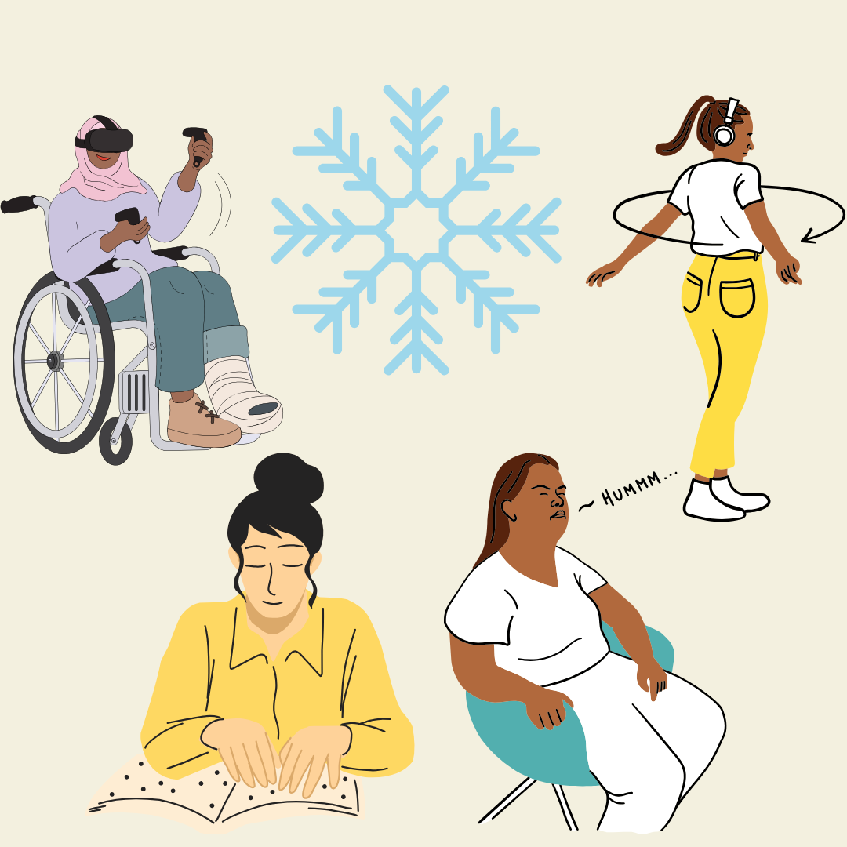

**Have fun!**

What indoor or wintery activities bring you joy?

**Thanks to WDV’s Local Leadership Hubs and their members for sharing lived experiences and wonderfully warming ideas.**

