2025-2026

WDV Board
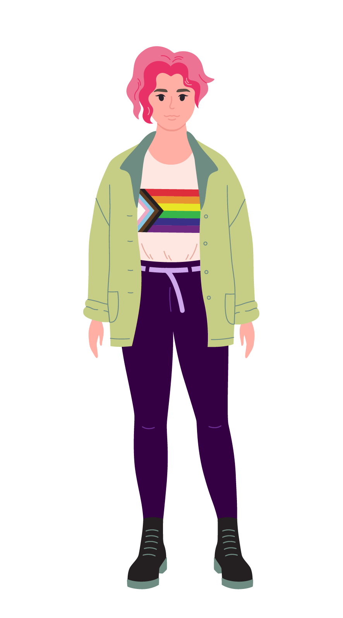
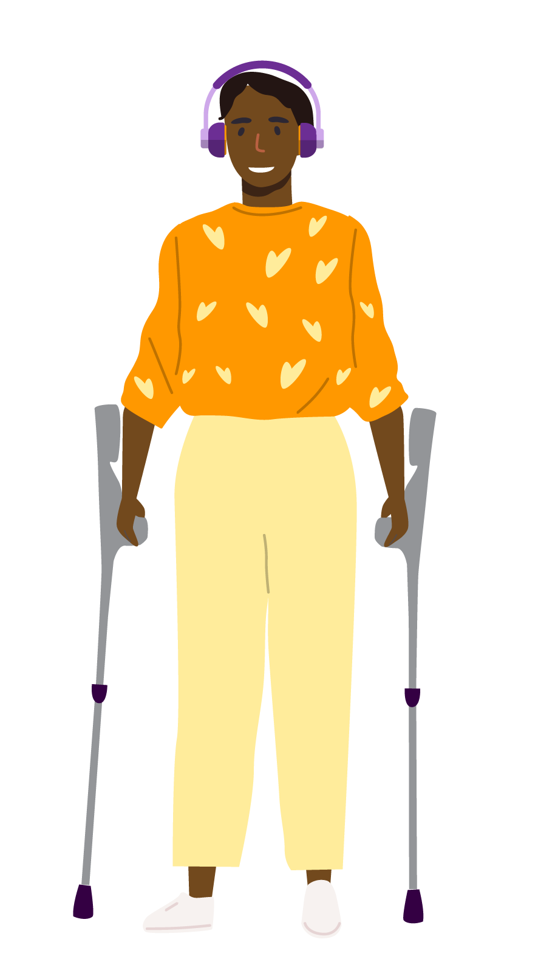
Nomination Form
Please read the ‘Nomination Guidelines’ before completing this form.
If you are nominating someone else, please speak to them first to make sure they are happy to be nominated.
1.1 Your details (the “Nominator”):
Information required | Your response
Preferred pronoun: | ​​ ☐​ She / her ☐​ They / them  ​​ ☐​ Other (please print preferred pronoun in space below)
First name:
Family name:
Best contact number:
Email:
Are you a Full WDV Member? | ​​ ☐​ Yes  ​​ ☐​ No  ​​ ☐​ Unsure  If you are unsure, please email  agm@wdv.org.au to confirm.

1.2 Their details (the “Nominee”):
(if nominating yourself, please write “as above” in the Self-Nomination box)
Information required | Your response
Self-Nomination
Preferred pronoun: | ​​ ☐​ She / her  ​​ ☐​ They / them  ​​ ☐​ Other (please print preferred pronoun in space below)
First name:
Family name:
Best contact number:
Email:
Are they a Full WDV Member? | ​​ ☐​ Yes  ​​ ☐​ No  ​​ ☐​ Unsure  If you are unsure, please email  agm@wdv.org.au to confirm.

2. Nomination Summary
To help Members decide who to vote for, we’d like you to tell us about yourself/the Nominee, and your/the Nominee’s experience and skills:
- There are five (5) questions below.
- Please supply your responses in the respective section after each question.
Note: please make sure the Nominee approves this.
- Please be brief and use a maximum of 150 words per question.
Note: to ensure fairness, answers that exceed the work limit will need to be edited by removing the last sentences until 150 words.
- All five (5) responses will be compiled into one document and presented as the Nominee’s nomination statement.

The first two questions are about you/the Nominee.
2.1 Tell us about yourself. Who are you, what are you passionate about?
Please provide a 150-word (maximum) response.
2.2 Why are you interested in being a Director on the WDV Board?
Please provide a 150-word (maximum) response.

The next two questions are about your/the Nominee’s skills.
2.3 In which areas do you have expertise and/or experience you can offer the WDV Board?
☐ Lived experience of disability – Personal insight into disability, especially for women and gender diverse people
☐ Governance and leadership – Board roles, strategy, risk, and financial skills
☐ Advocacy skills – Individual and systemic advocacy, focused on disability rights
☐ Legal and policy knowledge – Understanding of disability law, NDIS, CRPD, and policy work
☐ Community sector experience – Work in not-for-profits, disability services, or advocacy
☐ Grant writing and fundraising – Securing funding and supporting sustainability
☐ Research and evaluation – Impact measurement and evidence-based approaches
☐ Mentoring and capacity building – Supporting leadership development for women and gender diverse people with disabilities
☐ Stakeholder engagement – Building connections with government, organisations, and communities
☐ Regional/diverse community links – Networking with women and gender diverse people with disabilities across Victoria
☐ Professional qualifications – Relevant degrees and experience in law, policy, psychology, social work
☐ Other
Please provide a 150-word (maximum) response.
2.4 What professional skills, experience and/or expertise can you offer the WDV Board?
​​☐​ Previous board experience
​​☐​ Governance
​​☐​ Finance
​​☐​ IT or cyber security
​​☐​ Risk management
​​☐​ Government relations
​​☐​ Media, marketing, or public relations
​​☐​ Fundraising and philanthropy
​​☐​ Research, writing or policy development
​​☐​ Other
Please provide a 150-word (maximum) response.
The next question is about gender and disability.
2.5 What do you think are the most significant challenges and opportunities for women and gender diverse people with disabilities in Victoria?

Please provide a 150-word (maximum) response.

3. Photograph (optional)
Nominees are encouraged to submit a photograph to be used accompanying their nomination statements.
Note: Please make sure the Nominee approves this.
- Photographs are not required to nominate and are optional for all nomination submissions.
- Photographs should be included in your application as a separate attachment.
- WDV will use your compiled nomination statement and photograph to inform others (via email, post and WDV website) of your nomination and to show on screen at the AGM.
- All nominee photos and statements will be removed from the organisation’s website following the AGM.
- All photographs will be accompanied by a text description for those using screen readers to access. Please write a brief visual description (no more than 20 words) to accompany your photo in the box below:

Please provide a 20-word (maximum) photo description

4. Nomination summary recording (compulsory)
- Nominees will be required to submit a 60-second nomination summary recording to be presented to Members at the AGM. The video or audio recording may be made with a mobile device. If nominees require assistance with the recording, we will offer support to either record their statement via Zoom or do an audio recording on their behalf with a WDV staff member reading a transcript provided by the nominee. Recordings must be submitted by email by 2pm on 14 November 2025 to agm@wdv.org.au.
- If you would like to submit a transcript of your recording to assist with captioning, please do so.
- Nominees can contact us for assistance and book a session with our Board Governance Officer, Lori Boys by sending an email to agm@wdv.org.au
- These sessions will be online for 15 minutes and nominees must attend prepared with their nomination form and a script for their nomination summary recording.
- If you have accessibility requirements to participate in this session, please contact Lori at agm@wdv.org.au.
- PLEASE NOTE: late submissions will not be accepted and will mean a nomination cannot proceed.
- PLEASE NOTE: to ensure fairness all recordings will be cut to a maximum of 60 seconds.

5. Declaration
- I have read and understood the Nomination Guidelines and I am eligible to stand as a Director and stand for election.
- I understand and agree that if elected I will not be able to commence my position as Director until any relevant checks and approvals have been cleared (e.g., Police Check).
- I understand that if elected I will be required to attend a Board induction and any required training.
If nominating someone else:
- I am happy for my name to be mentioned as the Nominator for this Nominee.
- The Nominee has approved the question responses, the photo text description, and the photo attached to this form.
Signature of Nominee: | Date:
Signature of Nominator:  (if nominating yourself, please write “as above” in the box below) | Date:

