2025-2026

WDV Board

Nomination Guidelines

- All Full Members of Women with Disabilities Victoria are eligible to nominate themselves or another Full Member for a position as Director on the Board.
- Nominations for the position of Director must:
  - Be made by submitting the completed Nomination Form.
  - Include responses to the five (5) questions listed in the Nomination Form. (Responses will be compiled and presented as the Nominee’s nomination statement.)
  - Include a nomination summary in the form of a 60 second video or audio recording, or transcript to be read and recorded by a WDV staff member, in accordance with the instructions below.
  - Include the written consent of the Nominee (this can be an electronic or
  - handwritten signature where marked).
- Nominees are encouraged to submit a photograph to be used to accompany their nomination statements.
- Nominations close at 2pm AEDT on Friday 14 November 2025. Late nominations will not be accepted.
- Nominations must be received by the Board Governance Officer by either:
  - Email: agm@wdv.org.au
  - Web page: https://www.wdv.org.au/agm/
  - Post: in the Reply Paid Envelope attached
    - If you misplace the envelope, please send the form to Board Governance Officer, PO Box 18314, Collins Street East, VIC 8003.
    - PLEASE NOTE: if sending by post, please allow sufficient time for delivery (at least 4 business days) prior the date above.
- Nominations will be acknowledged via email within 7 days of the closing date.
- The written nomination statements provided by the Nominees will be sent in advance to all WDV Members and posted on the WDV website.
- Nominees will be required to submit a 60-second nomination summary recording to be presented to Members at the AGM. The video or audio recording may be made with a mobile device. If nominees require assistance with the recording, we will offer support to either record their statement via Zoom or do an audio recording on their behalf with a staff member reading a transcript provided by the nominee. Recordings must be submitted by email by 2pm 14 November 2025 to agm@wdv.org.au.
  - If you would like to submit a transcript of your recording to assist with captioning, please do so.
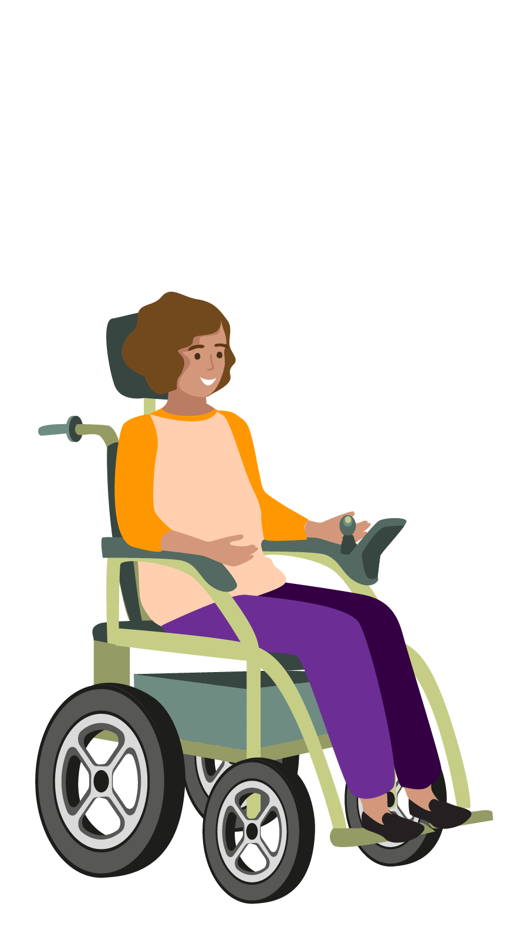
  - Nominees can contact us for assistance and book a session with our Board Governance Officer, Lori Boys, by emailing agm@wdv.org.au.
  - These sessions will be online for 15 minutes and nominees must attend prepared with their nomination form and a script for their nomination summary recording.
  - If you have accessibility requires to participation in this session, please contact Lori at agm@wdv.org.au.
  - PLEASE NOTE: late submissions will not be accepted and will mean a nomination cannot proceed.
  - PLEASE NOTE: to ensure fairness, all recordings will be cut to a maximum of 60 seconds.
- If the number of nominations received is equal to the number of vacancies, the members nominated shall be deemed to be elected without a poll, otherwise an election will be conducted at the AGM.
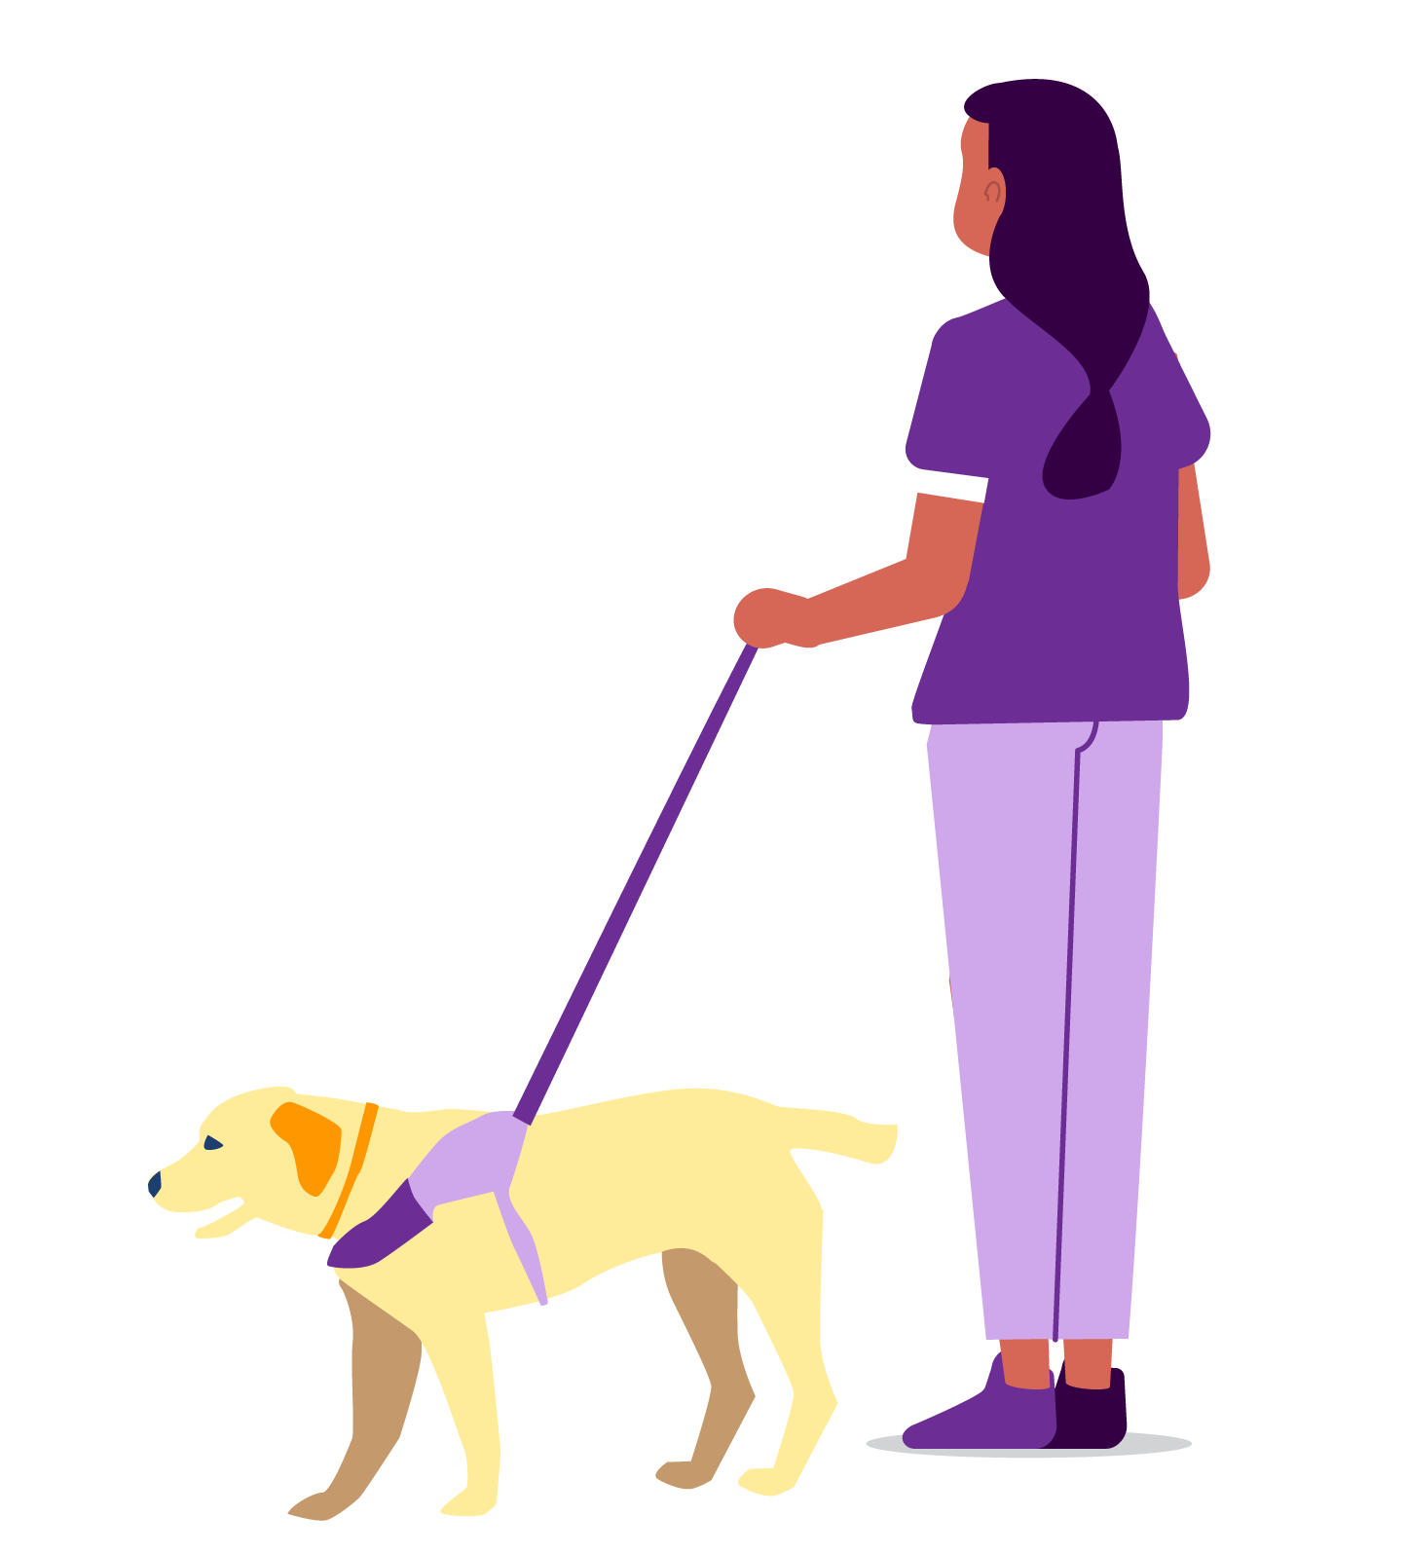
- Women with Disabilities Victoria values diversity and particularly encourages First Nations women and gender diverse people , women and gender diverse people from culturally and linguistically diverse backgrounds and people who are LGBTQIA+ who are Full Members to apply.
- If you have any questions regarding your eligibility for membership with Women with Disabilities Victoria or for your nomination to the WDV Board please contact us by:
- Email: agm@wdv.org.au
- Phone: 0497 186 467
- For further information regarding the role and responsibilities of the WDV Board please refer to the Board Position Description document.

