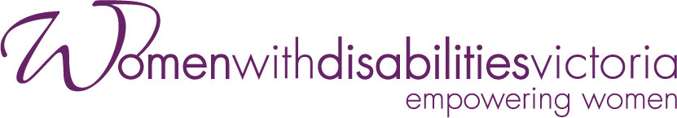
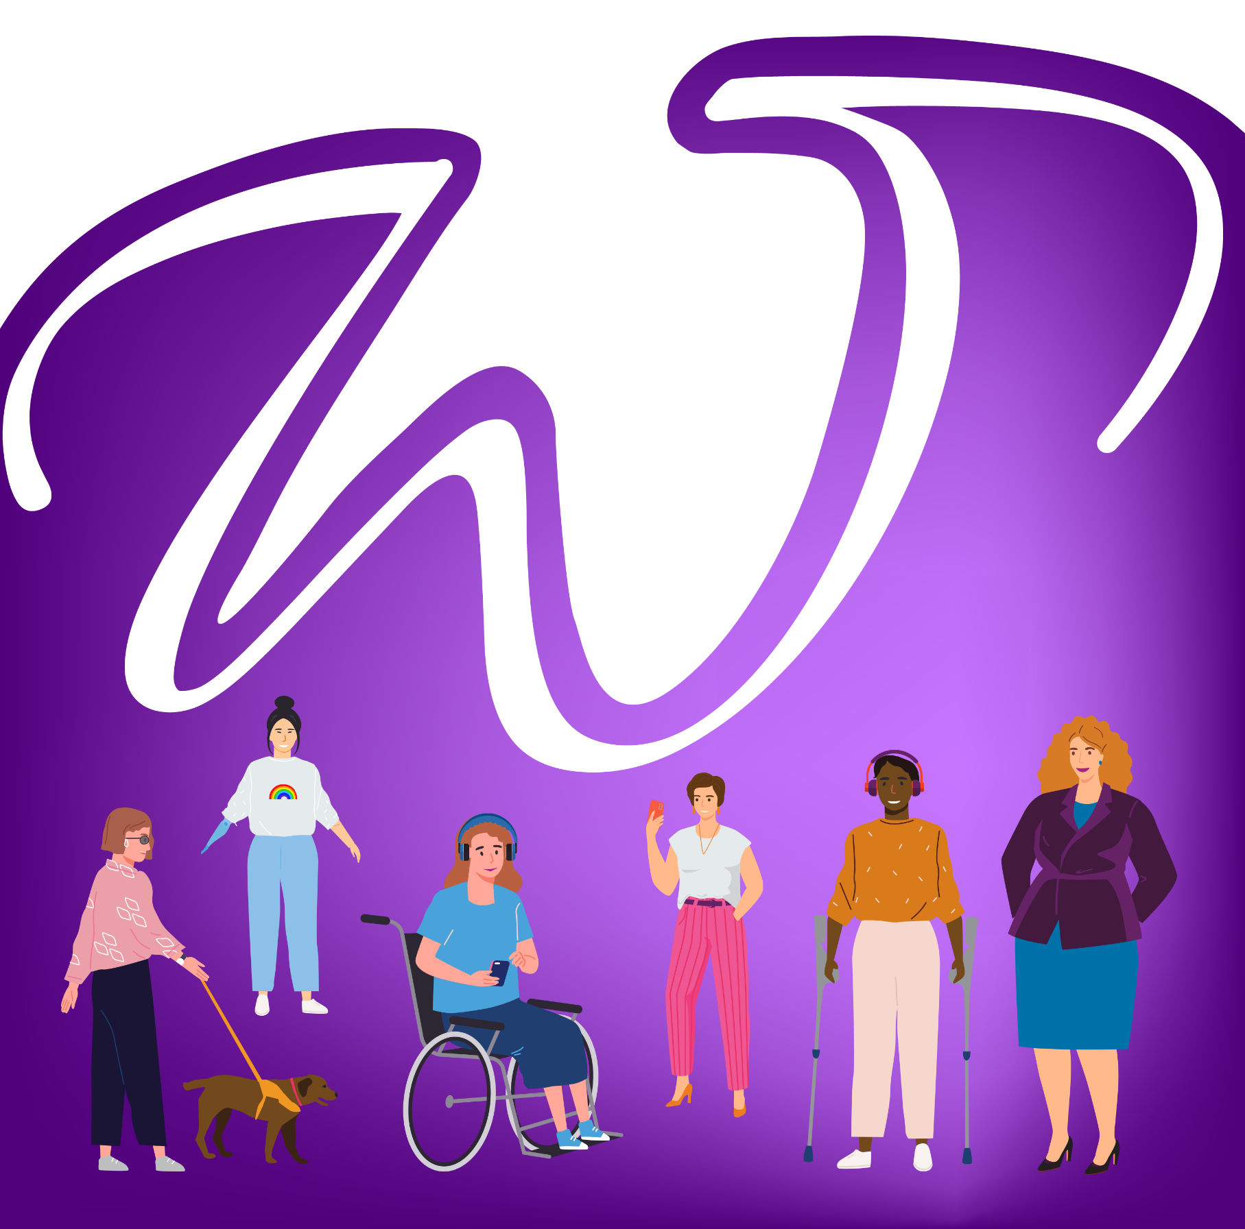

Annual Report
2023-2024

Women with Disabilities Victoria (WDV) acknowledges Aboriginal and Torres Strait Islander peoples as the first inhabitants and traditional custodians of the lands on which we live and work. We pay our respects to ancestors and Elders, past, present and emerging.
The WDV Community is committed to honouring the unique cultural and spiritual relationship Aboriginal and Torres Strait Islander peoples have with the land and waters, and their rich contribution to society.
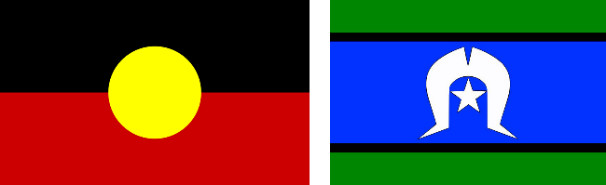

Our Vision
A world where all women are respected and can fully experience life.

WDV was established as an organisation run by and for women with disabilities. Our understanding of gender has grown over time. WDV is now working towards a contemporary understanding of gender and gender inclusivity in our work and our values.
Throughout this document we use the terms women and non-binary people with disabilities. We understand the word women to include cisgender and transgender women. We understand non-binary to include those who are gender diverse, gender non-confirming or other identifiers that our members may use.

Our Mission
To advance real social and economic inclusion for women with disabilities in Victoria, we will:
Be a voice for women with disabilities
Create opportunities for women with disabilities to be visible and to be heard in their communities
Build partnerships to deliver the best results for women with disabilities
Engage the community to challenge attitudes and myths about women with disabilities.

Our Values
Our values uphold human rights and social justice.
Equal Opportunity
Accessibility
Respect
Collaboration
Effectiveness
Creativity
Diversity
Accountability

Our Approach
We will:
Work with our members’ experiences as women with disabilities
Provide specialist policy advice and representation to government
Create opportunities for women with disabilities to realise their leadership and advocacy potential
Adopt a collaborative approach to government and community organisations
Build the evidence base to develop and share knowledge and resources to inform best practice
Monitor our work and report on outcomes.

Acting Chief Executive Officer (CEO) and Board Co-Chairs’ Statements

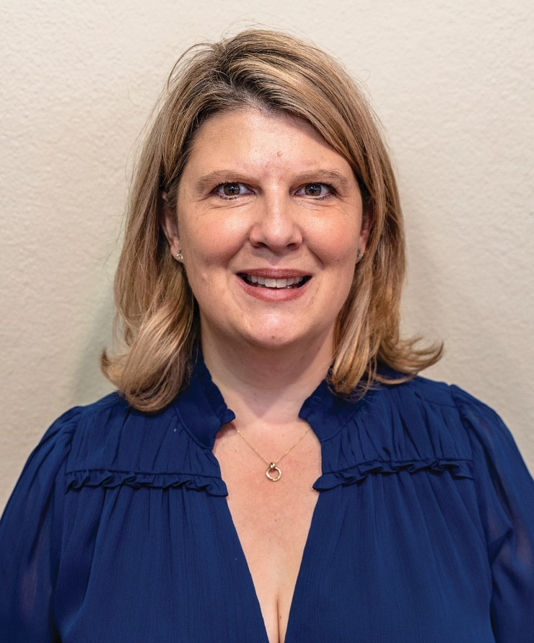

WDV Acting CEO’s Report
As I look back on the past year, I feel a deep sense of gratitude for the many opportunities we’ve had and pride in the achievements and progress we’ve made. However, I also feel concern for the challenges ahead, particularly regarding ongoing funding to ensure our sustainability. Our work is far from finished, and we must remain focused on building a future that allows us to continue empowering women and non-binary people with disabilities. I would like to extend my heartfelt thanks to everyone who supported our campaign to secure funding, which has enabled us to safeguard more than 14 jobs at Women with Disabilities Victoria (WDV). I thank the Department of Social Services for providing transitional funding for this program. This funding is essential, not just for the livelihoods of our staff but for the continuation of the vital work we do within the community.
In 2024, we marked a significant milestone, celebrating the 10-year anniversary of our Enabling Women program. This program has empowered so many women and non-binary people, and it was a moment to reflect on how far we’ve come.
We also completed an important piece of work with Our Watch, focusing on translating the ‘Changing the Landscape: A National Resource to Prevent Violence Against Women and Girls with Disabilities’ into practical resources and a government action plan. This collaboration underscores our ongoing commitment to creating a safer and more inclusive society for all women, non-binary people and girls with disabilities.
Our engagement with Lived Experience Experts remains a cornerstone of our work, and we are proud of the outcomes delivered through our Gender and Disability Program, Health Services Program, Sharing Our Expertise Program, and Enabling Women Leadership (Youth) Program. These initiatives continue to make a tangible difference in the lives of women and non-binary people with disabilities.
As the peak body for women and non-binary people with disabilities in Victoria, we have been actively involved in many initiatives, the Victorian Government’s Inquiry into Women’s Pain, a joint submission to the National Disability Insurance Scheme (NDIS) Amendment (Getting the NDIS Back on Track) and International Women’s Day 2023 (Count Us In, Accelerating Gender Equality for Women with Disabilities through economic empowerment).
We are always advocating for the needs and rights of our members. The growth in our membership shows that there is an increasing need for our advocacy and services and our 2024 Membership Survey provided valuable insights into the priorities of our members including the NDIS review and reforms, employment opportunities for women and non-binary people with disabilities, and the increasing cost-of-living pressures. These issues will continue to guide our work in the coming year.

In June 2024, we held our annual staff day. It was a day filled with emotion, as we faced the reality of some programs and roles coming to an end. However, the sense of community that underpins WDV shone through as we came together to support one another. It was a privilege to have Marsha and Nick Uppill from Arranyinha provide Foundational Cultural Respect training, and the theme of community was central to all our conversations. This year we continued our work on our Reflect Reconciliation Action Plan and received conditional endorsement from Reconciliation Australia. We are very grateful to WDV member Aunty Jane Rosengrave for creating a wonderful artwork to WDV.
As you read through this Annual Report, I hope it becomes clear just how much we have achieved together. None of this progress would have been possible without the tireless work of disability advocates across the state. I would like to extend my thanks to the Commonwealth and Victorian Governments and our donors who provide funding for our work, and the many organisations and individuals who have collaborated with us throughout the year. To our staff, your dedication to advancing social and economic inclusion for women and non-binary people with disabilities in Victoria is energising.
Finally, to the women and non-binary people who are our members, thank you for your ongoing support and contribution. You are at the heart of everything we do.
Belinda Burns, Acting CEO

WDV Board Co-Chairs’ Report
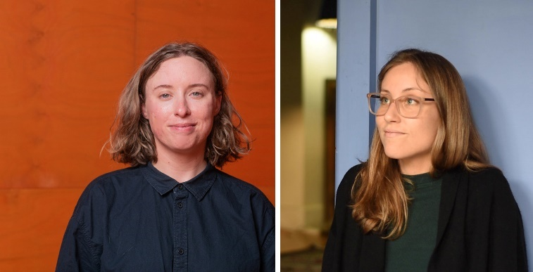
As we reflect on the past year, we are filled with a sense of gratitude and optimism. Our board has welcomed new directors and bid farewell to others. We want to take a moment to honour those who have been instrumental in guiding Women with Disabilities Victoria (WDV) to where it is today.
First and foremost, we bid farewell to outgoing directors Rachal Arbon, Crystal Bruton and Shakira Hussein, who completed their terms at the 2023 Annual General Meeting (AGM).
A special thank you to Shakira who offered her profound insights and innovative ideas, which have left a lasting impact on both the board and the broader organisation. We also extend our heartfelt thanks to directors Maggie Toko and Emily Unity who resigned in 2024. Despite their shorter time on the board, they brought infectious energy and deep expertise, enriching our discussions and decisions. We are deeply grateful for their service and eagerly anticipate seeing the continued excellence they will bring to the field.
As we say goodbye to these incredible leaders, we are equally excited to welcome new directors Talitha Travers and Annette Vickery, along with Treasurer Kalpana Raj. Kalpana has already made significant contributions, particularly in the areas of financial strategy and sustainability. Her thorough review of the organisation’s financial controls has set a new standard, positively influencing how we approach financial and risk governance. We are thrilled to have these directors on board. Their expertise bolsters confidence in the board’s leadership, strategy, and expertise.

In addition to these leadership changes, we have made some important adjustments to how our board operates. Membership and community engagement are now standing items on our board agenda following the dissolution of the Membership Committee.
This change represents our commitment to prioritising these areas directly within the board’s strategic focus, ensuring that they receive the attention they deserve. We are eager to invest in WDV members and to leverage our organisation’s brand and ability to influence more effectively. By adopting more inclusive and intersectional strategies, we aim to more powerfully advocate for our community.
This year also saw the introduction of the Board Observer Initiative, a program designed to address the unique barriers, often rooted in societal perceptions, that can limit access to participation on boards and in other strategic governance roles. We are particularly proud to note that this initiative began when our inaugural participant reached out to us, expressing a keen interest in board governance. Through this initiative, we have provided them with the chance to observe board meetings and gain valuable insights into governance and strategic decision-making—experiences that may have previously seemed out of reach.
Our goal is to empower participants by
offering them firsthand experience in board governance, thus opening doors to future leadership opportunities and ensuring that our board reflects the diversity and richness of the communities we represent and serve.
Looking ahead, we are thrilled to announce the appointment of NOUS Group consultants to support WDV’s strategic planning for 2025–2029. This partnership, secured through the hard work of our dedicated staff, promises to be transformative. The new strategy will align with our board’s commitment to investing in advanced technologies and systems, positioning WDV to be more agile, responsive, and capable of pursuing even more ambitious advocacy goals. These investments will strengthen our organisation, making us primed and ready to embrace the opportunities that lie ahead.
As we move forward, we do so with confidence in our board’s leadership, the dedication of our staff, and the support of our members. We thank the Commonwealth and Victorian Governments who fund the work we do. Together, we will continue to build a stronger, more inclusive WDV—one that is well-positioned to champion the rights and aspirations of women and gender-diverse people with disabilities.
Elyse Cox and Marlena Raymond
Board Co-Chairs

WDV Goals
1. Visibility and voice  Engage women with disabilities, build our self-advocacy and strengthen our membership across Victoria | 2. Pursue safety, wellbeing and connectedness for women with disabilities  Leverage government funded policy reform and programs | 3. Create long term change  through engagement, education and advocacy | 4. Key enablers  WDV will ensure strong organisational infrastructure to enable our strategy

Goal 1: Visibility and Voice
Engage women with disabilities, build our self-advocacy and strengthen our membership across Victoria

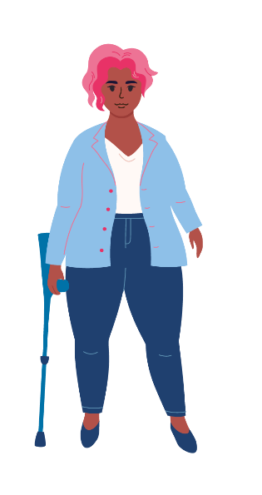
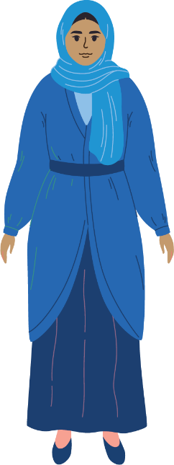
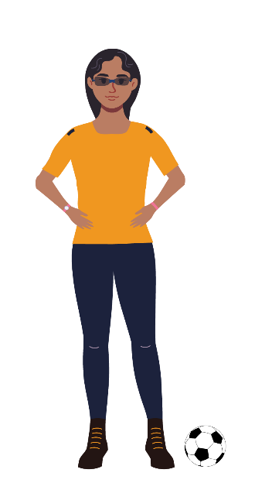
The Community Inclusion and Women’s Empowerment team (CIWE) works in the community to engage and educate on the positive ways inclusion makes for a more holistic world where all people are valued because of their diversity and are included.
As a team we feel empowered to create positive change through innovative ideas and bravery. Our goal is to be a source of knowledge and expertise that reaches out to the community. We believe in supporting each other as peers and expressing ourselves with kindness and determination. Our purpose is to raise awareness about problems faced by our community, both small and large. By sharing information well, we want to help everyone understand critical issues and encourage them to act.
We do this in 3 distinct ways – our Leadership Programs, our Youth Experts by Experience and our regional Hubs. The Leadership Programs include both generalist and youth programs and include a ‘values’ workshop. The programs take place over 6-8 weeks and creates not only an environment for lifelong specialist learning but for friendship and peer support. We have expanded the program to include online or hybrid statewide programs.

Enabling Women Leadership Program - Statewide 2024
In 2024 the Statewide Program proved again a catalyst for connection. One participant shared how despite growing up with a strength-based mindset, she still felt sometimes her autism was a deficit. All the things she heard from society reinforcing internalised ableism.
“I’ve always struggled with making friends, and I think this is one of the main reasons that I thought in that deficit-based way about my autism,” she shared.
With time, however, the participant’s perspective on her disabilities have changed. “While I do face some difficulties in life connected to my disabilities, I also feel that many of my strengths and characteristics also come from my neurodivergence, like my sense of humour and my strong empathy towards others. And so in a sense, while I feel that my disabilities don’t make up who I am entirely, I feel like they are one of the foundational building blocks upon which the rest of me is built. So if you took them away, the rest of my construction would just collapse and I wouldn’t be the same person anymore.”
This doesn’t negate the challenges she still faces, the participant acknowledged. Including the continuous difficulty with making friends. The Program she thought was a chance to connect. And so it was.

“I’ve really enjoyed being amongst this group of women with disability, all of whom have been accepting, welcoming and supportive. I think that this has helped to reinforce in me that I’m not actually the problem. I do have the ability to make connections with people. I just have to find the right people.”
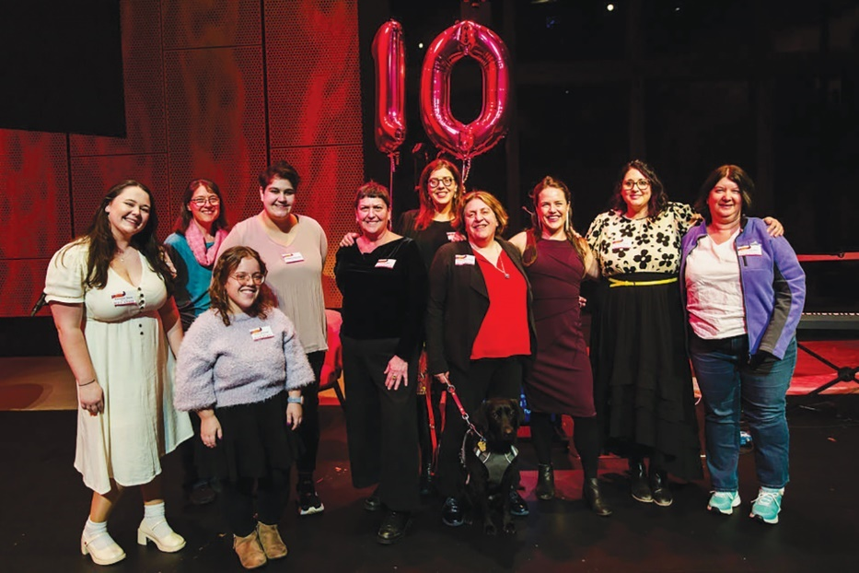 | The Enabling Women Ten Year Celebration. The Group is standing in front of the ‘10’ balloons. Everyone is smiling and facing the camera.  From left to right: Vanessa Davis, Jen Hargrave, Julie Dickson, Bella Fantasia, Liz Wright, Bridget Jolley, Nadia Mattiazzo and Abbey, Sara Franzoni, Brigitte Stone and Kerrie Forber.
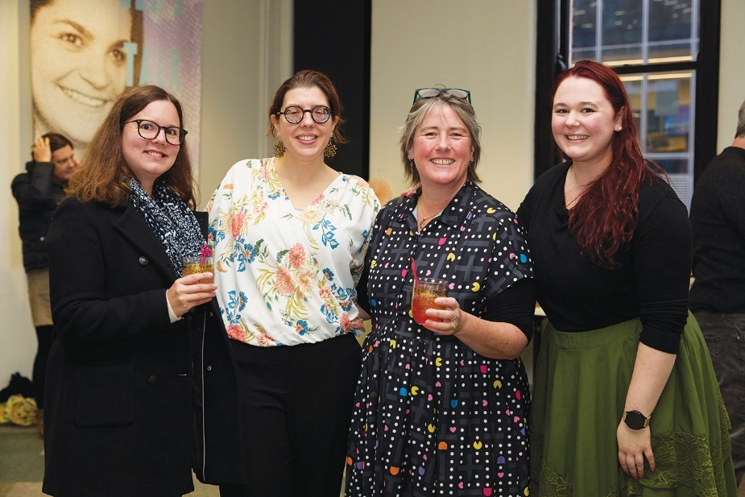 | The Enabling Women Leadership Program – Statewide 2024 Graduation. A group of four women smiling at the camera.  From left to right Soizic Brohan, Bridget Jolley, Libby Price and Vanessa Davis.
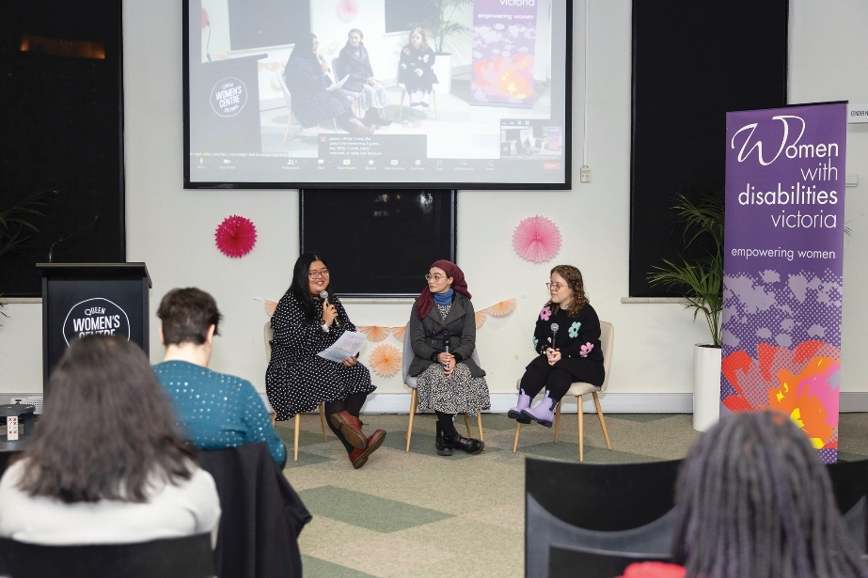 | The Enabling Young Women Leadership Program – Statewide 2023 Graduation. Panel discussion featuring graduates. There is a screen in the background and various audience members seated.  From left to right: Julia Coscuella, Venetia-Maria Kardogeros and Julie Dickson.

Goal 1: Facts and Figures
 | 12 editions of e-news published with an average open rate of 40%
 | 31,000K per annum website sessions
 | 1,101 WDV members = 1,050 Full Members and 51 Associate Members
 | Facebook: 5,900 followers = 5.91% growth
 | Instagram: 2,300 followers = 37.64% growth
 | LinkedIn: 1,880 followers = 52.5% growth

Gender Based Violence Program
The Gender Based Violence, Research and Evaluation work sits across three programs for primary prevention of gender-based violence and improving women’s health through a connected system.
In partnership with Our Watch, Changing the Landscape developed evidence-based practice resources for a national audience of practitioners to prevent violence against women and girls with disabilities before it starts.
The Women’s Health Services Capacity Building Project provides intensive capacity-building in partnership with Women’s Health and Primary Prevention Sector partners to develop a more gender and disability inclusive primary prevention infrastructure across Victoria. The project supports our partners in the Victorian Women’s Health Services and Primary Prevention of Gender Based Violence Sector to audit their organisations provision of gender and disability inclusive programs, policies, and procedures to deliver more accessible and inclusive initiatives, employment and campaigns across the state in work that ends violence for women and non-binary people with disabilities. We also take on the feedback and learnings from this process to develop resources and tools that support more gender and disability inclusive campaigns for Women’s Health Services to prevent gender-based violence.
The Victorian Women’s Health Program improves the health and wellbeing of women with disabilities across the state through co-designed health promotion activities focusing on: Gendered Violence Prevention, Gender Equality, Sexual and Reproductive Health, and Women in a Changing Society. The project develops resources, training and technical advice to promote the lived experience of women with disabilities in challenging barriers to better health outcomes.

Health Services Program
The Health and Social Services Program promotes the rights of women with disabilities to enjoy optimal health and economic participation. Through our various projects, the rights of women with disabilities to be free from violence and abuse, to receive equal access to health services and employment opportunities, and to advocate for these rights are upheld.
The Health and Social Services Program prioritises partnerships with the health and community sector to expand our work across Victoria. Recognising the value of the work of the Women’s Health Services in mobilising regional communities in prevention of violence against women, partnerships are formed to support them to ensure their prevention activities are disability inclusive. Collaboration with other organisations also occurs to produce resources supporting evidence-based practice according to frameworks such as Changing the Landscape.
A Program priority is support of women’s peer advocacy for accessibility of health services.
The program has developed resources and workshops to enhance women’s advocacy for inclusive service provision for themselves and their peers.
Resources and training are also delivered to health service providers across the health sector, offering guidance in inclusive service provision tailored to women’s individual needs. The Program further provides technical assistance, training and resources to organisations within the health and community sectors to reduce barriers to the employment of women with disabilities in these sectors. All program resources, activities and training are co-designed with women with disabilities, whose collaboration is essential to program success.

A Celebration of the Experts in Our Health Project

by Vicki Kearney - Member of the Experts in Our Health Experts Group
The Experts in Our Health Project aimed to centre lived experience of women with disabilities through co-design of resources, peer-led workshops and training for health workforces across Victoria.
The Project brought together a diverse team of women. There were a variety of ages, life experience, cultural heritage and disability. This diversity was important in enabling us to be representative of many different experiences within the healthcare system. Respect for each other’s differing but similar experiences allowed us to bond and grow as a cohesive working group.
The willingness to share personal stories, and learn from other’s experience, helps to build empathy and a want to advocate for better practices. This is our point of difference from traditional disability training.
“We are able to personalise and humanise our experiences, allowing others to somewhat experience the injustice themselves.”
—Vikki Kearney, Experts in Our Health
I was honoured to have the opportunity to co-facilitate training sessions where I was able to experience first-hand, the power of lived experience as a tool for advocacy and targeting allies.
The Experts in Our Health Project enabled 12 women with disabilities to identify, and have the confidence to utilise their expertise of lived experience of disability.

Gender and Disability Workforce Development Program
The Gender and Disability Workforce Development Program (G&D Program), funded by the Victorian Government, aims to prevent violence against women with disabilities before it occurs. Established in 2014, the Program has received another phase of funding until June 2027.
The G&D Program aims to:
- Build and consolidate strategic positions, communications, representations and partnerships for preventing violence against women with disabilities.
- Increase women with disabilities workforce engagement, leadership and representation in disability, social services and prevention.
- Build the capacity of women with disabilities and the disability, social services and prevention workforces to prevent violence against women with disabilities.
- Build the evidence base for preventing violence against women with disabilities.
All G&D Program activities seek to build the capacity of the specialist and contributor sectors and workforces that have a role to play in preventing violence against women with disabilities and target the underlying causes of violence – also known as the drivers of violence – to transform them.
G&D Program activities include:
- Experts by Experience advocacy, with a group of thirteen women and non-binary people with diverse experiences of disability who support the work of WDV and other organisations by sharing their lived experience through consultations and Experts training.
- Delivery of professional development sessions and credentialing/endorsing processes to practitioners and organisations, alongside the facilitation of a Community of Practice.
- Development of resources.
‘Difference is not just accepted but genuinely welcomed’
says WDV Expert by Experience Sarah Hookey.
“WDV provides a workplace where difference is not just accepted but genuinely welcomed. I have never been made to feel that any accommodation that I might need is an inconvenience and it has amazed me how staff are able to manage multiple access needs. This support has allowed me to find my feet in disability advocacy and learn how to use my experiences to effect change.
As part of the Experts, I have been able to participate in a range of different professional development sessions, I get to learn from my fellow Experts and be a part of consultations with organisations. One of the things that I particularly enjoy about the consultations is when an organisation comes back to share how they were able to use the insights and information that they gained from the Experts to help shape their practices, websites, events etc. It lets me see some of the impact of our work.”
“As I have grown in my skills, I have been a part of WDV events and panels and taken up opportunities outside of the organisation as well. WDV has allowed me to grow my confidence and abilities in disability advocacy and take this into the broader community.” —Sarah Hookey, Gender and Disability Expert by Experience Advocate and former Health Expert

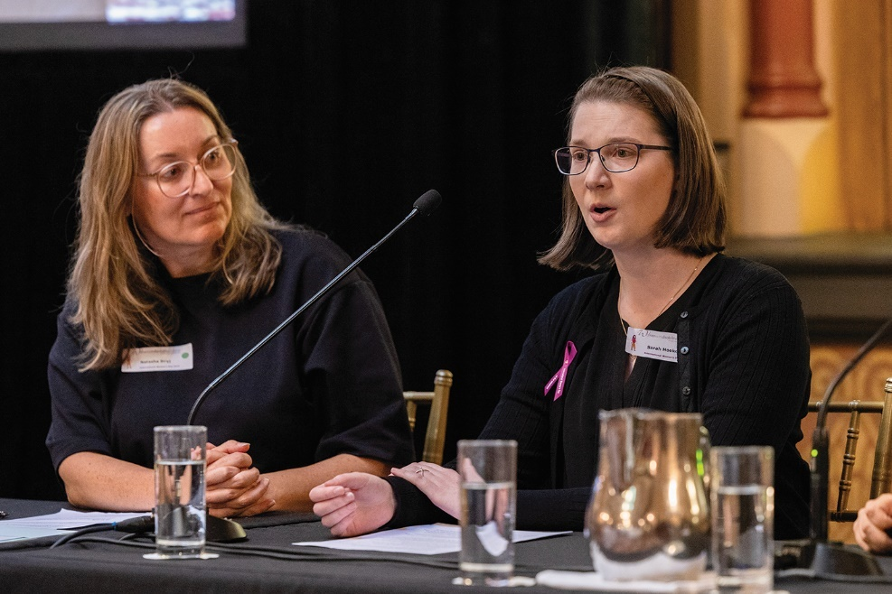 | 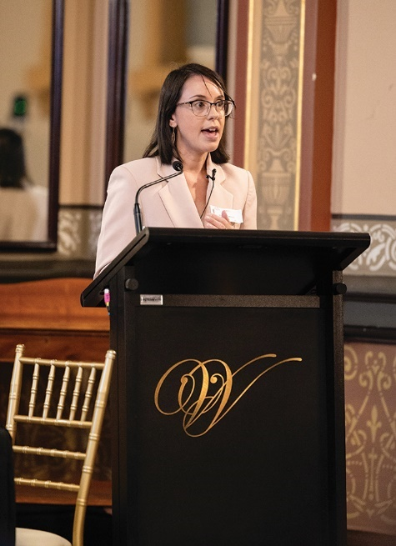
Above: A photo of panel chair Natasha Siryj (WDV Gender & Disability Expert by Experience) and panellist Sarah Hookey (WDV Health Expert by Experience) during the lived experience panel as part of WDV’s International Women’s Day event at Hotel Windsor. They are seated at a table with glasses of water and notes in front of them. Natasha has light coloured long hair and glasses and is wearing a black top. Sarah is also wearing glasses and a black cardigan with the International Women’s Day purple ribbon pinned to it, she has shoulder length brown hair and her mouth is open mid-speech. | Above: WDV International Women’s Day guest speaker Jessica Zammit speaking at the lectern. Jessica has dark shoulder length hair and is wearing a pale beige coloured blazer and glasses.
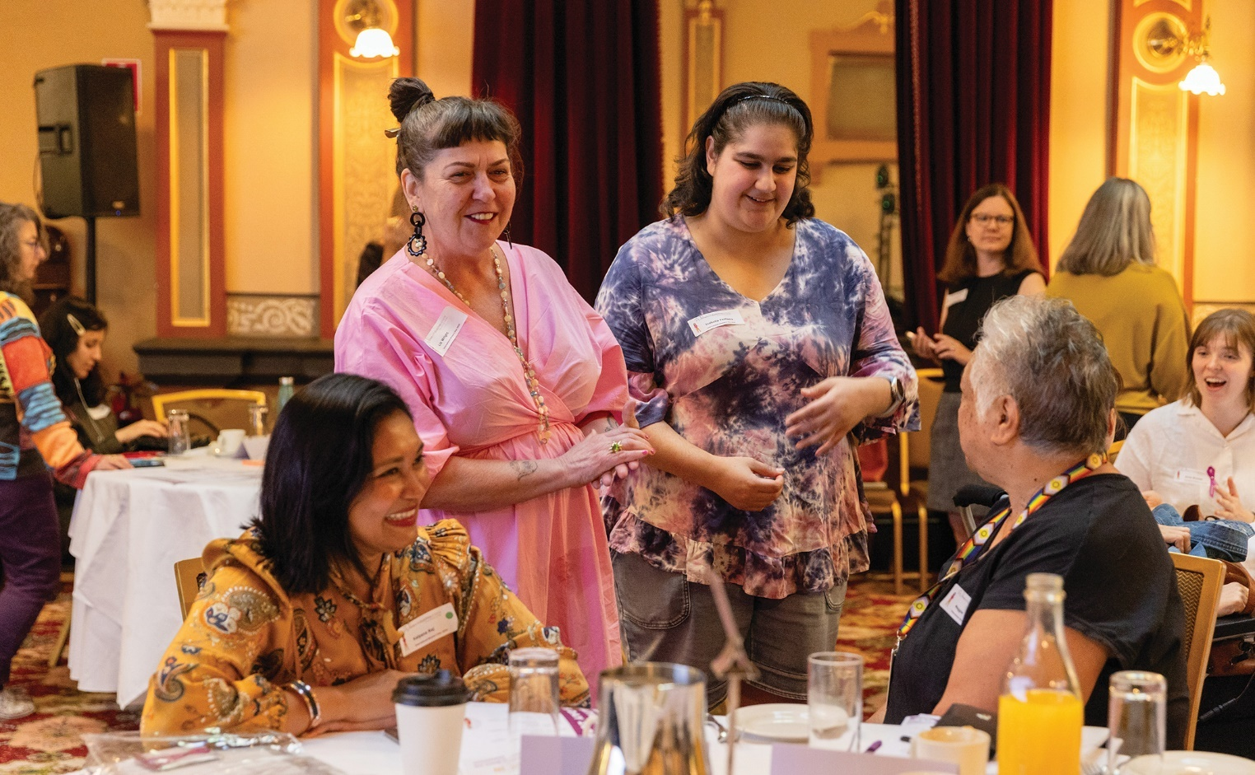
A photo of a group of WDV staff and board members during WDV’s International Women’s Day event at Hotel Windsor. From left: Kalpana Raj (WDV Board) is smiling and wearing a mustard yellow patterned top, Liz Wright (Manager Community Inclusion and Women’s Empowerment) is wearing a pink dress with black geometric earrings and laughing with the group, Isabella Fantasia (WDV Youth Expert by Experience) is wearing a tie die top and Maggie Toko (WDV Board), wearing a black top and multicoloured lanyard, is facing the group.

WDV Operations and Communications
The Operations and Communications team is responsible for the day to day running of WDV by providing human resources, finance, membership and communications, marketing, IT, program support services and support to the WDV Board. The Operations and Communications team aim to deliver excellent service to our stakeholders and customers which include Members, staff, Programs, the WDV Board, funders, government agencies and other partner and allied organisations. In FY23/24 we saw increased teamwork among Operations and Communications staff which improved the quality and increased the quantity of services provided.
The Operations and Communication team provides the internal systems, policies and processes to support delivery of WDV’s strategic and operational plans. The Operations and Communications team also provides information and advice to the WDV Board, Treasurer and the Executive Leadership Team regarding WDV’s financial wellbeing and business performance as well as risk management. The team also provides strategic direction and support for WDV’s infrastructure and Information Communications Technology and is responsible for security awareness training and cyber security.
The Communications staff co-ordinate WDV’s marketing and communications activities including membership services and our growing online presence. They are also responsible for media releases and manage our media activities including radio and television appearances.

Membership increased 15.7% alongside growing engagement and online presence
During the 2023-2024 year, WDV membership increased by 15.7% and we have increased our engagement both with members and outside WDV. We have seen a significant increase in followers and engagement statistics across our key social media channels of Instagram and LinkedIn.
We published 12 editions of eNews which was distributed to subscribers including WDV members, staff, allies and partners.
We now have over 2,475 subscribers.
Increased access, services and events for Members
The Operations & Communications Team delivered a successful hybrid Members Event and Brenda Gabe Leadership Award which was held in the Isabella Fraser room at the State Library Victoria in November 2023. The Team also led the 2023 Annual General Meeting (AGM) online, and it was pleasing to see we had 13 nominations for positions on the WDV Board. Prior to the AGM we hosted an online Board Recruitment event for prospective Board members.
The Communications team facilitated 3 online Quarterly Conversation events with topics including:
- Inclusive Sport and Art to support mental health and wellbeing
- WDV Youth Experts by Experience
- Talking with Melanie Guiney (recipient of the 2023 Brenda Gabe Leadership Award) about the intersection of sexuality and disability.
We continue to see increased attendance at the Quarterly Conversation events.

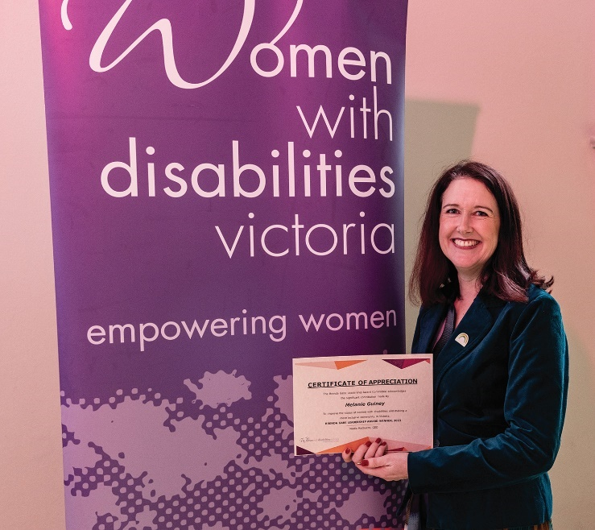 | 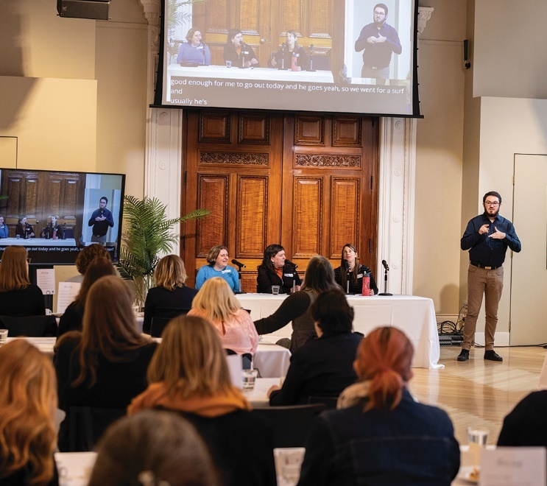
Above: Brenda Gabe Leadership Award Winner, Melanie Guiney, stands in front of a WDV banner holding her winner’s certificate. Melanie is wearing a emerald velvet blazer with a brooch and is smiling at the camera. | Above: Members and guests in the Isabella Fraser room, at the State Library for the WDV Members event and Brenda Gabe Leadership award. Guest are looking ahead to the front of the room where a panel is speaking and the Auslan interpreter is signing.

Profile of Financial Accountant, Kelly Xiao
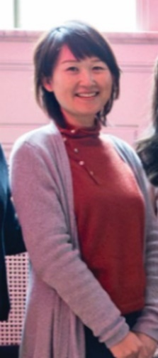 | “As the Financial Accountant in WDV Operations team, I am partnering with WDV management team and oversee everything finance related tasks to provide financial and accounting services at WDV. Throughout the year, WDV has moved to Single Touch Payroll Phase 2 and updated all finance related policies.  In my personal time, I enjoy spending time with my two school age daughters. Cheering and supporting them for their interschool sports. I am also an active member of my local golf club; I have participated in various Women’s Challenge Bowl and Interclub Competition this year.  “WDV understands the need for work-life balance and offers me with flexible hours, hybrid working, and individual flexibility plans to ensure my personalised career. I feel lucky to work in a place where I can feel supported - no matter your race, ethnicity, disability, culture, and beliefs.” Kelly Xiao – Financial Accountant
Above: photo of Kelly Xiao, smiling at the camera. She is wearing a red roll neck jersey with a grey cardigan over top and is standing in front of a window.

Reconciliation Action Plan – Artwork

Acknowledgement of the Artist - Aunty Jane Rosengrave

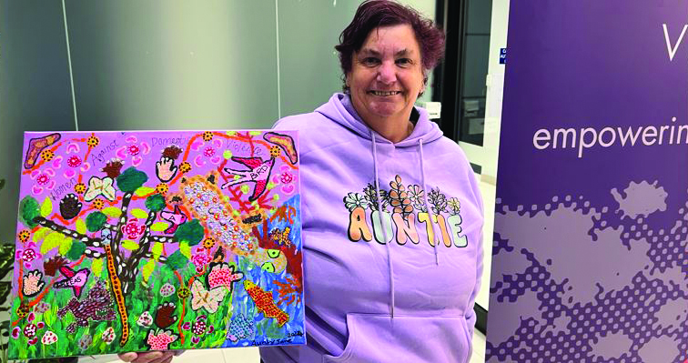
Above: Photo of Aunty Jane holding her painting and smiling at the camera. She is wearing a lilac hoodie that says AUNTIE with flowers above it.
Proud Yorta Yorta woman Aunty Jane Rosengrave is a disability advocate and artist. Jane has an intellectual disability and is a fierce self-advocate and champion for others. Experiencing institutionalisation and abuse from a very young age Jane was kept from her culture and communities. She endured an abusive relationship and further disconnection for many years. But happily, Jane is free as a bird now.
Once kept from her Aboriginal culture, Jane now thrives within it. Jane is a proud Aunty in her community. Once denied the pride of being a part of the disabled community, Jane is now a leader, empowering others.
Jane is a WDV member and has worked on projects that address violence against women with disability. She bravely uses her story to support others, so they can be free as a bird one day too.
Jane has often appeared in the media and her strong advocacy has been shared with self-advocates across the country through workshops and training. In 2016 Jane joined the First Peoples Disability Network (FPDN) Board and is also on the Board at People with Disability Australia (PWDA). Jane was awarded the Tony Fitzgerald Memorial Award at the Australian Human Rights Awards 2016.
Regaining her connection with Country and culture, Jane now shows her identities, proudly. Her tattoos; a turtle, based on her tribe — Yorta Yorta and an Aboriginal flag worn with pride. Alongside them what has become Jane’s life motto, a ‘free as a bird’ tattoo.
Storytelling through art has always been a part of Jane. Even when her culture was denied, deep down she knew the spirit was always within her. Jane’s painting is for the generations and for her communities. Her art connects her, it shows people who she is and what is important to her.
Aunty Jane’s painting has natural and abstract features. The colours are vibrant and the brush strokes and dots of paint are textured on the canvas. There is a blue sea/river in the bottom right corner with a turtle and fish. An orange-coloured tree grows near it. To the left of the sea is green grass and a black tree with white dashes. The background of the painting is lilac. There is a frog and a snake in the grass area. There are birds and butterflies across the painting. The birds have the words “Free as a bird” written on them. There is a boomerang in the top right and left corners. There are hand shapes across the painting. The words “Women against domestic violence” is written across the top third of the painting. There is an orange line intersected by yellow and brown circles. There are ten pink circles with boomerang shapes around them. Please see Aunty Jane’s detailed description below for more.
“My name is Aunty Jane and I’d like to begin by paying my respects to the Aunties, Uncles, mums, dads, nieces, nephews, brothers and sisters, grandmas and grandpas and to the traditional custodians of this land on where we are meeting today, its Elders past and present, and the self-advocacy people who have passed away and who are still here today on Aboriginal land.
Now the painting, this is the sea with the fish in it (bottom right of painting where there is a blue and silver sea) and green weeds in it as well, and some of the white sand that’s in it. This is a long neck turtle, my tribe Yorta Yorta (light brown turtle with lilac, orange and green spots on its back, blue dots on its head and green eyes). And this is the orange tree growing in the river or in the sea with the leaves of the tree, the green trees, the branches on there. And this is the red dirt, the red dust with the Aboriginal organisations that are here in the background (a dashed line in orange with 12 intermittent yellow circles with reddy brown dots in them), and the boomerang here (a boomerang with a black outline, purple sparkles and gold sparkles in it). And these are the ladies (pink circles with pale pink dots in them surrounded by 4 pink boomerang shapes) that are talking about their domestic violence and other problems or health problems, and money wise, you know what they’re going through sitting in a circle here the on the grass (dark and light green grass at the bottom left of the painting).
And these are the birds (three dark and light pink birds that are flying from the bottom left to top right of the painting that have the words on them) that are going from domestic
violence saying ‘free as a bird’ after what they’ve been through as well. These are the hands. These are for the white people (two hands made up of pale beige dots), and these ones are for the Aboriginal people (two hands made of dark brown dots).
And these are the rocks (white circles with dark pink dots in them), and the frog (a dark brown frog with blue dots in the middle and a white dot outline), and the nut and the grass and the leaves that are on the tree as well (light green leaf shapes on a black tree shape with white dashes along the trunk and branches). And the butterflies that are flying away saying I’m as free as a bird as well after I’ve been through domestic violence” (two pale blue butterflies with pale pink dots and gold intersecting lines on them).
Click here for a video of Aunty Jane describing her artwork: https://youtu.be/70Y9ZG9qEEg
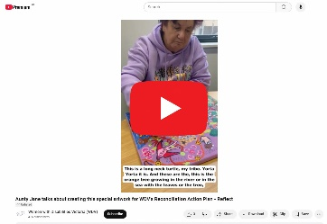

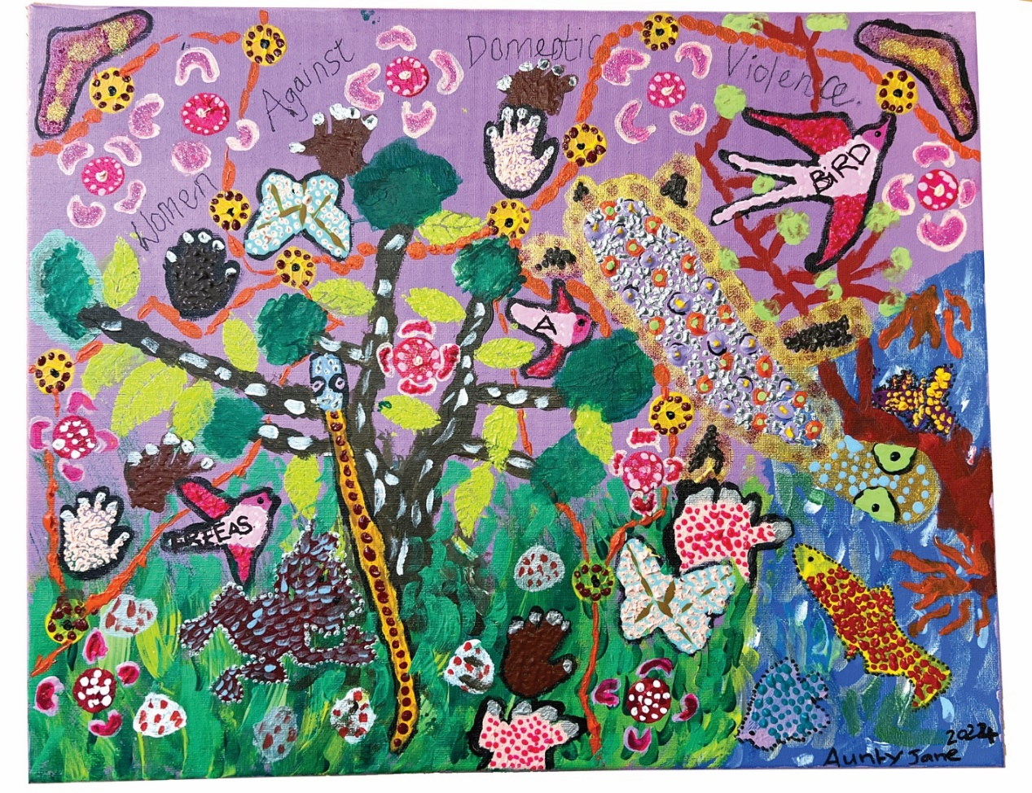
Above: Photo of Aunty Jane’s painting as described above and in the video link above.

Goal 2: Pursue safety, wellbeing and connectedness for women with disabilities
Leverage government funded policy reform and programs

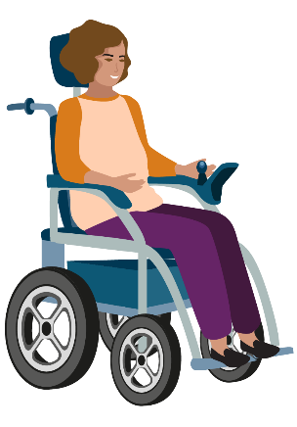

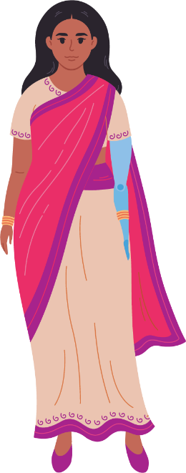

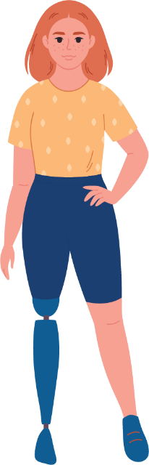

Expert Consultations and Co-Design
This year, we made significant strides towards our goal of promoting safety, wellbeing, and connectedness for women with disabilities. Our efforts began with the Gender and Disability Experts by Experience Advocates, who facilitated both internal and external consultations. They conducted seven internal consultations and eight external consultations. In particular, we co-designed 16 key statements and calls to action for preventing violence against women with disabilities. These contributions were prominently displayed in our campaign, In the Words of Women with Disabilities, showcasing the voices and experiences of women who often go unheard. Feedback from participants emphasised the importance of this work, with one resource user stating, “Their work is so critical in bringing their knowledge, experience and wisdom in promoting gender and disability inclusion.” This collaborative approach not only raises awareness but also serves as a foundation for future initiatives.

Advocacy and Engagement
Another noteworthy collaboration was with Safe and Equal, where we consulted on the accessibility features of their PreventX Conference. The reflective consultations provided valuable insights, with Safe and Equal highlighting the benefits for building access and inclusion in future events. Such partnerships are vital in ensuring that the voices of women with disabilities are integrated into broader community dialogues about safety and wellbeing.
In addition to consultations, we played an active role in governance discussions aimed at preventing violence against women and non-binary people with disabilities. We contributed feedback on the updated Preventing Family Violence & Violence Against Women Capability Framework as part of Safe and Equal’s Prevention Strategy Advisory Group. Our participation in the Women’s Health Victoria’s Advisory Group also allowed us to review essential training courses focused on primary prevention of violence against women. Through these initiatives, we are influencing policies that directly impact the lives of women and non-binary people with disabilities, advocating for their rights and needs at the highest levels of decision-making.

Collaborative Pilot Projects
This year, we launched a pilot project in collaboration with Brotherhood of St. Laurence and Boorndawan Willam Aboriginal Healing Service. This Endorsement Model for Organisations Project aims to support organisations in their journey towards inclusive prevention strategies.

Through professional development sessions, auditing processes, and implementation plans, we are fostering a culture of inclusion. Feedback from pilot participants reflected a positive experience, with one stating, “We’ve really enjoyed taking part in the pilot so thank you for including us on this journey!” Such collaborations highlight our commitment to promoting safety and wellbeing across different communities.

Advancing Health Care Access
In the realm of health care, we concluded the final phase of the Experts in Our Health project, which has been instrumental in providing training and resources for both women with disabilities and health workforces. Over the course of this project, 122 women accessed training, which equipped them with the tools needed to advocate for disability and gender-responsive health care. We also developed a comprehensive range of resources, including five fact sheets, a poster, and a video, all co-designed by women with disabilities to ensure accessibility. These materials are available on our website, enabling broader access to critical information on navigating health care systems and advocating for equitable health service delivery.

Employment Initiatives
Our commitment to improving employment opportunities for women with disabilities was further underscored by new funding from the Victorian Department of Families, Fairness and Housing. The Sharing our Expertise initiative aims to reduce barriers within the health and social service sectors by co-designing resources and training with a group of women with disabilities. Our outreach efforts have begun, promoting the project’s aims to organisations across Victoria. The training and technical assistance activities are scheduled for delivery next financial year, signalling a proactive approach to enhancing workforce participation for women with disabilities.

Amplifying Voices in Policy
We also recognise the importance of amplifying the perspectives of women with disabilities in governmental policies and programs. In partnership with Our Watch, we prepared a Framework for Action as part of the Changing the Landscape project. This framework provides a roadmap for governments and policymakers to prevent violence against women with disabilities, identifying actionable steps across policy, legislative, and institutional reform. By drawing on robust evidence, we aim to inform practices that will lead to lasting change in our communities.

Contributions to National Strategies
Our advocacy extended to the Commonwealth Government’s draft National Autism Strategy, where we highlighted the unique challenges faced by women with autism. We made recommendations for gender-responsive diagnostic services and daily living supports, emphasising the need to address violence and abuse specifically affecting this demographic.
Additionally, we provided crucial evidence at a special hearing for the Inquiry into Capturing Data on Family Violence Perpetrators in Victoria. Our insights focused on the potential impacts of data collection on women with disabilities, and our contributions will be included in the Committee’s published summary notes. By ensuring that these perspectives are part of legislative discussions, we continue to advocate for a system that prioritises the safety and wellbeing of women and non-binary people with disabilities.

Goal 3: Create long term change
through engagement, education and advocacy

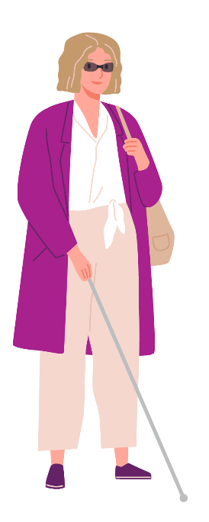
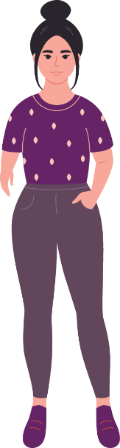
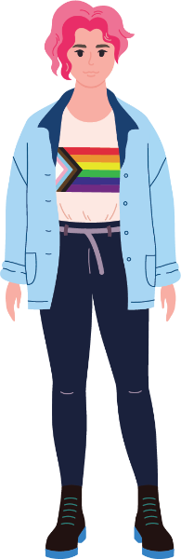

This year, we have made substantial progress towards creating long-term change for women and non-binary people with disabilities through our initiatives focused on engagement, education, and advocacy. Our comprehensive approach has involved training, community-building, resource development, and advocacy efforts that address the unique needs of women and non-binary people with disabilities and promote their rights and safety.

Training and Professional Development
A cornerstone of our efforts this year has been the training provided to disability, social services, and prevention staff. A total of 379 practitioners attended our Prevention of Violence Against Women with Disabilities training and professional development sessions. Among these, our Experts facilitated four training sessions, and 54 practitioners received individual professional development. Additionally, we offered bespoke training to four organisations. Participants expressed the impact of these sessions, with one attendee noting,
“The facilitation was great. I appreciated the personal stories weaved through the session. […] there were quite a few lightbulb moments. I’ve learnt a lot and there is a lot from the day that I’ll dive deeper into too.”
This feedback highlights the effectiveness of incorporating lived experiences into our training, which fosters deeper understanding and connection among participants.

Community of Practice
The G&D Program, the Women’s Health Services Capacity Building Project and the Victorian Women’s Health Project also convened a Changing the Landscape in Practice Community of Practice (CoP). This CoP brought together 20 practitioners from disability, social services, prevention, and women’s health sectors, meeting four times throughout the year. Members consistently reported the value of these sessions, with one stating,
“Well done on another informative and valuable CoP. I always come away with increased knowledge and confidence in the gender and disability space.”
By facilitating ongoing discussions and knowledge sharing, we are helping practitioners apply their learning in practical settings, which is essential for driving long-term change.

Resource Development
In our commitment to inclusive prevention, we developed six resources centred on the voices of lived experience. A notable partnership with the Multicultural Centre for Women’s Health resulted in a series of resources aimed at preventing violence against migrant and refugee women, non-binary, and gender-diverse people with disabilities.
This initiative culminated in a successful launch event attended by 141 professionals from disability, social services, prevention, and multicultural workforces. One attendee remarked,
“Such a rich and valuable event with so much useful and relevant information in such a short time. Perfect for us busy workers. Thank you.”
These resources are not only vital for awareness but also serve as practical tools for those working directly with marginalised communities.
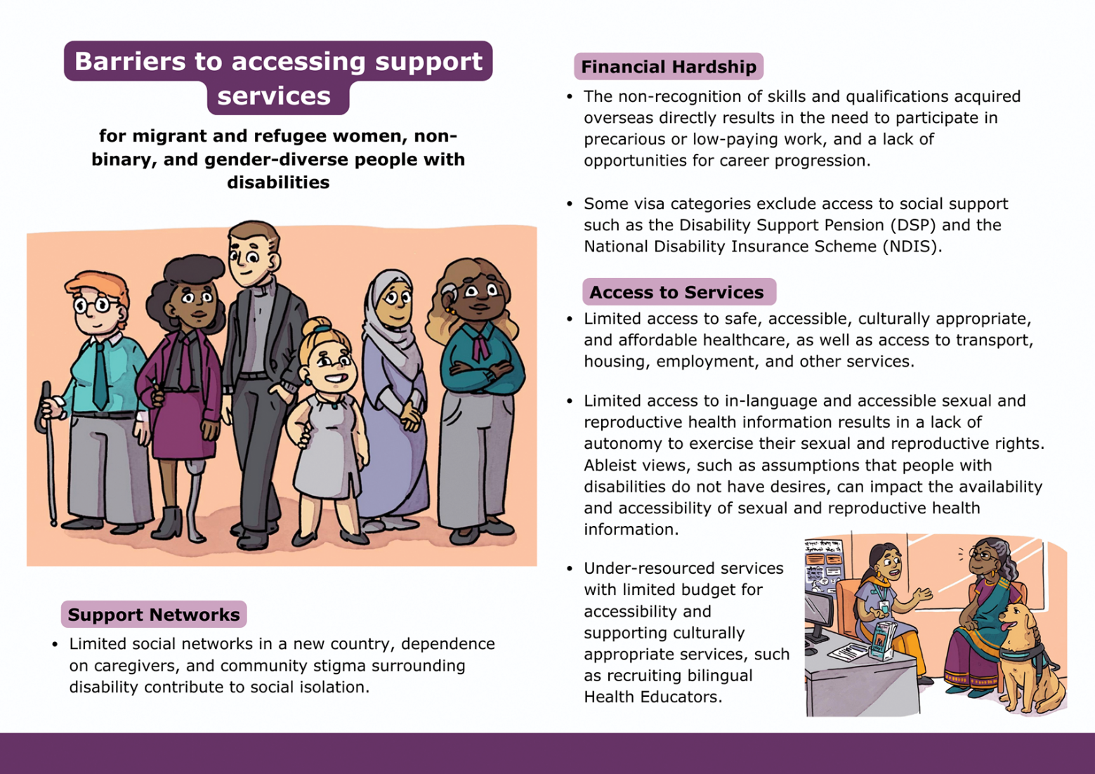
Above: An image of a resource created as part of the PVAWD & Multicultural Communities Project exploring the barriers to accessing support services for migrant and refugee women, non-binary, and gender-diverse people with disabilities. Find this resource on the WDV website: www.wdv.org.au/family-violence-resources/

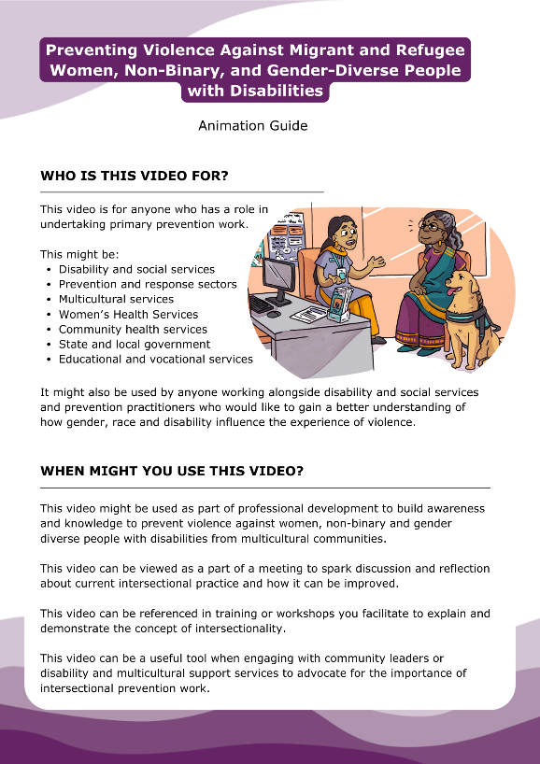  Above: An image of the animation guide created as part of the PVAWD & Multicultural Communities Project that explains who and how the animation can be used. | 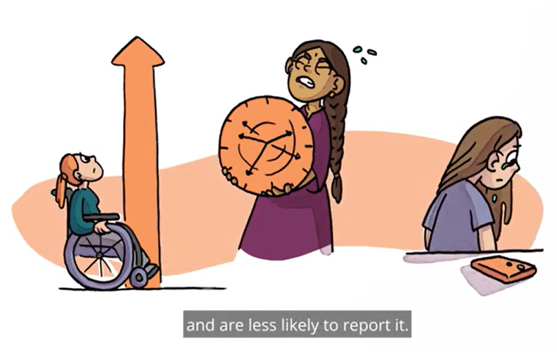  Above: A still taken from the Preventing Violence against migrant and refugee women, non-binary, and gender-diverse people with disabilities animation. It depicts 3 women. Woman 1 is in a wheelchair in front of an arrow representing migrant and refugee women, non-binary, and gender-diverse people with disabilities experience high rates of violence. Woman 2 is holding a heavy clock, representing migrant and refugee women, non-binary, and gender-diverse people with disabilities experience of violence over a longer period of time. Woman 3 is crying and facing away from their mobile phone, representing that migrant and refugee women, non-binary, and gender-diverse people with disabilities are less likely to report violence.

Changing the Landscape Project
This year also saw the culmination of the Changing the Landscape Practice Resource development project, which we undertook in partnership with Our Watch, the national organisation focused on preventing violence against women and children. Over two years, we co-designed resources with lived experience experts and practitioners from the disability service sector and primary prevention workforce. The outputs of this collaboration include eight video explainers in the series ‘Take Note’, five case study videos in ‘Get Real’, six audio episodes in ‘Shift the Culture’, and various infographic posters for workplace use. These resources are designed to translate evidence into practical strategies that practitioners can implement, thereby fostering an environment that prioritises safety and inclusion.
‘Our Watch’s partnership with WDV is one of our longest and most valued. Through working in close partnership with WDV and leveraging their expertise, we continue to learn about authentic co-design with women with disabilities. Together we continue to translate evidence into practice on the Changing the Landscape project, with the most recent suite of resources designed to equip and empower prevention practitioners, disability service providers and governments to take action to prevent violence against women with disabilities. Working with WDV ensures that our shared national prevention resources centre the needs and perspectives of women with disabilities, through highlighting lived experiences with care and authenticity’. – Patty Kinnersly, CEO, Our Watch

Advocacy Efforts
Our advocacy initiatives have also played a significant role in creating long-term change. One key submission was made to the State Government’s Inquiry on Women’s Pain, highlighting the unique experiences of women and non-binary people with disabilities. Through extensive engagement with our members, we gathered insights that challenge existing barriers related to pain management and access to gender responsive treatment options. This submission not only raises awareness but also informs policy discussions, ensuring that the voices of women and non-binary people with disabilities are heard in critical conversations about health and wellbeing.
Moreover, we collaborated with the Victorian Women’s Health Program and the Women’s Health Services Capacity Building Program to coordinate a statewide Community of Practice.
This initiative is focused on deepening the understanding of what works in gender and disability-inclusive practices across community and health services in Victoria. By sharing resources from various contexts and supporting staff in applying their training, we aim to strengthen the capabilities of practitioners and challenge the intersectional barriers faced by women and non-binary people with disabilities.
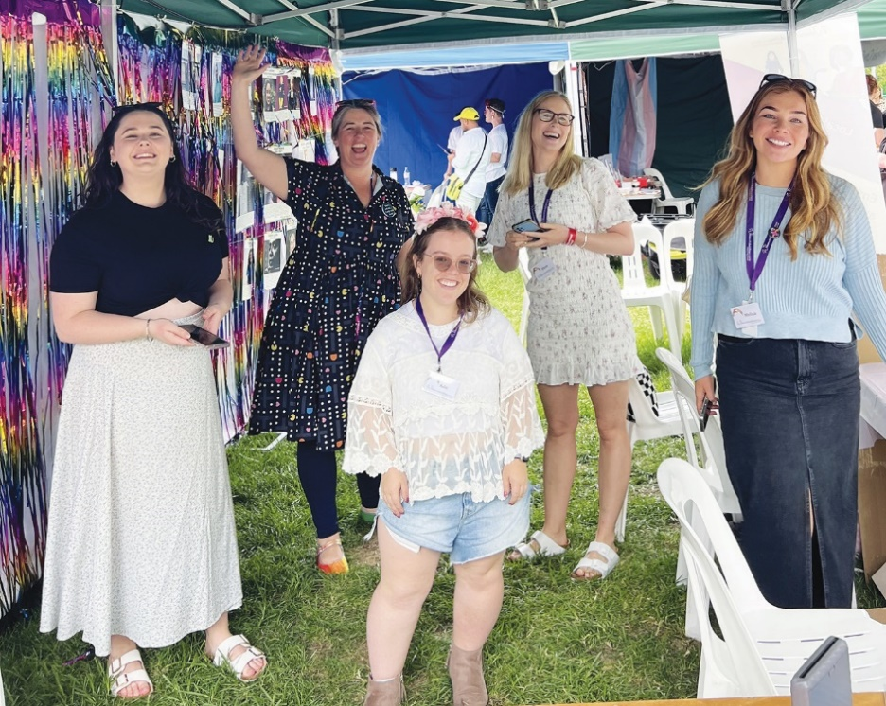  Above: some of the WDV Midsumma stall crew. Staff members from left to right, Vanessa Davis, Libby Price, Julie Dickson, Elysia Johnston, and Melissa Jolley, are standing within the stall with big, happy smiles. They are facing the camera, standing on grass, in front of the rainbow wall. | 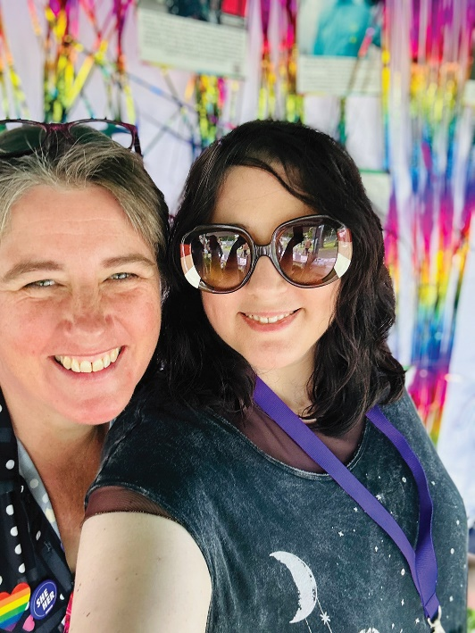  Above: Selfie photo of WDV Midsumma stall crew members Libby Price and Bridget stone, they are standing in front of the rainbow streamers of the stall and smiling at the camera. Bridget is wearing sunglasses and Libby has a rainbow badge.
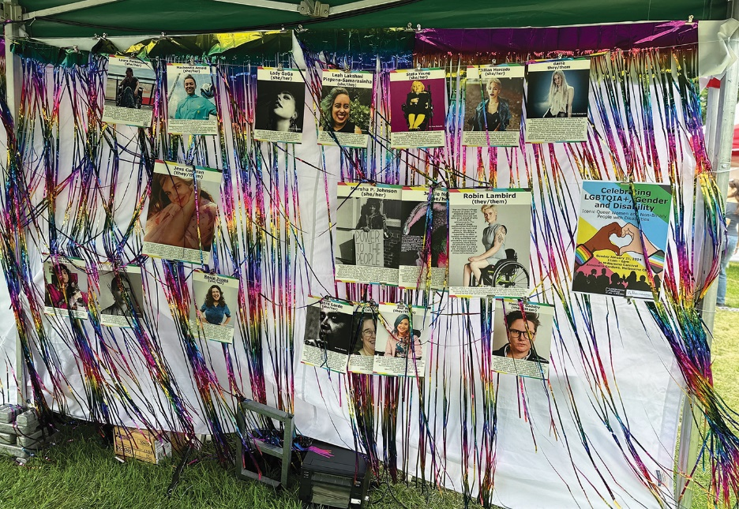  Above: rainbow wall with rainbow streamers and colourful posters/images hanging. The posters display people who are icons both as members of the LGBTQIA+ and disability communities. | 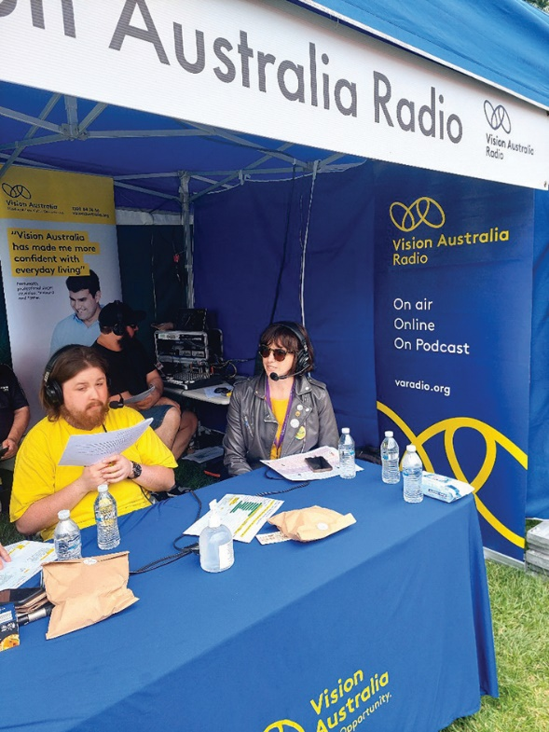
Above right: Lena Molnar, (Manager Gender Based Violence Research Evaluation Lead) featured in the Vision Australia stall. Lena is wearing a headpiece with a microphone, and talking on the radio. Lena is wearing a black leather jacket, and sunglasses. The Vision Australia logo is behind her, in yellow, white and blue colours.

Media Engagement
Our engagement with traditional media has increased significantly this year. We made a notable appearance on ABC Breakfast television, where our CEO, Nadia Mattiazzo, spoke about the issues facing women and non-binary people with disabilities who are escaping domestic violence. She emphasised the importance of calling 1800 Respect for support and advocated for increased resources for people with disabilities in crisis situations.
When faced with a funding shortfall in May 2024, we responded by sharing a press release across our channels, leading to an overwhelming community response. Over 700 emails were sent to Minister Rishworth and Minister Shorten, and our social media post was shared 258 times. Despite not directly engaging with the media, the story was picked up by the Bendigo Advertiser, resulting in two articles that highlighted the urgency of our work. This outpouring of support demonstrates the community’s recognition of our vital role and the impact we have in advocating for women and non-binary people with disabilities.
Furthermore, Nadia Mattiazzo co-authored an opinion piece with Our Watch CEO, Pat Kinnersly, titled “Disability Royal Commission Highlights Work to Be Done to End Violence Against Women and Girls with Disability.” In this piece, they emphasised the urgent need for action following the Royal Commission findings, stating, “The reality for women and girls living with disability is confronting. We must ensure that their testimony and the commission findings are not left on the shelf. It is time for action and a concerted effort to prevent violence against women with disability.” This collaboration amplifies our commitment to advocating for systemic change and ensuring that the voices of women and non-binary people with disabilities are central to these discussions.

Goal 4: Key enablers
WDV will ensure strong organisational infrastructure to enable our strategy

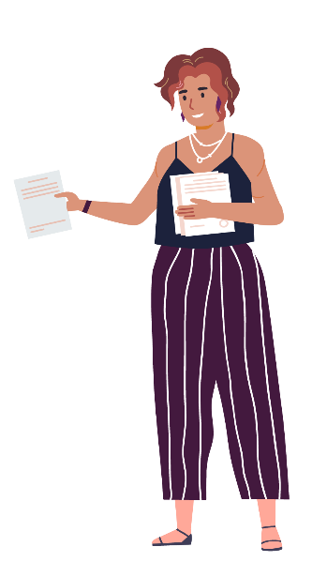

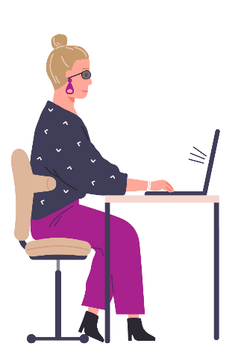
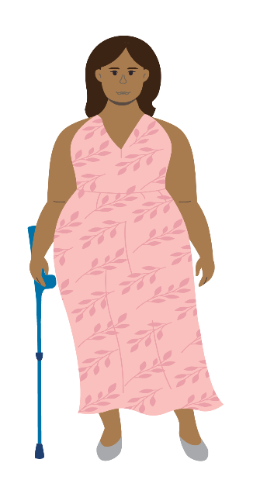

Strengthening Evaluation Processes
In the past year, WDV has focused on strengthening our organisational infrastructure to support our strategic goals. This commitment is reflected in our ongoing efforts to enhance evaluation processes, improve community engagement, and invest in technology and policies. To boost our inclusive prevention evaluation skills, G&D Program staff participated in two evaluation workshops and three evaluation check-ins. These sessions were crucial for developing our understanding of effective evaluation practices, and we also benefited from the internal evaluation report, which aimed to enhance our program deliverables. Our commitment to transparency and accountability is evident in the submission of our First Progress Report to the Department of Families, Fairness and Housing (DFFH). This collaboration continues to improve the accessibility of our planning and reporting templates, ensuring they meet the diverse needs of our community.

Enhancing Community Engagement
Our CIWE team undertook training in community engagement strategies and occasional counselling to better navigate the complexities of distress and trauma when facilitating groups. This training has empowered our team to create events and opportunities that showcase the achievements of our members from both the hubs and leadership programs. Notably, our youth Experts have engaged actively in events and shared their experiences through blogs, helping to elevate the voices of young women and non-binary people with disabilities.

Investing in Technology and Policies
We have also invested in our technological infrastructure by developing a new Intranet and implementing Multi-Factor Authentication and Security Awareness Training for staff. These enhancements have significantly improved our document management and internal communications while bolstering our cybersecurity readiness. Additionally, we reviewed and updated our internal policies and developed new framework templates to strengthen our financial and operational controls.

Commitment to Reconciliation
Another important initiative this year was our Reconciliation Action Plan (RAP) Working Group, which met monthly and received conditional approval from Reconciliation Australia for WDV’s first Reflect RAP. We were thrilled to have WDV member Aunty Jane Rosengrave contribute her artwork for the Reflect RAP, which reflects our commitment to reconciliation and inclusion.

Thank you…
to the following funders, partners and supporters

The Achieve Foundation

Bayside City Council

Better Health Network

Boorndawan William Aboriginal Healing Service

BreastScreen Victoria

Brotherhood of St. Laurence

Cancer Council of Victoria

Centre for Non-Violence

Cobram Community House

Commonwealth Department of Social Services

Coonara Community House

Family Safety Victoria

FVREE

Geelong Region Alliance G21

Golden Plains Shire Council

Greater Dandenong Council

Health Issues Centre

Juno

Melbourne Polytechnic

Moonee Valley City Council

Multicultural Centre for Women’s Health

Municipal Association of Victoria

National Disability Insurance Scheme Quality and Safeguards Commission

Nous Group

Office for the Prevention of Family Violence and Coordination, Victorian Department of Families, Fairness and Housing (DFFH)

Our Watch

Rainbow Health Australia

Respect Victoria

Royal Women’s Hospital

Rural City of Wangaratta

Safe and Equal

Sexual Assault Services Victoria

Swinburne University

Victorian Department of Families, Fairness and Housing (DFFH)

Victorian Department of Health

Victorian Trades Hall Council

WLK Consulting

Women’s Health and Wellbeing Barwon SouthWest

Women’s Health East

Women’s Health Goulburn NorthEast

Women’s Health Grampians

Women’s Health Loddon Mallee

Women’s Health in the North

Women’s Health in the South East

Women’s Health Victoria

Donors who supported WDV
this year
Suzi Chinnery
Kyleigh Finn
Molly Hoffman
Keran Howe
Jacinta Parsons
Marco Rojas
Jemma Swan
The Gross Foundation

WDV Regional Hub Partners

Centre for Non-Violence
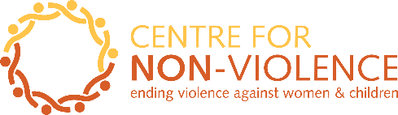

Cobram Community House
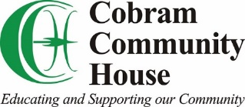

Coonara Community House
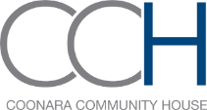

Geelong Region Alliance G21
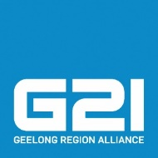

Southwest Advocacy Association
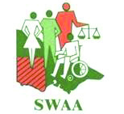

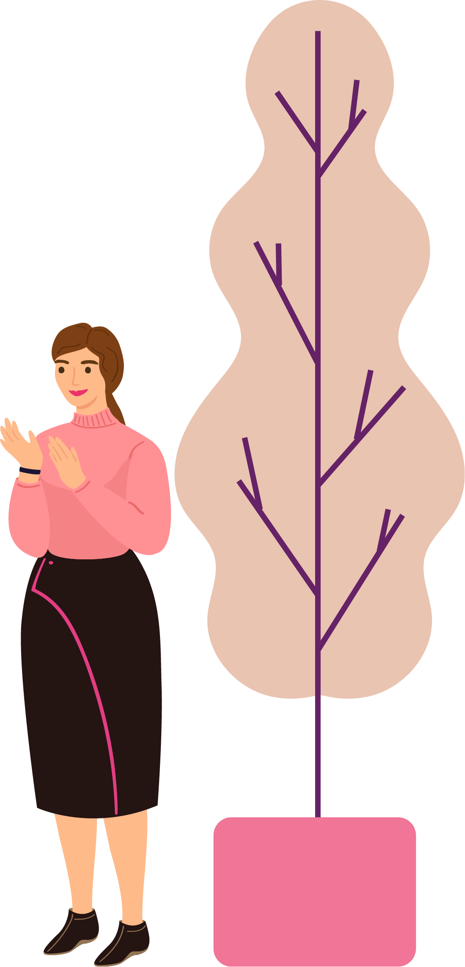

Financial Statements

The WDV Board and Finance & Risk Committee continued to strengthen WDV’s financial position.
WDV is in a strong financial position, and we are able to pay our debts if and when they are due.
The Profit and Loss Statement shows a deficit (loss) of $282,967 in the 2023/24 financial year.
Revenue (money coming in) for this year was $3,184,378, an increase of $410,731 from last year.
Expenses (money going out) for this year was $3,467,345, an increase of $799,793 from last year.
Equity (value of WDV) for this year was $1,732,408, a decrease of $282,867 from last year.
This year Current Assets are $2,376,585, which is equal to 4.8 times our Current Liabilities of $490,903. This is a healthy position.
Cash Reserves decreased this year to $2,312,686 an increase of $1,291,113 from last year.

Statement of profit or loss
and other comprehensive income for the year ended 30 June 2024

 | 2024  $ | 2023  $
Continuing operations
Revenue | 3,184,378 | 2,773,647
Expenditure
Depreciation expenses | (113,044) | (70,037)
Employee benefits expenses | (2,592,244) | (1,963,824)
Other expenses | (762,059) | (633,691)
Total expenses | (3,467,345) | (2,667,552)
Surplus (Deficit)  before tax | (282,967) | 106,095
Income tax expenses | – | –
Surplus (Deficit)  for the year | (282,967) | 106,095
Other comprehensive income | – | –
Total comprehensive Surplus/(Deficit)  for the year | (282,967) | 106,095

Statement of financial position
as at 30 June 2024

 | 2024  $ | 2023  $
ASSETS
Current Assets
Cash and cash equivalents | 2,312,686 | 3,603,799
Trade and other receivables | 4,663 | 4,035
Other current assets | 59,236 | 74,424
Total Current Assets | 2,376,585 | 3,682,258
Non-Current Assets
Property, plant & equipment | 17,356 | 24,074
Right of use asset | 329,927 | 426,588
Total Non-Current Assets | 347,283 | 450,662
Total Assets | 2,723,868 | 4,132,920
LIABILITIES
Current Liabilities
Trade and other payables | 490,903 | 1,540,810
Total Current Liabilities | 490,903 | 1,540,810
Non-Current Liabilities
Provisions | 125,692 | 112,563
Right of use liability | 374,865 | 464,172
Total Non-Current Liabilities | 500,557 | 576,735
Total Liabilities | 991,460 | 2,117,545
NET ASSETS | 1,732,408 | 2,015,375
EQUITY
Retained Earnings | 1,732,408 | 2,015,375
TOTAL EQUITY | 1,732,408 | 2,015,375

Statement of changes in equity
for the year ended 30 June 2024

 | Retained Earnings  $ | Total  $
Balance at 1 July 2022 | 1,909,280 | 1,909,280
Surplus/(Deficit) attributable to members | 106,095 | 106,095
Balance at 30 June 2023 | 2,015,375 | 2,015,375
Surplus/(Deficit) attributable to members | (282,967) | (282,967)
Balance at 30 June 2024 | 1,732,408 | 1,732,408

Cash flow statement
for the year ended 30 June 2024

 | 2024  $ | 2023  $
CASH FLOWS FROM OPERATING ACTIVITIES
Receipts from customers | 3,075,535 | 2,754,819
Payments to suppliers and employees | (4,465,198) | (2,286,481)
Interest received | 109,471 | 18,828
Net cash provided by (used in) operating activities | (1,280,192) | 487,166
CASH FLOWS FROM INVESTING ACTIVITIES
Payments for plant and equipment | (10,921) | (26,283)
Net cash provided by investing activities | (10,921) | (26,283)
Net increase in cash held | (1,291,113) | 460,883
Cash at beginning of financial year | 3,603,799 | 3,142,916
Cash at end of financial year | 2,312,686 | 3,603,799

Get in touch
Keep up to date with WDV; join our community

 https://www.facebook.com/womenwithdisabilitiesvictoria
 https://www.instagram.com/womenwithdisabilitiesvic/
 https://www.linkedin.com/company/womenwithdisabilitiesvictoria/
 https://twitter.com/WDVtweet
 https://www.youtube.com/user/WDVchannel

Wurundjeri Country
Level 1, 255 Bourke Street
Melbourne VIC 3000

Postal: PO Box 18314
Collins Street East VIC 8003

Phone: 03 9286 7800

Email: wdv@wdv.org.au
www.wdv.org.au



