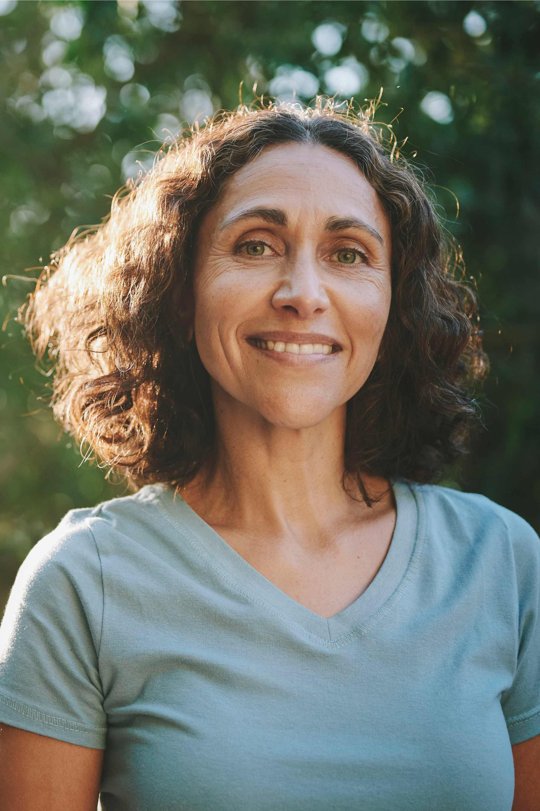
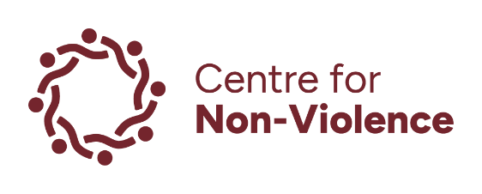

Submission:
Guidelines on addressing multiple and intersecting forms of discrimination against women and girls with disabilities in law, policy and practice.
OHCHR Call for Input:
31 October 2025
Acknowledgements
Our organisations are committed to the safety, participation, and empowerment of all people, including children and young people that engage with our organisations, including but not limited to individuals who identify as:
- Aboriginal and Torres Strait Islander.
- Culturally and/or linguistically diverse.
- Gender diverse and/or same sex attracted.
- People with disabilities.
We acknowledge Aboriginal and Torres Strait Islander peoples as the First Nations Peoples of these lands and water, their sovereignty and sacred link to these lands and waters, and the ongoing harms and impacts of colonisation.
We support all people to thrive and have zero tolerance for any form of racism, ableism, homophobia, sexism, ageism and hate speech/action that attempts to marginalise, threaten or silence.
We acknowledge the strength and resilience of survivors of family and sexual violence and recognise that women and girls with disability often face systemic barriers to safety and support when seeking a life free from violence. We recognise the courage of individuals who have experienced family violence, along with the dedicated workers responding to family violence.
About our Organisations:
Centre for Non-Violence (CNV)
Established in 1990, CNV is one of Victoria’s leading family violence prevention, response and recovery services. We deliver a range of programs, including prevention, crisis, and therapeutic services.

By working with both victim survivors and adults using violence, we provide increased safety, participation and support for families and individuals impacted by family violence. This integrated approach is key to how we support people. CNV has a commitment to ensuring victim survivors of family violence are safe and those who use violence are held accountable.

We welcome and support people of all backgrounds, ethnicities, cultures, ages, gender identities, sexual orientations, and abilities. CNV is a child-safe organisation and recognises that children are victim survivors of family violence in their own right.

CNV works with people across the lands of the Dja Dja Wurrung, Taungurung, Yorta Yorta and Wurundjeri peoples, with offices in Bendigo, Echuca, Kyneton and Maryborough.

Women with Disabilities Victoria (WDV)
Women with Disabilities Victoria (WDV) is a not-for-profit Disabled People’s Organisation (DPO) representing women and gender diverse people with disabilities in Victoria. The organisation is operated by and for women and gender diverse people with varied disability experiences. WDV has a diverse membership of people from different backgrounds across Victoria, Australia. Women with disabilities face intersecting forms of structural gender and disability discrimination. WDV actively advocates for our rights to safety and respect, with particular emphasis on disability policy, health services, violence prevention, workforce development, and leadership. WDV envisions a world where all women are respected and can fully experience life.
Further, not all WDV members or staff identifies as a woman with disabilities. That is why we refer to our members as ‘women and gender diverse people with disabilities’.
We acknowledge that while some concerns raised are shared across gender-marginalised communities, the experiences of gender diverse people warrant specific and direct exploration. WDV does not seek to speak for or replace the role of organisations led by and for LGBTIQA+ people with disabilities. Instead, we aim to work in coalition with them and amplify areas of shared concern.
Note on Language:
This submission uses ‘person first’ language (women and gender diverse people with disabilities). We acknowledge that people describe their experience of disability in different ways, and for many people, ‘identity first’ language is a source of pride and resistance.
Contact Us:
Dr Clare Shamier, Head of Business Development and Advocacy, Centre for Non-Violence:
clares@cnv.org.au
Saumya Kaushik, Policy Research Lead, Women with Disabilities Victoria
saumya.kaushik@wdv.org.au

Introduction
We welcome the opportunity to provide a submission to the United Nations Human Rights Office of the High Commissioner in preparation of the draft guidelines on addressing multiple and intersectional forms of discrimination against women and girls with disabilities.
The Centre for Non-Violence works with thousands of clients a year, providing prevention, crisis and recovery support across rural and regional communities in Central Victoria, Australia. We see first-hand the impact of family violence on women’s economic wellbeing, housing security, health and access to justice. These impacts are often exacerbated for women and girls with disabilities by unjust and discriminatory barriers to support and safety.
For over 30 years Women with Disabilities Victoria (WDV) has tirelessly worked at addressing compounding nature of specific barriers such as ableism, sexism, misogyny, and systemic exclusion that mainstream women’s advocacy and disability advocacy organisations may overlook. As an intersectional organisation, we also address other areas of marginalisation such as socio-economic status, ethnicity and geographic location which impact women and gender diverse people with disability. Our work is grounded in lived experience, with our members and staff bringing their lived experience as women and gender diverse people with disabilities.
We work with government, community services, and community members to improve outcomes for women and gender diverse people with disabilities with a focus on policy, equity, inclusion, and access. Ensuring that disability inclusion is embedded in broader gender equity efforts. We are continually challenging stereotypes and promote respect, agency, and visibility for women and gender diverse people with disabilities.

Key Questions
Do the anti-discrimination legislation and/or policy frameworks in force in your country recognize disability and the denial of reasonable accommodation as prohibited forms of discrimination against persons with disabilities?
Federally, Australia has the following suite of laws:
- Racial discrimination Act 1975
- Sex Discrimination Act 1984
- Disability Discrimination Act 1992
- Age Discrimination Act 2004
- Australian Human Rights Commission 1986
The Australian Human Rights Commission (ARHC) is an independent statutory body established by the Federal Government responsible for promoting and protecting human rights in Australia.
In addition, each state and territory in Australia have their own anti-discrimination or Equal Opportunity laws making it unlawful for a defined entity within these laws to discriminate against a person with disability.

Disability Discrimination Act 1992 (DDA)
Under the DDA it is unlawful to discriminate against a person due to their disability in specific areas of public life. This includes, but is not limited to, employment, education, accommodation, and accessing goods and services and public places. The DDA is underpinned by legislation:
- Disability Standards for Education 2005
- Disability (Access to Premises-Buildings) Standard 2010
- Disability Standards for Accessible Transport 2002
In 2023, a report by Royal Commission into Violence, Abuse, Neglect and Exploitation of People with Disability (DRC) provided 222 recommendations and 15 recommendations were in relation to improving DDA, including implementing Positive Duty – a preventative approach to eliminate discrimination and future proofing.
It was noted by the Disability Discrimination Commissioner, Rosemary Kayess that ‘[p]eople with disability continue to experience inequality and discrimination on a daily basis and are marginalised and excluded in many areas of their lives due to ableist systems, policies and attitudes.

Reasonable Adjustments
The DDA requires duty holders, such as public and private sector employers, educational institutions to provide a person with disability with any reasonable adjustments required to support their participation. It also states that an adjustment is not reasonable if it would impose unjustifiable hardship on the duty holder. However, the disability community and legal services have struggled with lack of clarity with the term ‘reasonable’. Some of the Royal Commission recommendations to improve the DDA included:
- replacing references to ‘reasonable adjustments’ with ‘adjustments’
- creating a ‘stand‑alone duty to provide adjustments’ to make it unlawful for a duty holder to fail or refuse to make an adjustment unless making the adjustment would impose unjustifiable hardship.
There is limited awareness on supports available to organisations to assist with supplying the requested adjustments and assumed knowledge that reasonable adjustments are costly. Workplaces have access to the Australian Government’s ‘JobAccess’ platform for information and resources to ‘drive disability employment’ and access to Employment Assistant Funds to assist workplace assessments and costs towards required adjustments.

Human Rights Legislation
While Australian Government ratified the UN CRPD in 2008, an international human rights treaty, it is the only western country to not have a Human Rights Act. Because of this missing piece of key legislation, housing is still regarded as a commodity rather than a basic human right.
While Queensland, Victoria, and the Australian Capital Territory have Human Rights Acts none explicitly protect the right to adequate housing.
State Housing Acts regulate the management of social housing and while there are legislative provisions including minimum standards in housing, the reality is there continues to be a condoning of discriminatory attitudes and practices along with systemic barriers that inhibit access to safe and affordable housing for women and girls with disability: the Australian Government is not upholding its commitment to the UN CRPD.

Which groups of women and girls with disabilities face the greatest risks of multiple and intersectional discrimination?
Prevalence of Disability
Nearly 1 in 5 Victorian women has a disability, representing a significant portion of the population who experience multiple layers of discrimination based on gender, disability, race, age, or sexual orientation.

Gendered Violence
Growing data indicates that women and gender diverse people with disabilities, across different age, race, ethnicity, sexual orientation or class, are assaulted, raped and abused at a rate at least two times greater than non-disabled women.
- 65% of women with disability report at least one incident of violence (inclusive of physical violence, sexual violence, intimate partner violence, emotional abuse and/or stalking, by any perpetrator).
- 37% of women with disabilities have experienced emotional and coercive abuse from domestic partners—nearly double the rate for women without disabilities.
- Different types of disabilities also impact on women’s experience of victimisation, with studies finding higher rates of violence experienced by people with psychosocial disabilities, intellectual disabilities, and complex communication needs.
- 27% of women with disability and 16% of women without disability report at least one episode of stalking.

Gender Diverse Experiences
- 78% of trans and gender diverse Victorians report unfair treatment based on gender identity and experience higher rates of social exclusion (36.4%), verbal abuse (33%), and sexual assault (10%).
- Among LGBTIQA+ Victorians, 38% have a disability.

What are the main Intersectional risks and forms of discrimination faced by women and girls with disabilities? Do you consider that the violence and discrimination against women and girls with disabilities is due to two or more of personal characteristics, or that is colored by these characteristics?
Intersectional factors increase risk of harm and discrimination for women, girls and gender diverse people with disability. Multiple intersecting factors compound individual, community and systemic discrimination and oppression.
These can include but are not limited to:
- Living in Rural/Regional Communities (lack of services, lack of accessible infrastructure and transport)
- Housing (discrimination in screening practices by private landlords and real estate agencies, inaccessible and unsuitable housing options)
- Specialist Support (lack of access to inclusive services)
- Healthcare (lack of inclusive services, prevalence of ableist, sexist and misogynistic attitudes)
- Transphobia, homophobia, racism and socio-economic status
First Nation, migrant, refugee or diverse communities are at even greater risk of experiencing serious risk, death and disability as a result of family and sexual violence often at the hands of an intimate partner or carer. First Nation women with disabilities who are also experiencing chronic restrictive health conditions, are for example, three times more likely to experience family violence by an intimate partner than a non-First Nation’s woman.
A recent report highlighted that in Australia, children with disability made up 30% of children exposed to family and domestic violence.
In 2024-2025, 40.9% of victim survivors supported by CNV identified having a disability. Often, there are complex intersecting needs that impact their journey to a life free from violence including but not limited to:
- Inadequate housing: this includes a significant lack of affordable, accessible and safe housing for victim survivors including children. Many women with disabilities and/or women with children with disabilities fleeing family violence report high incidences of discriminatory practices when seeking private rentals. Some of these discriminatory practices are protected by legislation that allows, for example, landlords and/or real estate agents to have access to financial information such as income sources. This falls outside of the DDA legislation where a person is not to be discriminated against on the basis of their disability and states that they have rights to accommodation same as a person without disability when renting or buying a house or land. However, it does not have any underpinning legislation for safe and universally accessible housing. Victim survivors of family violence report experiencing discrimination when applying for properties where the income source is, for example, disability and/or carers pension. This highlights the misalignment at legislative level, organisational policy level and at practice level and importantly, the burden, ultimately, falls on the individual.

- Cultural Background: For First Nation women and children with disabilities, the increased risk of violence and serious harm is profound. Latest research tells us that Aboriginal and Torres Strait Islander women are 33x more likely to require hospitalisation and we know that for these women who are also living with disability that this risk is increased further.

- Employment and Economic Disadvantage: Women and gender diverse people with disabilities face greater disadvantage than women and men without disabilities across key area, including:
- housing security,
- income and employment,
- access to education,
- are underrepresented in senior roles and,
- overrepresented in low-income brackets.
In recent CNV staff consultations, more than 70% of victim survivors identified financial insecurity as a factor in their decision-making on whether to leave a violent relationship or risk housing insecurity and/or homelessness. For women accessing our service with a disability this is further compounded with discriminatory barriers in private rental screening.
For example, in Australia, real estate agencies have significant oversight of application processes including:
- Requirements for previous rental history (often women have not entered the rental market before or have not rented in their own name)
- Access to financial arrangements (notably income sources). There is significant discrimination against women receiving disability payments.
- For women with disabilities who have to remain in the home with the perpetrator (where for example, the perpetrator is also their carer), they also face financial discrimination as a result. For example, eligibility for family violence support payments is reduced when a victim survivor and her family cannot leave the home post separation, or the perpetrator refuses to leave the home. This is problematic where tactics such as financial abuse are employed to keep victim survivors under the power and control of the perpetrator.

Gender Inequality

Women with disabilities also experience worse outcomes than men with disabilities in regard to income and employment. Alarmingly, 54% women with disabilities have experienced workplace sexual harassment in the last five years, compared to 38% of men with disabilities.
Health and Access Barriers
Women and gender diverse people with disabilities often lack access to adequate, inclusive health services, including culturally safe care, accessible facilities, and support for themselves and their children. Aboriginal women with disabilities face these barriers more acutely.

Describe the areas of life in which women and girls with disabilities exposed to multiple and intersecting forms of discrimination are more excluded from the access and enjoyment of their rights.

Housing
A recent national snapshot from the Australian Institute of Health and Welfare (AIHW) highlighted that:
- 96% people with disability lived in community and private dwellings
- Only 12% living in a home where their housing was tailored and modified to meet their needs (2018)
- 1 in 3 (36%) social housing households include at least one person with disability (2022)
- 1 in 3 (33%) individuals and families receiving rental assistance and disability support pensions identified they were in rental stress (2022)
Across the Loddon region where CNV operates, women, including women and girls with disability are reporting housing insecurity as a barrier to leaving violent relationships.

Access to Justice and the Family Law System:
Women with disability are much more likely to experience violence and abuse from domestic partners over the course of their lives than women without disability.
While Australia in recent years has experienced a range of legislative reforms to better address discriminatory practices in the justice system, women with disabilities still experience systemic discrimination when navigating legal and justice systems.
These reforms have not been supported through adequate resourcing, such as dedicated training and funding for legal professionals and court officials including judges. For example, in 2022, 1 in 4 (25%) people with disability said things were not explained clearly to them by justice and legal workers.
Ongoing training developed and delivered by specialist services and subject matter and lived-experience experts is critical to ensuring that Australia’s legal and justice system can better meet the needs of women with disabilities. This training must be regularly and independently evaluated for its effectiveness. This must include outcomes measures: evidence of improvements in the practice of professionals working in the family law system.
Women with disabilities are at increased risk of not being recognised as the protective parent and/or unable to appropriately provide care for their children. First Nation women in particular experience disproportionately higher rates of child protection involvement and removal. This is exacerbated where there is an intersect with family and sexual violence and legal proceedings are in motion and the woman’s former partner is also her carer.
Describe any example of positive initiative, plan, programme, strategy or piece of legislation addressing multiple and intersecting forms of discrimination against women and girls with disabilities.

The Bendigo Leadership Hub (‘Hub’)
Launched in early 2022, the Hub is a collaboration between WDV and CNV. It is a space for women and gender diverse people with disabilities living in the region to come together in a supportive and inclusive environment, share and exchange ideas, experiences and through lived experience expertise and shared understandings of the intersectional and complex needs of women and gender diverse people with disabilities advocate for greater accessibility and to supports for those living in regional and rural communities. Hub members are actively involved in strategic advocacy at local, state and federal level for committed and ongoing funding for the disability sector. Hubs are in operation right across Victoria under the leadership of WDV.
The aim of the Hubs are to:
- Create a safe, welcoming space for women and gender diverse people to come together to share experiences, gain information on their rights and connect with other women and gender diverse people with disability in their local area;
- Build capability and capacity for members to challenge ableism and sexism in the community;
- Promote and share ideas about leadership opportunities; and advocate about issues of concern in the local community.
Hub Liaison Officer (HLO) support hub members and coordinate collective activities. The HLO and Manager of Community Inclusion and Women’s Empowerment (CIWE) co-locate with CNV. Co-location supports the ongoing relationship between our organisations and coordinating advocacy, community outreach and statewide responses.
Recently, the Hubs across Victoria, including Bendigo were under threat of closure due to funding cuts. Through strategic advocacy and expertise of its members, there was a successful campaign to secure a further 12 months of funding. This important and much needed service needs ongoing and secure funding.
As noted by the AIHW (2024) a significant number of people with disability face discrimination through social isolation:
“Almost a third (31% or 730,000) people aged 5–64 with disability, living in households, do not leave home as often as they would like to. The most common main reasons for this are own disability or condition (53% or 384,000), fear or anxiety (13% or 98,000) and cost or inability to afford (9.2% or 67,000) (ABS 2019a).”
The importance of these Hubs and the support provided for its members cannot be downplayed. They serve as an important and necessary service for women with disabilities to be able to not only combat social isolation in a safe and accessible environment, but also are an important platform to discuss real issues facing women and gender diverse people with disability, and develop advocacy platforms and community campaigns – all of which serve to increase not only the safety and wellbeing of women with disabilities, but also advocate for social justice and inclusion.
Excerpt from a recent interview with Liz Wright, Manager of CIWE co-located at CNV:
When people have joined the hub, sometimes it may be their first step into having a conversation about themselves being disabled or being part of a group of disabled women, there's been big, big learnings around the strengths and diversity of the group. […] We also know that we've got three members who are on boards and committees for representing inclusion and disability and raising regional access issues to influence social policy and practice change.
[…] We utilise the strength of other groups meeting and join our voices, as often the issues are systemic.

Enabling Women Leadership Program
WDV also provide a free leadership and mentor program for women and gender diverse people with disabilities. Since 2013, the program has been empowering women with disabilities to:
- Build confidence and capability to advocate for systems and community change
- Human and gendered rights
- Community leadership
- Mentorship

This clearly shows the DDA is not working as intended. This is in part due to limitations in the definition of ‘services’ within the DDA. The definitions are problematic because they provide for only partial protection to a person with disabilities.
Barber A and Wailes S 2024. ‘Why Australia needs a Human Rights Act: Addressing the housing crisis and strengthening whistleblower protections’, Blog Post, Australian Human Rights Institute, University of New South Wales. Available from: https://www.humanrights.unsw.edu.au/students/blogs/human-rights-act-australia-housing-crisis-whistleblower-protections [Accessed: 23 October 2025]
See: Women with Disabilities Victoria 2022. ‘Understanding Disability Guide: Gender and Disability Workforce Development Program. Available from: chrome-extension://efaidnbmnnnibpcajpcglclefindmkaj/https://www.wdv.org.au/wp-content/uploads/2022/06/Understanding-Disability-June2022-PRINT.pdf [Accessed: 13 October 2025]
Sutherland G, Krnjacki L, Hargrave J, Vaughan C, Llewellyn G & Kavanagh A. 2021. ‘No More Excuses: Final report - primary prevention of violence against women with disability’. Melbourne: The University of Melbourne, p.15. Available from: https://www.respectvictoria.vic.gov.au/no-more-excuses-primary-prevention-violence-against-women-disability [Accessed: 13 October 2025]
ibid., p.17
Australian Bureau of Statistics. 2021. ‘Disability and Violence - In Focus: Crime and Justice Statistics.’ ABS, disability-and-violence, April. Available from: https://www.abs.gov.au/statistics/people/crime-and-justice/focus-crime-and-justice-statistics/latest-release [Accessed: 13 October 2025]
Sutherland G, Krnjacki L, Hargrave J, Vaughan C, Llewellyn G & Kavanagh A. 2021. ‘No More Excuses: Final report - primary prevention of violence against women with disability’. Melbourne: The University of Melbourne, p.15. Available from: https://www.respectvictoria.vic.gov.au/no-more-excuses-primary-prevention-violence-against-women-disability [Accessed: 13 October 2025]
Victorian Government 2023. ‘Pride in our future: Victoria’s LGBTQIA+ strategy 2022-2023’. Available from: https://www.vic.gov.au/pride-our-future-victorias-lgbtiq-strategy-2022-32/current-outcomes-lgbtiq-victorians [Accessed: 13 October 2025]
Australian Government 2024. Royal Commission into Violence, Abuse, Neglect and Exploitation of People with Disability: Final Report, p. 118.
Olivia Octoman, Martine Hawkes, Fernando Lima, Melissa O’Donnell, Carol Orr, Fiona Arney, Tim Moore, Sally Robinson, kylie valentine, Amy Marshall, Jala Burton & Chris Brebner, ANROWS, The nature and extent of domestic and family violence exposure for children and young people with disability, Research report, September 2022, p 8
See above for further data breakdown of intersectionality impacts for First Nation and diverse communities with disability.
Commission for Gender Equality in the Public Sector 2023. ‘Intersectionality at work: building a baseline on compounded gender inequality in the Victorian public sector’, Victorian Government, pp. 46-59. Available from: https://www.genderequalitycommission.vic.gov.au/intersectionality-work/chapter-3-gender-and-employees-disabilities [Accessed: 13 October 2025]
ibid.
Petrony S, Horsley P and Kavanagh A 2010. ‘Access to Health Services for Women with Disabilities’, Women with Disabilities Victoria. Available from: chrome-extension://efaidnbmnnnibpcajpcglclefindmkaj/https://www.wdv.org.au/documents/Access%20to%20health%20services%20-%20the%20issues%20for%20women%20with%20disabilities.pdf [Accessed: 13 October 2025] and: Disabled People’s Organisations Australia (DPO Australia) and the National Women’s Alliances 2019. The Status of Women and Girls with Disability in Australia. Joint position paper to the Commission on the Status of Women (CSW) Twenty-Fifth Anniversary of The Fourth World Conference on Women and The Beijing Declaration and Platform for Action (1995). Available from: chrome-extension://efaidnbmnnnibpcajpcglclefindmkaj/https://wwda.org.au/wp-content/uploads/2020/06/The-Status-of-Women-and-Girls-with-Disability-Asutralia.pdf [Accessed: 13 October 2025]
Australian Government 2024. Royal Commission into Violence, Abuse, Neglect and Exploitation of People with Disability: Final Report, p. 118
James Vincent, Dennis McCarthy, Hugh Miller, Kirsten Armstrong, Sarina Lacey, Grant Lian, David Qi, Nansi Richards & Tomas Berry, (Taylor Fry), The economic cost of violence, abuse, neglect and exploitation for people with disability, Report prepared for the Royal Commission into Violence, Abuse, Neglect and Exploitation of People with Disability, February 2023, p 359–360
Australian Government, Royal Commission into Violence, Abuse, Neglect and Exploitation of People with Disability: Final Report 2024. Vol. 8, pp.239-240.
For more information including insights into the program visit: https://www.wdv.org.au/our-work/our-work-with-women/enabling-women-leadership-program/ [Accessed: 15 October 2025]

