Community Inclusion and Women’s Empowerment

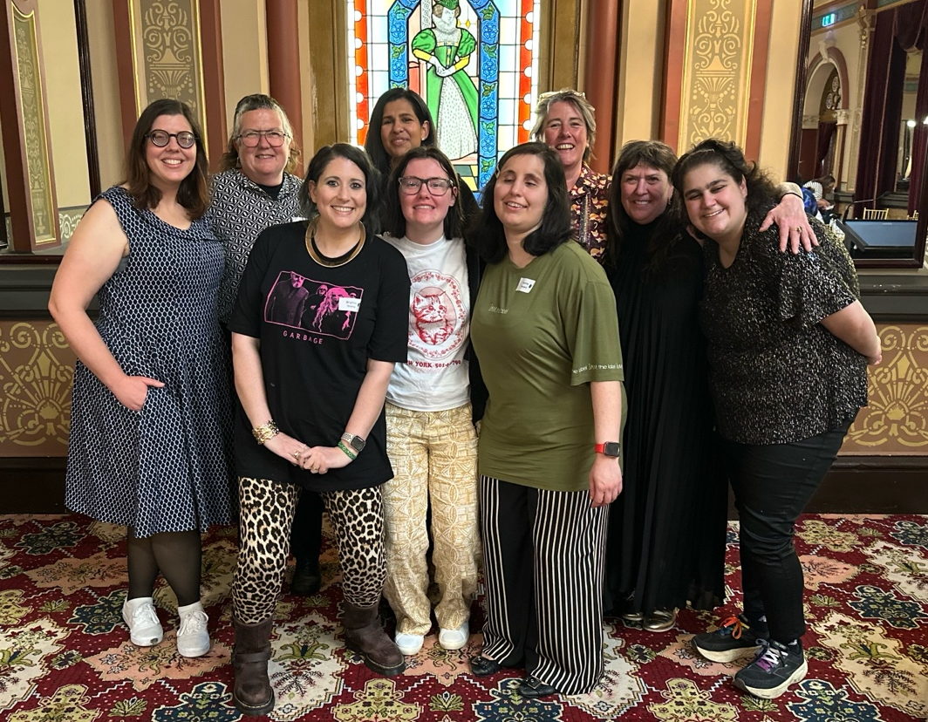
CIWE 2025 Wrap Up

Image Description: A group photo of the CIWE team. Back Row: Bridget Jolley, Emma King, Felicity Antony, Libby Price, Liz Wright and Bella Fantasia.
Front Row: Brigitte Stone, Teagan Mitchell and Husna Amani.

2025 has been a wild ride for WDV’s CIWE team. With funding and program uncertainty looming, the team began the year with a positive focus; to make an impact. We went to the Having a Say Conference, attended local events and showed the power of community inclusion. Mid-year good news finally came confirming the CIWE Program would receive additional funding for our core CIWE work.
Through the Enabling Women Leadership Program, the Youth Experts by Experience and our Local Leadership Hubs the team could continue improving the lives of women and gender diverse people with disabilities in our community.
Hub and Youth Expert driven events followed, and the Enabling Women Leadership Program thrived under familiar leadership.
Sadly, we farewelled the long-serving Moira Hub and Hub Liaison Officer Jenny Godwin. We also said so-long to Leadership Hub Coordinator Sara Franzoni and Barwon/Bendigo Hub Liaison Officer Vanessa Davis who went on to pursue exciting opportunities. In their stead we excitingly welcomed Felicity Antony as Leadership Hub Coordinator, Emma King as Bendigo Hub Liaison Officer and Teagan Micthell as Barwon Hub Liaison Officer. We also transitioned to an Online Hub, a timely response to our member’s needs.
We end 2025 with a celebration of these ups and downs. We acknowledge the leadership of Manager Liz Wright, all our team and wider WDV organisation to weather the storms and bring us together day after day with a unified purpose and more determination than ever to make a more inclusive and accessible community. Bring on 2026!

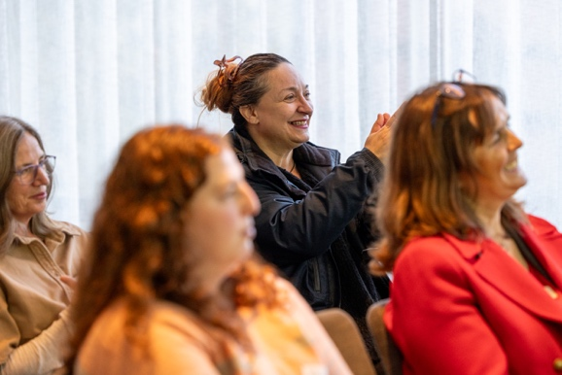
The Enabling Women Leadership Program
Image Description: Photo of Enabling Women Autumn Program graduates and their supporters seated in the audience. They are smiling and clapping.

This year WDV has hosted 2 and ½ Enabling Women Leadership Programs. The Autumn and Spring Programs celebrated a total of 22 new Graduates. Each Program brings together unique experiences therefore each graduation is unique and special to the participants. For the Autumn Program they acknowledged Traditional Owners in a meaningful way to the group while the Spring Program members enjoyed exploring Spoon Theory and managing expectations and our bodies as people with disability and chronic illness.
We also got to celebrate with the graduation for the 2024-25 Summer Program. Participants and their guests enjoyed the strengths tree activity where they wrote their qualities on a paper leaf, adding it to the strengths tree poster.
At this event the remarkable work of Women’s Empowerment Officer Bridget and her team were captured by Australia’s leader in primary prevention Our Watch. WDV and the Enabling Women Leadership Program were celebrated for their outstanding legacy in the primary prevention of violence against women and gender diverse people with disabilities. Facilitators Bridget and Julia Coscolluela will be welcoming a new Program in the new year, for more details be sure to follow WDV on socials.
Watch it here: This Is Prevention: People with disability | Women with Disabilities Victoria,
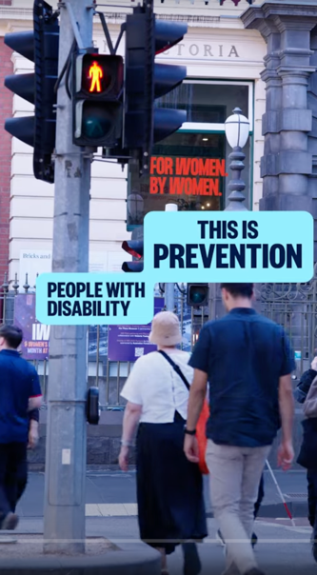
Image Description: still shot from the video features a busy street with traffic lights and a building in the background. A sign on the building’s window says, “By women, for women”. Digital text overlaid says “This is prevention. People with disability.”

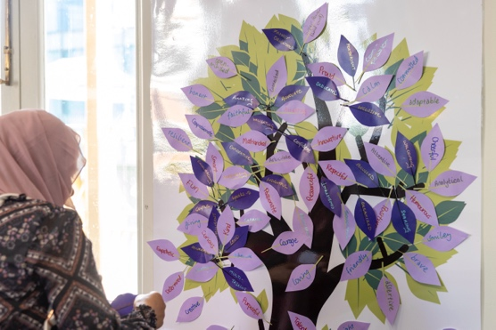
Image Description: A guest prepares to add a paper leaf to the group’s ‘Strengths Tree’. A largely printed tree trunk, laminated. Purple leaves labelled with empowering words of strengths make up the foliage.

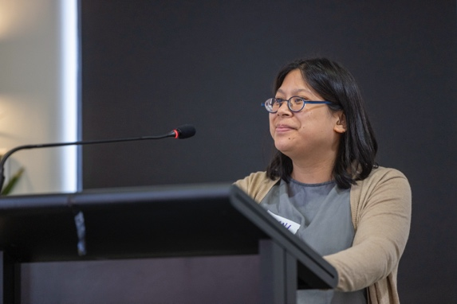
Image Description: At the lectern and microphone Graduate Sirani proudly takes a silent moment as she gives a speech.

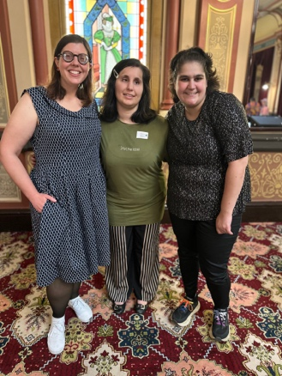
Youth Experts by Experience
Image Description: A group photo featuring Women’s Empowerment Officer – Youth Bridget Jolley and Youth Experts members Husna Amani and Bella Fantasia.

Change was also a common theme for the Youth Experts by Experience team this year as they farewelled members; Julie Dickson, Frances Roberts and Teagan Mitchell. Julie was recently nominated onto the WDV Board while Teagan is now the Barwon Hub liaison Officer. Before leaving to pursue other work and study commitments, Frances appeared in WDV’s Pleasure and Consent video ensuring a lasting impact at WDV.
The Expert Blogs have become a member favourite as Experts share their various experiences. The young group also took their expertise across the State visiting the Local Leadership Hubs presenting their resource Accessibility and Allyship.
Recently the Experts produced a series of posts for the 16 days of Activism Against Gender Based Violence that explore this year’s theme “UNiTE to End Digital Violence against All Women and Girls”.

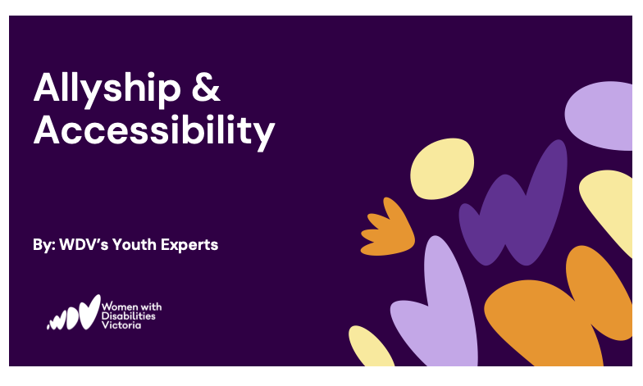
Image Description: Purple slide with WDV logo and abstract shapes to one side. Titled: Allyship & Accessibility By: WDV’s Youth Experts.

View Youth Expert Blogs https://www.wdv.org.au/why-do-i-need-to-be-married-with-kids/
https://www.wdv.org.au/wdv-youth-blog-endometriosis-awareness-month/
View Pleasure and Consent Video https://www.wdv.org.au/our-work/our-work-with-organisations/pleasure-and-consent/
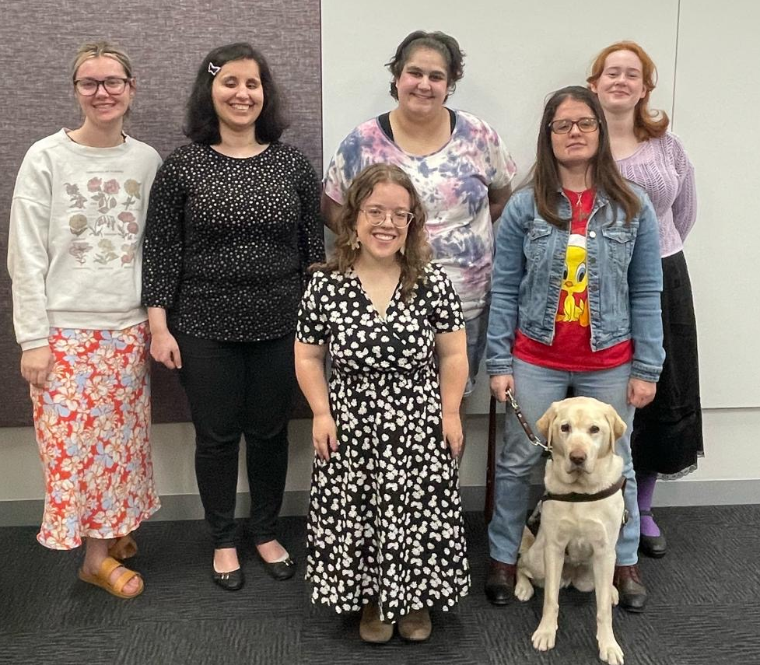
Image Description: Photo of the Youth Experts. Teagan Mitchell, Husna Amani, Bella Fantasia, Julie Dickson, Emma Jago and Frankie Roberts
Group photo (six experts).JPG

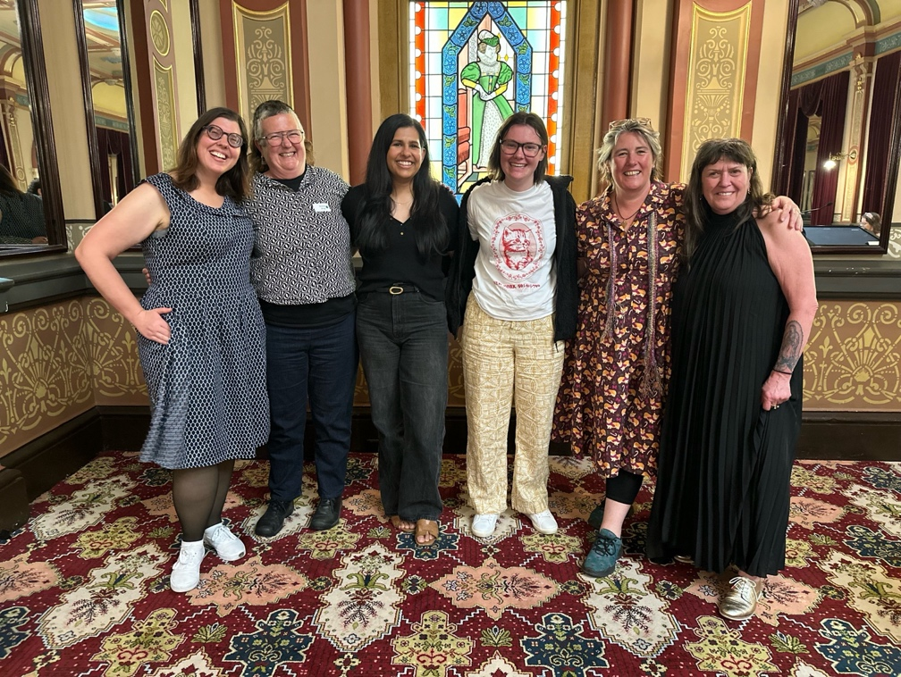
The Hubs
Image Description: Group Photo of the Local and Online Leadership Hub coordinators and facilitators. Bridget Jolley, Emma King, Felicity Antony, Teagan Mitchell, Libby Proce and CIWE Manager Liz Wright.

By Felicity Antony
It’s been a busy and exciting start to my new role as Leadership Hub Coordinator. Over the past couple of months, we’ve welcomed two new Hub Liaison Officers: Teagan Mitchell (Barwon) and Emma King (Bendigo). With these changes came an opportunity to refresh our Hub welcome pack, including updated Group Agreements, Support Worker Agreements, Hub Values, and Terms of Reference. We’ve also refreshed our branding and begun rolling out new promotional materials.
WDV currently has three regional Leadership Hubs across Victoria: Geelong (Barwon Hub), Bendigo (Loddon Hub) and Upper Ferntree Gully (Melbourne Outer East Hub). Our Hubs meet monthly and provide a space for women and gender-diverse people with disabilities to connect, build confidence, learn about their rights, and engage in activities focused on inclusion, collaboration, leadership, the prevention of violence, and systemic advocacy. We also regularly host local partner organisations to share resources and community knowledge.
In October, WDV launched its first Online Leadership Hub, offering another opportunity for connection, especially for those living outside hub locations or who may face travel barriers.
The team are busy preparing for our end of year Hub celebrations and planning an exciting line up of topics, guest speakers and events for 2026. Stay tuned!

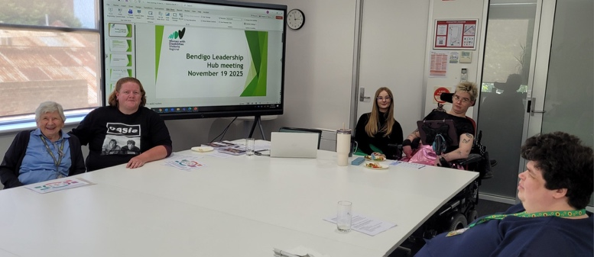
Bendigo Hub
Image Description: Photo of the Bendigo Hub meeting room. 5 members with diverse disabilities and appearances sit around a boardroom table. In the back a screen shows the slide “Bendigo Leadership Hub meeting November 19, 2025.
By Emma King
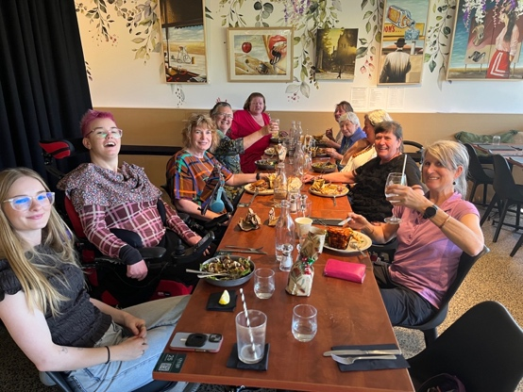
The core group of members have really enjoyed getting to know each other better and building connections and understanding. It’s been useful to have had a range of speakers attend the monthly meetings to help understand and address questions and concerns. A workshop and conversation about advocacy – what it is and how to do it – was really appreciated as it applies across issues, and can be used for self- advocacy as well as work for structural and systemic change. The Leadership group has engaged with local taxi and bus services about costs, services and access, had workshops on staying healthy in winter and emergency preparedness. We have shared community information and personal stories and struggles. Plans for 2026 include organising a public forum about ableism and how we can address it.
Image Description: The Bendigo Hub End of Year Celebration Lunch. 10 members with various disabilities and appearances sit at a restaurant table. They are smiling at the camera together.

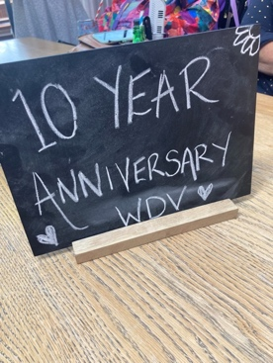
Barwon Hub
Image Description: Blackboard on a table with ’10 Year anniversary WDV’ written on it. Decorated with love hearts and a flower.

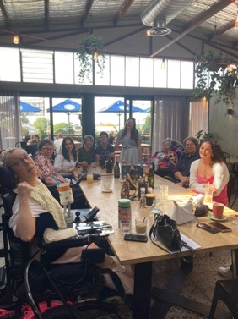

Image Description: Group photo inside a barn-style café. Members of the Barwon Hub pose around a large table smiling together at the camera.

This year the Barwon Hub celebrated a big 10 year anniversary. Former Hub Liaison Officer Deb Haygarth and members throughout the years got together with Vanessa Davis to celebrate the Hub’s legacy. After an impactful period as both Barwon and Bendigo Hub Liaison officer we farewelled Ness as she went on to pursue passions close to her heart, mentoring young people. Excitingly though we have since welcomed Teagan Mitchell as Barwon’s new lead. Teagan has come over from WDV’s Youth Experts by Experience team and she is already bringing much life and energy, to not only the Hub but the entire CIWE team too! Last month Teagan spoke with local newspaper the Geelong Advertiser about chronic pain and how she is turning her battle into support and advocacy for other local women and gender diverse people with disability.
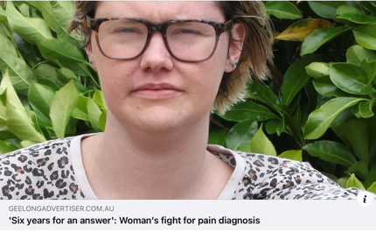
Read the article here: https://www.facebook.com/share/1Esz5QgSK7/?mibextid=wwXIfr
Image Description: Screengrab from the Geelong Advertiser Facebook page. It includes an image of Teagan with the caption: GEELONGADVERTISER.COM.AU ‘Six Years for an answer’: Woman’s fight for pain diagnosis.

Melbourne Outer East Hub
The Melbourne Outer East Hub have grown a lot in 2025. Early in the year Hub members Anna and Sarah went to VALID’s Having a Say (HAS) conference in Geelong. This year they did a 30-minute workshop presentation called Setting Goals And Achieving Success. “We spent a lot of time preparing for it. We created a slide show presentation and activity materials. We felt nervous when we were preparing for it, but also excited. We called it feeling Nervouscited! We think the presentation went awesome and we felt really happy afterwards,” they said after the event. Mid-year the Hub hosted the Youth Experts who presented Allyship and Accessibility. Hub Liaison Officer, Libby Price was delighted to see hub members expressing their opinions and having a go in such a positive way. This growth was more than evident in their Hub Federal Election Debate and culminated in the member lead film screening for the 16 Days of Activism, Disability and Defiance.
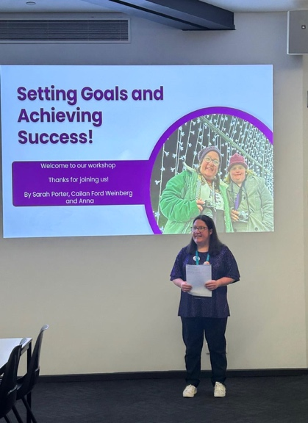
Image Description: A photo of Sarah presenting at the conference. She is standing in front of a screen with a slide that reads; “Setting Goals and Achieving Success! Welcome to our workshop. Thanks for joining us! By Sarah Porter, Cailin Ford Weinberg and Anna.” The slide has a photo of two women smiling at the camera with fairy lights behind them.

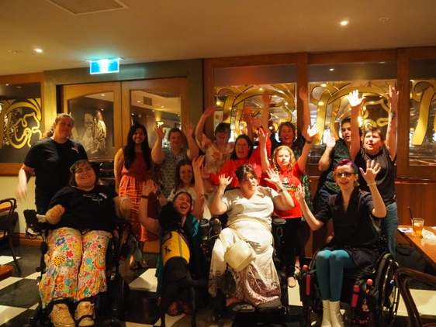
Image Description: Photo of the Melbourne Outer East Hub End of Year Lunch. The group of 14 women and gender diverse people with various disabilities and appearances pose together. Some members have their arms raised in celebration.

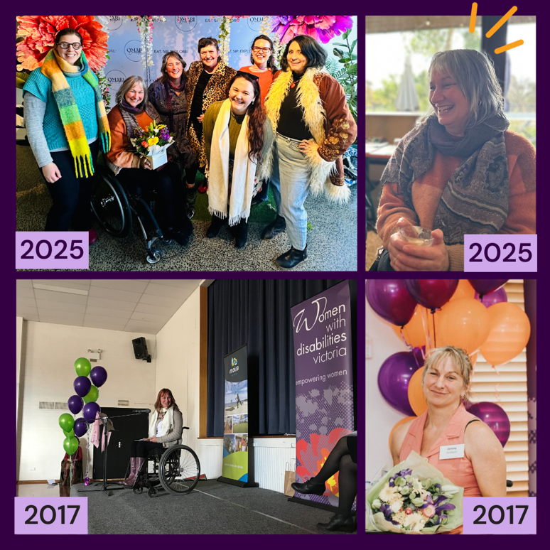
The Moria and Online Hubs
Image Description: Grid of four photos. 1) 2025 photo of the Community Inclusion and Women’s Empowerment Team posing with Jenny who holds a giftbox of colourful flowers.
2) 2025 Photo of Jenny mid-laugh. 3) 2017 Photo of Jenny at an Enabling Women Leadership Graduation. 4) 2017 Jenny poses in front of purple and orange balloons. She is wearing an orange dress and holds a large bouquet of flowers

Sadly, after years of advocacy and empowerment, WDV said goodbye to the Moira Hub and Liaison Officer, Jenny Godwin. For over a decade Jenny shared her experience and expertise as a woman with disability and worked to improve the lives of those in her community and beyond.

Addressing gaps in peer support and lack of leadership opportunities for many women and gender diverse people with disabilities in our community, WDV recently introduced an Online Leadership Hub. Online Hub members can now enjoy value and connection regardless of their location in the State. Meetings go for an hour and will continue fortnightly early in the new year, with more details to come. Hosted by Bridget Jolley and Teagan Mitchell.
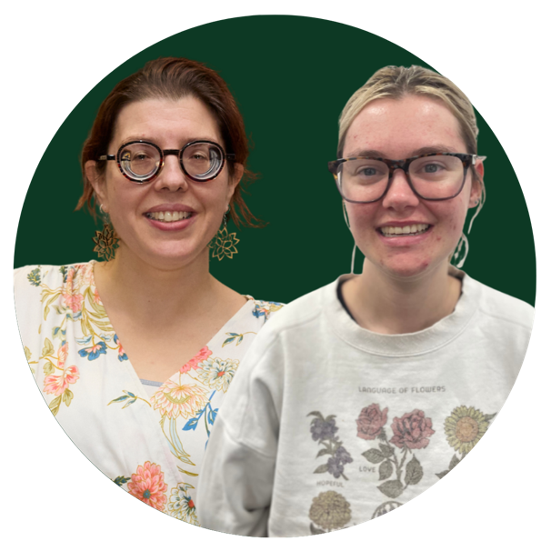
To be a part of this exciting new Hub please contact the Online Hub Team Email: hubs@wdv.org.au or Phone : (03) 9286 7827

Image Description: Photo of Bridget Jolley and Teagan Mitchell.

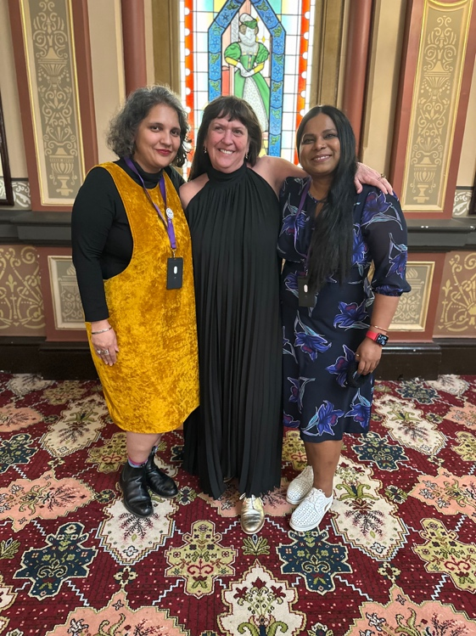
Campaigns and Advocacy
Image Description: Photo of Saumya Kaushik, Liz Wright and Jayashree Mayekar
​​​This year, members from across the four hubs, Youth Experts and the CIWE team began deepening their impact on WDV’s Policy and Priorities with a series of consultations with Brigid Evans WDV’s Senior Policy and Research Officer and Policy Research Lead, Saumya Kaushik. These sessions further highlighted the voices of women and gender diverse people with disabilities living in regional and rural areas and continued to inform WDV’s systemic work.

The CIWE Team attended conferences, events and webinars to build on our professional development and engage more broadly with the disability sector. Women’s Empowerment Officer Brigitte Stone attended VALID’s Advocacy in Action Conference. Amongst the delegates were many of our WDV Program members and graduates who showcased the true value of community inclusion and women’s empowerment to impact the wider community and empower their peers.
Our team continued developing peer led resources, like our Warm and Well in Winter resource, and highlighted member experiences with social media posts focusing on things like Self Advocacy.

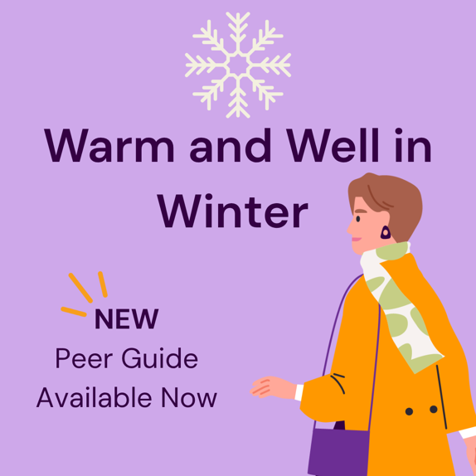
View resource here: https://www.wdv.org.au/warm-well-in-winter/.
Image Description: Light purple tile with a large white snowflake at the top. Underneath the text, “Warm and Well in Winter. New Peer guide available now.” The graphic of a woman wearing a scarf on the corner.

Finally, the CIWE team celebrated the release of our Community Inclusion video that was developed with local producers Milk Video. The animated video invites viewers to consider inclusion and accessibility and what it means for women and gender diverse people with disabilities to belong.
It shows what can happen when physical and social barriers are removed, Watch the video here: https://youtu.be/TDfOHLLg9xY?si=E99WS4Ho3RaStbBn
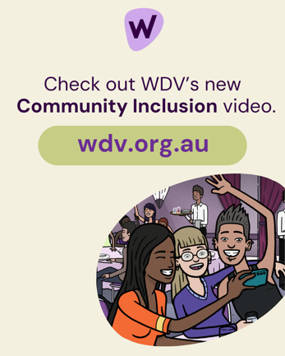
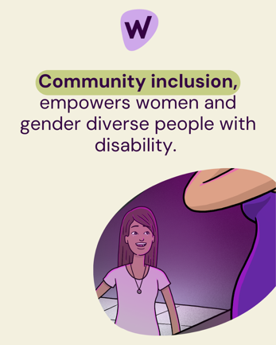
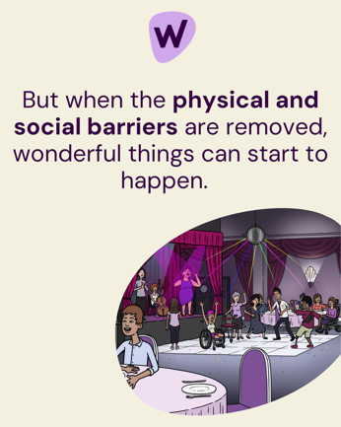
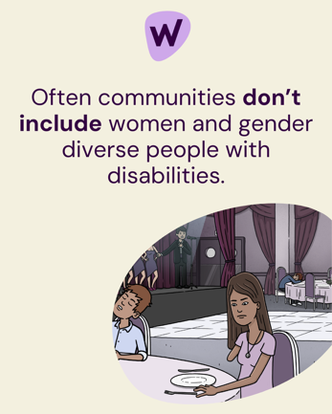
Image Descriptions: A lineup of 4 beige WDV social media tiles.
Tile 1. Reads “Often communities don’t include women and gender diverse people with disabilities.”
An organic oval shape frames a still shot from the video. It features a young woman with limb difference sitting at an event. She looks sadly at her plate. A guy is asleep next to her. The dancefloor is empty and onstage is a man with a microphone and 3 female backup singers.
Tile 2: Reads “But when the physical and social barriers are removed, wonderful things can start to happen.” An organic oval shape frames a still shot from the video. It featured the shame shot, however, the young woman’s seat is empty. The guy next to her is now engaged in conversation. The dancefloor is populated with women and gender diverse people with disability and people without disability, including a waiter from the event, dancing joyously. Onstage is a lead singer, she also has limb difference. She is joined by other musicians and an Auslan Interpreter. The young woman with limb difference now stands in front of the stage, looking up at the singer.
Tile 3: Reads “Community inclusion, empowers women and gender diverse people with disability.” An organic oval shape frames a still shot from the video. A mid-close up of the young woman’s face in complete awe and happiness as she watches the singer. The side of the singer’s body frames the edge.
Tile 4: Reads “Check out WDV’s new Community Inclusion video. Wdv.org.au”
An organic oval shape frames a still shot from the video. It is from a different angle with the dancefloor now just out of view. Sitting at a table three people pose for a selfie. Behind them other guests with and without disability watch happily in the direction of the dancefloor and stage.

