Online safety and ending digital violence
Image Description
There are 10 Tiles with a sandy coloured background, with various bright orange shapes on the edges and corners.
Various WDV logos are used throughout, including our dark purple logo and a yellow, orange and brown WDV Youth logo.

Tile 1:
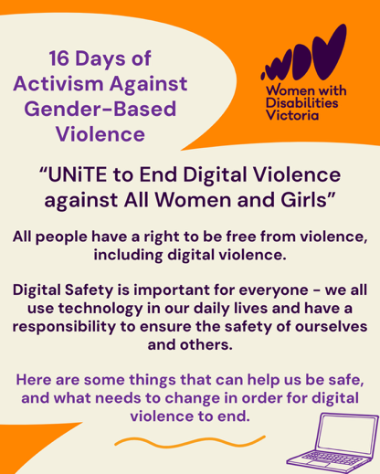
“16 Days of Activism Against Gender-Based Violence. “UNiTE to End Digital Violence against All Women and Girls”. All people have a right to be free from violence, including digital violence.
Digital Safety is important for everyone - we all use technology in our daily lives and have a responsibility to ensure the safety of ourselves and others. Here are some things that can help us be safe, and what needs to change in order for digital violence to end.” Includes graphic of an open laptop in deep purple.

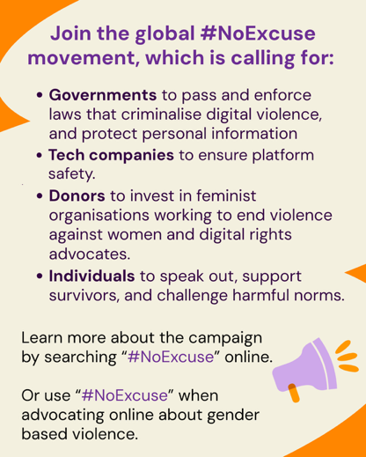
Tile 2:
“Join the global #NoExcuse movement, which is calling for:
- Governments to pass and enforce laws that criminalise digital violence, and protect personal information
- Tech companies to ensure platform safety.
- Donors to invest in feminist organisations working to end violence against women and digital rights advocates.
- Individuals to speak out, support survivors, and challenge harmful norms.
Learn more about the campaign by searching “#NoExcuse” online.
Or use “#NoExcuse” when advocating online about gender based violence.” Includes graphic of a megaphone.

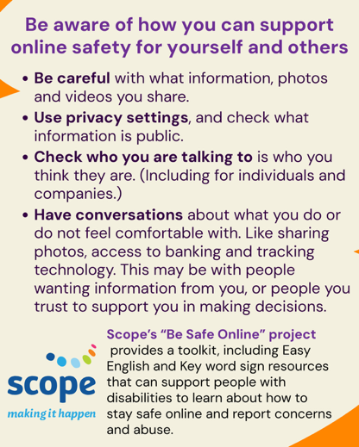
Tile 3:
“Be aware of how you can support online safety for yourself and others.
- Be careful with what information, photos and videos you share.
- Use privacy settings, and check what information is public.
- Check who you are talking to is who you think they are. (Including for individuals and companies.)
- Have conversations about what you do or do not feel comfortable with. Like sharing photos, access to banking and tracking technology. This may be with people wanting information from you, or people you trust to support you in making decisions.
Scope’s “Be Safe Online” project provides a toolkit, including Easy English and Key word sign resources that can support people with disabilities to learn about how to stay safe online and report concerns and abuse.” Includes Scope’s logo.

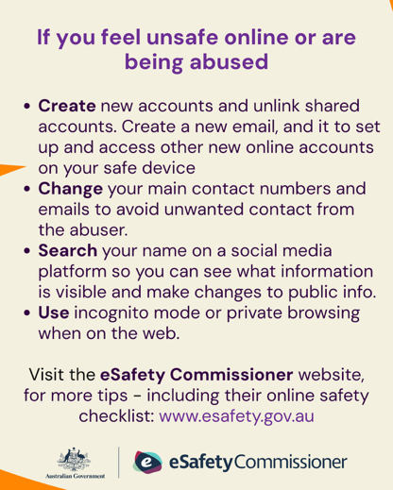
Tile 4:
“If you feel unsafe online or are being abused
- Create new accounts and unlink shared accounts. Create a new email, and it to set up and access other new online accounts on your safe device
- Change your main contact numbers and emails to avoid unwanted contact from the abuser.
- Search your name on a social media platform so you can see what information is visible and make changes to public info.
- Use incognito mode or private browsing when on the web.
Visit the eSafety Commissioner website, for more tips - including their online safety checklist: www.esafety.gov.au
Includes the Victorian Government eSafety Commissioner logo.

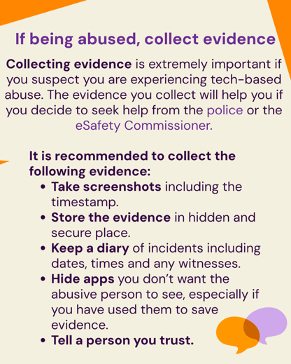
Tile 5:
“If being abused, collect evidence.
Collecting evidence is extremely important if you suspect you are experiencing tech-based abuse. The evidence you collect will help you if you decide to seek help from the police or the eSafety Commissioner.
It is recommended to collect the following evidence:
- Take screenshots including the timestamp.
- Store the evidence in hidden and secure place.
- Keep a diary of incidents including dates, times and any witnesses.
- Hide apps you don’t want the abusive person to see, especially if you have used them to save evidence.
- Tell a person you trust.”
Includes graphic of two speech bubbles.

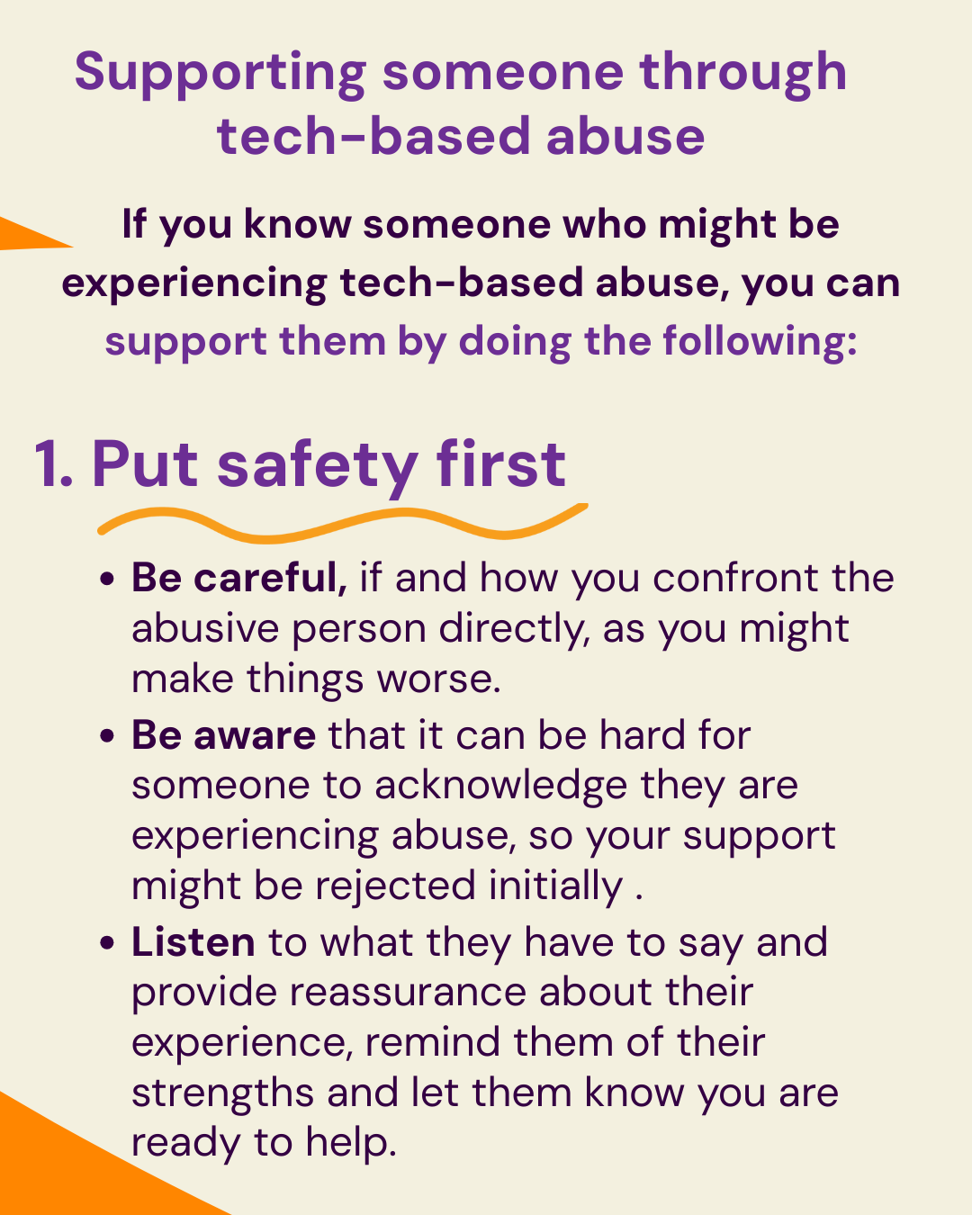
Tile 6:
“Supporting someone through tech-based abuse
If you know someone who might be experiencing tech-based abuse, you can support them by doing the following:
- Put safety first
  - Be careful, if and how you confront the abusive person directly, as you might make things worse.
  - Be aware that it can be hard for someone to acknowledge they are experiencing abuse, so your support might be rejected initially
  - Listen to what they have to say and provide reassurance about their experience, remind them of their strengths and let them know you are ready to help.”

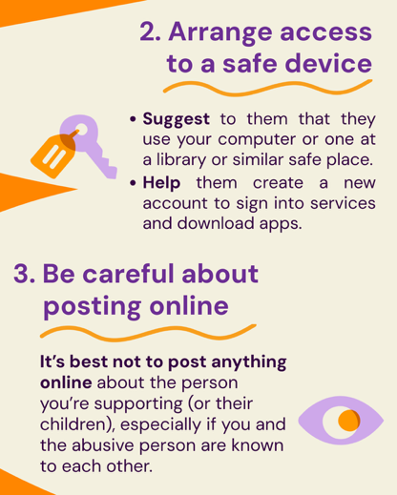
Tile 7:
- “Arrange access to a safe device
Suggest to them that they use your computer or one at a library or similar safe place.
Help them create a new account to sign into services and download apps.”
Includes graphic of a key with a tag.
- “Be careful about posting online
  - It’s best not to post anything online about the person you’re supporting (or their children), especially if you and the abusive person are known to each other.”
Includes stylized graphic of an eye.

Tile 8:
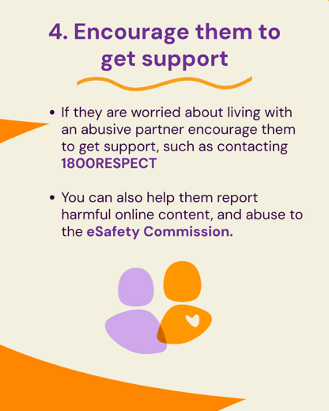
- “Encourage them to get support
If they are worried about living with an abusive partner encourage them to get support, such as contacting 1800RESPECT
You can also help them report harmful online content, and abuse to the eSafety Commission.”
Includes graphic of two stylized people one with a heart symbol on the chest.
Tile 9:
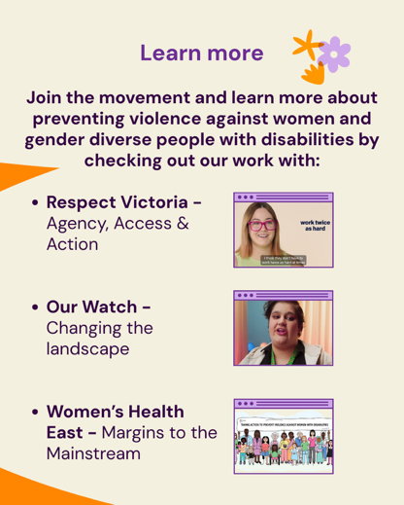
“Learn more
Join the movement and learn more about preventing violence against women and gender diverse people with disabilities by checking out our work with:
- Respect Victoria - Agency, Access & Action
- Our Watch - Changing the landscape
- Women’s Health East - Margins to the Mainstream”
Includes still shots from each of the 3 video projects mentioned.

Tile 10:
“This post was written by WDV's Youth Experts.
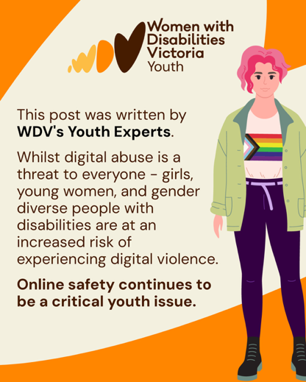
Whilst digital abuse is a threat to everyone - girls, young women, and gender diverse people with disabilities are at an increased risk of experiencing digital violence.
Online safety continues to be a critical youth issue."
A graphic of a white non-binary person with pink hair is on the right of the tile.

