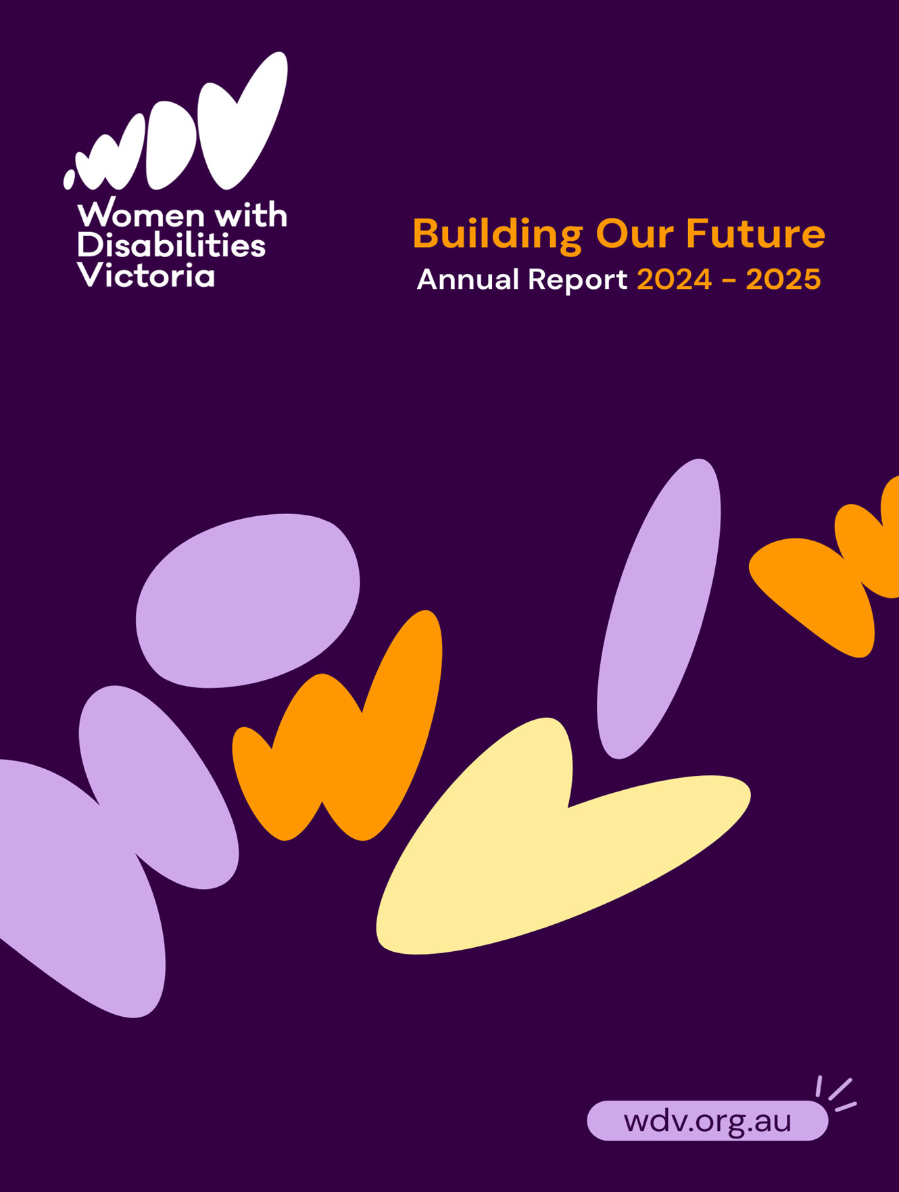



Women with Disabilities Victoria (WDV) acknowledges Aboriginal and Torres Strait Islander peoples as the first inhabitants and traditional custodians of the lands on which we live and work. We pay our respects to ancestors and Elders, past, present and emerging.

The WDV Community is committed to honouring the unique cultural and spiritual relationship Aboriginal and Torres Strait Islander peoples have with the land and waters, and their rich contribution to society.

Our Vision
All women and gender diverse people with disabilities in Victoria live safe and fulfilling lives.
WDV evolved from the Victorian Women with Disabilities Network, which was established in the early 1990s. We were incorporated in 2010, and our Constitution sets out our rules.
We are an organisation run for and by women and gender diverse people with disabilities. Our members, Board and staff live across the state and have a range of disabilities, lifestyles and ages. We are united in working towards our vision of a world where all women and gender diverse people in Victoria live safe and fulfilling lives.

Our gender perspective allows us to address critical inequities faced by women and gender diverse people with disabilities, such as inclusive access to health services, National Disability Insurance Scheme (NDIS) services, meaningful employment and safety from gender-based violence.

Our Values
Our values uphold human rights and social justice.
- Impact  - Equity  - Accountability  - Respect  - Creativity | - Inclusion  - Empowerment  - Accessibility  - Diversity  - Collaboration
Table of Contents
Our Vision 2
Our Values 2
Our Guiding Principles 4
Acting Chief Executive Officer (CEO) and Board Co-Chairs’ Statements 5
WDV Acting CEO’s Report 5
WDV Board Co-Chairs’ Report 6
WDV Strategic Priorities 8
WDV’s Impact Through Programs and Advocacy 17
The WDV Policy Programme 17
Policy Submissions in 2025 17
Community Inclusion and Women’s Empowerment Program 18
Consultations, Youth Expert Presentations and Hub Milestones 20
Our Watch Video 21
Conferences 21
Bendigo Hub participant insights 21
Gender and Disability Workforce and Health Services Programmes 22
Gender and Disability Workforce Development Programme 23
LGBTIQA+ Expert 24
Women’s Health Services Programmes 24
Sharing Our Expertise Project 28
Operations and Communications Team 29
Facts and Figures 30
Thank you 31
Funders, Partners, and Supporters 31
WDV Regional Hub Partners 32
Financial Statements 33
Statement of financial position 35
Statement of changes in equity 36
Cash flow statement 36
Keep in touch 37

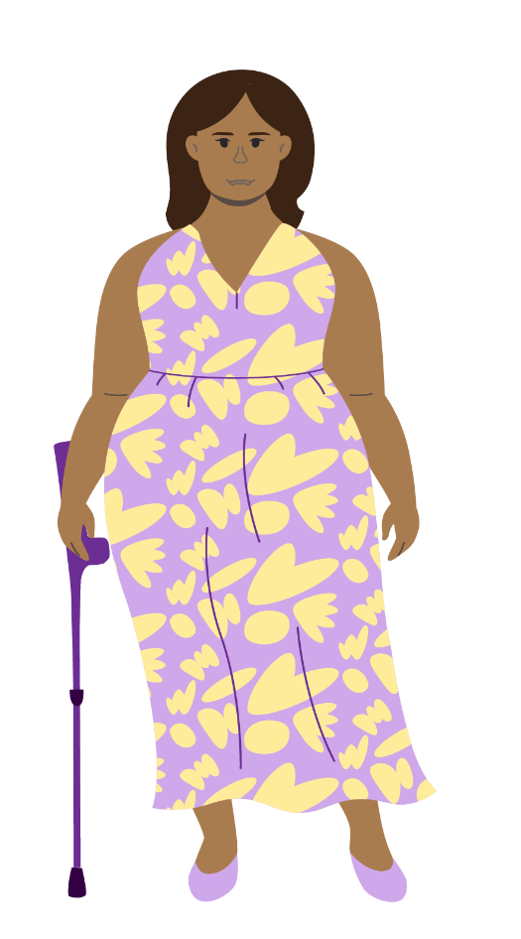
Our Guiding Principles
System advocacy
WDV advocates to address the gaps and barriers that exist between services and within complex systems to enable full access and inclusion. This includes supports to access NDIS, aged and health care, gender-based violence and employment services.
Equitable access
WDV is committed to supporting our community by prioritising women and gender diverse people who experience compounding access barriers. Our approach integrates data and personal stories to highlight the lived experiences and impacts on people with disabilities.
Community inclusion
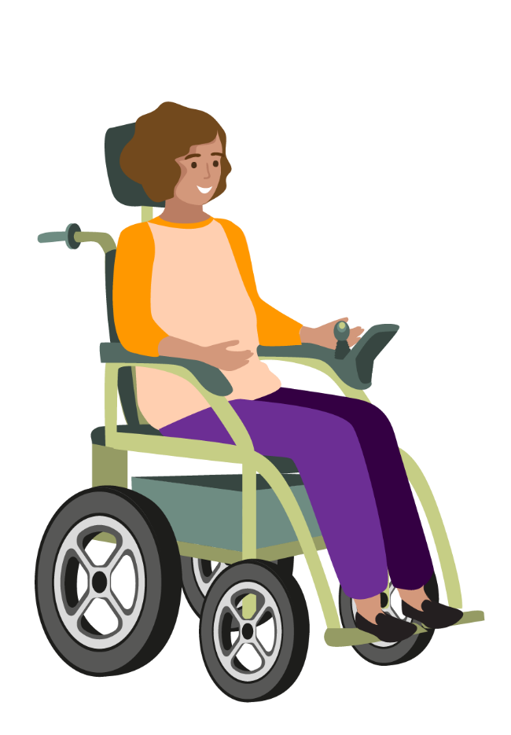
WDV advocates for broader community inclusion to ensure women and gender diverse people with disabilities can fully participate and engage with their communities. This includes providing places and spaces for the WDV community to access and engage.
Voice
WDV draws on its strong connection to members and community to amplify their voices and advocate
for the rights of women and gender diverse people with disabilities.
Evidence
WDV delivers evidence informed responses grounded in lived experience. We will build an evidence base through the embedding of a research and evaluation culture.

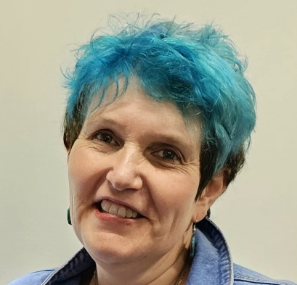
Acting Chief Executive Officer (CEO) and Board Co-Chairs’ Statements

WDV Acting CEO’s Report
It seems like every year we say it's been a big one for
WDV, but it is true every year.
This year has been all about producing and promoting
fantastic resources that centre the equity, inclusion, and rights of women and gender-diverse people with disability in Victoria. We've done strategic work to build our impact, including developing a new strategic plan with member input and creating a rebrand that
reflects who we are (and has already won two awards for accessibility and inclusivity!).

WDV has had a year filled with submissions and advocacy to the government, projects, and training that highlight the intersection of disability and gender while acknowledging that our community is made up of people of all sexualities, ethnicities, socioeconomic backgrounds, locations, religions, and more. It is by acknowledging and embracing this diversity that we can stay in unity.
As you flip through the annual report, I encourage you to read about the work we are doing to end violence against women and gender diverse people with disabilities.
You can also read about how we have focused on making workplaces more inclusive and accessible, building leadership within our community, assisting health professionals in understanding their role in creating welcoming, inclusive and accessible services for women and gender diverse people with disabilities, and building awareness of community members around cancer screening. You’ll also read how our partnerships with organisations like Safe and Equal and Victoria Legal Aid enable us to build our impact. I am so proud of what we have achieved.
Our members are at the heart of WDV, and we're thrilled our membership rose again to 1,207. I am especially proud of our new community quote bank, which was collected over the past year from surveys responses from our members, focus groups, community hub members, and Experts by Experience meetings.
These lived experience insights create a laser like focus on the issues facing women and gender diverse people with disabilities, providing the best evidence for the need for change and the solutions required.
This year, we said farewell to Nadia Mattiazzo we wish her the best and acknowledge her vital contributions. For a second year in a row, we got an extension of our Community Inclusion and Women Empowerment Program, and whilst pleased to have funding extended, we also acknowledge the impact of short-term funding is having on WDV and other organisations that like us are experience short term funding extensions.
Finally, huge thanks to our funders, who make our work possible; our passionate and skilled board and staff, who enable WDV to thrive; our members, without whom we wouldn't exist and centre our work; and our partners across the disability and gender rights movements, plus other organisational allies working with us to create a society where all women and gender diverse people with disability can exercise their rights and live full lives with abundant opportunity.
Julie Kun, Acting CEO

WDV Board Co-Chairs’ Report
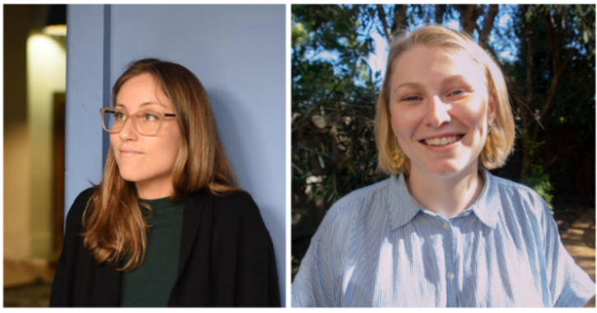
This year, the Board of Women with Disabilities Victoria (WDV) has welcomed new leaders and bid farewell to others. We want to take a moment to honour those who have been instrumental to WDV’s governance and direction. First and foremost, it is with sadness that we bid farewell to CEO Nadia Mattiazzo. Nadia joined WDV in October 2017 and served as CEO from December 2021 to December 2024. During her time as CEO, Nadia made an enormous contribution to progressing the rights of women and gender diverse people with disabilities in Victoria. Nadia led WDV through the incredibly challenging COVID lockdown period.
Nadia ensured that women and gender diverse people with disabilities were never far from the minds of government decision-makers. Along with WDV staff, Nadia built WDV’s intersectional practice and championed genuine co-design. We sincerely thank Nadia Mattiazzo for her service to WDV and the disability community and wish her all the best for her future endeavours.
As we say goodbye to Nadia, we want to sincerely thank Belinda Burns for her service as Acting CEO for the months of August and September 2024.
Belinda has provided tremendous leadership to WDV, both as Acting CEO and as Director of Business Operations. She has supported and navigated WDV through challenging times taking on the Acting CEO role and continually providing support to the organisation’s programs wherever it has been needed. We sincerely thank Belinda Burns for her leadership this financial year.
In October 2024, we were fortunate to welcome Julie Kun to WDV, joining us in the role of Acting CEO. Julie is a highly regarded gender equity leader. She brings significant CEO experience leading Women’s Information and Referral Exchange (WIRE), providing support information and referral to women and gender diverse and nonbinary people on any issue.
In addition to her work at WDV, Julie currently serves as Chair of the Board of Gender Equity Victoria. We are grateful to Julie for her leadership through what is a significant period of transition for WDV. Thank you, Julie, for your leadership as Acting CEO.
We bid farewell to two valued board members, Elyse Cox and Julia Manning, whose departure marks the end of significant contributions to WDV. The board, along with staff, thank them for their commitment to advancing the rights of women and gender diverse people with disabilities in Victoria. Their expertise shaped our strategic direction, and their genuine care for our community was evident in every decision and discussion.
As we say goodbye, we are equally delighted to welcome five new board members, Haidi Badawi, Zoi Jahau, Sarah Waters, Carly Myers and Ruvani Fernando. Each brings unique expertise, perspectives and passion for the governance and strategic direction of WDV. We look forward to their leadership towards a more inclusive and equitable Victoria for all women and gender diverse people with disabilities.
The combined Brenda Gabe Leadership Award and members’ event was a positive opportunity to bring people together and strengthen connections within WDV. The atmosphere was engaging and supportive, with conversations that highlighted the value of shared experiences and the importance of creating space for open discussion. It was affirming to see members actively contributing their perspectives and to reflect on the sense of community that events like this help build.
The event reinforced how important it is that WDV continues to nurture spaces for dialogue and connection, where diverse voices can be heard and celebrated.
Importantly, this year saw the development and launch of WDV’s 2025-2029 Strategic Plan, that steers a course towards enhanced advocacy impact, financial resilience, research capabilities, partnerships, and community inclusion, all while reflecting our members’ values.
As we move forward enlivening our new Strategic Plan, we do so with confidence in the board’s leadership and governance expertise, the dedication of staff, and the support of our members. Together, we will continue to build a stronger, more inclusive WDV— one with powerful advocacy impact, financial resilience, research capabilities and strong partnerships.
Marlena Raymond & Helena Jordan - Board Co-Chairs


WDV Strategic Priorities

Enhance WDV’s operational efficiency and funding resilience
Establish research partnerships with a focus on inclusion, health, gendered violence, sexual autonomy and economic justice
Build gender-based accessibility expertise across Victoria
Educate and empower our community to understand their rights and live safe and fulfilling lives
A member and community led approach to advocacy and system change.
Guided by our Vision and Principles, WDV’s five Strategic Priorities for 2024-2029 focus our strategic work:


Enhance WDV’s Operational Efficiency and Funding Resilience
This financial year, we completed key whole-of-organisation projects to improve efficiency and position WDV for the future.
We also undertook a comprehensive review of income and expenditure, resulting in a strategy to diversify funding, restructure staffing, and reduce operational overheads.
While this work has been challenging, it is essential and will continue into the next financial year.
Responding to Immediate Funding Challenges
- In 2024–25, WDV secured one years’ additional funding for the Community Inclusion and Women’s Empowerment (CIWE) program, enabling continued support for women and gender diverse people with disabilities, especially those facing compounding marginalisation in regional and rural Victoria .

- Developed successful grant applications in partnership with other organisations, including Cancer Council Victoria and La Trobe University.

- Commenced strategy to diversify funding
Resource Allocation Review and Gap Analysis
- Reviewed Operations and Communications team structure to reduce duplication and improve role clarity.

- Restructure led to better alignment with strategic goals

- Introduced a new HR and Payroll system to reduce admin burden and improve staff experience.

- Staff collaborated across teams to develop advocacy and capacity-building resources, maximising internal strengths.
Strategic Partnerships and Policy Influence
- Strengthened partnerships with funders and policy bodies, positioning WDV as an expert advisor.

- Staff consulted on national and state frameworks including:

  - Disability Lens on the National Plan to End Violence Against Women and Children.
  - Preventing Family Violence and Violence Against Women Capability Framework.

- WDV primary prevention programs align with Changing the Landscape framework, ensuring relevance to national prevention strategies.

- Contributed to policy conversations on sexual and reproductive health, safety, and justice.
Cost-Base Review and Monetisation
- Explored new revenue streams including:

  - Profit for purpose across evaluation, research, and co-design.
  - Research and partnership arrangements.
  - Philanthropic funding
Investment Decision-Making Framework
- Developed a new Strategic Plan (2025–2029) through member consultation, guiding investment decisions with is being actioned.

- Member perspectives continue to be embedded in decision-making and policy work processes.
Amplifying Brand and Community Engagement
- Rolled out a new brand identity, increasing digital engagement and visibility.

- Delivered a successful hybrid Members Event and Brenda Gabe Leadership Award.

- Positive community feedback confirmed strong engagement and impact.

Establish research partnerships with a focus on inclusion, health, gendered violence, sexual autonomy and economic justice.
Over the past year, WDV has strengthened its role as a leader in disability-led research and advocacy through meaningful partnerships, inclusive evaluation, and evidence-based practice.
Our work has focused on embedding research and evaluation across the organisation, advancing health equity, and deepening our commitment to sexual autonomy and reproductive justice for women and gender diverse people with disabilities. These efforts have built a strong foundation for sustainable, inclusive programs and policy influence.
Key Achievements
Building Evidence Through Inclusive Evaluation
- Conducted a participant evaluation of the Community Inclusion and Women’s Empowerment (CIWE) program.

- Engaged members and participants to capture lived experience insights on funding sustainability and the impacts of short-term funding.

- Used evaluation findings and member consultations to guide advocacy and research priorities.

Strengthening Research and Evaluation Across the Organisation
- Made significant inroads in embedding an organisation-wide approach to research and evaluation.
- Collaborated across teams to develop program logic models and tailored monitoring, evaluation, and learning tools.

- Built internal capacity for evidence-based practice and encouraged knowledge-sharing across programs and partnerships which saw tools such as a language guide being developed.

- Strengthened the evidence base supporting disability-led advocacy through the centring of lived experience across our research, programs and advocacy.
Advancing Health Equity Through Strategic Partnerships
- WDV partnered with Cancer Council Victoria (CCV) to secure and deliver a grant that promoted community education and health awareness around disability-inclusive cervical and bowel screening. This initiative uncovered new opportunities for collaboration, expert consultation, and future grant applications.

- WDV engaged in an Industry Linked Project Agreement with Swinburne University of Technology as part of the Preventing Violence Against LGBTIQA+ People with Disabilities Project. A systematic review of the literature on preventing violence against LGBTIQA+ people with disabilities was undertaken.

- WDV collaborated with Swinburne University of Technology as part of their Financial Abuse Symposium Series.

- WDV contributed to the White Paper Making financial abuse visible: Embedding women’s and children’s voices in policymaking and research.

- WDV partnered with Preventing Violence Together: Western Region to organise the Taking Action Against Technology-Related Abuse Against Women and Gender Diverse People with Disabilities Roundtable Discussion.

Build gender-based accessibility expertise across Victoria
Over the past year, WDV strengthened its leadership in advancing gender-based accessibility and inclusion across Victoria. Through partnerships, professional development, lived experience leadership and the creation of inclusive resources, we have supported organisations, practitioners and communities to embed disability inclusion at every level.
Our work continues to drive systemic change by positioning lived experience as central to best practice in gender equity, health, and violence prevention.
Sharing Lived Experience to Build Community Knowledge
- Create spaces for sharing lived experience through Hub Leadership meetings with Hub Liaison Officers, participants and guest speakers, sharing advocacy expertise and experience.

- Building Community knowledge by presenting to organisational networks, sporting clubs, support groups and specialist committees to promote gender and disability inclusion, rights and disability-led leadership

- WDV’s Experts by Experience programs which includes four Expert By Experience panels, youth, LBGTIQA+, Sharing our Expertise (Employment) and Gender and Disabilities enable panel members to share lived experience and build community knowledge through consultations, blogs and co-facilitating advocacy workshops.

- WDV Continues to champion best-practice co-creation and co-design to ensure genuine inclusion of disability and gender lived experience in shaping programs and initiatives through our Experts by Experience panels and projects such as Sharing our Expertise and Pleasure and Consent.
Partnering to Strengthen Inclusive Practice
- Partnered with Women Health Services, Our Watch, Safe & Equal, Victorian Legal Aid and Respect Victoria and others to provide expert advice on inclusive practice. For example, with Respect Victoria, we provided expertise in research, monitoring and evaluation. This directly informed updates to Respect Victoria’s Monitoring, Evaluation and Learning Toolkit.

- Supported FVREE’s Disability Action Plan audit by providing written feedback and planning guidance that improved accessibility and inclusion.
Delivering Inclusive Training and Professional Development
- Delivered prevention of violence against women and gender diverse people with disabilities training to 334 practitioners across disability, social services and violence prevention sectors.

- Six participants completed the Credential for Individuals Program, which supported deeper and expanded work to build skills and knowledge to prevent gender and disability violence through learning and community connection.

- The Gender and Disability Program partnered with Safe and Equal as part of the Endorsement for Organisations Program, building their inclusive practice across the organisation through professional development sessions, auditing processes and implementation planning.

Creating Resources and Communities of Practice
- WDV created a wide range of resources including videos, training programs information sheet, discussion papers, handbooks, posters and eLearning modules to support gender and disability access, inclusion and disability rights and justice.

- WDV is actively involved in strengthening Women’s Health Services disability inclusion through our Women’s Health Services Capacity Building Program and Victorian Women’s Health Projects. As part of this work, we facilitate the bimonthly Changing the Landscape Community of Practice, which brings together 13 practitioners from disability, social services, prevention, and women’s health sectors.

- Developed or updated eight inclusive prevention resources, centring lived experience and practical guidance.

- WDV’s Responding to Resistance and Backlash Guide was described by one resource user as “one of the most impactful resources” in over a decade of community service work.
Expanding Access Through Online Learning
- Partnered with Safe and Equal to develop and launch Unlearning Ableism: From Bias to Best Practice an eLearn module designed to build the capacity of family violence response organisations to deliver more inclusive services for victim survivors with disabilities by reducing ableism and unconscious bias. We plan to expand the eLearn offering next year, subject to funding.

- The Sharing Our Expertise project created an eLearning module on Empowering Disability Employment and Leadership in organisation. The course explores strategies for empowering workplaces to recruit and retain workers with disability and enable leadership which reduces barriers to employment within the health, social and community service sectors for women and gender diverse people with disabilities.

Educate and empower our community to understand their rights and live safe and fulfilling lives
In 2024–25, WDV empowered women and gender diverse people with disabilities to build confidence, leadership, and awareness of their rights.
Through inclusive education programs, strong community engagement, and lived experience–led advocacy, we created safe spaces for learning, connection, and growth.
Our expanding membership, digital reach, and partnerships continue to strengthen collective action toward equality, safety, and inclusion.
Strengthening Membership and Community Engagement
- WDV continued to grow and engage its membership and digital community, laying the foundation for a sustainable future for our education and leadership programs.

- We now have 1,207 active members; each provided with opportunities to contribute their lived experience and perspectives to our collective advocacy. Work is underway to better understand our membership base, which will help us build a more inclusive and representative community.
- Our digital presence has expanded significantly, with Instagram followers increasing by 185% from 2,300 to 6,555. This growth was driven by a consistent posting strategy and a viral collaboration with Respect Victoria that reached 1.4 million views. Facebook and LinkedIn also saw strong growth, reflecting the impact of our revitalised branding and storytelling approach.
- We developed a members quote and insights bank developed from focus groups and surveys of our members which have been and will continue to be used in our policy and advocacy work.
Creating Safe and Inclusive Learning Environments
- Across WDV’s Hubs, Enabling Women Programme, and Youth Experts Programme, participants consistently described the importance of safe, inclusive spaces. Many shared that they felt a sense of relief in not having to explain their disability or justify their presence. For many, this was a new experience, and it laid the groundwork for honest conversations, connection, and personal growth. This foundation of safety and belonging made it possible for participants to fully engage and begin to see themselves as leader, advocatess and contributors.
Embedding Evaluation to Strengthen Impact
- The Gender and Disability Workforce Development Program delivery team worked with Aspire Change to strengthen WDV’s evaluation processes. This included attending workshops, conducting surveys and focus groups, and producing 33 evaluation briefs.
- Aspire Change recognised these efforts as part of a maturing approach to monitoring, learning and accountability, one that supports both program improvement and advocacy outcomes.
- Building on previous evaluation work, we partnered with Women’s Health in the North to deliver community education and health promotion workshops focused on inclusive sexual and reproductive health, with an emphasis on consent and pleasure.
- WDV undertook capacity building activities to enable a redesign of our Victorian Women’s Health Program and develop a program logic for our Community
Engagement and Women’s Empowerment programme.
- We have started embedding evaluation and reporting into everyday practice, meaning that rather than being standalone tasks, evaluation becomes an integral component of reflective learning and program delivery. This approach strengthens teams and informs our organisation wide commitment to continuous improvement and evidence-based advocacy.


Amplifying Voices and Building Partnerships
- WDV partnered with Respect Victoria to produce the Agency, Access and Action video campaign for the 16 Days of Activism. Thirteen short videos featured the voices and expertise of women and gender diverse people with disabilities.
- The campaign reached over 2.4 million views and generated more than 264,000 engagements, amplifying lived experience and promoting inclusive messaging.
- Established an LGBTIQA+ co-design group to support the Preventing Violence Against LGBTIQA+ People with Disabilities project. The group collaborated to create an animation that reflects their experiences and aspirations. Participants described the process as affirming and empowering, highlighting the value of inclusive co-design.
A member and community led approach to advocacy and system change.
In 2024–2025, WDV strengthened advocacy by streamlining engagement processes, embedding member voices in over 15 submissions, and building proactive consultation methods. Our work influenced key inquiries, supported member-led advocacy, and advanced systemic change for safety, inclusion, and rights of women and gender-diverse people with disabilities.
Building a Responsive and Coordinated Advocacy System
- This year, WDV introduced a new process for managing engagement and advocacy requests. By streamlining how we triage inbox requests, we improved our responsiveness and ensured that our limited resources are directed to areas where they can have the greatest impact. This system has strengthened coordination across the organisation, allowing us to respond to external engagement opportunities with a more unified and strategic voice.
Embedding Member Voices in Policy and Advocacy
- WDV contributed to more than 15 inquiries and consultations this year, with each submission guided by the voices of our members. These contributions called on government to address the drivers of violence and improve the wellbeing, safety and inclusion of women and gender diverse people with disabilities.

Featured Submission:

Submission to the Victorian Department of Health: Inquiry into Women’s Pain – Giving Voice to the Experiences and Needs of Women with Disabilities Living with Pain.

“Women with Disabilities Victoria’s submission to the Inquiry into Women’s Pain highlights the systemic gendered and ableist barriers faced by women and gender-diverse people with disabilities when seeking pain treatment. Drawing on feedback from a member survey, we shaped our recommendations in response to the experiences, concerns, and solutions raised by members, including calls for co-designed healthcare, better coordination between systems, and disability-led research. We continue to advocate for inclusive, accessible, and rights-based reforms to ensure pain is recognised, believed, and effectively treated for all women and gender-diverse people with disabilities.”

Proactive and Inclusive Consultation Methods
- To ensure member voices are consistently embedded in our advocacy, WDV implemented a proactive consultation approach. This includes anticipating upcoming government inquiries and conducting early thematic consultations with members and experts by experience. We also scoped the interests of our community hub members and developed a database of insights to inform future submissions. This innovation has strengthened our submissions and supported Youth Experts to develop their own submissions.
Supporting Member-Led Advocacy in Action
- WDV’s policy submissions are led by the voice of members and community. For example, our submission to the Commonwealth Inquiry, Next Steps in Supported Employment, was shaped by direct input from members.
Through surveys and focus groups, members shared their experiences and advocated for a transition to open employment with award wages and mainstream workplace protections.

- WDV’s Gender and Disability Experts by Experience Advocates played a key role in shaping both internal and external advocacy. They contributed to eight internal consultations to support WDV’s policy work and participated in 13 external consultations, including the Agency, Access and Action video campaign with Respect Victoria.

WDV’s Impact Through Programs and Advocacy

The WDV Policy Programme
The WDV Policy Programme funded by the Victorian Government is responsible for undertaking policy and research activities that align with the priorities identified in WDV’s Strategic Plan. The programme builds the credibility and reach of our advocacy and policy work. Ensuring our work is intersectional, relevant, accurate and reflects the reality of the lives of women and gender diverse people with disabilities.

Policy Submissions in 2025
- Inquiry into Women’s Pain, July 2024 | - Submission to National Carer Strategy, September 2024
- Response to Survey - National Roadmap to Improve the Health and Mental Health of Autistic People, September 2024 | - National Suicide Prevention Strategy Survey Responses, October 2024
- Department of Community Justice and Safety-Aboriginal Victims of Crime Strategy, January 2025 | - Supporting Choice, Gender Equity and a Whole of Person approach to NDIS Supports, July 2025
- Specialist Disability Accommodation Submission, April 2025 | - Inquiry on Next Steps in Supported Employment, June 2025

In addition, WDV continues to advance its collaborative, intersectional, and rights-based approach to gender and disability. Through strategic submissions and papers, WDV influenced national and state policies, including case studies for the National Plan to End Violence Against Women and Children, a background paper on pleasure and consent in sexual health, and a gendered analysis of the NDIS review published in Equity in Health.

Key collaborations produced a white paper on financial abuse with Swinburne University, incorporating disability, gender, and LGBTIQA+ perspectives, while an inclusive language guide was completed to standardise advocacy efforts.
Our advocacy and policy are underpinned by strong partnerships which include Our Watch, Respect Victoria, universities, and Women with Disabilities Australia and Women with Disabilities ACT, Women’s Health Services Network, DANA, AFDO. Through these partnerships we amplified WDV's impact.
We strengthened our capacity for lived experience–centred advocacy by creating a member databank of member insights and quotes, drawn from proactive consultations on topics ranging from social media limits to suicide prevention.
Significant initiatives include NDIA engagement advocating for gender-aware policies. Developing in partnership with Safe and Equal the eLearning module "Unlearning Ableism," which was launched with reflective sessions, and contributing to WDV’s Pleasure and Consent resources to enhance workforce capacity in health and violence prevention.
This was undertaken alongside our sector role advocating for women and gender diverse people with disabilities via advisory groups and speaking engagements on a broad range of topics including financial abuse, sexuality, and gendered violence.

Community Inclusion and Women’s Empowerment Program
Due to late certainty around funding, service delivery for this year did not commence until October 2024.
Key achievements:

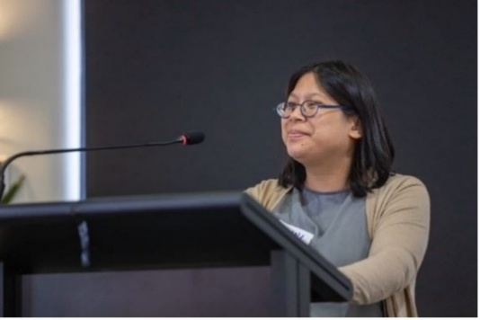
Funded by the Commonwealth Government, the work of the Community Inclusion and Women’s Empowerment team (CIWE) extends across the Local Leadership Hubs, Youth Experts by Experience and the Enabling Women leadership programs.
They are separate programs with distinct participation, inherently united by the goal, mission and uncompromising belief in the leadership value of woman and gender diverse people with disabilities.
2024-25 Summer Enabling Women Leadership Program: Graduation Celebration

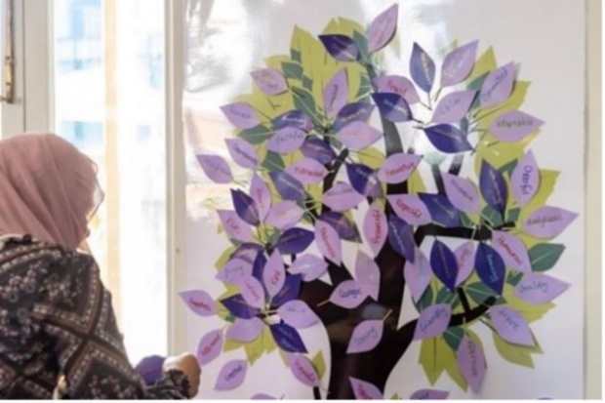
Enabling women, the hubs and the experts are the stepping stones to empowered leadership. As women and gender diverse people with disabilities we know that the pathway to leadership is often inaccessible. Empowering members, participants and WDV team members isn’t just about sharing resources and sending people on their way, it’s about creating safety and belonging, connection and peer support and learning through lived experience.
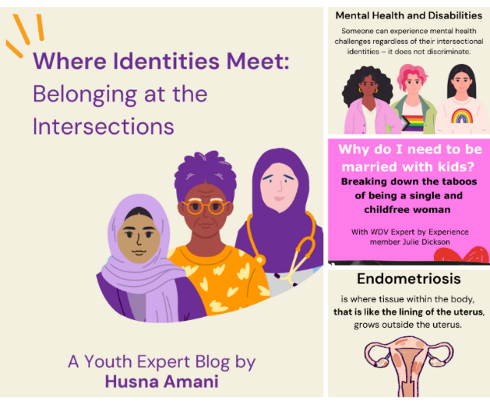
The program champions the experiences of women and gender diverse people with disabilities as leaders who consistently and historically drive change and create influence. CIWE has a targeted approach to include women and gender diverse people with disabilities in regional and remote areas, as well as younger parts of the community, who both experience higher rates of social isolation, limited access to support, and exclusion from leadership positions.
This program builds leadership capability and establishes partnerships across Victoria, CIWE enables are program participants and CIWE staff members to advocate for change in their communities making sure to platform the voices of women and gender diverse people with disabilities in local activities and creating positive change.
Youth Experts by Experience Blogs
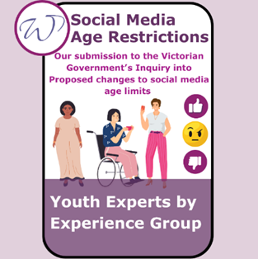 | 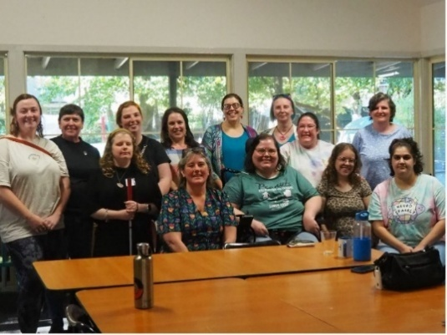 | 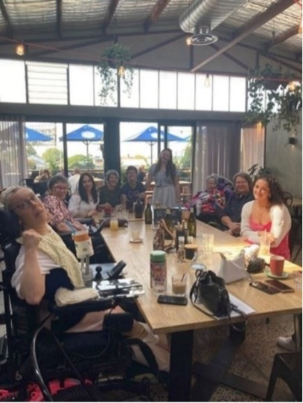

Consultations, Youth Expert Presentations and Hub Milestones

Our Watch Video
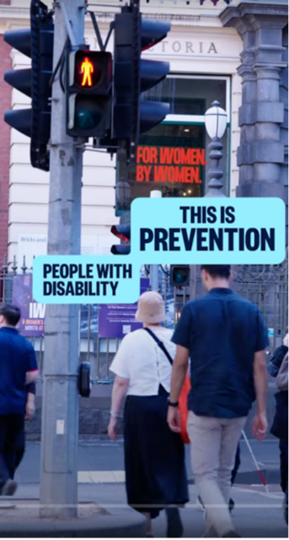
In this powerful new video from Australia’s leader in primary prevention, Our Watch, WDV and the Enabling Women Leadership Program are celebrated for their outstanding legacy in the primary prevention of violence against women and gender diverse people with disabilities.
“We need to recognise and address violence is an issue. When we are talking about prevention knowing that you have networks and that you have community is really important to that they can speak up or that they have a place to go.”

Conferences
WDV’s CIWE team were thrilled to be a part of VALID’s Having a Say Conference. Event hosts, Deakin University, invited WDV’s Community Inclusion and Women’s Empowerment (CIWE) Team to run a Lead Your Way workshop. This empowering session focused on showing participants how to practice showing kindness and understanding for themselves to encourage confidence!
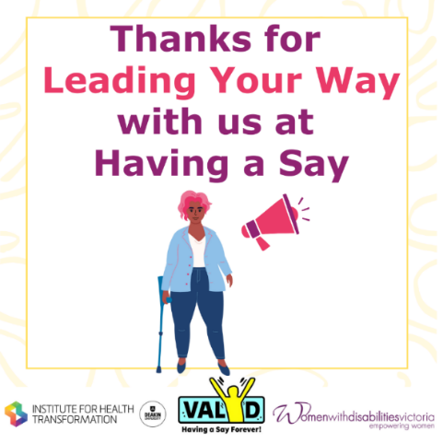 | 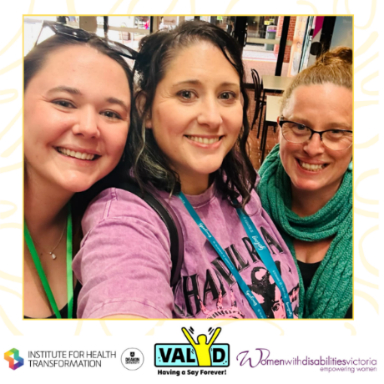 | 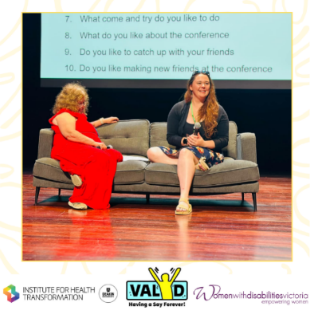

Bendigo Hub participant insights
“The Bendigo Hub means a lot to me. As Covid restrictions were lessened, I heard about the new hub for women in Bendigo. I had a stroke in 2021 and that changed a lot for me. I wanted to be socially connected. I heard about the hub either from both radio or the newspaper – I think the radio. I came along to a meeting and have been coming along since. What I really like about the hub is that there is a feeling of belonging and acceptance. Even though we all have different disabilities we speak the same language.
The group is intergenerational and that provides us with a great variety of things to talk about with each other.
We had a lovely Christmas lunch out and I invited my friend from my stroke group to come along. Everyone made her feel welcome and we had a great lunch with a large table of us. My friend comes every month now.
There Is nothing like the hub. I’d be so disappointed and upset if anything stopped the hub from continuing. It’s good for all of us.”
Bendigo Hub participant 2025

Gender and Disability Workforce and Health Services Programmes

Gender and Disability Workforce Development Programme
Gender and Disability Workforce Development Program, funded by the Victorian Government, aims to prevent violence against women and gender diverse people with disabilities before it occurs. Established in 2014, the Program received another phase of funding until July 2027.
The Program aims to:
- Build and consolidate strategic positions, communications, representations and partnerships for preventing violence against women and gender diverse people with disabilities.
- Increase women and gender diverse people with disabilities workforce engagement, leadership and representation in disability, social services and prevention.
- Build the capacity of women and gender diverse people with disabilities and the disability, social services and prevention workforces to prevent violence against women and gender diverse people with disabilities.
- Build the evidence base for preventing violence against women and gender diverse people with disabilities.
All Program activities seek to build the capacity of the specialist and contributor sectors and workforces that have a role to play in preventing violence against women and gender diverse people with disabilities and target the underlying causes of violence – also known as the drivers of violence – to transform them.
Program activities include:
- Experts by Experience advocacy, with a group of twelve women and gender diverse people with disabilities who support the work of WDV and other organisations by sharing their lived experience through consultations and Experts training.
- Delivery of professional development sessions and credentialing/ endorsing processes to practitioners and organisations, alongside the facilitation of a Community of Practice.
- Development of resources.
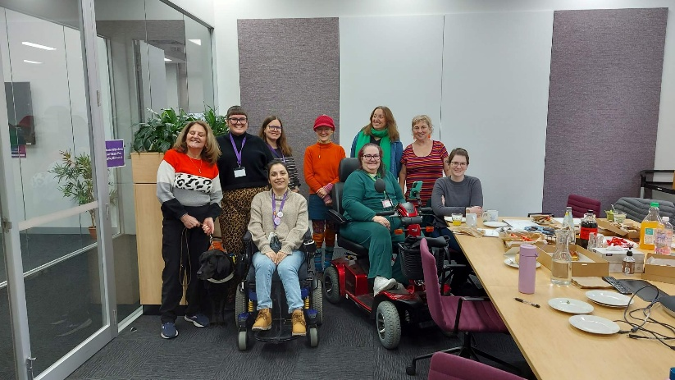
A group of Experts by Experience and program staff having lunch after the end of financial year focus group meeting. A list of the people in the photo: Marie Allen, Tess Karambelas, Julyne Ainsley, Sarah Hookey, Amy Turton, Soizic Brohan, Larissa MacFarlane, Natasha Sirji and Kat Mansbridge.

LGBTIQA+ Expert

“This year, I’ve worked as a lived experience expert in WDV’s Preventing Violence Against LGBTIQA+ People with Disabilities Project. Participating in our co-design meetings to develop an animation has allowed me to blend two significant aspects of my advocacy and lived experience: disability and LGBTIQA+ identity.
As someone who lives proudly at this intersection – and has experience navigating the challenges and systems affecting us as queer disabled folks – it’s such as privilege to contribute to my community in this way.
We commenced the project with an empathy forecasting session, which allowed us to make a basic plan of the narrative we wanted to guide the audience through, and their accompanying emotions. We then developed a script and received the first storyboard draft. Many of the words and animation panels required multiple rounds of detailed feedback, including large edits and smaller tweaks.
This effort signifies the importance of co-design in this process – to achieve the authenticity and success of the final product, we needed the expertise that comes from our lived experience. I’ve loved working with my fellow community members at WDV, and collectively shaping the animation into something that speaks sensitively and respectfully about LGBTIQA+ people with disabilities, and encourages allyship through action.
I feel immensely proud of what we’ve produced so far. The script addresses violence and bigotry against our community, while also underscoring our strength and resilience. The animation depicts a wide variety of LGBTIQA+ identities and disability experiences – showcasing our diversity in race, age, gender and more. It’s been such a rewarding project, and I hope it makes a difference in the world. You can watch the animation at this link.”
Alex Creece, LGBTIQA+ Expert

Women’s Health Services Programmes
Funded by the Victorian Government the Women’s Health Services Program In 2024–2025, strengthened systemic advocacy and evidence-building through strategic partnerships and research.
We have now partnered with every regional Women’s Health Service and several statewide bodies to embed gender and disability inclusion in violence prevention and health promotion, while advancing two key programs focused on primary prevention and improving health outcomes for women and gender-diverse people with disabilities.

These programs are:
Women’s Health Services Capacity Building Program (WHSCBP):
The WHSCBP strengthens the primary prevention of gender-based violence infrastructure across Victoria’s Women’s Health Sector to be more gender and disability inclusive. In partnership with Women’s Health Services and other primary prevention stakeholders, the program supports auditing of organisational policies, programs, and procedures to enhance accessibility and inclusion. The project also develops tools and resources informed by sector feedback to support inclusive campaigns that prevent violence against women and gender diverse people with disabilities.
After partnering with Women’s Health and Wellbeing Barwon SouthWest and Women’s Health East this program year, the WHSCBP has now partnered with every regional Victorian Women’s Health Service, and two statewide peak body organisations to support gender and disability inclusive prevention of gender-based violence throughout organisational practice across the state.
Victorian Women’s Health Program (VWHP):
This program promotes the health and wellbeing of women and gender diverse people with disabilities through co-designed health promotion initiatives, with a particular focus on sexual and reproductive health. The VWHP focuses on gender and disability inclusive produces resources, delivers training, and offers technical advice for women’s, community, public, and sexual health organisations across Victoria.
This financial year our main partnerships were through the Cancer Council of Victoria and Women’s Health in the North, as well as ongoing stakeholder engagements and consultations across the state.
Both programs centre lived experiences of women and gender diverse people with disabilities to challenge systemic barriers and improve health outcomes, and pulling evidence into outcomes for our community and the whole organisation. These programs are both funded by the Victorian Government’s Department of Families, Fairness and Housing.
Victorian Women’s Health Program (VWHP) participant
" Cancer Council Victoria is an extremely large organisation with 400 staff, therefore the impact of me as a single staff member working with WDV has been relatively very minor on my organisation. However, for me as a staff member and my direct team the impact has been much larger and more direct.
As a result of my work with WDV I have been able to implement activities and initiatives in my team that particularly champion inclusion, respect, access, and equity for women and gender diverse people with disabilities.
I have gained a greater understanding of the work WDV does, their level of expertise, and of their impact and partnerships. My awareness and appreciation for the quality and diversity of the work the organisation does has grown tremendously.
As a result of my work with WDV I have further understood that equity in sexual and reproductive health for women and gender diverse people with disabilities is more than just reducing or removing barriers but instead includes positives longer term outcomes such as increased pleasure. I have also increased my knowledge about effective ways health workers and women and gender diverse people can communicate on taboo topics such as sexual pleasure. "
VWHP Reference Group Member, Cancer Council of Victoria
Spotlight on Pleasure and Consent
WDV’s Women’s Health Program, in collaboration with the Gender and Disability Workforce Development Program, produced a suite of resources focused on increasing access to pleasure and consent in health promotion and violence prevention with women and gender diverse people with disabilities.
Pleasure & Consent Project
- Launch of the Pleasure and Consent suite of resources provides opportunities for further funding and research.
- Continued to build relationship with partners such as, Sexual Health Victoria, Our Watch and the Women’s Health Services Network.

- Building on our Pleasure and Consent work, we were able to partner with La Trobe University who were successful in being awarded a seed grant through the National Disability Research Partnership to co-design research that will enable us to progress our Pleasure and Consent work

- Contributed expert input to address gaps identified in discussion papers, developed by ourselves and with our partners.
Participant Reflections:
“The thoroughness and evidence-base of your work, alongside the accessibility, has produced incredibly informative and usable resources.”

“Participating in this project motivated me to continue with my commitment to reproductive justice. I feel more confident about what I’m doing now.”



“It will improve disability inclusion in the work that I do with LGBTQ+ people who have experienced sexual violence.”

Pleasure and Consent Launch Event

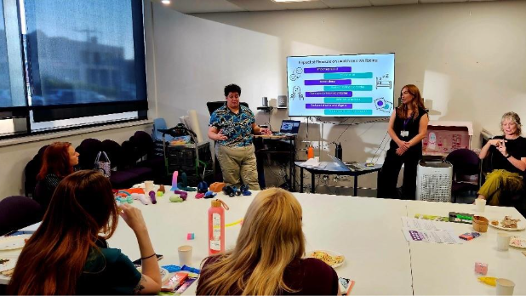
Heti MacKallah (WHIN) and WDV’s Melissa Jolley co-facilitating “Pleasure for Every Body” community workshops about gender and disability inclusive sexual pleasure.

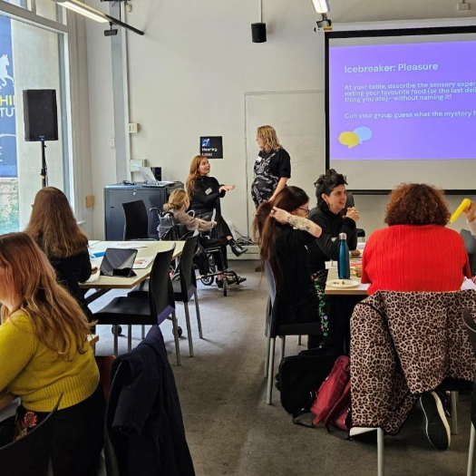
Photograph from the launch event depicting attendees in colourful clothing at tables talking and chatting over activities with a PowerPoint sharing instructions for an Icebreaker activity about the topic of Pleasure. WDV project team (Stephanie Sayer, Melissa Jolley, Brigid Evans) are at the back of the room chatting.

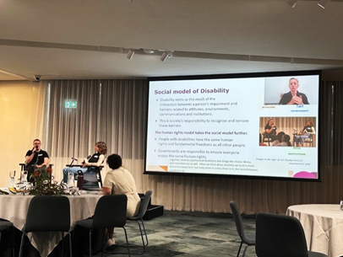
Tess Whelan (Our Watch) and WDV’s Lena Molnar co-facilitating a presentation about the Changing the Landscape resources at the FVREE Disability Inclusion and Safety Forum, December 2024.

Sharing Our Expertise Project
The Sharing Our Expertise project was funded by the Victorian Government to reduce barriers to the employment of women and gender diverse people with disabilities within health, social and community sectors. The project delivered a range of resources, training and technical assistance to support employers to consider the abilities, strengths and value of women and gender diverse people with disabilities. The advocacy program’s focus is the promotion of the rights of women and gender diverse people to inclusive employment fostering economic independence, and their safety from violence and abuse.
The project had many notable achievements including
- Employer Scoping Survey and Insights Report: Conducted a survey of 59 organisations to explore attitudes, barriers, and enablers to employing women and gender diverse people with disabilities in operational, leadership, and governance roles, providing foundational data for all training design.
- Inclusive Employment Training Workshops: Designed and delivered sessions for 35 managers from health and social sectors, focusing on addressing barriers, fostering inclusive practices, and enhancing recruitment/retention strategies, with 100% participant-reported knowledge gains.
- Demystifying Disability Resources Pack: Developed and disseminated accessible materials, including guides on disability rights, workplace inclusion, and practical tools to reinforce training content and promote organizational change beyond workshops.
- Technical Assistance Program: Provided one-on-one guidance to 12 committed organisations, offering tailored advice on reviewing recruitment processes, implementing accessibility provisions, and supporting employment applications from women with disabilities.
- Online E-Learning Module: Created a self-paced digital module based on workshop content to sustain engagement, enabling ongoing access to key messages on barriers, strategies, and inclusive practices for broader employer reach post-project.
- Advocacy and building the evidence base: Project staff have additionally made submissions to employment-related Commonwealth government inquiries, promoting disability and gender inclusion, equity and rights.
The Sharing Our Expertise Project-An Employer’s Reflections
“The impact of the Sharing Our Expertise project has been significant for the City of Ballarat, as we strive to promote workplace accessibility in Council and municipality.
As part of this project, we had three key internal procedures reviewed and a staff Lunch and Learn session on enhancing accessible workplaces. The procedure reviews were helpful in driving progress of our Disability Access and Inclusion Plan in the priority area of Employment. Feedback by people with lived experience has been invaluable in identifying key accessibility gaps.
The Lunch and Learn session received extremely positive feedback from staff from various directorates across Council. Staff took away guidance on accessibility improvements and reasonable workplace adjustments.
My team and I have changed our messaging and plan to develop resources to better support applicants with disabilities.
The lived experience focus of this project has been invaluable. The feedback on our procedures and resources has built my professional knowledge on accessibility needs for consideration across our policies, projects, procedures and programs. I am exploring engagement with local people with disability to contribute to resource design.
Recently, several hiring managers across Council have employed staff with disabilities, with exemplary results. I am excited to explore working with local organisations to increase the leadership of women with disabilities in social procurement and business start-ups, which we promoted in our Accessibility in Practice Forum.
I wish funding could be extended to allow all local governments to be involved in this incredibly important project.”
The reflections above were contributed by Meg Laughton, Ballarat City Council, following her participation in the training workshops and technical assistance components of the Sharing Our Expertise Project.

Operations and Communications Team
Funded by the Victorian government and at the heart of WDV’s day-to-day functions, the Operations and Communications Team plays a vital role in ensuring the organisation runs smoothly and effectively. From managing human resources, finance, IT, marketing and communications, to providing program and governance support, the team underpins the successful delivery of WDV’s strategic and operational goals.
By maintaining robust internal systems, policies, and processes, the Operations Team creates the essential foundation that allows the entire organisation to thrive. The team advises the Board, Treasurer, and Executive Leadership Team on financial performance, business operations, and risk management—ensuring WDV remains both accountable and agile.
Operations staff also oversee payroll, human resources, and drive the development of our infrastructure and Information Communications Technology (ICT), enabling a responsive and future-ready organisation.
Within the Operations Team, the Communications Team leads WDV’s marketing, member engagement, and digital presence. This includes growing our online platforms, enhancing visibility, and strengthening connections with members and the broader community.
Together, these functions support WDV’s mission with efficiency, insight, and strategic foresight.

Facts and Figures
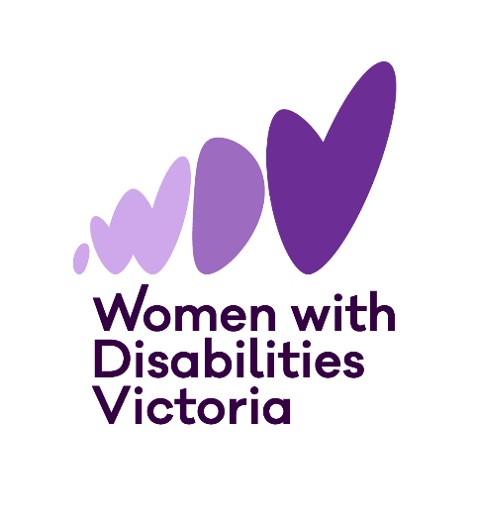

Thank you
Thank you to all our funders, partners, and supporters for your invaluable contributions.

Funders, Partners, and Supporters

Achieve Foundation
Aspire Change

Breast Screen Victoria
Cancer Council of Victoria
Centre for Non-Violence
Centre for Workforce Excellence / Family Safety Victoria / Department of Families, Fairness and Housing / Victorian Government
Cobram Community House
Coonara Community House
Department of Families Fairness and Housing
Department of Social Services
Family Safety Victoria
FVREE
G21
Golden Plains Shire Council
Greater Dandenong Council
InLife
Jan Siobhann
La Trobe University
La Trobe University’s Research Centre in Sex, Health and Society
Multicultural Centre for Women’s Health
Municipal Association of Victoria
National Disability Insurance Scheme Quality and Safeguards Commission
National Disability Research Partnership
Office for Disability
Olga Tennison Autism Research Centre
Our Watch
Preventing Violence Together Western Region
Rainbow Health Australia
Reducing Gender-based Violence Research Group (ReGEN)
Respect Victoria
Safe & Equal
Sexual Health Victoria
Storyfolk
Swinburne University of Technology
The National Disability Research Partnership
TODAY Design
VicHealth
Victoria Legal Aid
Victorian Department of Families, Fairness and Housing
Victorian Department of Families, Fairness and Housing, Office for Women, Disability, Fairness and Emergency Management
Victorian Department of Health
Victorian Trades Hall Council
WLK Consulting
Women with Disabilities ACT (WDACT)
Women with Disabilities Australia (WWDA)
Women’s Health and Wellbeing Barwon South West
Women’s Health East
Women’s Health Goulburn North East
Women’s Health Goulburn Northeast
Women’s Health in the South East
Women’s Health Loddon Mallee
Women’s Health Victoria
Women’s Health Grampians
Women's Health in the North
Donors who supported WDV this year:
Damon O'Sullivan
Jemma Swan
Kristina Greenwood
Prestige InHome care
The Eric & Elizabeth Gross Foundation

WDV Regional Hub Partners

Centre for Non-Violence | Cobram Community House
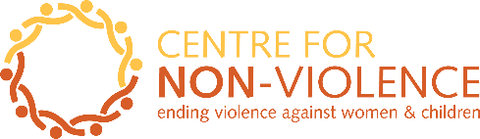 | 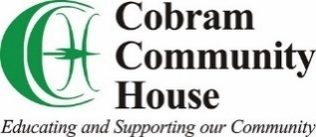
Coonara Community House | Geelong Region Alliance G21
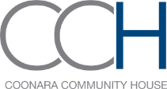 | 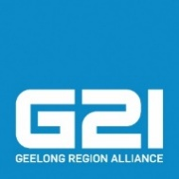
Southwest Advocacy Association

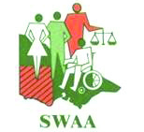

Thank you!

Financial Statements

The WDV Board and Finance & Risk Committee continued to strengthen WDV’s financial position.
The Profit and Loss Statement shows a deficit (loss) of $610,815 in the 2024/25 financial year.
Revenue (money coming in) for this year was $2,398,487, a decrease of $785,891 from last year.
Expenses (money going out) for this year was $3,009,302, a decrease of $458,043 from last year.
Equity (value of WDV) for this year was $1,121,593 a decrease of $610,815 from last year.

This year, Current Assets are $1,415,985, which is equal to 9.04 times our Current Liabilities of $156,671. WDV is in a financial position that we are able to pay our debts if and when they are due.
Cash Reserves decreased this year to $1,361,254 a decrease of $951,432 from last year.

Statement of profit or loss
and other comprehensive income for the year ended 30 June 2025

 | 2025  $ | 2024  $
Continuing operations
Revenue | 2,398,487 | 3,184,378
Expenditure
Depreciation expenses | (109,193) | (113,044)
Employee benefits expenses | (2,300,049) | (2,592,242)
Other expenses | (600,060) | (762,059)
Total expenses | (3,009,302) | (3,467,345)
Surplus (Deficit)  before tax | (610,815) | (282,967)
Income tax expenses | – | –
Surplus (Deficit)  for the year | (610,815) | (282,967)
Other comprehensive income | – | –
Total comprehensive Surplus/(Deficit)  for the year | (610,815) | (282,967)

Statement of financial position
as at 30 June 2025

 | 2025  $ | 2024  $
ASSETS
Current Assets
Cash and cash equivalents | 1,361,254 | 2,312,686
Trade and other receivables | 3,680 | 4,663
Other current assets | 51,051 | 59,236
Total Current Assets | 1,415,985 | 2,376,585
Non-Current Assets
Property, plant & equipment | 6,243 | 17,356
Right of use asset | 231,847 | 329,927
Total Non-Current Assets | 238,090 | 347,283
Total Assets | 1,654,075 | 2,723,868
LIABILITIES
Current Liabilities
Trade and other payables | 156,671 | 490,903
Total Current Liabilities | 156,671 | 490,903
Non-Current Liabilities
Provisions | 100,148 | 125,692
Right of use liability | 275,663 | 374,865
Total Non-Current Liabilities | 375,811 | 500,557
Total Liabilities | 532,482 | 991,460
NET ASSETS | 1,121,593 | 1,732,408
EQUITY
Retained Earnings | 1,121,593 | 1,732,408
TOTAL EQUITY | 1,121,593 | 1,732,408

Statement of changes in equity
for the year ended 30 June 2025
 | Retained Earnings  $ | Total  $
Balance at 1 July 2023 | 2,015,375 | 2,015,375
Surplus/(Deficit) attributable to members | (282,967) | (282,967)
Balance at 30 June 2024 | 1,732,408 | 1,732,408
Surplus/(Deficit) attributable to members | (610,815) | (610,815)
Balance at 30 June 2025 | 1,121,593 | 1,121,593

Cash flow statement
for the year ended 30 June 2025
 | 2025  $ | 2024  $
CASH FLOWS FROM OPERATING ACTIVITIES
Receipts from customers | 2,305,946 | 3,075,535
Payments to suppliers and employees | (3,348,936) | (4,465,198)
Interest received | 91,558 | 109,471
Net cash provided by (used in) operating activities | (951,432) | (1,280,192)
CASH FLOWS FROM INVESTING ACTIVITIES
Payments for plant and equipment | - | (10,921)
Net cash provided by investing activities | - | (10,921)
Net increase in cash held | (951,432) | (1,291,113)
Cash at beginning of financial year | 2,312,686 | 3,603,799
Cash at end of financial year | 1,361,254 | 2,312,686



Keep in touch

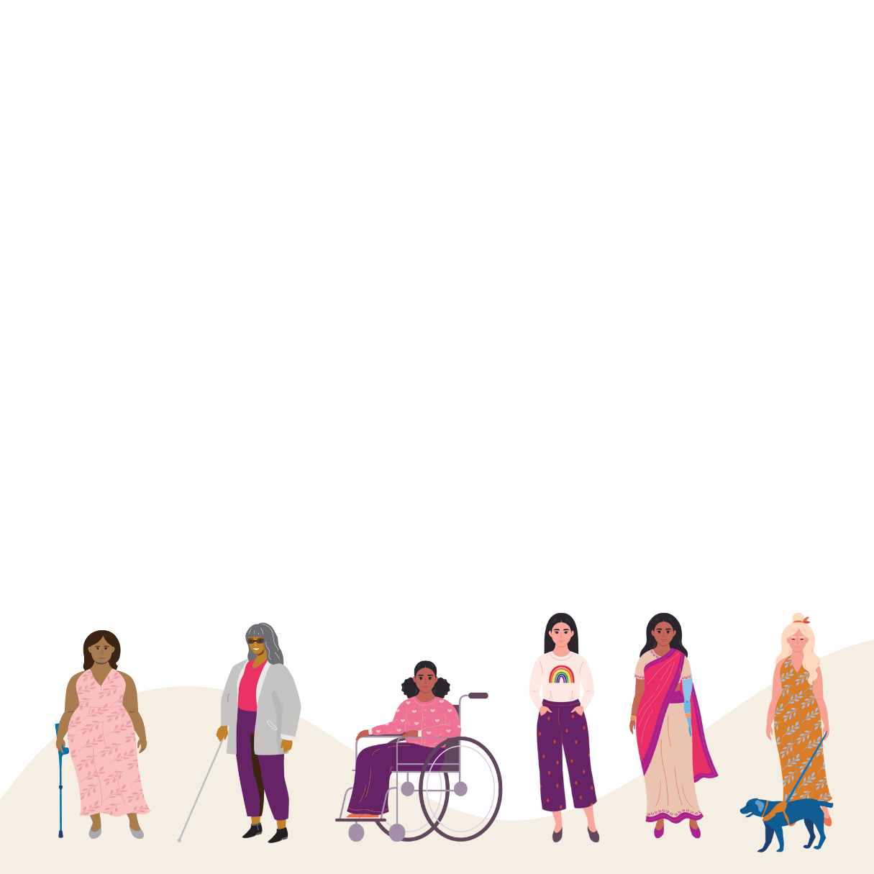
Address: Postal: PO Box 18314
Level 1, 255 Bourke Street Collins Street East
Melbourne VIC 3000 VIC 8003
Wurundjeri Country
Phone: 03 9286 7800 Email: wdv@wdv.org.au




Website: www.wdv.org.au

